HOW TO PLAY RACQUETBALL
The following information will walk you through the basics of how to play racquetball. We created this page so that you could learn how to play the game as quickly as possible while providing links on certain topics for you to explore deeper.
[How to Win] [Quick Rules] [Game Variations] [Court Lines]

How to Win a Racquetball Game
In short, the object of the game is to outscore your opponent while reaching an agreed upon score. Most competitions are played in a best-of-three format, known as a racquetball match, with games scored to 15 and a tie-breaker played to 11. See more on racquetball scoring rules.

Quick Rules: How to Play Racquetball
- Players agree on the rules of the match and decide who serves
- Play begins with a serve and continues after a successful serve (see more on racquetball serving rules)
- Once in play, the opposing player (or team) must hit the ball against the front wall before the ball bounces twice
  - The ball can be struck by the returning player either in mid-air or after the ball has bounced once
  - Once the ball is hit by the returning player, the ball must travel to and hit the front wall (using any number of walls including the ceiling) before the ball hits the floor
- Play continues in this manner until one player wins the rally
  - If the player serving wins the rally a point is issued
  - If the player returning the serve wins the rally, they win the serve
  - Only the player who serves can win a point (see more on how to score in racquetball)
- Once a player reaches the agreed upon number of points in a game, that game is over
We have a diagram and explanation of the racquetball court lines below and another page on racquetball scoring.

Racquetball Game Variations
There are multiple ways to play racquetball, mainly decided by how many players there are. Each game:

Racquetball Singles
When racquetball is played with two people, playing in a one vs one match, it is referred to as a racquetball singles match. This is the most common way the game is played, both recreationally and competitively. Dive deeper into the rules, tips, and strategy of a racquetball singles game.

Racquetball Doubles
When racquetball is played with four people, playing in a two vs two match, it is referred to as a racquetball doubles match. This gameplay is popular in both competitive tournament play and non-competitive recreation matches. Learn more about racquetball doubles rules.

Cutthroat Racquetball or 3 Player Racquetball
3 player racquetball, also known as cutthroat racquetball, is commonly played in a 1 vs 1 vs 1 style, where the server attempts to score against the other two players playing as a team. This game style is not a tournament play variation but can be a lot of fun when you have an odd number of people. Read more about racquetball cutthroat rules.

Racquetball Court Lines Explained
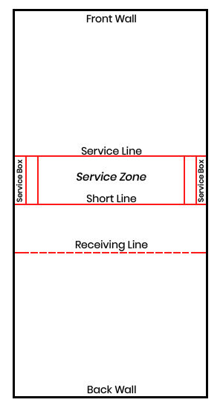Below you will find a brief overview of the racquetball court lines. These are by no means an exhaustive set of the rules, but should be enough to get you up and running in a racquetball singles or doubles match. Check out our detailed racquetball rules if something is not covered here.
Service Line - This is the line that is closest to the front wall. The line plays an important role in the serve. The person serving must have both feet on or behind the line. If one or both feet cross over the service line, this is called a foot fault, and the serve is lost.
Short Line - This line divides the court in two. The short line plays three important roles.
- During the serve, after the ball hits the front wall, the ball must travel past the short line in the air before the first bounce. If the ball hits the floor on a serve before traveling past the short line, it is considered a short serve, and is a fault
- During the serve, the player serving the ball cannot begin with their foot extended beyond the short line. If the foot extends beyond the line it is considered a fault
- The player serving the ball cannot cross behind the short line until the ball passes past the short line on a serve
Service Zone - The service zone, or service box, is the area between the service line and the short line. This area extends all the way to the side walls with two sets of perpendicular lines along the edges. This is the area that the server has to serve within and stay within until the ball passes the short line.
Service Boxes - This area is the box on either side formed closest to the wall in the service zone and is used in a doubles racquetball match. The teammate of the person serving the ball must stand inside one of these service boxes.
Receiving Line or Encroachment Line - The player returning the serve must not cross the receiving line until one of two things happen:
- The ball bounces after it crosses the Short Line on a valid serve
- The ball crosses the receiving line in the air
- Should the player step on or cross the receiving line before one of these two things happen, a point is granted to the server

Racquetball Rules Summary

