Sustainability proposal
Lot #22 & #24 LED Lighting Retrofit

Submitted by:
Brandon McCoy & Gabe Crain

Submitted on:
04/13/2016

- Identification of Sponsors
  - Project Sponsors
      - Brandon McCoy
833 East Elm Street- Sunvilla Tower 804
Springfield, MO 65807
(417) 872-5689
McCoy116@live.missouristate.edu

2. Gabe Crain
1001 East Harrison Street- Hammons 309
Springfield, MO 65807
(417) 812-9811
Crain16@live.missouristate.edu

  - Faculty/Staff advisor
1. Pilar Karlen
Energy Manager
901 South National Avenue
Springfield, MO 65897
(417) 836-8984
PilarKarlen@missouristate.edu

  - Project Manager
      - Pilar Karlen
II. Description of Proposed Project
- General Description of Proposal
This proposal is recommending that the (26) 400 Watt High Pressure Sodium lights in parking lot #22 be replaced with light-emitting diode (LED) lighting system. With this conversion, there will be a reduction in energy usage of 70%, annual energy savings of $2,719 and a reduction of 55,113 pounds of Carbon Dioxide Equivalent.
This proposal is also recommending that the (21) 400 Watt High Pressure Sodium lights in parking lot #24 be replaced with light-emitting diode (LED) lighting system. With this conversion, there will be a reduction in energy usage of 70%, annual energy savings of $2,196 and a reduction of 44,514 pounds of Carbon Dioxide Equivalent.
In total, we would be replacing (47) 400 Watt High Pressure Sodium lights with LED lights.
- Proposal Details
Product (LED) Selected: LSI Slice Small (XLCS)
• Voltage: 120-277 V
• LED Color Temperature: 5000K
• Typical initial lumens: 15,500
• Typical system wattage (208V): 140 Watts
• Die-cast aluminum housing
• System rating is 60,000 to 100,000
• Temperature rated at -40°C to 50°C
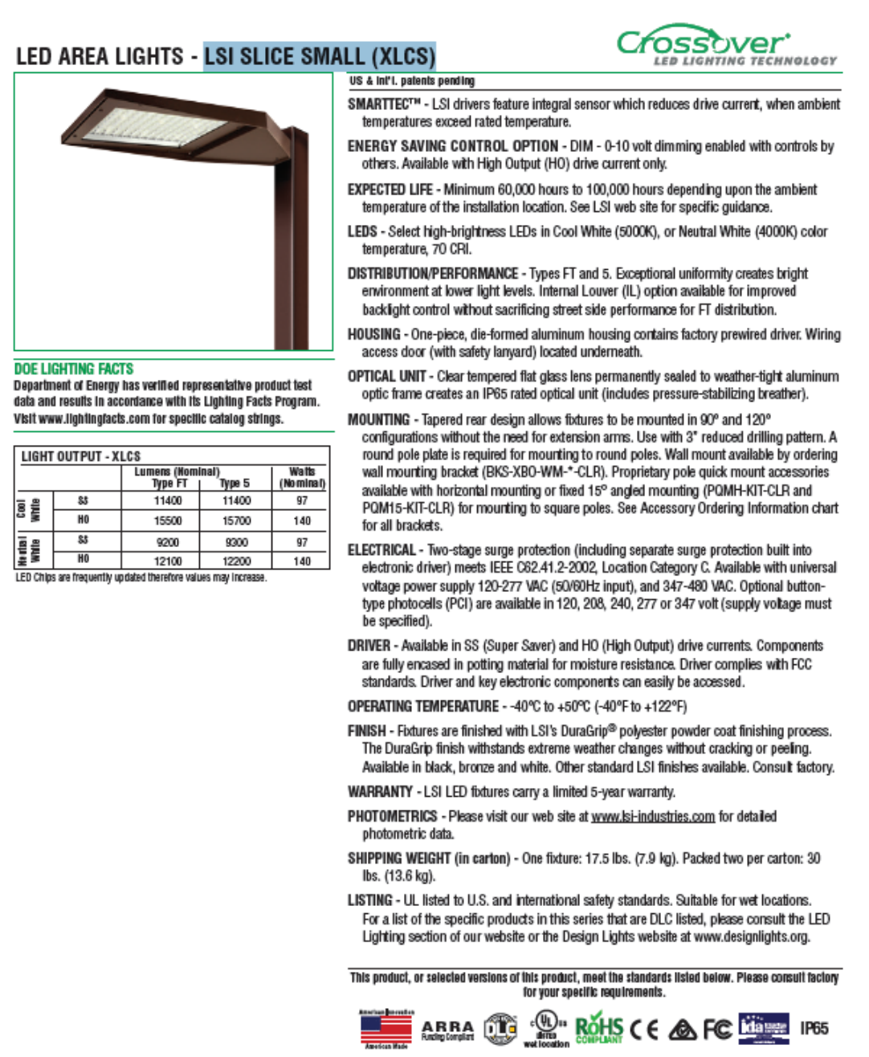

- Proposed location for the object of the proposal
The location is parking lot #22 and #24 south of Grand Street.
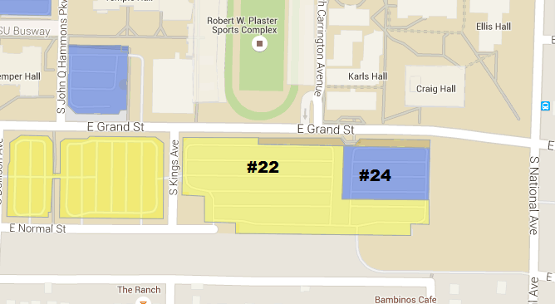
- Alternative Uses
In addition to being more sustainable and cost-effective, LED lighting provides a brighter illumination of the parking lots at night, making students feel safer.

- Drawbacks
Aside from the upfront capital cost, the project provides no long-term drawbacks, as its payback time is 7.75 years.

- Necessary modifications to existing structures
In order to install the selected LED lights on the existing poles, a pole top tenon is required. The price of the pole adaptor is included on the first cost of the equipment.
- Estimated Cost of the Project
  - Provisions of Alternatives in Order of Preference
Only Lot #22
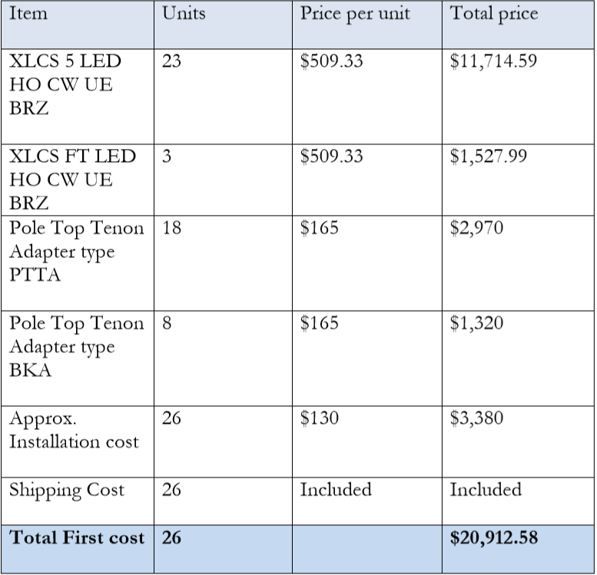

Total cost = $20,912.58
Total cost (plus 10% contingency) = $23,003.84

Only Lot #24

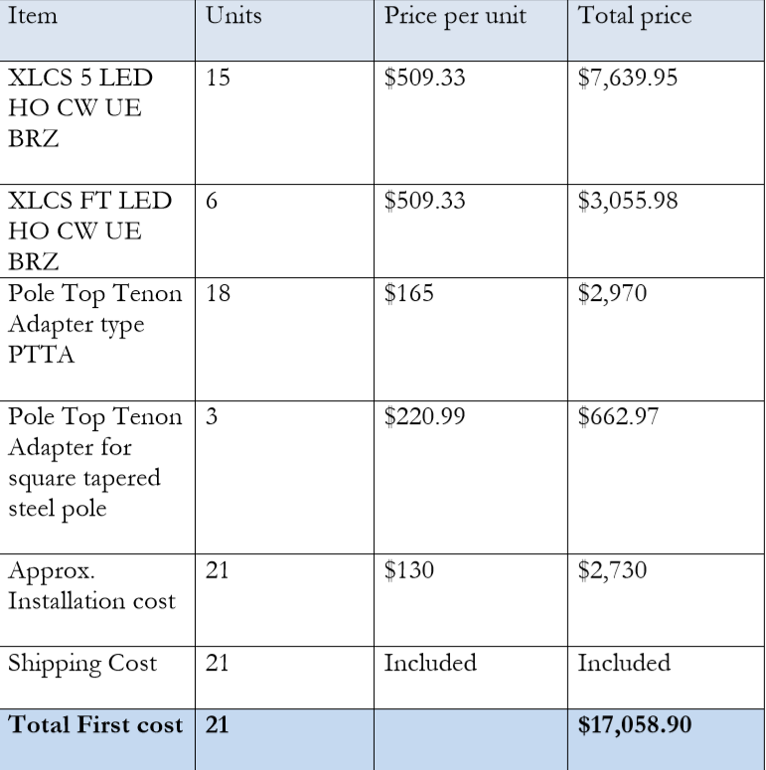
Total cost = $17,058.90
Total cost (plus 10% contingency) = $18,764.79
  - Provisions of Complete Cost Breakdowns
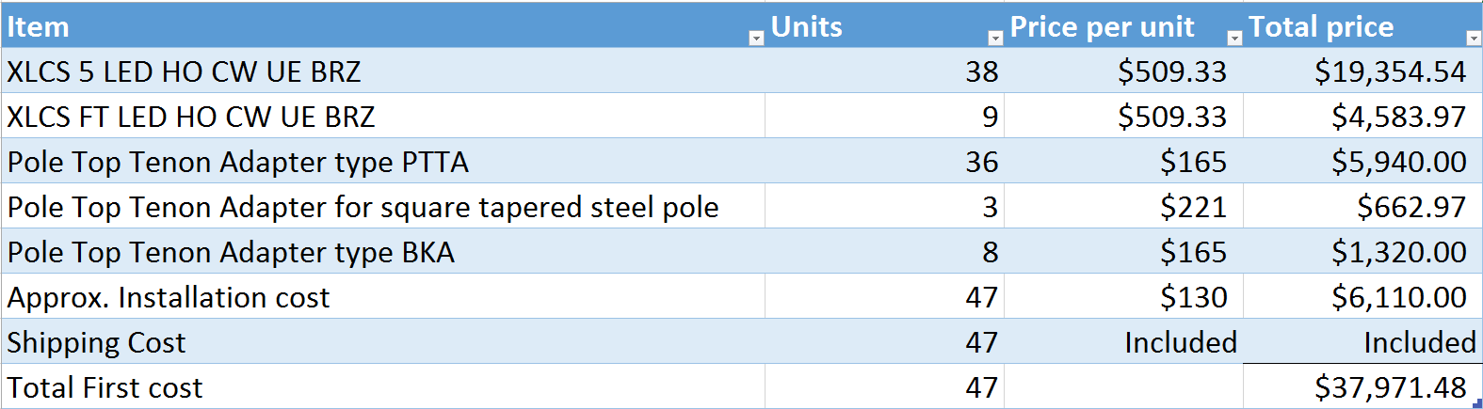
Total cost = $37,971.48
Total cost (plus 10% contingency) = $41,768.63
  - Provisions of any Ongoing Costs
Facilities Management will absorb ongoing costs.
- Estimated Completion Time of Project
The project should be completed by fall of 2016.
- Estimated Life of Project
This specific model is rated at 60,000 (minimum) – 100,000 hours (approx. 14-24 years), at a temperature range of -40C to 50C. This system will be installed with a photocell and it will work from sunset to sunrise (11.5 hours per day, 4200 hours per year). This lighting system is able to interact with occupancy sensor and/or dimming controller therefore the life of the system will be extended.

- Justification of Project
The retrofit of the lights in parking lots #22 and #24 would provide more sustainable lighting to a large area of campus often trafficked by commuter students at night. LED lights not only save money on energy costs and reduce emissions, but they are brighter, providing a safer environment.
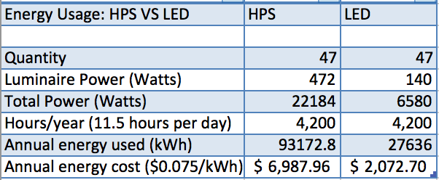
From the money saved, the payback period will be 7.75 years. There is a 70% reduction in energy used, a reduction of 99,627 pounds of Carbon Dioxide Equivalent, and a $4,915 annual savings. Not only does this project provide direct tangible benefits to the university, but is a selling point to prospective students and their families.

- University Support (if applicable)
Kielhofner, Brad
Tue 4/19/2016 3:10 PM
To:McCoy, Brandon M <McCoy116@live.missouristate.edu>;
Cc:Johnson, Thomas R <TomJohnson@MissouriState.edu>; Morris, Matthew D <MattMorris@MissouriState.edu>; Chorn, Gary D <GChorn@MissouriState.edu>; Cox, Jennifer C <JenCox@MissouriState.edu>;
Brandon:

Facilities Management is in support of the Sustainability Commission proposal to retrofit the existing lighting on parking lots 22 and 24 with LED fixtures.

If approved and funded, Facilities Management is prepared to implement the project and will work in cooperation with Safety and Transportation to maintain the fixtures in the same manner as the lighting on our existing parking lots.

We are excited at the prospect of energy savings and improved lighting that this project will provide.

If you have any questions or need additional information, please feel free to contact me.

BRAD KIELHOFNER, P.E.
Director of Facilities Management
Missouri State University

