Sustainability proposal
Ellis Hall and Davis-Harrington Welcome Center Recycling Bin Additions

Submitted by:
Gabe Crain

Submitted on:
04/03/2017
Missouri State University
Student Government Association



- Identification of Sponsors
  - Project Sponsors
      - Gabe Crain
1146 East Cherry Street
Springfield, MO 65807
(417) 812-9811
crain16@live.missouristate.edu
  - Faculty/Staff advisor
1. David Vaughan
Director of Environmental Management
901 South National Avenue
Springfield, MO 65897
(417) 836-8334
dvaughan@missouristate.edu

  - Project Manager
      - Gabe Crain
II. Description of Proposed Project
- General Description of Proposal
The Valuta model recycling bins offers one of the best services when it comes to recycling waste. These bins are stable, durable, and clearly labeled, meaning less students will throw garbage in the wrong bins. With the approval of this proposal I hope to see the addition of recycling bins in both Ellis Hall and the Davis-Harrington Welcome Center.
- Proposal Details
The Valuta models typically come in pairs of three, one for comingle, one for paper, and one for landfill waste. Below is a picture of what the models look like.
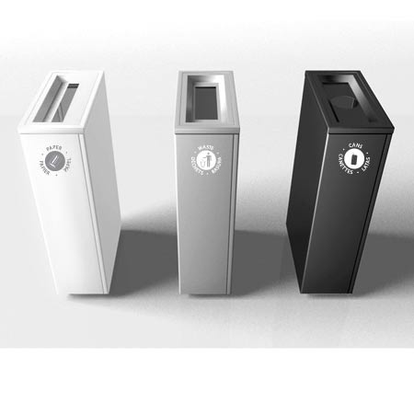
The Director of Environmental Management at Missouri State, David Vaughan, wrote a grant asking for funding for this project and received funding for all project costs aside from the third type of bin, the landfill bin. The reason this portion of money was denied is because they said the purpose of recycling bins should be to divert materials from the landfill. However, research shows that most effective recycling occurs when there is an option for a landfill bin included. With partnership from the Student Government Association with the Sustainability Fund, the full amount of money required for this project will be available, meaning there will be enough money for all eight bins to be purchased. It should be noted that there are eight groups of bins, each with three separate compartments, not only eight bins total.
- Proposed location for the object of the proposal
The two proposed locations for these bins is Ellis Hall and the Davis-Harrington Welcome Center. Six of these bins are to be distributed in Ellis Hall, and two in the welcome center. The specific locations in the two facilities have already been determined by the Director of Environmental Management.
- Alternative Uses
N/A
- Drawbacks
Although this project costs slightly more than $5,000, the Sustainability Fund is only paying for 33% of the total project cost. While it may be granted that these bins seem expensive, the environmental impact they have will far outweigh any drawbacks, especially given the recycling bins’ life span.
- Necessary modifications to existing structures
No existing structures are to be modified. The locations for these eight recycling bins have already been determined by the Director of Environmental Management.
- Estimated Cost of the Project
  - Provisions of Alternatives in Order of Preference
N/A
  - Provisions of Complete Cost Breakdowns
Although the total project cost comes to a total of $12,608.80, the grant that was approved will cover 64% of that. It is only the trash bin component of the three-piece station that the Sustainability Fund will be paying for. This total comes out to $4,581.60. Including a 10% contingency of $458.16, this equates to a grand total project cost of $5,039.76.
  - Provisions of any Ongoing Costs
There will be no ongoing costs for this project that are to come from the Sustainability Fund.
- Estimated Completion Time of Project
After the purchase of the bins, it will take only weeks for them to be delivered and set up in their locations in the two facilities.
- Estimated Life of Project
The Valuta recycling bins are made very sturdy and will last for many years to come.
- Justification of Project
Not only will additional recycling bins in these facilities provide students with even more opportunities to recycle, but material from these bins are tracked as a part of the collection program. Based on existing records on identical stations in other buildings, it is anticipated that these eight stations will divert approximately 8,000 pounds of material from the landfill annually.
- University Support
David Vaughan- Director of Environmental Management
Dvaughan@missouristate.edu

