
Sustainability Proposal
Bike Maintenance Stations
Rebecca Rice
I. Identification of Sponsors
a. Project Sponsors
1. Teresa Frederick
Assistant Director, Residence Life, Housing and Dining Services Facilities and Operations
Hammons House 107
901 South National Avenue
Springfield, MO 65897
(417) 836-8923
TeresaFrederick@missouristate.edu

2. Rebecca Rice
Recycling Coordinator Residence Life, Housing and Dining Services Facilities and Operations
Hammons House 107
901 South National Avenue
Springfield, MO 65897
(417) 379-9681
Rice410@live.missouristate.edu

b. Staff Advisor
1. Jessica Yates
Graduate Assistant, Residence Life, Housing and Dining Services Facilities and Operations
Hammons House 107
901 South National Avenue
Springfield, MO 65897
(417) 836-8923
Yates619@live.missouristate.edu

c. Project Manager
1. Rebecca Rice

II. Description of Bike Maintenance Stations
a. General Bike Maintenance Stations Project Description
The goal of this proposal is to lay the foundation for four bicycle maintenance/repair stations on the Missouri State University Springfield campus. The proposed bike maintenance stations would help Missouri State University in its sustainability efforts by encouraging students to ride bicycles more than driving from location to location on campus. This would, in turn, set an example in the community for furthering the sustainability efforts of Springfield, Missouri. Having bike maintenance stations would also inspire camaraderie amongst the students by inspiring students to build a bicycling community.
b. Bike Maintenance Station Project Details
The purpose of the bike maintenance stations would be to allow students, staff, and faculty on the Missouri State University, Springfield campus to easily fix and maintain bicycles. The bike maintenance stations would be located near heavy bike traffic areas and bicycle parking areas, to maximize the usefulness and convenience for students, faculty and staff.
The tools are attached to the station with stainless-steel cables, which are slow to rust. There are three types of air pumps that are part of the maintenance station, the third type-air kit 3- is designed specifically for heavy-duty public usage and has a waterproof gauge. Choosing this style of air pump will mean that it will not have to be replaced as often as the other, less heavy-duty air pumps would.
c. Proposed Location for Bike Maintenance Stations
There are four locations where a bike maintenance station would serve the bulk of the student population on Missouri State University.
The first location would be on the north side of Kentwood Hall next to the bike racks, and would serve students at Kentwood Hall, the Jim D. Morris Center, and the Student Exhibition Center; it would also be useful for students who are in the downtown area.
The second location would be next to the bike racks in front of Blair-Shannon, and would serve the students at Blair-Shannon House, Foster Recreation Center, Wells House, Woods House, Plaster Student Union, Freudenberger House, Taylor Health and Wellness Center, Monroe Apartments, and the Missouri State University Bookstore.
The third location for a bike maintenance station would be at the bike rack location between Strong Hall and Glass Hall. This location would serve Strong Hall, Kemper Hall, Glass Hall, Temple Hall, Meyer Library, Bear Park South, and the Forsythe Athletics Center.
The fourth and last location would be on the north side of Craig Hall, next to those bike racks. This would serve students at Craig Hall, Karls Hall, the Art Annex, Plaster Field, Pummill Hall, Hill Hall, Ellis Hall, Carrington, Siceluff Hall, and Cheek Hall.
Each location is next to bike racks, making them out of the path of pedestrian students, and more convenient for bicyclists.
These are general locations and University Architect, Doug Sampson, would be consulted on all specific locations before installation.
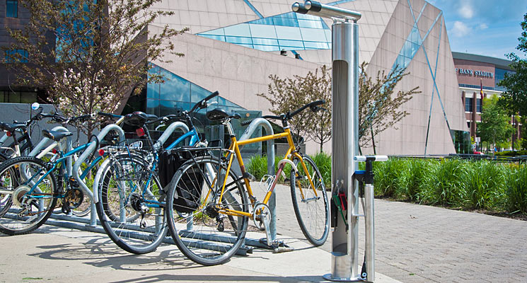
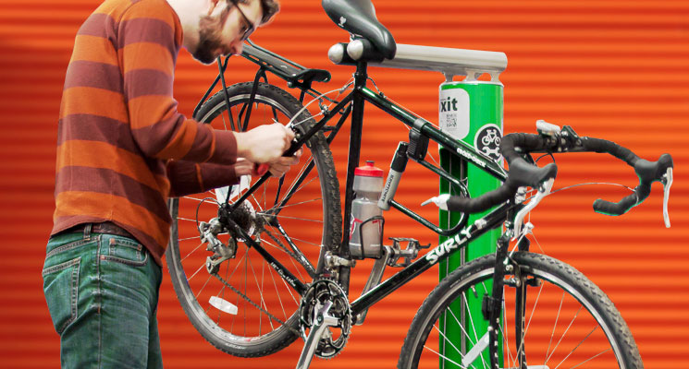
Pictures of the stations as supplied by the Dero website.
d. Alternative Uses
This would serve as an educational piece about the importance of bicycle maintenance. When paired with the Green Bike Program, it would also educate students, staff, faculty, and the general public on ways that they can be more sustainable in their everyday lives.
e. Drawbacks
If students have a spare wheel or bike chain, they can replace a bicycle wheel or chain. If not, they wouldn’t be able to do that; the stations provide just the tools and air pumps, not the parts. Also, a significant amount of space is required for the stations: they must be 60 inches away from the street, 45 inches away from any side walls, and 12 inches away from any wall behind them.
f. Necessary Modification to Existing Structures
The bike maintenance stations will have to be drilled into the ground, but because they are self-contained units, there will not have to be modifications to any buildings.
III. Estimated Cost of the Project
Without shipping, each bike maintenance station on its own is $940.00. This is with the basic air pump that will need to be replaced multiple times. However, each has an option of replacing the basic air pump with an air pump that is designed for heavy-duty public usage, and has a waterproof gauge. With these air pumps, each unit is $1,450.00. This extra cost is made up for by not having to replace the pumps nearly as often as the basic pumps would have to be replaced. Altogether, without shipping, the four bike maintenance stations would be $5,800. With the shipping through UPS ground shipping estimated at $54.39, it would cost $6017.56 to obtain four bike maintenance stations.
Residence Life, Housing and Dining Services has ordered one of these stations for Garst Dining Center already. With shipping and the basic air pump, the total cost of that station was $986.00.
That said, I have received a quote from Dero Bike Rack Company, the company that makes the Dero bike maintenance stations, and-with shipping included- stating that the cost would be $5,930.
According to Mike Orf, Construction Manager Facilities Management-Business Services, the cost of installation for each bike station should not exceed $300 per bike station, bringing the total cost of the project to $7,130.
IV. Ongoing Costs
Many of the universities and colleges report there being no significant ongoing costs for the bike maintenance stations. Setting aside $200 every year for replacement of parts and labor -with the stipulation that if the money is not used, it is placed back into the sustainability fund- would be sufficient.

V. Estimated Completion Time of Project
The only time required to complete the project is shipping time and installation time. Once the bike maintenance stations have been shipped to Missouri State University, the only time required would be for installation.
VI. Estimated Life of Project
The bicycle maintenance stations should last as long as the university is willing and able to maintain and replace parts when necessary. Each part of the station is meant to last for a long time. That said, each separate part is replaceable, so that as different pieces of the maintenance station wears down, those individual parts can be replaced, instead of replacing the entire bike maintenance station.
VII. Justification of Project
Bike maintenance stations fit in with Missouri State University’s efforts towards sustainability by encouraging students to ride bicycles instead of driving from location to location on campus and also to near-campus locations. Having the stations located around the entirety of the campus would make students aware of Missouri State University’s sustainability efforts, as well as encouraging the students to think about their own sustainability efforts and how those efforts could be improved. This would follow two of the three pillars of Missouri State University’s public affairs mission: Ethical leadership and community engagement. Students who use the bike maintenance stations would be encouraging other students to not only use the stations, but also to ride bicycles more than driving cars, and thus would be ethical leaders.
The project would also fit in with the “Community Engagement” goals of Missouri State University’s public affairs mission by encouraging students to build a community around sustainability and sustainable practices.
Finally, the increase in student housing near campus creates an increased amount of bicycle traffic in and around traffic. Having bike maintenance stations in multiple places around the campus assists both students who live in the Residence Halls and students who live off campus in becoming more sustainable in their everyday lives by making it easier to be a bicycle owner.
VIII. Reviews of Product
Many other universities and colleges have installed these stations: University of Washington, University of Arizona, MIT, UC Berkely, UC Davis, University of Maryland, Harvard University, Purdue University, University of Georgia, Pomona College, University of Kentucky, Pennsylvania State University, Northeastern University, and North Seattle Community College are just a few of them. Those universities and colleges that have reviewed them report that they are easy to use, educate students about sustainability, the parts are easy and inexpensive to replace, and are designed to prevent vandalism. They also state that bicycle ridership has increased since installing the bike repair stations.
IX. Administrative Support
On the following page is a letter of administrative support from Teresa Frederick.

