Sustainability Proposal
Bicycle Rack
Casey Cusick

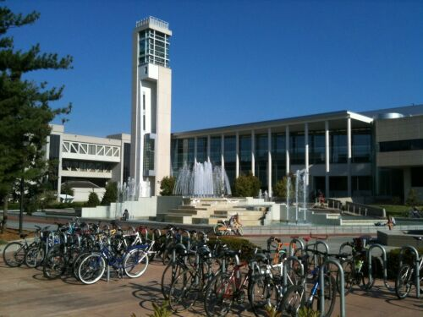
(Photo of the bicycle racks is from Missouri State University’s website)

I. Identification of Sponsors
a. Project Sponsors
1. Casey Cusick
Civil Engineering Student
Missouri State University
Cooperative Engineering Program
405 N. Jefferson Avenue
Springfield, MO 65806
(417) 629-4043
cbc001@live.missouristate.edu

2. Matthew Koppitz
Civil Engineering Student
Missouri State University
Cooperative Engineering Program
405 N. Jefferson Avenue
Springfield, MO 65806
(417) 209-2533
mattkoppitz@gmail.com

3. Nathan Jaffe
Electrical Engineering Student/s
Missouri State University
Cooperative Engineering Program
405 N. Jefferson Avenue
Springfield, MO 65806
(417) 350-0995
jaffe8146@live.missouristate.edu

4. Nathaniel Kelly
Electrical Engineering Student/s
Missouri State University
Cooperative Engineering Program
405 N. Jefferson Avenue
Springfield, MO 65806
(417) 862-5866
nathaniel3@live.missouristate.edu

b. Staff Advisor
1. Dr. Matthew Pierson
Civil Engineering Professor
Missouri State University
Cooperative Engineering Program
405 N. Jefferson Avenue
Springfield, MO 65806
(417) 837-2320
matthewpierson@live@missouristate.edu

c. Project Manager
1. Casey Cusick
Civil Engineering Student
Missouri State University
Cooperative Engineering Program
405 N. Jefferson Avenue
Springfield, MO 65806
(417) 629-4043
cbc001@live.missouristate.edu

II. Description of Bike Rack Stations
a. General Bike Rack Station Project Description
The goal of this proposal is for the implementation of one bicycle rack. The proposed bike rack would help Missouri State University’s Sustainability Program by encouraging students to ride bicycles. The bike rack would be a visual reminder of Missouri State University’s commitment to sustainability. A bike rack station would also foster a student-bicycling community.

b. Bike Rack Station Project Details
The purpose of the bike rack station would be to allow students, staff, and faculty on the Missouri State University, Springfield campus to safely secure their bicycle while inside the Plaster Center building.
The bicycle rack SKU is 05CL1678, and the model is 11-Bike Rack (surface mount).
Bicycle racks require a 60’’distance away from the street, 45’’ clearance from any side walls, and 12’’clearance from posterior wall.
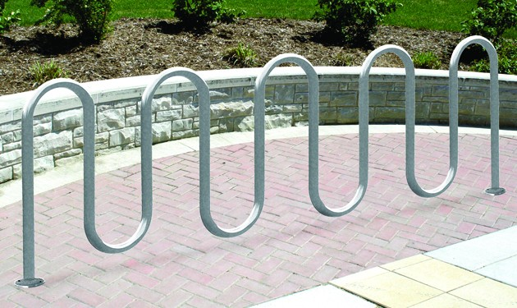
Figure 1 Park-it galvanized bike rack, 11 bike capacity, surface mount

c. Proposed Bicycle Rack Location
The bicycle rack’s proposed location is on the west end of Robert W. Plaster Center for Free Enterprise and Business Development, 405. N. Jefferson Avenue, Springfield, MO 64806.
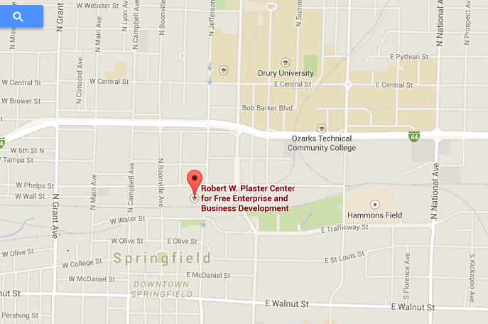
North

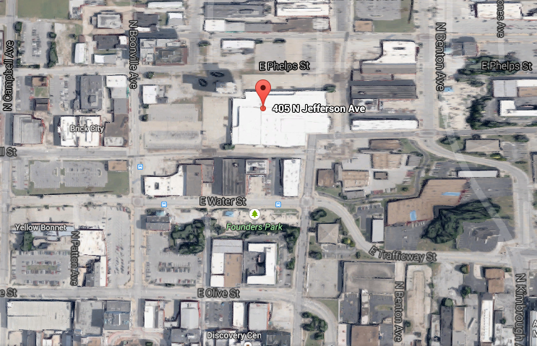
Proposed Bicycle Rack Location
North
d. Alternative Uses
This would serve as an extension of the Green Bike Program to promote a network of bicycle racks. The Green Bike Program could also educate students, staff, and faculty by highlighting an additional bicycle rack location. The student body could be educated on sustainability by encouraging students to bicycle in lieu of driving.
e. Drawbacks
No drawbacks besides the cost of the bicycle rack.
f. Necessary Modification to Existing Structures
The bicycle rack will have to be fastened to the ground.
III. Estimated Cost of the Project
According to Jen Cox, Associate Director of Facilities at Missouri State University, the cost of bicycle rack and installation is $5,657. There is also a ten percent contingency cost equaling $566, bringing the total cost of the project to $6223. The ten percent contingency cost is a governing document of the Sustainability Commission.
IV. Ongoing Costs
The bike rack should not require any maintenance costs for the foreseeable future.
V. Estimated Completion Time of Project
The time required to complete the project is three to four weeks, weather permitting.
VI. Estimated Life of Project
The bicycle rack should last as long as the university is willing and able to maintain the bicycle rack. Missouri State University has bicycle racks that have lasted for decades and are still in use.

VII. Justification of Project
The bicycle rack project would be a benefit for the students and faculty because it would be another option for commuting to school. The bicycle rack would alleviate parking congestion, and it would be a public display of Missouri State University’s commitment to sustainability.
Additionally, the project would align with Missouri State University’s public affairs mission for “Community Engagement” by boosting student involvement in sustainability.
There is a bicycle rack on the east side of the building, but students aren’t granted access to the door on the east. Students access the building from the west side and currently there is no location to secure their bikes. This results in bikes being locked to random places including hand rails. Some students have decided not to ride a bike because of this problem. Installation of a bike rack would solve these problems and encourage more students to commute by bike.
Additionally, the parking lot serving the Plaster Center and Brick City is regularly full. A bike rack may delay the need to expand this parking lot saving money and resources.
VIII. Reviews of Product
Many universities have bicycle racks like Missouri State University, Ozark Technical College, and Drury University. Bicycle racks are common, practical, and useful.
IX. Administrative Support
On the following page is a letter of faculty support from Dr. Douglas Carroll.

February 10, 2015

Student Sustainability Fund:
Students in the Cooperative Engineering Program have written a proposal to have a bike rack installed on the west side of the Plaster Center for Free Enterprise. I support the proposal.
Students are given access to the building through the west side door using their BearPass Cards. They can access the building through the east side door during normal business hours, but not in the evenings or on weekends. The design and construction of student projects such as Steel Bridge, Concrete Canoe and senior design projects are done primarily in the evenings and on weekends. We need to provide student access to the building during evenings and weekends, but we also need to protect the building. The fence around the parking lot and building makes the west side door the safest and most convenient place to provide student access to the building.
For the students who ride bicycles, there is no bike rack on the west side of the building. If students use the bike rack on the east side of the building they must walk 3 blocks to get around the fence and access the building. If they drive a car they can park in the parking lot on the west side of the building and have safe, convenient access to the building. This discourages students from riding bicycles. We need to have a bike rack installed on the west side of the building.
Installing a bike rack on the west side of the Plaster Center for Free Enterprise will help with the sustainability effort on campus by encouraging students to ride bicycles instead of driving cars. It will also provide a safer and more convenient place for students to park their bicycles at the building. I hope that you will fund the project.
Sincerely,

Douglas R. Carroll
Director of Cooperative Engineering Program

