The Bear Pantry Hydroponic Expansion and Maintenance Proposal
Missouri State University

Project Sponsor
Shae Casey
Graduate Assistant
The Bear Pantry
901 South National Avenue
Springfield, Missouri 65897
417-766-0600
Sha224@live.missouristate.edu

Faculty/Staff Advisor and Project Manager
Alex Johnson
Director of Community-Engaged Learning
Center for Community Engagement
901 South National Avenue
Springfield, Missouri 65897
417-836-5774
Alexjohnson@missouristate.edu

The Bear Pantry
University Hall
1141 East Madison Street
Springfield, Missouri 65897

- Description of Proposed Project
a. Installation of hydroponic tower
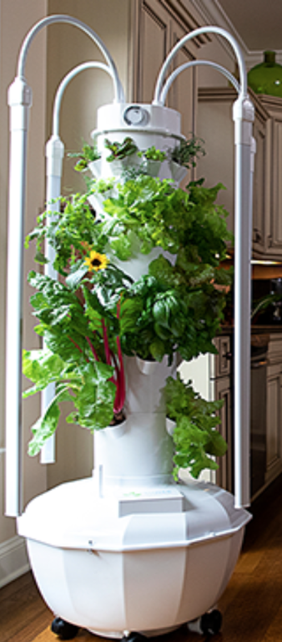
This proposal will help secure the funding to install two Tower Garden HOME Growing Systems and two Tower Garden FLEX Growing Systems from Tower Garden inside of the Bear Pantry alongside previously created hydroponic growing systems to grow fresh produce indoors. Aeroponics is the use of water, oxygen, and nutrients to create a growing environment in replacement of soil. This allows for year-round frequent harvesting with high yield indoors, energy efficiency, lower environmental impact, no use of pesticides, and elimination of potential contamination from animals/bugs/unauthorized people.
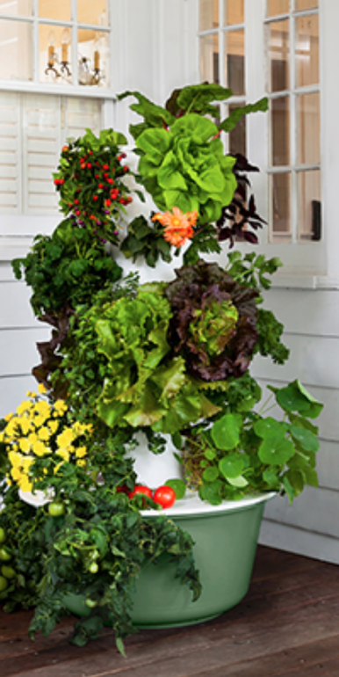
Figure 1. Tower Garden HOME Growing System Figure 2. Tower Garden FLEX Growing System
b. Proposal Details
Tower Garden HOME Growing Systems and Tower Garden FLEX Growing Systems will be placed in a designated area alongside other hydroponic growing systems inside of University Hall. There will be four Tower Garden HOME and FLEX Growing Systems housed in the pantry. Each Tower Garden HOME is approximately 58"x 24" x 24" inches in dimension. The Tower Garden FLEX is approximately 62" x 30" x 30" inches in dimension. The required LED lights for growing will be purchased separately and are included in the cost breakdown section. Nutrient solutions will be added to the water holding tanks of deionized water, circulated by air pumps. The area will be cleaned and sterilized before installation of the towers. Conditions will be maintained in the room to reduce risk of developing insects and growth of unhealthy microorganisms.
Student Interns, advised by Darr School of Agriculture, and Bear Pantry staff will be responsible for maintaining the systems. The Bear Pantry staff will acquire the proper training and skills from the agricultural interns to help provide consistent maintenance of the systems. Maintenance includes, but is not limited to, placing seeds in the required growing medium, testing pH, mixing and measuring nutrient solutions, filling tanks with deionized water, and transporting deionized water along with requested materials by the student interns from Karl’s Hall. The faculty from the Darr School of Agriculture will be advising and support the intern in charge of the systems should any problems arise.
Maintenance will be provided by the Bear Pantry staff and the annual intern chosen by the Darr School of Agriculture. Maintenance includes, but is not limited to, replacement of needed LED grow light bulbs, water pumps, irrigation tubing, and any unforeseen problems. For specific Tower Garden part replacement and warranty related issues with the aeroponic systems, Planting Seeds, LLC will assist with all complaints.
II. Proposed location for the object of the proposal
This new aeroponic system will be installed in a multipurpose workspace located on the East side of the University Hall basement. University Hall is located on Madison Street near the east side of Missouri State’s main campus.
III. Alternative and additional uses
There are no alternative or additional uses for the resources written for in this proposal.
IV. Drawbacks
This proposed addition and needed resources for maintenance will be of little risk since the previous systems in pantry have already been expanded upon to keep up with demand and growth is needed. The only potential drawback that could occur with this proposal is the failure of the crops due to improper care and maintenance. Appropriate steps to keep the room pest free will be taken.
V. Estimated Costs
a. Total Cost of Project
The total cost of the project will be $9,887.39.
b. Provisions of Complete Cost Breakdowns
FloraGro x ....................................................................................$27.99/Gallon x 6 = $167.94
FloraMicro........................................................................................$13.59/Quart x 6 = $81.54
PH Up.................................................................................................$9.19/Quart x 6 = $55.14
PH Down..........................................................................................$14.93/Quart x 6 = $89.58
Rapid Rooter 1400 Count.......................................................................................$312.43/Box
EcoAir 4 Air Pump.........................................................................$41.95/Pump x 6 = $251.70
AquaNeat Air Stone 2 Pack...............................................................$10.19/Pack x 6 = $61.14
Kolem LED Grow Light.................................................................$79.99/Light x 4 = $319.96
5 Gallon Plastic Hedpack with Cap.............................................$16.99/Hedpack x 4 = $67.96
Tower Garden A and B Mineral Blend............................................$60.00/Set x 12 = $720.00
Tower Garden HOME Growing System............................$1,940.00/ System x 2 = $3,880.00
Tower Garden FLEX Growing System..............................$1,940.00/ System x 2 = $3,880.00
Grand Total……………………………………………………………........................$9,887.39
c. Provisions of any Ongoing Costs
All ongoing costs will be paid through the Bear Pantry Foundation Account and is addressed in letters of support attached to this proposal.
VI. Estimated Completion Time of Project
Once total funding is secured, the project will move forward immediately with the purchase and installation of equipment. Training will be provided by Planting Seeds, LLC to College of Agriculture students and all Bear Pantry staff and aid in completion of a formal training manual. After the appropriate training has been completed the use of the systems will begin. After initial start-up, the first harvest will be expected in the summer semester of 2021.
VII. Estimated Life of Project
The life of this project is expected to last indefinitely. This proposal covers not only the products and installation, but also required maintenance resources for all aeroponic systems and current hydroponic systems in pantry. Any ongoing costs incurred outside of those written for in this proposal will be paid for by the Bear Pantry.
VIII. Justification of Project
Hydroponic and aeroponic grown produce allows for affordable consistent produce offerings to the food insecure population of the Missouri State University community. Food insecurity is defined by the Oxford Dictionary as a current state of not having reliable access to one’s needed quantity of affordable, nutritious food. The goal of this addition is to help supply the food insecure population of our campus community with fresh healthy produce that will promote long-term positive health outcomes and prevent chronic disease. By expanding the amount of indoor grown produce, we can expect there to be consistent supply of healthy fresh fruits and vegetables meeting the basic needs of those using the Bear Pantry.
By having growing systems in pantry can cut out transportation time, costs, and the risk of contamination associated. These systems provide great cost savings compared to purchasing traditional produce. Overall, there is sustainable energy efficiency due to lower energy use from time of planting to harvest. This increased control will result in a sustainable use of water, tailored nutrient amounts provided to plants preventing waste, and limited or zero use of pesticides resulting in a reduction in the number of environmental contaminants.
Student workers, interns, and volunteers will obtain hands-on learning experience while helping maintain the hydroponic growing systems and how they impact one’s food security status. This opportunity will help students learn about alternative sustainable production of food to promote sustainable consumption. This is a unique campus experience producing food that will be consumed by students, staff, and faculty facing food insecurity. This experience, when advertised, can become an attractive factor for prospective students and current students to provide a diverse and enriched time at the University, creating a deeper connection to our community and environment.
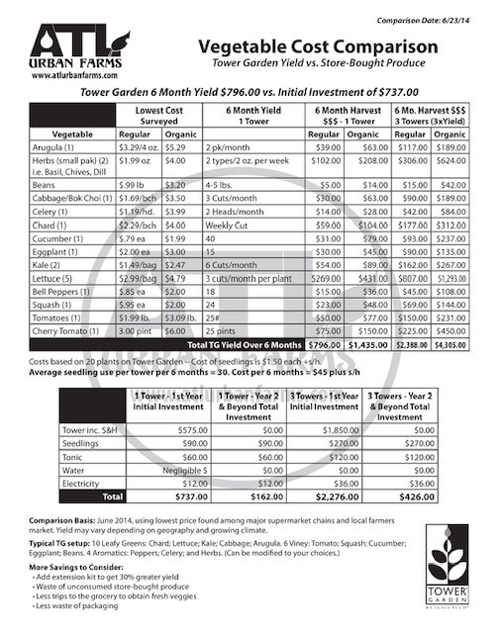
Figure 3. Vegetable Cost Comparison
IX. University Support
Attached to this proposal are letters of support detailing involvement from mentioned parties.
Ross Hawkins, Director of Academic Advisement and Transition - University Hall Building Manager
Dr. Ronald Del Vecchio, Dean, Darr College of Agriculture
Dr. William McClain, Assistant Professor, College of Agriculture
Dr. Keri Franklin, Associate Provost for Assessment and Public Affairs
Dr. Kelly Wood, Associate Provost for Student Success
X. References
Oxford languages and Google - English. Retrieved March 12, 2021, from https://languages.oup.com/google-dictionary-en/

