Using Campus LINK for Your Personal Profile
To Access
Access Campus LINK by logging on to My Missouri State: https://my.missouristate.edu/cp/home/loginf
Select the Profile tab
Click the Campus LINK logo
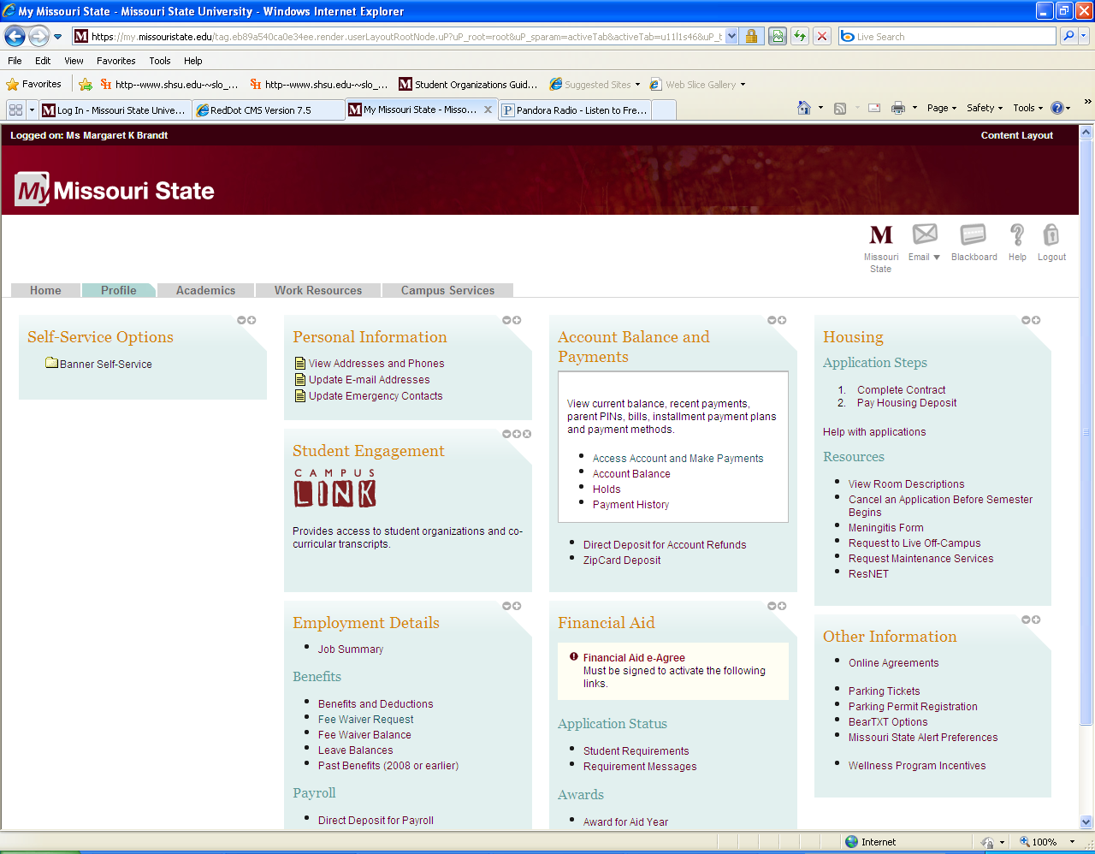

Creating/Editing Your Profile
Once logged in to Campus LINK, go to the very top of the page and click the Account button.
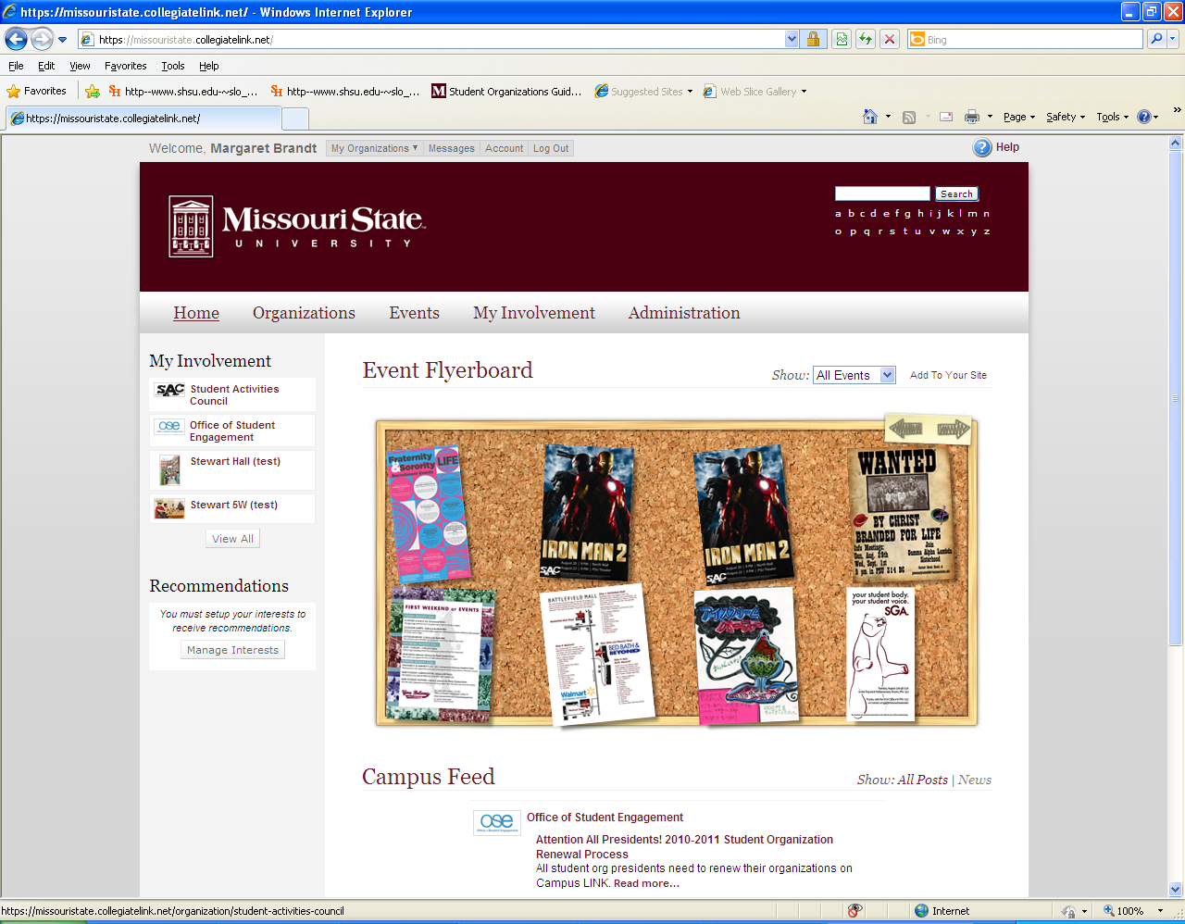

Fill in the fields for Profile Information. If you would like to connect your Campus LINK to Facebook (your activities and updates on Campus LINK will show up in your Facebook News Feed), click the blue Connect button for Facebook. You can also upload your profile picture by clicking Change Picture. When you are finished with this page, click Update Account. 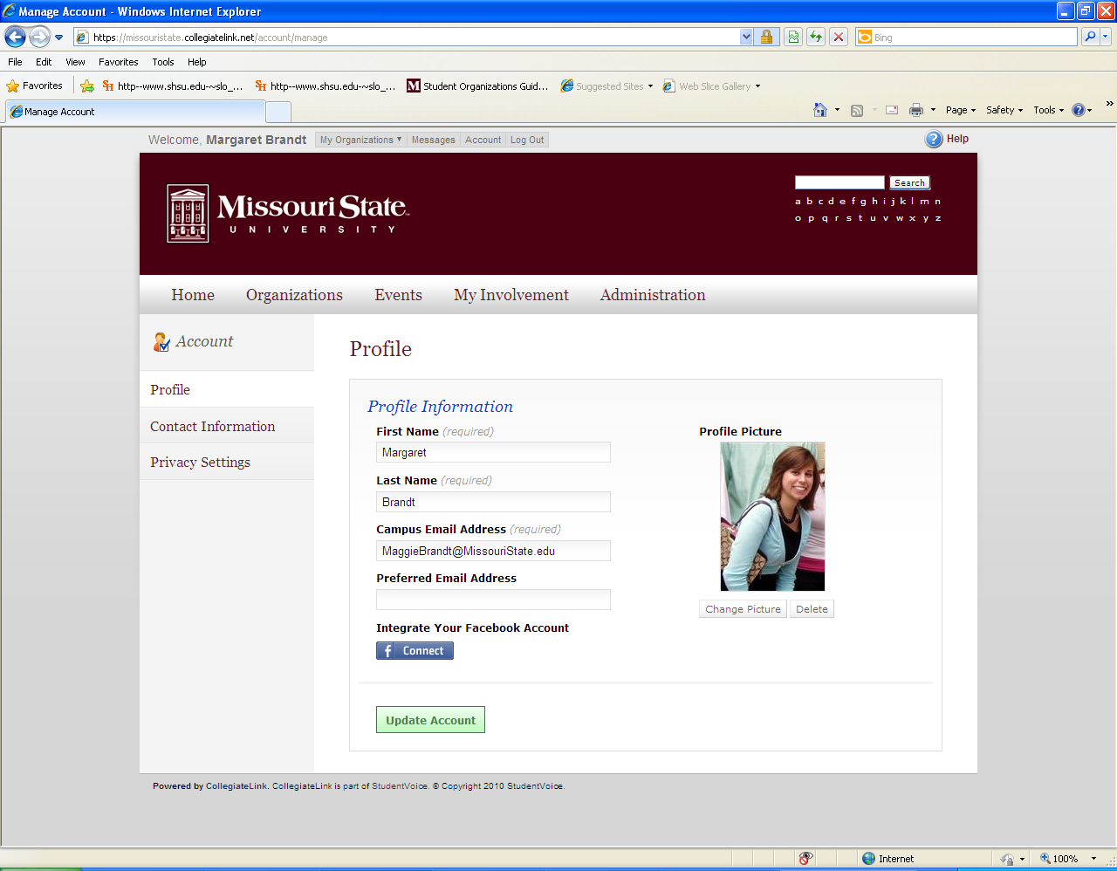

Click the Contact Information option on the left-hand side. Contact information is only visible to those people who are members of the same organization as you. When you finish this page, click Update.
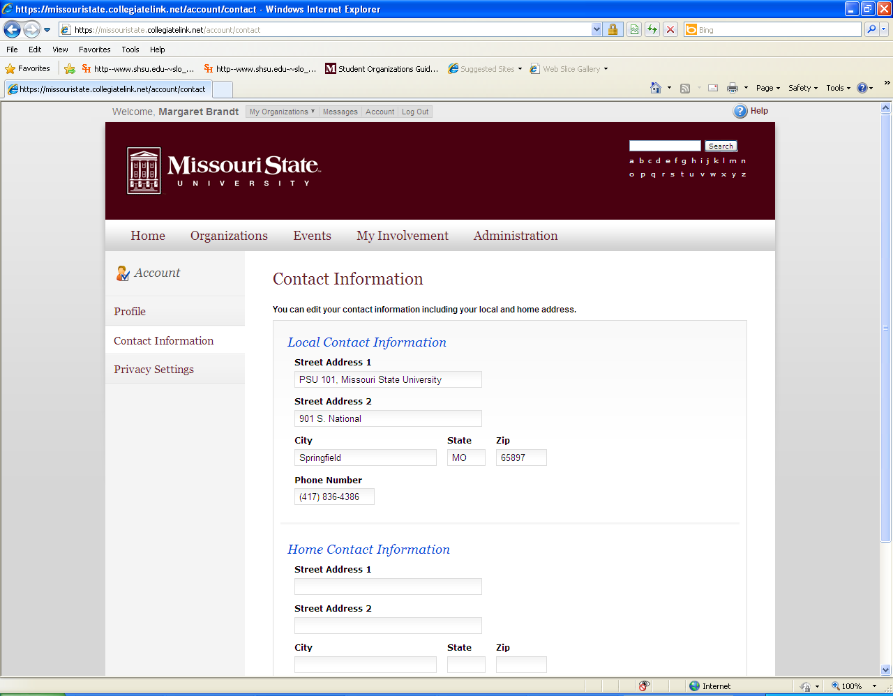
The Privacy Settings option on the left-hand side refers whether or not you want your name to appear in your groups. You will probably always want your name to appear, but in case you do not (ex. you belong to a political or religious group but do not want others knowing), uncheck the Show Name box next to that group.


