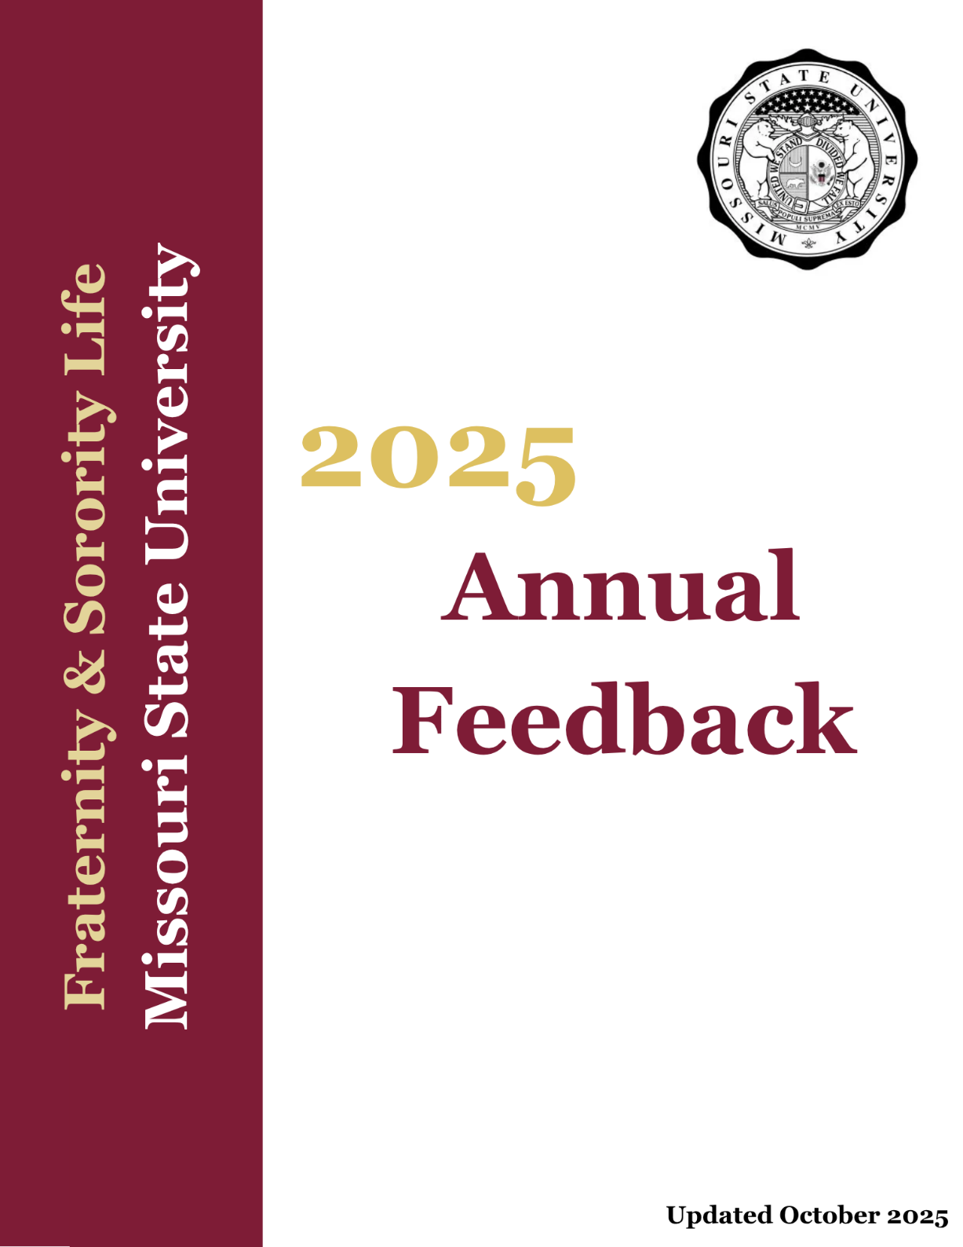

Annual Feedback Overview
Annual Feedback is a compilation of key measures from the calendar year for each fraternity and sorority chapter. It includes information submitted by chapters, along with data collected by Fraternity and Sorority Life and the Office of Student Engagement.
Annual Feedback Purpose
The purpose of Annual Feedback is to provide each chapter with a clear overview of its progress, achievements, and opportunities for growth. This process supports accountability, continuous improvement, and recognition of the positive impact made by the fraternity and sorority community. In alignment with both Missouri State University’s public affairs mission and Fraternity and Sorority Life’s mission to foster inclusivity, unique connections, and continuous growth, Annual Feedback reinforces the shared values of leadership, service, development, scholarship, and community.
Documentation
Chapters must submit all documentation by the deadlines set by the Office of Student Engagement and Fraternity and Sorority Life. Submissions should include all required data, forms, and supporting materials. Documentation should be compiled and submitted throughout the year, with final materials due by Study Day, December 5, 2025, at 4:00 p.m.
Rating Structure
- Exemplary – Indicates a chapter that exceeds expectations and demonstrates exceptional performance.
- Above Average – Indicates a chapter that performs above standard expectations, with minor areas for improvement.
- Satisfactory – Indicates a chapter that meets all required standards and fulfills expectations.
- Needs Improvement – Indicates a chapter that falls short in some areas and is encouraged to strengthen performance.

Section Point Levels
Each section within a category is scored on a 0–15-point scale, using increments of 5 points. Points are cumulative: to earn a higher point value, a chapter must meet all criteria of the lower point values first.
FSL Awards Eligibility
Chapters must meet at least the ‘Satisfactory’ rating in all categories to be eligible for Chapter Awards. Chapters that receive a ‘Needs Improvement’ rating in any category, or have been found responsible for violations of university policies or state/local laws, are ineligible for Chapter of the Year but may apply for other chapter and individual awards.

Annual Feedback Summary Report
Throughout December and January, Fraternity and Sorority Life staff will compile an Annual Feedback Summary Report for each chapter, outlining point values, ratings, and activity descriptions for all sections of the Annual Feedback. At the first individual chapter president one-on-one meeting in January, chapters will review their evaluation with an FSL staff member. Incoming and outgoing presidents are expected to attend, unless the outgoing president is no longer enrolled at the university. The report will also be referenced in subsequent one-on-one meetings throughout the semester to ensure progress and goal alignment.
A final copy of the report will be shared with the chapter president, chapter advisors, and the inter/national organization. Chapters are encouraged to continue these discussions internally with advisors and executive officers to identify opportunities for growth.
2025 Important Dates
☐ January 13, 2025 – Rosters distributed in mailboxes
☐ January 21, 2025 – Rosters due to OSE by 4:00 p.m.
☐ February 3, 2025 – Presidents Meeting at 4:00 p.m.
☐ March 3, 2025 – Rosters distributed in mailboxes
☐ March 3, 2025 – Presidents Meeting at 4:00 p.m.
☐ March 10, 2025 – Rosters due to OSE by 4:00 p.m.
☐ April 7, 2025 – Chapter Risk Management Plan due via BearLink
☐ April 7, 2025 – Presidents Meeting at 4:00 p.m.
☐ April 14, 2025 – Academic Support Plan due via BearLink
☐ April 21, 2025 – Rosters distributed in mailboxes
☐ April 28, 2025 – Rosters due to OSE by 4:00 p.m.
☐ May 2, 2025 – Deadline for service hours, educational events, philanthropic donations, roster changes, etc. by 4:00 p.m.
☐ August 18, 2025 – New Member Education Plan due via BearLink
☐ September 8, 2025 – Presidents Meeting at 4:00 p.m.
☐ September 26, 2025 – Leadership program roster due via BearLink
☐ October 6, 2025 – Presidents Meeting at 4:00 p.m.
☐ October 15, 2025 – Transitions Meeting at 5:00 p.m.
☐ November 3, 2025 – Presidents Meeting at 4:00 p.m.
☐ November 17, 2025 – FSL Rosters distributed in mailboxes
☐ December 1, 2025 – FSL Rosters due to OSE by 4:00 p.m.
☐ December 5, 2025 – Deadline for service hours, educational events, philanthropic donations, roster changes, 2026 Officer Contact Information, Annual Feedback, etc. by 4:00 p.m.
Scholarship & Academic Support
(Maximum: 60 points)
Academic Support Plan
Point Value | Criteria | Documentation
0 | Chapter does not submit an Academic Support Plan annually | BearLink
5 | Chapter submits an Academic Support Plan | BearLink
10 | Academic Support Plan includes support strategies for members below GPA requirement | BearLink
15 | Academic Support Plan includes annual academic goals and action steps | BearLink
Alumni & Advisor Engagement
Point Value | Criteria | Documentation
0 | Chapter has no faculty/staff advisor listed on BearLink | Verified by FSL Staff
5 | Faculty/staff advisor is listed on BearLink | Verified by FSL Staff
10 | Chapter meets with advisor at least twice annually (once with Chapter President and once with Executive Board and/or Chapter) | BearLink
15 | Chapter actively engages with Alumni through newsletters or events | BearLink
Chapter GPA
Point Value | Criteria | Documentation
0 | Chapter GPA is below 2.75 each semester | Verified by FSL Staff
5 | Chapter GPA meets or exceeds the all-men’s or all-women’s average, or 2.75 (whichever is higher) each semester | Verified by FSL Staff
10 | Chapter GPA meets or exceeds the respective gender average each semester | Verified by FSL Staff
15 | Chapter GPA is at least 0.1 above the respective gender average each semester | Verified by FSL Staff
New Member GPA
Point Value | Criteria | Documentation
0 | New Member GPA is below 2.75 each semester | Verified by FSL Staff
5 | New Member GPA meets or exceeds the all-men’s or all-women’s average, or 2.75 (whichever is higher) each semester | Verified by FSL Staff
10 | New Member GPA meets or exceeds the respective gender average each semester | Verified by FSL Staff
15 | New Member GPA is at least 0.1 above the respective gender average each semester | Verified by FSL Staff
NOTES:

Membership Development
(Maximum: 60 points)
Member Education & Support
Point Value | Criteria | Documentation
0 | Chapter does not submit a New Member Education Plan | BearLink
5 | Chapter submits a New Member Education Plan | BearLink
10 | New Member Education Plan includes education about all three councils (PHA, IFC, NPHC) | BearLink
15 | Chapter co-hosts and registers a non-alcoholic event with a chapter from another council | Verified by FSL Staff
New Member Retention
Point Value | Criteria | Documentation
0 | New Member retention is at or below 80% | Verified by FSL Staff
5 | 81-89% retention | Verified by FSL Staff
10 | 90-99% retention | Verified by FSL Staff
15 | 100% retention | Verified by FSL Staff
Health & Wellness Educational
Point Value | Criteria | Documentation
0 | Chapter does not host or co-host a Health & Wellness workshop/presentation (e.g. stress management, self-care, healthy habits, etc.) per semester | BearLink
5 | 25–50% of members attend | BearLink
10 | 51-75% of members attend | BearLink
15 | Greater than 76% of members attend | BearLink
Belonging Educational
Point Value | Criteria | Documentation
0 | Chapter does not host or co-host a Belonging workshop/presentation (e.g. values based, building supportive member connections, etc.) per semester | BearLink
5 | 25–50% of members attend | BearLink
10 | 51-75% of members attend | BearLink
15 | Greater than 76% of members attend | BearLink
NOTES:

Risk Management & Accountability
(Maximum: 60 points)
Risk Management Educational
Point Value | Criteria | Documentation
0 | Chapter does not host or co-host a Risk Management workshop/presentation (e.g. hazing prevention, alcohol safety, etc.) per semester | BearLink
5 | 25–50% of members attend | BearLink
10 | 51-75% of members attend | BearLink
15 | Greater than 76% of members attend | BearLink
Chapter Crisis & Risk Management Plan
Point Value | Criteria | Documentation
0 | Chapter does not submit a Risk Management Plan annually | BearLink
5 | Chapter does submit a Risk Management Plan | BearLink
10 | Chapter educated at least 50% of members on Chapter crisis procedures and risk response | BearLink
15 | At least one chapter representative attended a local/regional/national training (e.g. AFLV, Conference, etc.) | BearLink
Transition & Governing Documents
Point Value | Criteria | Documentation
0 | Chapter does not submit governing documents at re-registration | Verified by FSL Staff
5 | Chapter submits governing documents (constitution & bylaws) during re-registration | Verified by FSL Staff
10 | At least 50% of current executive board attended transition meeting hosted by FSL | Verified by FSL Staff
15 | Chapter completed an internal governing document (constitution and bylaws) review and transition meeting between current and incoming executive board | BearLink
Accountability
Point Value | Criteria | Documentation
0 | Chapter does not have an internal standards board or no documentation | BearLink
5 | Chapter provides a list of members on the Standards/Judicial board | BearLink
10 | Chapter educates members on self-governance and expectations of university/HQ conduct policies during membership | BearLink
15 | Chapter annually reviews internal accountability and conduct policies with chapter to ensure alignment with university/HQ expectations | BearLink
NOTES:

Community & Campus Relations
(Maximum: 60 points)
Community Service (Chapter members log these individually)
Point Value | Criteria | Documentation
0 | Chapter does not record any community service hours | BearLink
5 | Annual average of 6 community service hours per member | Verified by FSL Staff
10 | Annual average of 9 community service hours per member | Verified by FSL Staff
15 | Annual average of 12 community service hours per member | Verified by FSL Staff
Philanthropy
Point Value | Criteria | Documentation
0 | Chapter does not host or co-host a philanthropic event per semester | BearLink
5 | Hosts or co-host 1 philanthropic event per semester | Verified by FSL Staff
10 | Hosts or co-host 2 philanthropic events per semester | Verified by FSL Staff
15 | Hosts or co-host 3 philanthropic events per semester | Verified by FSL Staff
Campus Engagement
Point Value | Criteria | Documentation
0 | Chapter registers no events | BearLink
5 | Chapter registers a non-alcoholic event per semester | BearLink
10 | Chapter registers more social events without alcohol than with | Verified by FSL Staff
15 | Chapter submits a list of more than 1 member involved in a campus leadership program (e.g. Centennial Leaders, SGA, URSA Major, SOAR, University Ambassador, Council Exec, etc.) | BearLink
FSL Staff & Council Engagement
Point Value | Criteria | Documentation
0 | Chapter attends no meetings with FSL Staff | Verified by FSL Staff
5 | Chapter President schedules and attends monthly 1:1 meeting with FSL staff | Verified by FSL Staff
10 | Chapter President attends all monthly Chapter Presidents' Meetings | Verified by FSL Staff
15 | Chapter has a member apply and interview for their respective council executive board | Verified by FSL Staff
NOTES:

SCHOLARSHIP & ACADEMIC SUCCESS
Rating | Value
Exemplary | 55-60 points
Above Average | 45-50 points
Satisfactory | 35-40 points
Needs Improvement | 0-30 points
MEMBERSHIP DEVELOPMENT
Rating | Value
Exemplary | 55-60 points
Above Average | 45-50 points
Satisfactory | 35-40 points
Needs Improvement | 0-30 points
RISK MANAGEMENT & ACCOUNTABILITY
Rating | Value
Exemplary | 55-60 points
Above Average | 45-50 points
Satisfactory | 35-40 points
Needs Improvement | 0-30 points
COMMUNITY & CAMPUS RELATIONS
Rating | Value
Exemplary | 55-60 points
Above Average | 45-50 points
Satisfactory | 35-40 points
Needs Improvement | 0-30 points
OVERALL SCORING
Rating | Value
Exemplary | 220-240 points
Above Average | 180-215 points
Satisfactory | 140-175 points
Needs Improvement | 0-135 points

Chapter Performance Summary
Category | Rating | Points Earned
Scholarship & Academic Support | [Insert Rating] | [Insert Points]
Membership Development | [Insert Rating] | [Insert Points]
Risk Management & Accountability | [Insert Rating] | [Insert Points]
Community & Campus Relations | [Insert Rating] | [Insert Points]
Overall Performance | [Insert Rating] | [Insert Points]

