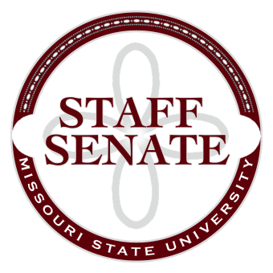
Staff Senate Agenda
11/5/15
11:00-12:00
- Roll Call
  - Excused Absences
  - Welcome new MSU Employees in Attendance
- Call To Order
- Approval of Agenda
- Approval of Minutes (October, 2015)
- Guest Speaker: Dr. Ken Coopwood
- Chair Report (Christina Bowles)
  - Staff Satisfaction Survey update
  - Board of Governor’s meeting
  - Master Planning Committee update
- Chair Elect Report (Ryan Wilson)
  - Bear Fest Village report
  - President’s Task Force on Family Leave and Support report
- Past Chair Report (Scott Fiedler)
  - Faculty Senate
  - Tours of new buildings
- Secretary/Treasurer Report (Rob Moore)
  - Financial Update
  - Staff Leadership Training
- Director of Staff Relations (Vacant Position)
  - Standing Committee Reports
    - Administrative Professionals Forum Committee (Sandra Johnson)
    - Public Affairs Committee (Christina Bowles)
    - Scholarship Committee (Addie Douglas)
    - Staff Activities Committee (Janelle Melton)
    - Staff Relations Committee (Ryan Wilson)
      - Staff Senate Website Revamp
  - Ad Hoc Committee Reports
    - Denim Day Committee (Kelly Bridges)
    - Staff Excellence in Service Awards Committee (Paul Essel)
    - BearFest Village Workgroup (Andrew Garton)
  - Staff Senate Representative Reports
    - My Ideas Committee (Sharon Lopinot)
    - Public Arts Committee (Kelly Bridges)
    - Shared Leave Committee (Brenda Stewart)
      - Representative Structure (Ryan Wilson)
    - Sustainability Commission (Ryan Wilson)
    - Wyrick Commission (Janelle Melton)
- Old Business

- New Business

- Announcements
  - Heath Risk Assessment (HRA)
  - Open enrollment for health benefits
- Adjournment
Next Meeting: December 3, 2015, 11:00 in PSU 313

