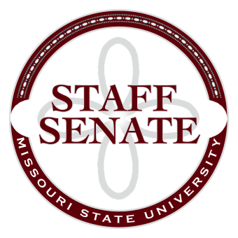
Staff Senate Agenda
5/7/15
- Roll Call
  - Excused Absences

  - Welcome new MSU Employees in Attendance
- Call To Order
- Approval of Agenda
- Approval of Minutes (March and April, 2015)
- Chair Report
  - Angela Strider, Bear Crew and House Calls
  - Staff Salary and Merit pay for FY2016
  - Freecycle Program Update
- Chair Elect Report
  - Staff Handbook Committee – No Report
  - Staff Satisfaction Survey
  - New Committee Members needed next year for the following:
    - Staff Excellence in Service Awards
    - My Ideas
    - Shared Leave Committee
- Past Chair Report
  - Faculty Senate Update
- Secretary/Treasurer Report
  - Financial Update
  - Elections for open Board Seats
- Director of Staff Relations – Committee Reports
    - Christina: Applications for new Director of Staff Relations
    - Staff Senate Calendar – how it will function
  - Bylaws – Need to form a work group
    - Work group charge
  - Denim Day Committee
  - Public Affairs Committee
  - Staff Relations Committee
  - Scholarship Committee
  - Staff Activities Committee
  - Staff Excellence in Service Awards Committee
  - Administrative Professionals Forum Committee
  - Faculty Senate
  - My Ideas Committee
  - Public Arts Committee
  - Sustainability Commission
  - Wyrick Commission
  - Shared Leave Committee
- Old Business

- New Business

- Announcements
- Adjournment
Next Meeting: June 4, 2015 at 11:00am, PSU 313

