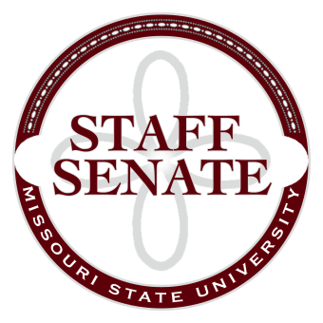
Staff Senate Agenda
6/4/15
- Roll Call
  - Excused Absences
  - Welcome new MSU Employees in Attendance
- Call To Order
- Approval of Agenda
- Approval of Minutes (May, 2015)
- Chair Report
  - Recognition of Outgoing Senators
  - Welcome to new Senators
    - Shelly Deckard, Barbara Jones and Phil Bridges
- Chair Elect Report
  - Staff Handbook Committee – No Report
  - Staff Satisfaction Survey – No Report
  - New Committee Members needed next year for the following:
    - Staff Excellence in Service Awards
    - Director of Staff Relations applications
- Past Chair Report
  - Faculty Senate Update
- Secretary/Treasurer Report
  - Financial Update
  - 2015-16 Meeting Dates, Times and Locations
- Director of Staff Relations – Committee Reports
  - Bylaws
  - Denim Day Committee
  - Public Affairs Committee
  - Staff Relations Committee
  - Scholarship Committee
  - Staff Activities Committee – funding Request
  - Staff Excellence in Service Awards Committee
  - Administrative Professionals Forum Committee
  - Faculty Senate
  - My Ideas Committee
  - Public Arts Committee
  - Sustainability Commission
  - Wyrick Commission
  - Shared Leave Committee
- Old Business

- New Business

- Announcements
  - Passing the Gavel
- Adjournment
Next Meeting: July 9th, 2015 11:00am. Location TBA

