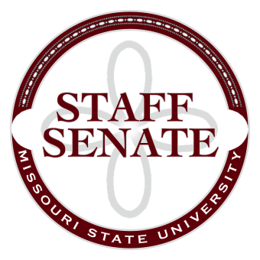
Staff Senate Agenda
1/8/15
- Roll Call
  - Excused Absences
  - Welcome new MSU Employees in Attendance
- Call To Order
- Approval of Agenda
- Approval of Minutes (December, 2014)
- Chair Report
  - STAFF SENATE PHOTO!!
  - Possible Change in Committee Structure – it’s time to vote!
    - Bylaws to an ad-hoc committee
    - March 5th meeting – HLC update and Master Planning Committee Presentation
    - Combine public relations/Staff Activities to Staff Relations – update regarding funding!

  - Staff Senate Polo Shirts – on order, payment needed
  - Master Planning Committee Presentation – Coming soon!
- Chair Elect Report
  - Staff Handbook Committee – No report this month
  - HR Promotional Items – board request for funds
  - Common Reader
- Past Chair Report
  - Faculty Senate Update
- Secretary/Treasurer Report
  - Financial Update
- Director of Staff Relations – Committee Reports
    - Staff Salary Incentive Program Update – Brian Edmond
  - Bylaws Committee
  - Denim Day Committee
  - Public Affairs Committee
  - Public Relations Committee
  - Scholarship Committee
  - Staff Activities Committee
  - Staff Excellence in Service Awards Committee
  - Administrative Professionals Forum Committee
  - Faculty Senate
  - My Ideas Committee
  - Public Arts Committee
  - Sustainability Committee
  - Wyrick Commission
  - Shared Leave Committee
- Old Business
  - Staff Satisfaction Survey – Follow-Up (no report)
  - Sit/Stand Work Stations survey and possible campus study (no report)
- New Business
  - Requested revision to Parking Policy - Scott

- Announcements
- Adjournment
Next Meeting: February 5, 2015 11:00am, PSU Ballroom East

