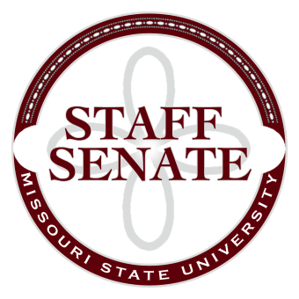
Staff Senate Agenda
8/6/15
11:00-12:00
- Roll Call
  - Excused Absences
  - Welcome new MSU Employees in Attendance
- Call To Order
- Approval of Agenda
- Approval of Minutes (July, 2015)
- Chair Report
  - Staff Handbook Workgroup Report
  - Appropriations Request for Capital Report
  - Staff Satisfaction Survey update
- Chair Elect Report
  - Bylaws Work Group
  - Bear Fest Village Tent Report
  - President’s Task Force on Family and Leave Support Report
- Past Chair Report
  - Staff Salary Incentive Program
  - Faculty Senate
- Secretary/Treasurer Report
  - Financial Update
- Director of Staff Relations
  - Committee Sign Up
  - Committee Reports
Standing Committees
    - Public Affairs Committee
    - Staff Relations Committee
    - Scholarship Committee
    - Staff Activities Committee
    - Administrative Professionals Forum Committee
Ad Hoc Committees
    - Denim Day Committee
    - Staff Excellence in Service Awards Committee
University Representative Committees
    - My Ideas Committee
    - Public Arts Committee
    - Sustainability Commission
    - Wyrick Commission
    - Shared Leave Committee
- Old Business

- New Business

- Announcements
  - Call for Guest Speakers
- Adjournment
Next Meeting: September 3, 2015, 11:00 in PSU 313

