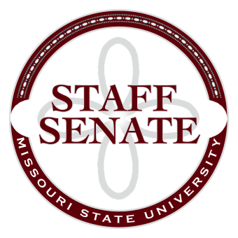
Staff Senate Agenda
4/2/15
- Roll Call
  - Excused Absences

  - Welcome new MSU Employees in Attendance
- Call To Order
- Approval of Agenda
- Approval of Minutes (February 2015)
- Chair Report
  - Staff Salary Incentive vs. Merit pay for FY2015
  - Freecycle Program – Brenda Stewart (Sustainability, Property Control, Internal Audit, database?)
- Chair Elect Report
  - Staff Handbook Committee – No Report
  - Staff Satisfaction Survey
  - Administrative Professionals Luncheon Reminder
- Past Chair Report
  - Faculty Senate Update
- Secretary/Treasurer Report
  - Financial Update
  - Call for nominations for open Senator Seats
  - Call for nominations for open Board Seats
- Director of Staff Relations – Committee Reports
    - Staff Salary Incentive Program Update – Brian Edmond
  - Bylaws Committee
  - Denim Day Committee
  - Public Affairs Committee
  - Public Relations Committee
  - Scholarship Committee – My Missouri State Shirt Status??
  - Staff Activities Committee
  - Staff Excellence in Service Awards Committee
  - Administrative Professionals Forum Committee
  - Faculty Senate
  - My Ideas Committee
  - Public Arts Committee
  - Sustainability Committee
  - Wyrick Commission
  - Shared Leave Committee
- Old Business

- New Business
  - Inclement Weather Policy – Andrew Garton
- Announcements
- Adjournment
Next Meeting: May 7, 2015 at 11:00am, PSU 313

