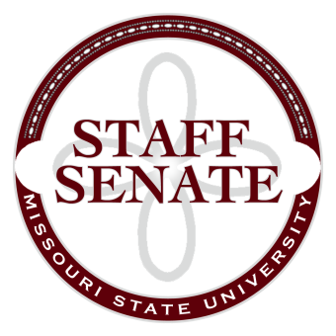
Staff Senate Minutes
Meeting Date: January 11, 2024
Presiding Officer: Chair Derrick
The Staff Senate held the January Session in Glass Hall, room 486. Chair Derrick called the session to order at 11:03 a.m.

Absences: Rebeca Reut-Robinson JF1, Sandy Johnson JF1, Peggy Kahre JF1, Ingrid Hintze JF2, Jared Steeves JF2, Leonard Haymans JF2, Danny Winkley JF3, Nicole Webster JF4, Brandon Decker JF4, Rachel Rigby JF4.

Guests: Meadow Eddleman, Adam Niesen, Shannon Ailor, Joseph Fairchild

Greetings
- Chair Derrick welcomed everyone to the January Staff Senate Meeting.
Guest Speaker
  - President Clif Smart & Vice President Matt Morris
    - Campus Updates
    - Approval of July 5th as an extra given day
  - Scot Scobee, Director-Office of Human Resources
    - ADP Resolution Items Update
Approval of the Minutes
- No corrections were notes, minutes were approved by unanimous consent.
Announcements
- Breast Cancer Awareness t-shirts are still available
- Staff Appreciation T-shirts are available for preorder
- Working with library to provide a computer in a private space for staff members
- Presidential Search Update posted on the website
Executive Board Reports
- Chair report: Discussed events including Isabell’s House Coat Drive, Movie night at Alamo and Staff appreciation lunch and reviewed the family leave policy.
- Chair Elect: $11,868 for budget.
- Past-Chair: No report.
- Coordinator of communications: No report.
- Coordinator of Committees: No report.
- Secretary: No report.
- Parliamentarian: No report.
External Representation Reports
- Academic Calendar: The 2025 – 2026 football schedule changed slightly.
- Employee Wellness: Events for the beginning of the semester are up and posted on the website for signups.
- Executive Budget: Suggestions to think about for the meeting: Across the board or percentage plus increase; benefits increase or paying more for benefits; FMLA leave policy moving forward; staff getting paid twice monthly instead of once; all compensation or certain job families; merit increase.
- Faculty Senate: Discussion and updates were given on the faculty concern survey, nine-month faculty start and end dates, honorary bachelor's degree, Tom Dicke, and ombudsman policy to include non-administrative candidates.
- Inclusion Awareness team: Inclusion Awareness conversation panel at the PSU 313 on 1/11/2024.
- Shared Leave: One case approved.
- Staff Excellence in Service Awards: Nine awards were given out on 1/10/2024.
Committee Reports
- The Professional Development Committee: No report.
- Public Affairs Committee: Coat drive went well and were donated to Isabel’s house prior to Christmas. Next meeting is January 23rd at 1:30 in University Hall 113 or by zoom.
- Staff Activities: Upcoming events include 1984 movie arcade and another movie event at Alamo.
- Recruitment and Retention: Discussed what the committee will work on next including the credit fee waivers, getting information out easier, and a benefits survey. Next meeting
Old Business
- Family Leave Draft Resolution Discussion
  - Discussed at the Executive Board meeting.
  - Discussion about moving it to six weeks for our yearly budget goal.
Open Forum
- If you have questions about the Staff Awards Nomination process, reach out to Senator Keele.
Adjournment
- January Staff Senate meeting was adjourned at 12:58 p.m.

