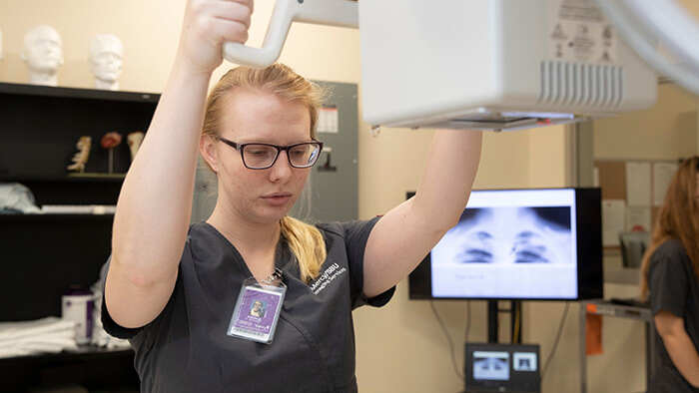
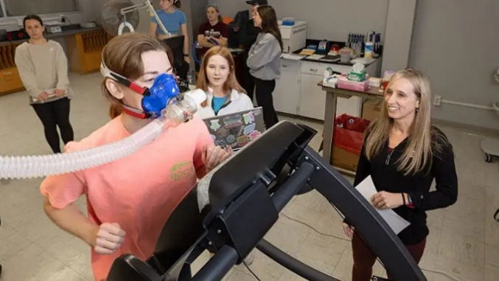
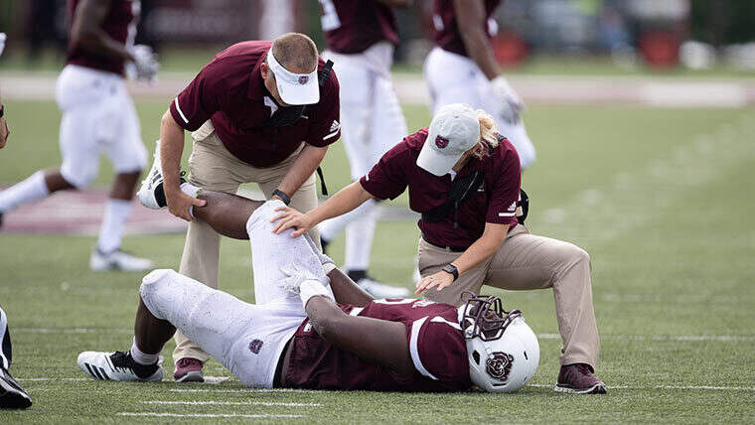
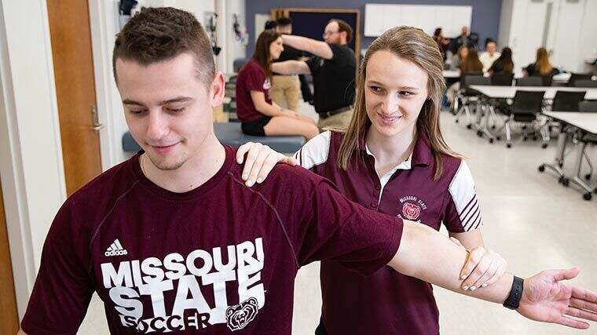
MoState Sports Medicine and Health Sciences Camp

A Summer Camp for Students That Want to Explore Health Professions
and Level Up Their Health Care Skills
- Students get hands-on experience with a variety of health care skills and gain insight into health-related careers and college life. They’ll learn about professional pathways under the umbrella of sports medicine and health sciences - athletic training, dietetics, physician assistantship, physical therapy, radiography, exercise science, health education/promotion, public health, health services and more, while building a foundation in health care concepts and skills. Students will have opportunities to engage with expert faculty, explore career pathways, experience campus life, and build new friendships
- Who it’s for: High school students, including those who’ll begin 9th grade in the fall and those who are graduating this spring.
- When: June 15–18; Register by June 1st
- Daytime or overnight: Your choice! Campers have the option of commuting for a daytime-only version or staying on campus for a full residential experience.
- Contact: SHS@MissouriState.edu or tonahetzler@Missouristate.edu
- More information: Sports Medicine and Health Sciences Camp website

