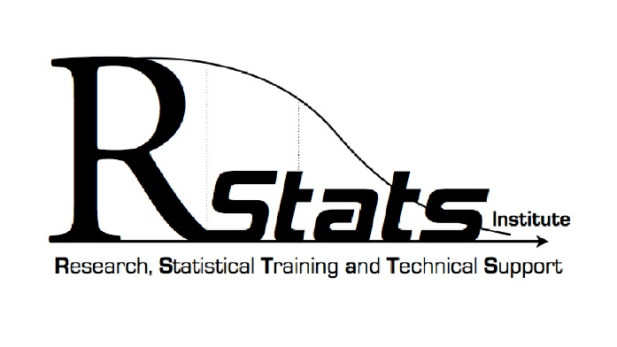
RStats THESIS and RESEARCH Project APPROVAL FORM - 2025

Statistical consultants intend to provide statistical advice and guidance, not to design, analyze, or complete any part of a student's thesis or research project. When a particular project is beyond the expertise of the student and/or the advisor, additional statistical consultation may be an option (i.e., fee-for-service). Students who meet independently with a statistical consultant should do so only with the permission of their committee or principal investigator (PI), and the student should inform the committee/PI of the general content of the meeting.

I hereby certify that I have obtained the necessary permission for statistical consultation on my Thesis or research project for the topics indicated on the online, request form

_________________________________________
Printed Name of Student

_________________________________________ ________________
Signature of Student Date

FACULTY ADVISOR APPROVAL
I accept and approve of the collaboration and consultation as indicated above.

_________________________________________
Printed Name of Faculty Advisor

_________________________________________ ________________
Signature of Faculty Advisor Date

RStats APPROVAL
We accept and approve of the collaboration and consultation as indicated above.

_________________________________________
Printed Name of RStats Consultant

_________________________________________ ________________
Signature of RStats Consultant Date

