

MISSOURI STATE UNIVERSITY
FIELDWORK EDUCATION MANUAL
Occupational Therapy Program

640 E Cherry St.
Springfield, Missouri 65897
Table of Contents
PREFACE 4
GENERAL PROGRAM CONTACT INFORMATION 5
OCCUPATIONAL THERAPY FACULTY 5
INTRODUCTION TO THE OCCUPATIONAL THERAPY PROGRAM 6
Mission and Values 6
Curricular Threads 7
RELATION OF FIELDWORK EXPERIENCES TO CURRICULUM 8
FIELDWORK ATTENDANCE POLICY 9
COURSE SEQUENCE IN OCCUPATIONAL THERAPY CURRICULUM 10
AOTA OFFICIAL DOCUMENTS 11
The Philosophical Base of Occupational Therapy 11
Occupational Therapy Fieldwork Education: Value and Purpose 11
LEVEL I FIELDWORK POLICIES AND PROCEDURES 11
Introduction to Level I Fieldwork 11
Definition and Purpose 12
Linkage of Fieldwork to Coursework 12
Fieldwork Site Identification 13
Clinical Education Agreements 13
Schedule 13
Level I Fieldwork Experience Schedule: 13
Fieldwork Educators: Level I Experiences 14
Fieldwork Sites 14
Evaluation of Level I Fieldwork Performance 14
Level I Fieldwork Objectives 15
Level I Fieldwork Expectations 16
Site Assignment Process 16
AFWC Responsibilities 16
Student Responsibilities 17
Level I Fieldwork Failure Policy 17
LEVEL I FIELDWORK FORMS 18
Fieldwork Experience Personal Data Sheet 18
Health Status/Clinical Program Training Attestation Form 20
Level I Fieldwork Performance Plan 21
Level I Fieldwork Performance Plan 22
Level I Fieldwork Performance Plan 23
AOTA Level I Fieldwork Competency Evaluation for OT and OTA Students 24
24
AOTA Level I Fieldwork Competency Evaluation for OT Students 25
Level I Fieldwork Weekly Attendance Log & Supervisor Feedback - 31 -
LEVEL II FIELDWORK POLICIES AND PROCEDURES - 32 -
Introduction to Level II Fieldwork - 32 -
Definition and Purpose - 32 -
Linkage of Fieldwork to Coursework - 32 -
Fieldwork Site Identification - 33 -
Clinical Education Agreements - 33 -
International Fieldwork Policy - 33 -
International Fieldwork Acknowledgment Statement - 36 -
Schedule - 37 -
Fieldwork Educators - 37 -
Fieldwork Sites - 38 -
Evaluation of Level II Fieldwork Performance - 38 -
OT Program-Specific Level II Fieldwork Objectives - 38 -
Fieldwork Level II Expectations - 39 -
Site Assignment Process - 39 -
AFWC Responsibilities - 39 -
Student Responsibilities - 40 -
Fieldwork Educators Responsibilities - 41 -
Level II Fieldwork Failure Policy - 41 -
LEVEL II FIELDWORK FORMS - 44 -
Student Preference Form for Fieldwork II Planning - 44 -
Fieldwork Experience Personal Data Sheet - 47 -
Health Status/Clinical Program Training Attestation Form - 49 -
Student/Supervisor Weekly Review - 50 -
Student Evaluation of the Fieldwork Experience (SEFWE) - 51 -
Student Evaluation of the Fieldwork Experience Form - 52 -
Occupational Therapy Process - 54 -
Level II Evaluation of Student Fieldwork Experience - 63 -
AOTA FWPE Form - 63 -
APPENDIX - 70 -
Student Requirements for Fieldwork Participation - 70 -
A. Student Immunization Requirements - 70 -
B. Applicability, Documentation and Enforcement of Immunizations - 71 -
C. Additional Fieldwork Placement Requirements - 71 -

PREFACE

Information in this manual is provided to help Occupational Therapy students prepare for fieldwork experiences and to provide the foundation from which Fieldwork Educators and the Occupational Therapy Program can begin a collaborative relationship to prepare future professional Occupational Therapists through the academic and fieldwork education process.
Missouri State University, the Occupational Therapy Program Director, faculty, and staff welcome comments and suggestions for improving all areas of the academic and fieldwork process.

Created June 2017, revised June 2023

GENERAL PROGRAM CONTACT INFORMATION

Missouri State University
Occupational Therapy Program
O’Reilly Clinical Health Sciences Center
640 E. Cherry St.
Springfield, MO 65897
Phone: 417-836-6109
Fax: 417-836-6208

OCCUPATIONAL THERAPY FACULTY
Program Director:
Dr. Sapna Chakraborty, OTD, OTR/L 417-836-8749
sapnachakraborty@missouristate.edu

OT Faculty:
Dr. Tara Boehne, OTD, OTR/L 417-836-8990
Dr. Ashlea D. Cardin, OTD, OTR/L, BCP 417-836-8721
Dr. Naomie Corro, OTD, OTR/L 417-836-3701
Dr. Traci Garrison, DHS, OTR/L 417-836-8569
Dr. Michelle Jackson, OTD, OTR/L 417-836-3288
Dr. Jennifer Yates, OTD, OTR/L, CPAM 417-836-6172

Academic Fieldwork Coordinator
Tara Boehne, OTD, OTR/L 417-836-8990
taraboehne@missouristate.edu

Fieldwork Education Specialist
Riannon Shelley 417-836-4281

INTRODUCTION TO THE OCCUPATIONAL THERAPY PROGRAM

Mission and Values
Missouri State University (MSU) is a public, comprehensive metropolitan system with a statewide mission in public affairs, whose purpose is to develop educated persons. The University's identity is distinguished by its public affairs mission, which entails a campus-wide commitment to foster expertise and responsibility in ethical leadership, cultural competence, and community engagement. The academic experience is grounded in a general education curriculum that draws heavily from the liberal arts and sciences. This foundation provides the basis for mastery of disciplinary and professional studies. It also provides essential forums in which students develop the capacity to make well-informed, independent critical judgments about the cultures, values, and institutions in society.
The mission of the Occupational Therapy Department at Missouri State University is to educate holistic, reflective occupational therapy practitioners who understand the complexity of occupation and value its role in the promotion of health and wellness. Didactic and experiential learning promotes occupation-based practice, community engagement, cultural humility, scientific inquiry, ethical leadership, and lifelong learning to develop generalist practitioners who are prepared to meet the needs of persons, groups, and populations across a variety of settings, including those in rural and underserved communities.
The Occupational Therapy Programs at Missouri State University will be nationally recognized as dynamic programs grounded in the core values of occupational therapy. Graduates will function as change agents and partner with a diverse society to facilitate quality care through evidence-based practice, interprofessional collaboration, scholarship, and a commitment to lifelong learning.
Statement of Philosophy
The Occupational Therapy (OT) Department at Missouri State University embraces the Philosophical Base of Occupational Therapy (American Occupational Therapy Association [AOTA], 2017) and the Philosophy of Occupational Therapy Education (AOTA, 2018). In concordance with this philosophy, we assert that:
Humans are complex beings with an innate need and inalienable right to engage in purposeful activity, who learn through participation in meaningful occupation and are intrinsically and extrinsically motivated, creative, and inquisitive. The OT program integrates these concepts to foster academic achievement and self-reflection in students as they prepare to serve individuals, groups, communities, and populations (AOTA, 2018).
In alignment with Adult Learning and Engagement Theories, knowledge and skill acquisition are accomplished through an on-going process of self-determination, direct participation, intrinsic motivation, authentic focus, and collaborative problem solving (Kearsley & Schneiderman, 1998; Knowles, 2012). Individuals bring with them life experience and prior knowledge that will shape the learning of both teacher and student.
In-person and virtual classrooms, labs, community experiences, and clinical seminars are structured to facilitate learner reflection and enhance human problem-solving skills (AOTA, 2018; Schӧn, 1983). These attributes are considered central to lifelong learning, cultural humility, and ethical, evidence-based practice. Small group work encourages collaboration and consensus among members of the learning community and facilitates dynamic understanding, diversity exploration, and enhancement of leadership, advocacy, and communication skills. Authentic focus emphasizes real-world learning to promote transfer of didactic knowledge to current and emerging practice settings.
In concordance with the American Occupational Therapy Association (AOTA, 2007), we believe that best practice in occupational therapy education “emphasizes continuing critical inquiry in order that occupational therapists (are) prepared to function and thrive in the dynamic environments of a diverse and multicultural society, using the power of occupation as the primary method of evaluation, intervention, and health promotion” (p. 678).

Curricular Threads
The curriculum is organized around six major curricular threads. The curricular threads are woven through the fabric of each OT Program and represent the key integrated learning elements emphasized throughout the courses. Curricular threads influence course content, preparing students for self-directed occupational therapy practice. They include:
- Occupation-Based Practice: Using meaningful occupation as both a therapeutic means and an end; maximizing health status and well-being through provision of opportunities for occupational engagement; embracing a strengths-based perspective to facilitate occupational performance.
- Ethical Leadership: Understanding the ethical dimensions of leadership and transferring didactic and experiential learning to individual practice areas and communities to create positive change.
- Community Engagement: Developing collaborative relationships with persons, groups, and populations in the local, national, and global community to promote cultural sensitivity and reflective occupational therapy practice that addresses the diverse needs and interests.
- Cultural humility: Developing self-awareness of personal and cultural biases as well as awareness and sensitivity to significant cultural issues of others through reflection, lifelong inquiry, and recognition of power differentials. Core to the process of cultural humility is the practitioner’s deliberate reflection of their values and biases (Yeager & Bauer-Wu, 2013).
- Scientific Inquiry: Building on foundational sciences and theory to foster holism and create curiosity, scholarly investigation, and rigorous examination of evidence used to guide professional practice.
- Lifelong Learning: Undertaking learning activity throughout life, with the aim of improving knowledge, skills, and competence to remain current in occupation-based and client-centered practice; intentionally bettering oneself for the betterment of others.
References
American Occupational Therapy Association [AOTA]. (2007). Philosophy of occupational therapy education. American Journal of Occupational Therapy, 61(6), 678. doi: 10.5014/ajot.61.6.678

American Occupational Therapy Association. (2017). Philosophical base of occupational therapy. American Journal of Occupational Therapy, 71(Suppl. 2), 7112410045. https://doi.org/10.5014/ajot. 716S06

American Occupational Therapy Association. (2018). Philosophy of occupational therapy education. American Journal of Occupational Therapy, 72(Suppl. 2), 7212410070. https://doi.org/10.5014/ajot.2018.72S201

American Occupational Therapy Association. (2020). Occupational therapy’s commitment to diversity, equity, and inclusion. American Journal of Occupational Therapy, 74(Suppl. 3), 7413410030. https://doi.org/10.5014/ajot.2020.74S3002

Dillon, T.H. (2001). Authenticity in occupational therapy leadership: A case study of a servant leader. American Journal of Occupational Therapy, 55, 441-448.
https://doi.org/10.5014/ajot.55.4.441

Isaacson, M. (2014). Clarifying concepts: Cultural humility or competency. Journal of Professional Nursing, 30(3), 251-258. https://doi.org/10.1016/j.profnurs.2013.09.011

Kearsley, G., & Shneiderman, B. (1998). Engagement theory: A framework for technology-based teaching and learning. Educational Technology, 38(5), 20-23.

Knowles, M., Holton, E., & Swanson, R. (2012). The adult learner: The definitive classic in adult education and human resource development. Elsevier.

Schӧn, D. (1983). The reflective practitioner: How professionals think in action. Basic Books, Inc.

RELATION OF FIELDWORK EXPERIENCES TO CURRICULUM
Fieldwork experiences are considered an integral component of the educational process within the OT Program. The fieldwork program has been developed and integrated within the curriculum to ensure that students learn to apply theoretical and scientific principles learned in the didactic portion of the program in preparation for addressing actual client needs during the fieldwork experiences. All level I fieldwork courses are linked with a didactic course to promote carryover of skills and knowledge to the fieldwork experience. Level I fieldwork occurs in conjunction with specified courses and begins in the second semester of study. During the first year, Fieldwork Level I Seminar, Part 1 (OTE 761) occurs in the spring, in conjunction with Psychosocial Perspectives in Occupational Therapy Practice (OTE 620). This experience consists of students observing and interacting in various settings providing services to individuals with psychosocial and mental health conditions. Fieldwork Level I Seminar draws upon didactic coursework addressing psychosocial dysfunction, assessment tools, and evaluation techniques learned during the semester. Fieldwork Level I Seminar Part 2 (OTE 761) occurs during the second fall semester, in conjunction with Therapeutic Skills I: Adult Practice (OTE 745) and consists of students observing and interacting in various settings providing services to adults and older adults. This experience draws upon didactic coursework addressing physical dysfunction, assessment tools, and evaluation techniques learned during the semester. Fieldwork Level I Seminar Part 3 (OTE 761) occurs during the second spring semester of the program. This experience addresses the pediatric population and is affiliated with Therapeutic Skills II: Pediatric Practice (OTE 750). This experience consists of students observing and interacting in various settings providing services to children and/or adolescents. The pediatric fieldwork experience provides an opportunity for the application of didactic coursework addressing dysfunction related to children and adolescents, assessment tools, and evaluation technique.
The matriculation process to level II fieldwork requires students to successfully complete all level I fieldwork experiences, as well as all didactic coursework. The sequence of the curriculum ensures a comprehensive relationship between didactic preparation and practical clinical experiences. Fieldwork Level II, Part I (OTE 780) occurs in the second summer semester and Fieldwork Level II, Part 2 (OTE 790) occurs during the final fall semester of the program.

FIELDWORK ATTENDANCE POLICY
The student is responsible for maintaining the assigned fieldwork schedule including prompt attendance and following site requirements regarding personal illness or emergency situations, for reporting absences. Only personal illness or emergency situations (serious illness or death in the immediate family) are justifiable reasons for missing fieldwork. Beyond a cumulative three days, absences are to be made up at the discretion of the fieldwork educator. Options may include evening or weekend scheduling but may also involve extending the rotation.

COURSE SEQUENCE IN OCCUPATIONAL THERAPY CURRICULUM
Access full course descriptions at http://www.missouristate.edu/ot/Courses.htm

Fall I - Semester 1 (15 credits)
OTE 610 Foundations and Theory in Occupational Therapy (OT) (4)
OTE 612 Occupational Development through the Lifespan (3)
OTE 645 Clinical Gross Anatomy (5)
OTE 732 Applied Research Methods in Health Care (2)

Spring I - Semester 2 (14 credits)
OTE 620 Psychosocial Perspectives in OT practice (3)
OTE 640 Evidence Based Practice (2)
OTE 646 Neuroscience (4)
OTE 650 Clinical Biomechanics in Human Performance (3)
OTE 761 Fieldwork Level I Seminar, Part 1 Psychosocial (2)

Summer I - Semester 3 (98credits)
OTE 720 Conditions I: Cognitive Dysfunction (3)
OTE 765 Community and Health Practice in OT (3)
OTE 615 Professional Communication and Documentation (2)

Fall II - Semester 4 (14 credits)
OTE 725 Environmental Adaptations and Assistive Technology (2)
OTE 730 Enablers and Barriers: Adult Occupations (4)
OTE 745 Therapeutic Skills I: Adult Practice (4)
OTE 760 Specialty Topics (Splinting and PAMS) (2)
OTE 761 Fieldwork Level I Seminar, Part 2 Adults (2)

Spring II - Semester 5 (15 credits)
OTE 746 Management and Policy in Occupational Therapy Practice (2)
OTE 749 Enablers and Barriers: Pediatric Occupations (4)
OTE 750 Therapeutic Skills II: Pediatric Practice (4)
OTE 760 Specialty Topics (Wheelchair & Professional Transition) (2)
OTE 761 Fieldwork Level I Seminar, Part 3 Pediatric (2)

Summer II - Semester 6 (6 credits)
OTE 780 Fieldwork Level II, part 1 (6)

Fall III - Semester 7 (6 credits)
OTE 790 Fieldwork Level II, part 2 (6)

Total Program Credits: 78

AOTA OFFICIAL DOCUMENTS

The Philosophical Base of Occupational Therapy
https://research.aota.org/ajot/article/71/Supplement_2/7112410045P1/6364/Philosophical-Base-of-Occupational-Therapy

Occupational Therapy Fieldwork Education: Value and Purpose
https://research.aota.org/ajot/article/76/Supplement_3/7613410240/23992/Occupational-Therapy-Fieldwork-Education-Value-and
AOTA 2020 Code of Ethics
https://ajot.aota.org/article.aspx?articleid=2767077
FIELDWORK LEVEL II AND OCCUPATIONAL THERAPY STUDENTS: A POSITION PAPER
https://research.aota.org/ajot/article/72/Supplement_2/7212410020p1/6516/Fieldwork-Level-II-and-Occupational-Therapy
AOTA PRACTICE ADVISORY: SERVICES PROVIDED BY STUDENTS IN A LEVEL II FIELDWORK SETTING
https://www.aota.org/Education-Careers/Fieldwork/StuSuprvsn.aspx

LEVEL I FIELDWORK POLICIES AND PROCEDURES

Introduction to Level I Fieldwork
The American Occupational Therapy Association's document entitled The Standards for an Accredited Educational Program for the Occupational Therapist governs the length and type of clinical training required of students pursuing a degree in occupational therapy. The Occupational Therapy (OT) Program at Missouri State University (MSU) enables students to receive the appropriate amount and type of clinical training experiences needed to meet these standards. It is the collaborative responsibility and effort of the occupational therapy faculty, Academic Fieldwork Coordinator (AFWC), the fieldwork education sites, and the occupational therapy student (OTS) to facilitate the fieldwork relationship. The clinical training experiences may also be referred to as “clinical affiliations” or “Fieldwork” (FW) and will occur in varied locations. The OT Program requires completion of three level I FW experiences which correlate with didactic coursework. Learning objectives for each experience are designed by the AFWC to provide an extension of the didactic material to the FW experience.

Definition and Purpose
The AOTA Accreditation Council for Occupational Therapy Education Standards describe the goal of level I FW “to introduce students to fieldwork, apply knowledge to practice, and develop understanding of the needs of clients” (AOTA, 2018). Level I FW is not intended to develop independent performance, but rather to “promote clinical reasoning and reflective practice. transmit the values and beliefs that enable ethical practice and develop professionalism and competence in career responsibilities.” (AOTA, 2018) In accordance with ACOTE standards, “no part of level I fieldwork can be substituted for any part of level II fieldwork” (AOTA, 2018, standard C.1.9).
Services may be provided to a variety of populations through a variety of settings. Experiences may include those directly related to occupational therapy, as well as other situations to enhance an understanding of the developmental stages, tasks, and roles of individuals throughout the life span. Day care centers, schools, skilled nursing facilities, homeless shelters, community mental health centers, and hospitals are among the many possible sites. Level I FW may also include services management and administrative experiences in occupational therapy settings, community agencies, or school settings. Populations may include disabled or well populations, as well as age-specific or diagnosis-specific clients.
Level I FW is a required curriculum component and includes experiences designed to enrich didactic coursework through direct observation and participation in selected aspects of the occupational therapy process. These experiences are not intended to emphasize independent performance. Rather, the settings utilized are equipped to demonstrate clinical application of principles learned in the occupational therapy curriculum. Students are supervised by qualified personnel including, but not limited to, certified/licensed occupational therapy assistants, teachers, social workers, nurses, physical therapists, and/or other professionals who may be part of the intervention team. Each level I FW is designed collaboratively with the faculty member, AFWC, and FWE.
Level I FW is required as part of the curriculum beginning in the second semester of the program. Level II FW can only be initiated after successful completion of level I FW. Depending on the course, this affiliation may occur in a concentrated one-week period or be extended throughout the semester. Students must be in good academic and professional behavior standing to engage in level I fieldwork experiences as scheduled during the semester. If they are not, an alternative schedule will be arranged following remediation of the academic or professional behavior issue.

Linkage of Fieldwork to Coursework
Level I FW occurs in conjunction with specified courses and begins in the second semester of study. During the first year, Level I FW Seminar, Part 1 Psychosocial (OTE 761) occurs in the spring, in conjunction with OTE 620 (Psychosocial Perspectives in Occupational Therapy Practice). This experience consists of students spending time in a setting among individuals with psychosocial and mental health conditions. Level I FW Seminar, Part 2 Adults(OTE 761) occurs during the second fall semester, in conjunction with OTE 745 (Therapeutic Skills I: Adult Practice) and consists of interactions with adults and older adults. Level I FW Seminar, part 3 Pediatrics (OTE 761) occurs during the second spring semester of the program. This experience addresses the concept of pediatrics and is affiliated with OTE 750 (Therapeutic Skills II: Pediatric Practice). During this experience, students will spend time in a setting with children and/or adolescents.
Students must successfully pass all three level I FW rotations. No part of level I FW can be substituted for level II FW.
These learning opportunities are often regarded by students as the highlight of their student experience, and they return to campus with a new enthusiasm for learning!

Fieldwork Site Identification
The AFWC collaborates with faculty to identify and select appropriate sites that serve as FW settings. These sites are selected to optimize student learning consistent with the philosophy of the curriculum. The process of identifying active sites is to explore the alignment of site philosophies and practices relative to the OT Philosophy and Mission, in conjunction with the specific FW objectives for that FW experience. Faculty site visits, as well as connections with colleagues through projects or meetings, help to identify potential FW sites. The OT program maintains affiliation agreements for FW with enough sites to meet placement needs. In the unlikely event that sites become unavailable (i.e., cancellation of placement by that site) the schedule may be delayed, but that delay should not exceed the time allowed to complete the program.

Clinical Education Agreements
A signed Clinical Education Agreement (also known as an Affiliation Agreement) between MSU and the clinical site is in place prior to and throughout the student’s placement at the site. The Clinical Education Agreement clearly documents the responsibilities of MSU and the FW site and is signed by both parties. Students are responsible for adhering to the site-specific expectations, which are available to the student via the Fieldwork Education Specialist.
The Clinical Education Agreements are auto renewed annually, or as specified by the individual FW site. Revisions or adjustments to the agreement may impact the FW schedule. In this case, the student will be informed of the issue as soon as possible to allow for alternate arrangements.

Schedule
The AFWC projects FW needs for each placement before the semester starts. The AFWC communicates requests for student placements to the fieldwork sites via the course specific Level I Fieldwork Reservation Form at least three months prior to the scheduled level I fieldwork experience. The AFWC and each fieldwork site student coordinator or educator collaborate on student placement, objectives, and scheduling. The AFWC continues to serve as the liaison for the University, Program, faculty, and FW sites on all fieldwork issues. Fieldwork experiences are scheduled on days and times that do not conflict with regularly scheduled classes. Students are notified of fieldwork placement during the semester in which the upcoming fieldwork experience occurs. Reserved FW placement spots are confirmed at the start of the semester in which the FW experience occurs by the AFWC.

Level I Fieldwork Experience Schedule:
OTE 761: Level I Fieldwork Seminar Psychosocial Fieldwork Experience
First spring semester
OTE 761, Level I Fieldwork Seminar, Adult/Older Adult Fieldwork Experience
Second fall semester
OTE 761, Level I Fieldwork Seminar, Pediatric Fieldwork Experience
Second spring semester

Fieldwork Educators: Level I Experiences
Qualified personnel for supervision of students may include but are not limited to, academic or FWEs, occupational therapy practitioners initially certified nationally, psychologists, physician assistants, teachers, social workers, nurses, physical therapists, social workers, activity directors and others who provide services to clients whose performance in daily functioning is limited due to physical injury, illness, cognitive impairment, psychosocial dysfunction, mental illness, developmental delay, or adverse environmental conditions. The supervisor must be knowledgeable about occupational therapy and cognizant of the goals and objectives of the level I FW experience. It is the policy of the OT program that no more than a ratio of 1:2 (1 FWE to 2 FW students) should occur to ensure a quality learning experience.

Fieldwork Sites
Settings for level I FW experiences vary and depend upon the objectives of the FW. Possible placements for FW experiences include homeless youth outreach program, community based mental health center, hospitals, outpatient clinics, group homes for developmentally disabled, specialized autism programs, inpatient psychiatric hospital, and adult day care centers.

Evaluation of Level I Fieldwork Performance
Students are responsible for completing several forms prior to, during, and upon completion of level I FW experiences. They are also responsible for giving the necessary evaluation forms to their FWE at the site and ensuring completion of these forms upon completion of the rotation. These courses are graded Pass/Not Pass.
- Personal Data Form: This form is completed prior to initiation of the FW experience as a mode of introduction of the student to the FWE. The form is completed 4 weeks prior to the start of the FW experience and is sent electronically to the FWE. (See level I Forms Section)
- Level I FW Performance Plan: The student completes this form prior to starting the FW experience and lists at least three goals/ideas for professional growth during the FW experience. Upon arrival at the FW site, the student shares this form with the FWE, who then documents site-specific planned opportunities to support student growth during the FW experience. Upon completion of the experience, the student and FWE reflect on the professional growth that occurred during participation in the experience. Both parties sign the form, and the student submits the completed evaluation form to the AFWC upon returning to campus as criterion to pass the course. (See level I Forms Section)
- AOTA Level 1 Fieldwork Competency Evaluation for OT Students: This document is completed by the educator via the eValue platform. Student and FWE discuss the student’s performance and rating upon completion of the experience and both parties should sign the form. The completed evaluation form is submitted via the eValue platform and the AFWC reviews it as a criterion to pass the course. (See level I Forms Section)
- Student Feedback to Fieldwork Supervisor Form: Students complete the form via the eValue platform prior to completion of the experience and discuss it with their FWE at the final meeting. Completion of this form is a criterion to pass the course. (See level I Forms Section)
- Attendance Log: Students log all hours they attend their fieldwork site and submit via the eValue system. The educator then verifies the student’s hours through the eValue platform.
- Students can review their evaluations within the eValue platform. Level I FW evaluations are reviewed by the course instructor and the AFWC. Any concerns are communicated in writing to the student’s advisor and are kept in a secure student file.

Level I Fieldwork Objectives
The AFWC, Clinical Education Coordinators and/or FWE collaborate on an ongoing basis through the development of site-specific learning objectives prior to student placement at the FW site. The AFWC meets with the FWE to develop or review site-specific learning objectives and goals prior to the student beginning the FW experience. The AFWC, Clinical Education Coordinators and/or FWE collaborate to achieve curriculum-based goals, assignments, and FW objectives through various methods. These methods may include but are not limited to distribution of the FW handbook, providing handouts, research articles, and other resources for suggested FW activities, and ongoing communication.
The OT Program-specific level I FW objectives are as follows:
- Develop and demonstrate increased comfort when interacting with individuals within settings that promote wellness, prevent disease or injury, and offer medical model services.
- Appreciate the client’s perception of quality of life, well-being, and occupation.
- Demonstrate concepts of empathy and respect for the values and diversity of persons with disabilities, caregivers, staff, and families.
- Observe client behaviors and informally document observations accurately in various formats for learning purposes.
- Develop basic clinical reasoning skills through observation and reflection about healthcare delivery, including an appreciation for procedures, formation of therapeutic interactions, and basic understanding of the evaluation and intervention process.
- Demonstrate the ability to respond to supervisory feedback and conduct one’s behavior in an ethical and professional manner.
- Examine the psychosocial factors for a client at the fieldwork site and explain how those factors influence participation in the occupational therapy process.

Level I Fieldwork Expectations

Site Assignment Process
The AFWC schedules and assigns all FW placements. Input from the student and student’s faculty advisor is also considered, with the AFWC having final authority in making the assignment. The AFWC then confirms availability of sites and matches the student to a site.
Students must successfully pass the level I FW component to pass the designated course. No part of level I FW can be substituted for level II FW.
There will be no changes to assigned FW sites unless in the event of extreme and rare circumstances. Practice settings constantly change; when a site agrees to take a student, it is based on available FWEs at that time. Students should keep in mind that each year FW sites cancel for various reasons, such as staffing, etc. Cancellations can occur at the last minute, and students should be prepared for such an occurrence. The AFWC will facilitate an alternate placement in this circumstance.
Students are notified of level I FW placement during the semester in which the rotation occurs, to allow time for travel and living arrangements, if needed. Also included in the notification are the learning objectives for the level I experience and contact information for each site. Fieldwork objectives are distributed by the course instructor.
Student FW assignments are tracked throughout progression in the program, via the E*Value Learning Management System, to ensure exposure to multiple practice areas and populations.

AFWC Responsibilities
A. Contact sites to confirm availability of slots for student placement via the course-specific reservation form, at least three months prior to the start of the semester with a scheduled level I FW experience.
B. Collaborate with the Clinical Education Coordinator and/or FW Educator to develop site-specific learning objectives. The AFWC may provide site with general objectives, as an example, if no site-specific objectives have been developed for the level I experience.
C. Track student placements via the eValue platform.
D. Communicate FW placement information, as well as objectives and site expectations, to the students ideally two months prior to the start of the rotation.
E. Provide students with:
1. An explanation of the Level I Fieldwork Performance Plan document, AOTA Level I Fieldwork Competency Evaluation Form, and the Student Feedback to Fieldwork Supervisor form, including guidelines for completion and due dates.
2. Site-specific learning objectives and expectations.
F. Collect and track completion of required documentation upon completion of the FW experience.
G. Provide counsel in the event of a student’s difficulty with or inability to complete a FW experience.

Student Responsibilities
A. Read, be familiar with, and ask questions regarding the information presented in the FW manual.
B. Obtain and provide an electronic copy of all items listed on the Health Status/Clinical Training Attestation form to the OT Program Administrative Assistant and to the FWE, upon request.
C. Complete and send the Fieldwork Experience Personal Data Sheet as a method of introduction to the assigned FWE within four weeks of beginning the FW experience.
D. Contact your FWE to determine the schedule you will work. This may include ten hour days, evenings, etc.
E. Check with site for specific dress expectations; otherwise, follow the MSU OT Program dress code and always wear the program nametag when on site.
F. Arrange and prepare for all travel and accommodation expenses prior to starting the FW experience.
G. Complete all assignments and return to AFWC by due dates/upon return to campus.
H. Write and mail a thank you note to the FWE within one week of completing the FW experience.
I. Provide AFWC with the FWEs name and contact information for completion of a PDU certificate.

Level I Fieldwork Failure Policy
To successfully complete level I FW the student must pass each assigned experience with a score of no more than 3 “Unacceptable (U)” ratings on the AOTA Level I Fieldwork Competency Evaluation Form. In rare cases the FW experience may be extended to allow extra time to receive a passing rating for the FW. If the student does not successfully complete a level I FW experience initially the student will be required to:
A. Contact the AFWC immediately (within 24 hours of notification of failure).
B. Meet with the AFWC and develop a behavioral remediation plan in collaboration with the FWE. The behavioral remediation plan will be signed by the AFWC, the student, and the FWE. A copy will be provided to the student and the original will be placed in the student’s secure permanent file.
C. Remediate the behaviors that caused the failing performance through completion of all activities and assignments outlined in the behavioral remediation plan.
D. Upon successful remediation of the failing behaviors the student will be placed in a remediation level I FW site, to be scheduled by the AFWC.
E. Any student who is unsuccessful in completing the remediation placement for level I FW will receive a Not Pass grade for the course and his/her status within the program will be subject to program retention guidelines.

LEVEL I FIELDWORK FORMS

Missouri State University
Occupational Therapy Program

Fieldwork Experience Personal Data Sheet
Date: __________________

Last Name First Name MI Preferred Phone # (Include area code)

Local Address Email Address

Permanent Address

Emergency Contact Name Relationship to Student Phone Number (Include area code)

Student Medical Insurance Carrier Policy Number

Professional Liability Insurance Coverage Limits: Mercer Consumer: Liberty Insurance Underwriters Inc.

Current Policy Number
Limits: $1,000,000 per Occurrence $3,000,000 Aggregate

MOT Curriculum
FALL | SPRING | SUMMER
Year 1
OTE 610 Foundations and Theory in OT (4)  OTE 612 Occupational Development through the Lifespan (3)  OTE 645 Clinical Gross Anatomy (5)  OTE 732 Applied Research Methods in Health Care (2) | OTE 620 Psychosocial Perspectives in OT Practice (3)  OTE 640 Evidence-based Practice (2)  OTE 646 Neuroscience (4)  OTE 650 Clinical Biomechanics in Human Performance (3)  OTE 761 Level I Fieldwork Seminar, Part 1 Psychosocial (2) | OTE 720 Conditions 1: Cognitive Dysfunction (3)  OTE 765 Community and Health Practice in OT (3)  OTE 612 Professional Communication and Documentation (2)
Year 2
OTE 730 Enablers and Barriers: Adult Occupations (4)  OTE 760 Specialty Topics (1)  OTE 745 Therapeutic Skills I: Adult Practice (4)  OTE 725 Environmental Adaptations and Assistive Technology (2)  OTE 761 Level I Fieldwork Seminar, Part 2 Adults (2) | OTE 746 Management and Policy in Occupational Therapy Practice (2)  OTE 749 Enablers and Barriers: Pediatric Occupations (4)  OTE 750 Therapeutic Skills II: Pediatric Practice (4)  OTE 760 Specialty Topics (Wheelchair & Professional Transition) (2)  OTE 761 Fieldwork Level I Seminar, Part 3 Pediatric (2) | OTE 780 FW Level II, Part 1 (6)
Year 3
OTE 790 FW Level II, Part 2 (6)

Schedule of fieldwork experiences
Fieldwork Rotation | Site Name | Dates | Client diagnoses/ages
Level I, Part 1
Level I, Part 2
Level I, Part 2
Level II, Part 1
Level II, Part 2

- What do you feel are your strengths?

- What do you feel are your growth areas?

- Areas of interest, activities, hobbies, etc.:

- What do you expect to gain from your fieldwork experience?

- Do you have reliable transportation for the duration of your fieldwork? YES_____ NO_____

Please attach your updated resumé as page 3 of this document.

Health Status/Clinical Program Training Attestation Form

- I verify the following information for the required health screenings, immunizations or documented health status and will provide documentation upon request.
  - Tuberculosis screening within the past 12 months (negative PPD skin test or a chest x-ray and health care provider review if a previous positive PPD reaction) dated: ___________
  - Measles, mumps, and rubella (MMR) immunity (positive antibody titers or 2 doses of MMR) dated: __________ and ____________
  - Diphtheria, pertussis, and tetanus immunity (Tdap, Adacel, or Boostrix) dated: ___________
  - Polio immunity (3-dose series or positive antibody titer) dated: __________
  - Varicella immunity (positive history of chickenpox and positive antibody titer or Varicella immunization dated: ___________________________
  - Hepatitis B immunity (3-dose series and positive antibody titer) dated: _____
  - Seasonal flu vaccine dated: ________________
  - COVID vaccination series and booster: _________________ _______________ ____________________
- Missouri State University provides the following required program instruction to all students. I verify that I have received instruction in all areas:
  - CPR certification Date: __________ Recommended Renewal: ____________
  - Confidentiality (Patient Rights)
  - Dress Code
  - Universal Precautions, including needle safety date: _________________
- I attest that a retrospective background check was completed upon my admission to the Occupational Therapy Program. The background check included the following reviews:
  - Social Security number verification
  - Criminal search (7 years)
  - Multi-state Sex Offender Registry
- I attest that a urine 10 panel + Alcohol drug test was completed.

I agree to abide by all policies and procedures of the sites hosting my clinical experiences.
My signature acknowledges that the information I have provided is complete and accurate and that I authorize the above information to be disclosed to fieldwork educators prior to clinical experiences.
______________________________________
Student Name (Print)

______________________________________ ___________________
Student Signature Date

Level I Fieldwork Performance Plan
OTE 761, Level I Fieldwork Seminar, Part 1 Psychosocial
Name: ______________________________________
Student’s Current OT Competencies
Definition of OT | Basic skills in therapeutic use of self
Basic Activity Analysis | Basic skills in planning, leading, & participating in groups
Basic medical terminology | Basic understanding of OT Practice Framework document

Suggested Fieldwork Activities
- Explain what OT is to other staff or clients/participants
- Observation of and participation (as appropriate) in activities
- Formal and informal interactions with clients/participants
- Basic activity analysis
- Completion of population-specific screening tool (if appropriate) for learning purposes only
Student plan for professional growth during fieldwork experience:

Site-specific planned opportunities to support student growth:

Student reflection on professional growth during the fieldwork experience:

_________________________________ __________________________________________
Fieldwork Student Fieldwork Educator

Level I Fieldwork Performance Plan
OTE 761, Level I Fieldwork Seminar, Part 2 Adults
Name: ______________________________________
Student’s Current OT Competencies
Definition of OT | Activity Analysis
Medical Terminology | Code of Ethics
Basic skills in planning, leading & participating in groups | Basic skills in therapeutic use of self
Understanding of OT Practice Framework document | Human Development across the Lifespan
Understanding of human anatomy and neuroanatomy | Understanding of difference between observation and assessment of client
MMT | ROM

Suggested Fieldwork Activities
- Explain what OT is to other staff or clients/participants.
- Observation of and participation (as appropriate) in activities
- Formal and informal interactions with clients/participants
- Basic activity analysis
- Completion of population-specific screening tool (if appropriate) for learning purposes only

Student plan for professional growth during fieldwork experience:

Site-specific planned opportunities to support student growth:

Student reflection on professional growth during the fieldwork experience:

_______________________________ ___________________________________
Fieldwork Student Fieldwork Educator

Level I Fieldwork Performance Plan
OTE 761 Level I Fieldwork Seminar, part 3 Pediatrics
Name: ______________________________________
Student’s Current OT Competencies
Definition of OT | Activity Analysis
Medical Terminology | Code of Ethics
Basic skills in planning, leading & participating in groups | Basic skills in therapeutic use of self
Understanding of OT Practice Framework document | Human Development across the Lifespan
Understanding of human anatomy and neuroanatomy | Understanding of difference between observation and assessment of client
Understanding of child development | Understand how occupations impact health & well-being and contribute to role development across the lifespan
MMT | ROM
Suggested Fieldwork Activities
- Explain what OT is to other staff or clients/participants.
- Observation of and participation (as appropriate) in activities
- Formal and informal interactions with clients/participants
- Basic activity analysis
- Completion of population-specific screening tool (if appropriate) for learning purposes only

Student plan for professional growth during fieldwork experience:

Site-specific planned opportunities to support student growth:

Student reflection on professional growth during the fieldwork experience:
______________________________ _______________________________________
Fieldwork Student Fieldwork Educator

AOTA Level I Fieldwork Competency Evaluation for OT and OTA Students
Introduction
The purpose of Level I fieldwork is to provide experiential opportunities for students to gain the performance competency and confidence for progressing successfully in the academic program, including successive Level I and Level II fieldwork.
The Level I Fieldwork Competency Evaluation for OT and OTA Students complements the AOTA Fieldwork Performance Evaluation for the OT Student and for the OTA Student. It is designed to assess performance skills that build a foundation for successful completion of Level II fieldwork.
This tool is divided into five sections:
- Fundamentals of Practice
- Foundations of Occupational Therapy
- Professional Behaviors
- Screening and Evaluation
- Intervention
The first 3 sections are identified as mandatory, as they are applicable to all practice settings and assess basic skills.
The last 2 sections are optional, allowing an OT/OTA academic program to select relevant sections for a particular Level I experience in that program.
The AFWC should make this clear to the FW Ed. The criterion for satisfactory performance is determined by the OT/OTA academic program.
Directions
This tool is to be completed by the identified FW Ed for the level I experience.
COMMENT REQUIRED FOR ALL ITEMS SCORED “B” or “U.”
U | Unacceptable | Performance is weak in most required tasks and activities. Work is frequently unacceptable.
B | Below Standards | Opportunities for improvement exist; however, student has not demonstrated adequate response to feedback. Performance is occasionally unacceptable.
M | Meets Standards | Carries out required tasks and activities. This rating represents good, solid performance and should be used most often.
E | Exceeds Standards | Frequently carries out tasks and activities that surpass requirements. At times, performance is exceptional.
O | Outstanding | Carries out tasks and activities in consistently outstanding fashion. Performance is the best that could be expected from any student.

AOTA Level I Fieldwork Competency Evaluation for OT Students
Missouri State University Program in Occupational Therapy

STUDENT INFORMATION:
Student Name: _ __________________________________ | _______________________________ ______________________________ | _____________ | Date:
First | Middle | Last | Semester: | Spring / Fall
Site Name: |  |  | Practice Setting:
Hours Completed: |  |  | FW Sequence: | 1☐ 2☐ 3□

PRIMARY FWEd INFORMATION
FWEd Name: |  |  | Past Experience:
 | First | Last | Credentials | (# of FWI Students) | (# of FWII  students)
FWEd License #: |  |  | FWEd Credentials: | OT OTA
Years of Experience: |  |  |  | - Other:
Have you attended the AOTA FWEd Certificate Course? ☐ Yes ☐ No |  |  |  | If other:

Indicate the student's level of performance using the scale below.

U | Unacceptable | Performance is weak in most required tasks and activities. Work is frequently unacceptable.
B | Below Standards | Opportunities for improvement exist; however, student has not demonstrated adequate response to feedback. Performance is occasionally unacceptable.
M | Meets Standards | Carries out required tasks and activities. This rating represents good, solid performance and should be used most often.
E | Exceeds Standards | Frequently carries out tasks and activities that surpass requirements. At times, performance is exceptional.
O | Outstanding | Carries out tasks and activities in consistently outstanding fashion. Performance is the best that could be expected from any student.

COMMENT REQUIRED FOR ALL ITEMS SCORED “B” or “U.”

- FUNDAMENTALS OF PRACTICE
THE STUDENT: | U B M E O
1. Adheres consistently to AOTA’s Occupational Therapy Code of Ethics.  Follows ethical standards for FW setting. Abides by Health Insurance Portability and Accountability Act (HIPAA) and Family Education Rights and Privacy Act (FERPA). Respects privacy of client.  COMMENTS: | U B M E O
2. Adheres consistently to safety regulations and uses sound judgment to ensure safety. Follows FW setting’s policies and procedures for client safety. Demonstrates awareness of hazardous situations, and reports safety issues to supervisor.  COMMENTS: | U B M E O

- FOUNDATIONS OF OCCUPATIONAL THERAPY
THE STUDENT: | U B M E O
1. Articulates values and beliefs of occupational therapy.  Verbalizes definition of occupational therapy as relevant to FW setting or audience. COMMENTS: | U B M E O
2. Utilizes relevant evidence to make informed practice decisions.  Connects class concepts to FW through inquiry or discussion. Articulates value of using evidence- based practice. Identifies and provides evidence that is relevant to setting or clients.  COMMENTS: | U B M E O

- PROFESSIONAL BEHAVIOR
THE STUDENT: | U B M E O
1. Time management skills.  Consider student’s ability to be prompt, arriving and completing assignments on time. COMMENTS: | U B M E O
2. Organization.  Consider student’s ability to set priorities, be dependable, be organized, and follow through with responsibilities.  COMMENTS: | U B M E O
3. Engagement in FW experience.  Consider student's apparent level of interest, level of active participation while on site, and investment in individuals and treatment outcomes.  COMMENTS: | U B M E O
4. Self-directed learning.  Consider student’s ability to take responsibility for own learning and to demonstrate motivation.  COMMENTS: | U B M E O
5. Reasoning and problem solving.  Consider student’s ability to use self-reflection; willingness to ask questions; ability to analyze, synthesize, and interpret information; and understand OT process.  COMMENTS: | U B M E O
6. Written communication.  Consider student’s ability to use proper grammar and spelling, legibility of work, successful completion of written assignments, and documentation skills.  COMMENTS: | U B M E O
7. Initiative.  Consider student’s initiative, ability to seek and acquire information from a variety of sources, and demonstrate flexibility as needed.  COMMENTS: | U B M E O
8. Observation skills.  Consider student’s ability to observe relevant behaviors related to occupational performance and client factors and to verbalize perceptions and observations. COMMMENTS: | U B M E O

9. Participation in supervisory process.  Consider student’s ability to give, receive, and respond to feedback; seek guidance when necessary; and follow proper channels of communication.  COMMENTS: | U B M E O
10. Verbal communication and interpersonal skills with patients/clients, staff, and caregivers.  Consider student’s ability to interact appropriately with individuals, such as eye contact, empathy, limit-setting, respectfulness, use of authority, and so forth; degree and quality of verbal interactions; use of body language and non-verbal communication; and exhibition of confidence. COMMMENTS: | U B M E O
11. Professional and personal boundaries.  Consider student’s ability to recognize and handle personal and professional frustrations; balance personal and professional obligations; handle responsibilities; work with others cooperatively, considerately, and effectively; and be responsive to social cues.  COMMENTS: | U B M E O
12. Use of professional terminology.  Consider student’s ability to respect confidentiality; appropriately apply professional terminology (e.g., Occupational Therapy Practice Framework terms and OT acronyms/abbreviations) in written and oral communication.  COMMENTS: | U B M E O
Copyright © Philadelphia Region Fieldwork Consortium. Used with permission. Direct questions c/o caryn.johnson@jefferson.edu

SECTIONS IV AND V NOT APPLICABLE DURING PSYCHOSOCIAL LEVEL I FIELDWORK
- SCREENING AND EVALUATION (enter N/A = Not Applicable if not required on this placement)
THE STUDENT: | U B M E O N/A
1. Contributes to screening/evaluation process.  Communicates observations. Identifies resources for evaluation process. Could include chart review.  COMMENT: | U B M E O N/A
2. Completes an interview and drafts an occupational profile.  COMMENT: | U B M E O N/A
3. Identifies potential goals from evaluation process.  COMMENT: | U B M E O N/A
4. Drafts documentation consistent with practice setting.  COMMENT: | U B M E O N/A

- INTERVENTION (enter N/A = Not Applicable if not required on this placement)
THE STUDENT: | U B M E O N/A
1. Contributes to intervention process.  Could include preparing clinic area and identifying resources and evidence. COMMENT: | U B M E O N/A
2. Identifies interventions consistent with client evaluation and goals.  COMMENT: | U B M E O N/A
3. Identifies (verbal or written) interventions consistent with client-centered approach and provides clinical reasoning for interventions identified.  COMMENT: | U B M E O N/A

- INTERVENTION (conti) (enter N/A = Not Applicable if not required on this placement)
THE STUDENT: | U B M E O N/A

4. Engages in and values evidence-based practice by seeking evidence to support or negate intervention approach.  COMMENT: | U B M E O N/A
5. Administers interventions that are occupation-based and client-centered within guidelines of facility.  COMMENT: | U B M E O N/A
6. Recognizes (verbal, written, or demonstration) need to modify interventions on basis of client response.  COMMENT: | U B M E O N/A
7. Recognizes (verbal, written, or demonstration) need to modify or terminate intervention plan on basis of client response.  COMMENT: | U B M E O N/A
8. Drafts documentation for intervention using typical procedures used in FW practice setting.  COMMENT: | U B M E O N/A

Summary:

Student Signature:

Date:

FW Ed. Signature:

FW Ed. Printed name:

Date:

Student Feedback of Level I Fieldwork Experience

Students: Please complete this form and discuss it with your FW educator at your final meeting. Submit the completed form via eValue.
Student Name: _____________________________ Date: ______________________________
Supervisor Name: ___________________________ Site: _______________________________
- What strengths did your supervisor have in teaching and serving as a professional role model?

- What were the key learning experiences and outcomes for you during this fieldwork?

- Did you understand what was expected of you? (If not, please explain)

- How could the experience have been improved?

- How comfortable were you in approaching your supervisor with questions or concerns?

- How did the supervisor bridge your learning between coursework and fieldwork (i.e., assist you in thinking about the FW assignment, explain how he/she reasons through problems, etc.)?

Student signature: ___________________________ Date: ________________________
Supervisor signature: ________________________ Date: ________________________
Comments:

Level I Fieldwork Weekly Attendance Log & Supervisor Feedback
If any questions or concerns arise during the student’s fieldwork experience, please do not hesitate to contact the Academic Fieldwork Coordinator:
Tara Boehne
(417)836-8990
TaraBoehne@MissouriState.edu

Name: _____________________________ Fieldwork Site: __________________________

Date: _______________________________

- The student arrived promptly at scheduled time Yes _______ No_______
- The student interacted appropriately with staff Yes ______ No _______
- The student interacted appropriately with clients Yes ______ No _______
- The student followed all safety precautions, as applicable Yes ______ No _______
- The student was dressed professionally and demonstrated professional behaviors while at the site
Yes ______ No ________

Additional Comments:

LEVEL II FIELDWORK POLICIES AND PROCEDURES

Introduction to Level II Fieldwork
Level II FW focuses on the in-depth process of the delivery of occupational therapy services to clients. This is a full-time, 12-week or equivalent experiential education at approved FW sites off campus, with mandatory assignments facilitated by the AFWC. Under the supervision of a qualified OT practitioner, the student integrates academic coursework by focusing on the application of purposeful and meaningful occupation in the administration and management of occupational therapy services.

Definition and Purpose
The purpose of level II FW is three-fold:
- Promotion of clinical reasoning and reflective practice skills.
- Application of the OT process including occupational assessment and intervention.
- Professional behavior development.
An additional purpose of level II FW “is to develop competent, entry-level, generalist occupational therapists.” (AOTA, 2018). Level II FW provides experiences that promote clinical reasoning and develop and increase a student’s skill in evaluation, planning, and intervention related to human occupation. The experiences include an in-depth experience in delivering occupational therapy services to clients, focusing on the application of purposeful and meaningful occupation.

Linkage of Fieldwork to Coursework
OTE 780 and OTE 790 are the level II FW courses that occur following satisfactory completion of all established criterion and didactic coursework. Students participate in 24 weeks of level II FW on either a full-time or part-time basis, as defined by the FW sites’ usual or customary personnel policies. It is customary for the student to be assigned to two affiliations of 12-week duration in facilities throughout the United States or internationally. However, the student can complete level II FW in a minimum of one setting if it is reflective of more than one practice area, or in a maximum of four different settings. The FW education site, the education program, and the OTS cooperatively develop a FW plan and objectives for these experiences.
Participation in level II FW is contingent upon several factors including, but not limited to, student preparation, clinical site availability and suitability for clinical skill development. The general intent of level II FW is to provide the broadest exposure to the field of occupational therapy with experiences across the lifespan and an exposure to a variety of settings or treatment models. Participation in level II FW is designed to include experiences in settings including traditional and emerging practice areas, where psychosocial, developmental, physical disability, and/or health and wellness evaluation and intervention occur. The goal is a thorough understanding and development of client-centered, meaningful, and occupation-based outcomes.

Fieldwork Site Identification
The AFWC collaborates with faculty and students to identify and select appropriate sites that may serve as level II FW settings. Sites are selected to optimize student learning consistent with the philosophy of the curriculum. The process of identifying FW sites includes exploring the alignment of site philosophies and practices relative to the OT Program Philosophy and Mission, in conjunction with the specific FW objectives for the level II FW experience. Faculty site visits, as well as connections with colleagues through projects or meetings, help to identify potential FW sites. The OT program maintains agreements with enough sites to meet student placement needs. In the unlikely event that a site becomes unavailable (i.e., cancellation of placement by that site) the student schedule may be delayed, but that delay is not expected to exceed the time allowed to complete the program.
Various FW sites and service delivery models that reflect current professional practice may provide the setting for level II FW. These settings help students to acquire a rich background of experiences with clients across the lifespan, with psychosocial, developmental, and physical performance deficits, and from diverse cultural and socioeconomic backgrounds.

Clinical Education Agreements
A signed Clinical Education Agreement (also known as an Affiliation Agreement) between MSU and the clinical site is in place prior to and throughout the student’s placement at the site. The Clinical Education Agreement clearly documents the responsibilities of MSU and the FW site and is signed by both parties. Students are responsible for adhering to the site-specific expectations and can gain easy access to the document via the MOT program administrative assistant.
The Clinical Education Agreements are auto renewed annually, or as specified by the individual FW site. Revisions or adjustments to the agreement may impact the FW schedule. In this case, the student will be informed of the issue as soon as possible to allow for alternate arrangements.

International Fieldwork Policy
The Occupational Therapy (OT) Program will consider international fieldwork requests from students who meet the following criteria:

- Maintain a cumulative GPA of 3.5 or higher

- Demonstrate exemplary professional behaviors as delineated on the Professional Identity Evaluation and as recommended by the student’s advisor

- Demonstrate an acceptable record of leadership and participation in Program volunteer events

- Have documented prior travel experience and demonstrate a readiness to live abroad for an extended period

- Have the recommendation of the occupational therapy program faculty based on their interactions with the student in the academic setting and/or level I fieldwork experiences

All qualified students requesting an international fieldwork must adhere to the Missouri State University (MSU) OT International Fieldwork Policy as follows:

- An application must be initiated at least 12 months prior to the rotation start date.

- At least 9 months prior to the placement date, the student must submit to the Academic Fieldwork Coordinator a budget that represents the expected travel and living expenses associated with the international rotation; the budget is to be based on research of the country/area in which the rotation is to occur; students must also provide an explanation of how they will meet the budget; and a signed statement indicating that the student understands that all costs associated with the fieldwork are the student’s responsibility including if/when the site cancels the experience, the student no longer meets the requirements and is unable to be placed at the site, and/or travel to the area becomes unsafe as defined by the MSU Study Away office.

- Upon application, students must submit to the Academic Fieldwork Coordinator a current résumé that includes a summary of the student’s academic, work, and service/volunteer experiences. A student’s résumé must demonstrate strong academic performance, leadership, and professional behaviors up to and throughout the time of the second level II fieldwork experience as measured by a GPA of 3.5 or higher, documented progress on the Professional Behavior Checklist, and leadership roles that were maintained as an OT student.
- Students must also submit an essay of 300-500 words that clearly states why they desire to complete an international rotation (goals and objectives), what contributions they intend to offer to the site, and the anticipated professional development that is expected by the student (i.e., how does the student expect this experience will influence their development as a professional and a clinician on a long-term basis).

- Students must provide a written acknowledgment that the clinical site has the authority and right to decline a potential/specific student based on their own program requirements and that the identified fieldwork educator at the international clinical site has graduated from a World Federation of Occupational Therapy approved program and has at least one year of practice experience.

- Students must adhere to the University’s policy on international travel in addition to adhering to OT Program’s policy.

- Students must follow all policies outlined by any associated sponsoring institutions.

- Students must meet all requirements of the MSU Study Away Office

- An international fieldwork experience will only be considered for a second level II rotation and students must pass their first level II fieldwork to proceed to an international fieldwork experience. If students should not pass their first level II experience, the international fieldwork experience will be cancelled, and students incur all associated costs related to cancellation.

- A maximum of 2 students will be placed at an international fieldwork site each year.

The University and/or the OT Program retain the right to decline requests for international placement based on issues of student safety and matters such as health conditions, crime, unusual entry requirements, areas of instability, the location of the nearest U.S. embassy or consulate in the subject country, and accreditation concerns or challenges.

International Fieldwork Acknowledgment Statement

_____________________________ acknowledges the following:
(Print name)

(Read and initial all following paragraphs)

____ All costs associated with the fieldwork are the student’s responsibility including if/when the site cancels the experience, the student no longer meets the requirements and is unable to be placed at the site, and/or travel to the area becomes unsafe as defined by the Missouri State University Study Away office.
_____ The clinical site has the authority and right to decline a potential/specific student based on site-specific program requirements.
_____ The identified fieldwork educator at the international clinical site has graduated from a World Federation of Occupational Therapy approved program and has at least one year of practice experience.
_____ Student will adhere to the University’s policy on international travel in addition to adhering to OT Program’s policy;
____ Follow all policies outlined by any associated sponsoring institutions.
_____ A maximum of 2 students will be placed at an international fieldwork site each year.
_____ The University and/or the OT Program retains the right to decline requests for international placement based on issues of student safety and matters such as health conditions, crime, unusual entry requirements, areas of instability, the location of the nearest U.S. embassy or consulate in the subject country, and accreditation concerns or challenges.

_______________________________ ____________________________________
Print Name Date
_______________________________ ____________________________________
Signature Date

Schedule
Students begin level II FW upon satisfactory completion of all didactic coursework and three level I FW experiences. Students are required to complete 24 weeks of full-time fieldwork. This may be completed on a part-time basis, as defined by the FW site in accordance with the site’s usual and customary personnel policies if the supervising therapist is at least 50% of an FTE at that site. If a student works a part-time schedule, the length of the rotation will be adjusted accordingly. Level II FW must be completed within 24 months of completing the didactic coursework. Level II fieldwork schedules are as follows:
OTE 780 Level II, Part 1
Second summer semester
OTE 790 Level II, Part II
Third fall semester

Fieldwork Educators
Per ACOTE requirements, in the level II FW experience, the primary educator:
- Must be a registered occupational therapist with at least one year of experience as a practitioner following the successful completion of the certification exam.
- Must meet state regulations to practice as an OT.
- May be employed part-time or full-time at the site.
- May be engaged by the FW site or by the educational program (as in the case of adjunct faculty).
5. Should provide direct supervision initially and then decrease to less direct supervision as appropriate for the setting, the severity of the client’s condition, and the ability of the student.
Fieldwork Educators are expected to provide supervision and guidance that is commensurate with the level of the student’s performance and allows for mastery of entry-level skills and progresses toward a higher level of independence by the end of the experience.
Level II FW may take place at a site where occupational therapy services are not currently provided if there is a currently licensed OT with at least three years of experience available to provide at least eight hours of supervision per week and have a designated supervisor available in his/her absence. The OT acting as a supervisor must also be available to the student for communication and consultation during working hours via a variety of contact methods.
The OT Program faculty, including the Program Director, are all capable of supervising a FW student, if a site does not have a qualified OT available to provide supervision for at least eight hours per week.
Before a student is placed at a site where there is no on-site occupational therapy service provision, the AFWC, in collaboration with the site supervisor, the supervising OT, and the Program Director will develop a plan for the provision of OT services, to meet guidelines as specified in ACOTE standard C.1.14. This plan will be documented in the FW site file and the student’s FW file.

Fieldwork Sites
Students may be required to commute up to 60 miles or relocate to another region for any level I or II FW if there is a limited availability of placements within commutable distance, or per student preference. Priority for local sites is only possible when the student is a primary caregiver for a child, older adult, or disabled person. Documentation of this responsibility is required. Many FW sites are located outside of southwest Missouri, and students are responsible for the arrangement and costs of travel and transportation. Before making travel and housing arrangements, the student should contact the AFWC and site supervisor to confirm that there has been no change in the contract/reservation.

Evaluation of Level II Fieldwork Performance
The AOTA Fieldwork Performance Evaluation for the Occupational Therapy Student (FWPE) is the evaluation instrument recommended by the American Occupational Therapy Association and used by the OT program at MSU. This evaluation instrument will be thoroughly explained to the student by the AFWC prior to the student’s first level II FW assignment. This evaluation form measures all aspects of entry-level competence of occupational therapy students to engage in the process of delivering services in a variety of practice settings. Students should familiarize themselves with this tool.
AOTA has established passing scores to be met on the FWPE. The minimum criterion scores include: 111 points cumulative final score, a minimum score of three (3) on all items in Fundamentals of Practice (ethics and safety) section, a minimum rating of 2 on all additional items. All students must meet the minimum scores to pass the level II FW experience. The AFWC records a Pass or Fail grade for each FW experience based on the final score reported on the FWPE. Students must pass level II FW to be eligible for graduation and registration for the certification examination.
Students must be aware that the FW education site, not the OT department or faculty, makes the determination as to the passing or failure of the FW II experience. Students must pass all level II FW experiences to be eligible for graduation and registration for the certification examination.

OT Program-Specific Level II Fieldwork Objectives
At the completion of the level II FW experience, the student can:
1. Student will develop skills for entry level competency by the end of the Level II Fieldwork rotation (as defined by achieving a passing score on the AOTA Fieldwork Performance Evaluation document).
2. Student will assume all responsibilities for full client caseload, as defined by the Fieldwork site, by the end of the rotation.
3. Student will submit correct and complete documentation in a timely manner, according to policies and procedures of the Fieldwork site.
4. Student will consistently report to the Fieldwork site on time.
5. Student will attend all meetings as directed by Fieldwork educator or Student Coordinator at site.
6. Student will follow all policies and procedures as outlined by the Fieldwork site and the Missouri State University Occupational Therapy Program.
7. Student will demonstrate initiative when exploring new learning opportunities.
8. Student will actively participate in the supervisory process.
9. Student will utilize resources available to them when planning and performing assigned duties. These resources include, but are not limited to other personnel at the fieldwork site, reference material, or experts outside of those available at the fieldwork site.
10. Student will be familiar with and utilize treatment/intervention approaches that demonstrate in-depth knowledge of the various frames of reference in Occupational Therapy practice.
11. Examine the psychosocial factors for a client at the Fieldwork site and explain how those factors influence occupational engagement.

Fieldwork Level II Expectations

Site Assignment Process
The AFWC schedules and assigns all level II FW placements. Input from the student and faculty advisor are also considered, with the AFWC having final authority in making the assignment. Student input to FW placements is discussed prior to placement and students are given an opportunity to indicate preferences about upcoming level II FW assignments the semester prior to placements being requested. Student preference forms are due to the AFWC by the end of the first spring semester to begin soliciting availability of student placement spots at designated FW sites.
Students will be notified during the beginning of the second spring semester of placement for their level II experiences, to allow time for securing travel and living arrangements. Also included in the notification are the learning objectives for the FW experience and contact information for each site.
There will be no changes to assigned FW sites unless in the event of extreme and rare circumstances. Practice settings constantly change; when a site agrees to take a student, it is based on available FWEs at that time. Students should keep in mind that each year FW sites cancel for various reasons, such as staffing, etc. Cancellations can occur at the last minute, and students should be prepared for such an occurrence. The AFWC will facilitate an alternate placement in this circumstance.
Student assignments are tracked throughout progression in the program using the eValue platform to ensure exposure to multiple practice areas and populations.

AFWC Responsibilities
A. Contact sites to confirm availability of slots for student placement via the course-specific reservation form.
B. Request a copy of site-specific fieldwork objectives or provide each site with the general objectives and assist with development of site-specific FW objectives.
C. Review student preference forms and place students in appropriate settings.
D. Communicate FW placement information to the students and student placement information to the fieldwork site and educator.
E. Provide students with an explanation of the AOTA Fieldwork Performance Evaluation Form, and the Student Evaluation of Fieldwork Experience Form, including guidelines for completion and due dates.
F. Review the Student /Supervisor Weekly Review form upon receipt from FW site and follow-up with the student and FWE on any issues indicated prior to the end of the current week.
G. Complete mid-term visit/conference via phone or virtually between weeks 5-7 with student and FW Educator to discuss student’s current status.
H. Collect and track completion of required documentation upon completion of the FW experience.
I. Provide counsel, as often as needed, in the event of a student’s difficulty with or inability to complete a FW experience.

Student Responsibilities
A. Read, be familiar with, and ask questions regarding the information presented in the FW manual.
B. Provide an electronic copy of all items listed on the Health Status/Clinical Training Attestation form (p. 3 of the Fieldwork Experience Personal Data Sheet) to the fieldwork site and/or to the FWE, upon request.
C. Complete and send the Fieldwork Experience Personal Data Sheet as a method of introduction to the FWE within four weeks of beginning the FW experience.
D. Secure transportation and housing prior to beginning the FW experience. All travel and accommodation expenses are the student’s responsibility.
E. Check with the site for specific dress expectations; otherwise, follow the MSU MOT Program dress code and always wear the program nametag when on site.
F. Communicate early, openly, and often with the FWE and AFWC in the event of challenges, difficulties, or an inability to complete the FW experience. This includes participation in a weekly meeting with the fieldwork educator to collaborative complete the Student-Supervisor Weekly Review form.
G. Work a full-time schedule as defined by the site, typically 32-40 hours per week. Please note students will work the same schedule as the FWE, which may include weekends, holidays, etc. Should your FWE take vacation during your rotation, you may be assigned to an alternate therapist or assignment as needed. **No vacation time is allowed during level II Fieldwork rotations.
H. Complete all designated FW paperwork and assignments by designated due dates.
I. Write a thank you note to the FWE prior to the end of the fieldwork experience.
J. Provide AFWC with the FWEs name and contact information for completion of a Professional Development Unit certificate.

Fieldwork Educators Responsibilities
A. Communicate with student prior to start of FW experience general information regarding dress code, schedule of FW, and necessary information to provide.
B. Review and sign-off on site-specific learning objectives and/or collaborate with AFWC in development of learning objectives.
C. Conduct weekly supervisory meetings with the student to discuss student’s strengths and weaknesses, and progress towards learning objectives of the experience. Student and FW educatorcomplete the Student /Supervisor Weekly Review form via the eValue fieldwork management system and submit electronically.
D. Provide supervision and guidance that is commensurate with the level of the student’s performance and allows for mastery of entry-level skills and progresses toward a higher level of independence by the end of the experience.
E. Communicate any student issues as early as possible to the AFWC and be readily available for conferences as needed.
F. Complete the AOTA Student Fieldwork Performance Evaluation Form at the midterm and upon completion of the experience and discuss the results with the student. Be available for a conference with the AFWC and student if issues are identified.

Level II Fieldwork Failure Policy
When a level II FW experience is terminated early a grade of “Not Pass” will be recorded. A FW site may terminate a student before the end of the 12-week placement for a variety of reasons including, but not limited to: (a) behavior that is unsafe, unethical, or breaks the site policies; (b) lack of fundamental work habits, i.e. arrives late, takes unscheduled breaks, unauthorized cell phone usage, nonadherence to facility dress code, use of offensive language; (c) lack of engagement in learning opportunities; (d) in the opinion of the FW educator the student will not make sufficient progress to earn a passing score on the Fieldwork Performance Evaluation (FWPE).
In the case of termination due to behavior that is unsafe, unethical or breaks facility policies, the student will be provided a written explanation of the infraction. The AFWC will receive a copy of the written explanation and will schedule a meeting with the student. A copy of the written explanation will be placed in the student’s secure FW file and the student will receive a “not pass” grade for the course.
The process for terminating a FW experience due to failure to perform assigned duties or to show expected performance skills falls under two categories: (A) failure to meet mid-term objectives; and (B) failure to make progress after a satisfactory mid-term evaluation.
A. Failure to meet mid-term objectives:
1. Near mid-term (week 5, 6, or 7) all students are rated on the Fieldwork Performance Evaluation (FWPE) for the Occupational Therapy Student (2020), by the FWE. A student is considered at risk of failing the FW if they receive a mid-term score of less than 100 points.
2. The AFWC will be informed of the situation by the FWE, and the following steps will be followed:
i. A meeting with the student and FWE will be scheduled (either face-to-face or virtual).
ii. The AFWC will assist in the development of a learning contract with specific objectives and timelines.
iii. The AFWC will assist both the student and FWE in identifying resources to support corrective actions.
iv. The learning contract will be signed by the student, FEW, and AFWC.
v. The AFWC will file a copy of the learning contract in the student’s electronic FW file.
3. The AFWC will closely monitor the weekly progress of the student regarding the objectives outlined in the learning contract and will provide support and resources to both the student and the FWE prn.
4. At the end of the learning contract timeline, the student will be informed in writing whether they are on track to pass the FW. If they are not expected to pass the FW experience, the student will be rated on the FWPE for the Occupational Therapy Student by their FWE and a final score will be determined at that time. Students who have not met the terms of their learning contract may be terminated from the FW site prior to the scheduled end date of the FW experience.
5. Once the FWPE has been completed by the FWE a grade of ‘Not Pass” will be recorded for the course.
6. The student will schedule a meeting with the AFWC within three days of the termination. The student’s status within the program will be subject to program retention guidelines.
B. Failure to make progress after a satisfactory mid-term evaluation
1. The student and the AFWC will be informed in writing, no later than week 10 that the student is at risk of not passing the FW course.
2. Specific behaviors/criteria that are not meeting performance standards/expectations will be explained in the written notification.
3. A copy of the written notification will be filed in the student’s FW file.
4. The AFWC will initiate a meeting with the student and FWE (may be face-to-face or virtual).
5. The AFWC will assist in the development of a learning contract with specific objectives and timelines.
6. The AFWC will assist both the student and the FWE in identifying resources to support corrective actions.
7. The AFWC will place a copy of the learning contract in the student’s electronic FW file.
8. The AFWC will closely monitor the weekly progress of the student regarding the learning contract timeline and will provide support to both the student and the FWE as requested.
9. At the end of the learning contract timeline the student will be informed in writing whether they are on track to pass the FW. If this is the case, the student will be rated on the FWPE for the Occupational Therapy Student by their FWE and a final score will be determined at that time. Students who have not met the terms of their learning contract may be terminated from the FW site prior to the scheduled end date of the FW experience.
10. Once the FWPE has been completed by FWE a grade of ‘Not Pass” will be recorded for the course.
11. The student will schedule a meeting with the AFWC within three days of the termination. The student’s status within the program will be subject to program retention guidelines.

Withdrawal from FW
Students who struggle personally or experience some type of emergency during FW have the option to voluntarily withdraw from the site or terminate the experience early. A student who is considering this option should contact the AFWC as soon as possible to discuss their concerns. The student also needs to contact the Office of Student Financial Aid to discuss and understand the implications on their financial aid package, if applicable. Students are only allowed to consider a voluntary withdrawal option prior to the midterm evaluation due to extenuating circumstances. Students who withdraw after receiving a failing FWPE score (at either the mid-term or final) will have a “Not pass” grade recorded for the course. Any student who elects to withdraw from fieldwork will need to repeat the course. The student will meet with the AFWC to determine options available for alternative placement, if appropriate.

LEVEL II FIELDWORK FORMS

Student Preference Form for Fieldwork II Planning
Name: _________________________________ Date: ______________________________
Phone: _________________________________ Email: ______________________________
Current Adress: ________________________________________________________________
Permanent Address: ____________________________________________________________
Complete this form and return to the AFWC via email by (date) as part of the reflective process for determining placement in upcoming Level II FW experiences.
Part I: Reflective Profile of Previous Experiences:
Please indicate all previous level I FW experiences.
Level I FW Experience | Site/Setting
FW I, Part 1: OTE 680 (Spring I)
FW I, Part 2: OTE 690 (Fall II)
FW I, Part 2: OTE 690 (Spring II)

Part II: Priorities
Thinking practically about future placements, please indicate the top five priorities that influence your FW II selection. Rate only five priorities, 1-5 (one being your top priority).
_______ Have an in-depth experience in my area of special focus: __________________
_______ Experience a wide range of practice (populations and settings)
_______ Make contacts in a region where I hope to practice after graduation
_______ Experience in a practice setting where I hope to work upon graduation
_______ Experience with a different population, culture, SES, or setting
_______ Experience with an underserved population
_______ Challenge myself in a dynamic and complex setting
_______ Experience in an area that builds self-confidence and sustained performance
_______ Experience in a particular practice model: medical, school-based; community-based, etc.
_______ Experience at the organizational level (AOTA, etc.)
_______ Other: __________________________________________________________
Part III: Preferences
Further considerations prior to indicating your preferences:
- You will complete two additional level I FW experiences (adults/older adults, pediatrics) prior to starting FW Level II experiences.
- All travel and accommodation expenses are the responsibility of the student.
- Upon graduation you will be a generalist, competent to begin practice in a wide range of settings.
Please indicate your first, second and third preferences in each of the categories below.
Setting:
Age Group  ____Children/ Youth  ____ Adults  ____ Older Adults  ____ No Preference | Continuum of Service  _____ Community-based  _____ Facility based  _____ Organization based  _____ No Preference | Practice Area  _____ Psychosocial  _____ Physical Dysfunction  _____ Pediatrics/ School System  _____ Other/ no Preference
Location:
____ Rural  ____ Urban  ____ Suburban  ____ No Preference | _____ In Springfield  _____ In State**  _____ Out-of-State  _____ No Preference | ** Please indicate preferred areas in Missouri:  1)  2)  3)
Please list two professional goals. Consider what practice areas of occupational therapy you see yourself working in immediately after graduation. What about in 5 years? In 10 Years? (It is okay if you don’t know for sure at this point!) ____________________________________________________________________
___________________________________________________________________________
___________________________________________________________________________
___________________________________________________________________________
___________________________________________________________________________
Do you have a specific practice area of interest? ______________________________________
What is your preferred style of learning? _____________________________________
___________________________________________________________________________
Do you speak any other languages? _________________________________________
Please indicate level of fluency______________________________________________
Specific Site Requests:
Instructions: List the site and location in order of preference for sites you are interested in. There is no guarantee that you will be scheduled at a particular site; all requests will be considered on a case by case basis. Indicate two adult sites and two pediatric sites, one for each rotation timeframe (summer, fall).
1. | 2.
Summer | Fall
3. | 4.
Summer | Fall

Missouri State University
Occupational Therapy Program

Fieldwork Experience Personal Data Sheet
Date: __________________

________________________________________________________________________________________
Last Name First Name MI Preferred Phone # (Include area code)

_________________________________________________________________________________________
Local Address Email Address

_________________________________________________________________________________________
Emergency Contact Name Relationship to Student Phone Number (Include area code)

________________________________________________________________________________________
Student Medical Insurance Carrier Policy Number

Professional Liability Insurance Coverage Limits: Mercer Consumer: Liberty Insurance Underwriters Inc.
Limits: $1,000,000 per Occurrence $3,000,000 Aggregate

MOT Curriculum
FALL | SPRING | SUMMER
Year 1
OTE 610 Foundations and Theory in OT (4)  OTE 612 Occupational Development through the Lifespan (3)  OTE 645 Clinical Gross Anatomy (5)  OTE 732 Applied Research Methods in Health Care (2) | OTE 620 Psychosocial Perspectives in OT Practice (3)  OTE 640 Evidence-based Practice (2)  OTE 646 Neuroscience (4)  OTE 650 Intro to Biomedical Biomechanics (3)  OTE 761 Level I Fieldwork Seminar Part 1, Psychosocial (2) | OTE 720 Conditions 1: Cognitive Dysfunction (3)  OTE 765 Community and Health Practice in OT (3)  OTE 612 Clinical Reasoning and Documentation (2)
Year 2
OTE 730 Enablers and Barriers: Adult Occupations (4)  OTE 760 Specialty Topics (1)  OTE 745 Therapeutic Skills I: Adult Practice (4)  OTE 725 Environmental Adaptations and Assistive Technology (2)  OTE 761 Level I Fieldwork Seminar Part 2, Adults (2) | OTE 749: Enablers and Barriers: Pediatric Occupations (4)  OTE 750 Therapeutic Skills II: Pediatric Practice (4)  OTE 760: Specialty Topics (1)  OTE 746 Management and Policy in OT Practice (3)  OTE 761 Level I Fieldwork Seminar, Part 3, Pediatrics (2) | OTE 780 FW Level II, Part 1 (6)
Year 3
OTE 790 FW Level II, Part 2 (6)

Schedule of fieldwork experiences
Fieldwork Rotation | Site Name | Dates | Client diagnoses/ages
Level I, Part 1
Level I, Part 2
Level I, Part 2
Level II, Part 1
Level II, Part 2

NAME: __________________________________________

- What do you feel are your strengths?

- What do you feel are your growth areas?

- Areas of interest, activities, hobbies, etc.:

- What do you expect to gain from your fieldwork experience?

- Do you have reliable transportation for the duration of your fieldwork? YES_____ NO_____

Please attach your updated resumé as page 3 of this document.

Health Status/Clinical Program Training Attestation Form
- I verify the following information for the required health screenings, immunizations or documented health status and will provide documentation upon request.
  - Tuberculosis screening within the past 12 months (negative PPD skin test or a chest x-ray and health care provider review if a previous positive PPD reaction) dated: ___________
  - Measles, mumps, and rubella (MMR) immunity (positive antibody titers or 2 doses of MMR) dated: __________ and ____________
  - Diphtheria, pertussis, and tetanus immunity (Tdap, Adacel, or Boostrix) dated: ___________
  - Polio immunity (3-dose series or positive antibody titer) dated: __________
  - Varicella immunity (positive history of chickenpox and positive antibody titer or Varicella immunization dated: ___________________________
  - Hepatitis B immunity (3-dose series and positive antibody titer) dated: _____
  - Seasonal flu vaccine dated: ________________
  - COVID Vaccination series dated: ___________ and _____________ Booster (six months post second shot) ________________________
- Missouri State University provides the following required program instruction to all students. I verify that I have received instruction in all areas:
  - CPR certification Date: __________ Recommended Renewal: ____________
  - Confidentiality (Patient Rights)
  - Dress Code
  - Universal Precautions, including needle safety date: _________________
- I attest that a retrospective background check was completed upon my admission to the Master of Occupational Therapy Program. The background check included the following reviews:
  - Social Security number verification
  - Criminal search (7 years)
  - Multi-state Sex Offender Registry
- I attest that a urine 10 panel + Alcohol drug test was completed.

I agree to abide by all policies and procedures of the sites hosting my clinical experiences.

My signature acknowledges that the information I have provided is complete and accurate and that I authorize the above information to be disclosed to fieldwork educators prior to clinical experiences.

______________________________________
Student Name (Print)

______________________________________ ___________________
Student Signature Date

Student/Supervisor Weekly Review

Week #: Student: Fieldwork Instructor:

Strengths:

Growth Areas:

Goals for Next week:

Meetings, Assignments die, etc.:

*Adapted from Washington University School of Medicine Program in Occupational Therapy.

Student Evaluation of the Fieldwork Experience (SEFWE)

Purpose:
This evaluation serves as a tool for fieldwork sites, academic programs, and students. The main objectives of this evaluation are to:
- Enable the Level II fieldwork student who is completing a placement at the site to evaluate and provide feedback to the supervisor and fieldwork setting.
- Enable academic programs, fieldwork sites, and fieldwork educators to benefit from student feedback to develop and refine their Level II fieldwork programs.
- Provide objective information to students who are selecting sites for future Level II fieldwork: and

This form is designed to offer each program the opportunity to gather meaningful and useful information.

STUDENT EVALUATION OF THE FIELDWORK EXPERIENCE (SEFWE)
Instructions to the Student:
Complete the STUDENT EVALUATION OF THE FIELDWORK EXPERIENCE (SEFWE) form before your final meeting with your fieldwork supervisor(s). Make a copy of the form for yourself. This form is submitted via the eValue platform after you review your final fieldwork performance evaluation (FWPE).

Instructions to the Fieldwork Educator(s):

Review the SEFWE with the students after the final Fieldwork Performance Evaluation (FWPE) has been reviewed and signed. The SEFWE is signed by both the fieldwork educator(s) and the student. Return both the FWPE and SEFWE promptly upon completion of the fieldwork to the academic fieldwork coordinator.

Student Evaluation of the Fieldwork Experience Form

Fieldwork Site:

Address:

Type of Fieldwork:

Placement Dates: from _________________________ to _______________________

Order of Placement: [ ] First [ ] Second [ ] Third [ ] Fourth

Student work schedule:
Hours required: per week
Weekends required Evenings required
Flex/Alternate Schedules Describe:

Identify Access to Public Transportation:

Please write your e-mail address here if you don’t mind future students contacting you to ask you about your experience at this site: ______________________________________

We have mutually shared and clarified this Student Evaluation of the Fieldwork

Experience report on.
(date)
___________________________________ |  | ____________________________________
Student's Signature |  | FW Educator's Signature
___________________________________ |  | _________________________________________
Student’s Name (Please Print) |  | FW Educator’s Name and credentials (Please Print)
 |  | FW Educator’s years of experience ____________

ORIENTATION—WEEK 1

Indicate the adequacy of the orientation by checking “Yes” (Y) or “Needs Improvement” (I).

TOPIC | Adequate |  | Comment
 | Y | I
Site-specific fieldwork objectives
Student supervision process
Requirements/assignments for students
Student schedule (daily/weekly/monthly)
Agency/Department policies and procedures
Documentation procedures
Safety and Emergency Procedures

CLIENT PROFILE

Check age groups worked with List most commonly seen occupational performance
issues in this setting

Age |  |  | Occupational Performance Issues
0–5 years old
6–12 years old
13–21 years old
22–65 years old
65+ years old

Describe the typical population:

Occupational Therapy Process
I. EVALUATION
List assessment tools used | Observed | Performed

II. INTERVENTION
List major therapeutic interventions frequently used and indicate whether each was provided as individual, group, or co-treatment, or as a consultation. List other professionals involved.
Types of Intervention | Individual |  | Group |  | Co-Tx |  | Consultation
Occupations: client-directed life activities that match/support/address identified goals
Activities: meaningful to client, address performance skills and patterns to facilitate occupational engagement
Preparatory methods: modalities, devices and techniques. These are provided to the client, no active engagement

Preparatory tasks: actions that target specific client factors or performance skills. Requires client engagement

Education: provides knowledge & enhances understanding about occupation, health and well-being to client to develop helpful behaviors, habits, routines
Training: develops concrete skills for specific goal attainment. Targets client performance
Advocacy: promotes occupational justice and empowers clients

Identify theory(ies) that guided intervention:

III. OUTCOMES
Identify the types of outcomes measured as a result of OT intervention provided:
Type of outcome | yes | no | Provide example
Occupational Performance
Prevention
Health & Wellness
Quality of Life
Participation
Role competence
Well-being
Occupational Justice

**OTPF-III terminology

ASPECTS OF THE ENVIRONMENT
Yes No
The current Practice Framework was integrated into practice

Evidence-based practice was integrated into OT intervention

There were opportunities for OT/OTA collaboration

There were opportunities to collaborate with other professionals

There were opportunities to assist in the supervision of others—
specify:

THEORY—FRAMES OF REFERENCE—MODELS OF PRACTICE

Indicate frequency of theory/frames of reference used
 | Never | Rarely | Occasionally | Frequently
Model of Human Occupation
Occupational Adaptation
Ecology of Human Performance
Person–Environment–Occupation Model
Biomechanical Frame of Reference
Rehabilitation Frame of Reference
Neurodevelopmental Theory
Sensory Integration
Behaviorism
Cognitive Theory
Cognitive Disability Frame of Reference
Motor Learning Frame of Reference
Other (list)

FIELDWORK ASSIGNMENTS
List the types of assignments required of you at this placement (check all that apply), and indicate their educational value (1 = not valuable ------- 5 = very valuable)
 | Case study applying the Practice Framework | 1 2 3 4 5 N/A
 | Evidence-based practice presentation:  Topic: | 1 2 3 4 5 N/A
 | Revision of site-specific fieldwork objectives | 1 2 3 4 5 N/A
 | Program development  Topic: | 1 2 3 4 5 N/A
 | In-service/presentation  Topic: | 1 2 3 4 5 N/A
 | Research  Topic: | 1 2 3 4 5 N/A
 | Other (list) | 1 2 3 4 5

ASPECTS OF THE ENVIRONMENT | 1 = Rarely  2 = Occasionally  3 = Frequently  4 = Consistently  1 2 3 4
Staff and administration demonstrated cultural sensitivity
The Practice Framework was integrated into practice
Student work area/supplies/equipment were adequate
Opportunities to collaborate with and/or supervise OTs, OTAs, and/or aides
Opportunities to network with other professionals
Opportunities to interact with other OT students
Opportunities to interact with students from other disciplines
Staff used a team approach to care
Opportunities to observe role modeling of therapeutic relationships
Opportunities to expand knowledge of community resources
Opportunities to participate in research
Additional educational opportunities (specify):

How would you describe the pace of this setting? (circle one) | Slow | Med | Fast
Types of documentation used in this setting:
Ending student caseload expectation: _____ # of clients per week or day
Ending student productivity expectation: _____ % per day (direct care)
SUPERVISION
What was the primary model of supervision used? (Check one)
One supervisor: one student
One supervisor: group of students
Two supervisors: one student
One supervisor: two students
Distant supervision (primarily off-site)
Three or more supervisors: one student (count person as supervisor if supervision occurred at least
weekly)

List fieldwork educators who participated in your learning experience.

Name | Credentials | Frequency | Individual | Group
1.
2.
3.
4.
5.

ACADEMIC PREPARATION

Rate the relevance and adequacy of your academic coursework relative to the needs of THIS fieldwork placement, circling the appropriate number. (Note: may attach own course number)

 | Adequacy for Placement | Relevance for Placement
Anatomy and Kinesiology | Low High  1 2 3 4 5 | Low High  1 2 3 4 5
Neurodevelopment | 1 2 3 4 5 | 1 2 3 4 5
Human development | 1 2 3 4 5 | 1 2 3 4 5
Evaluation | 1 2 3 4 5 | 1 2 3 4 5
Intervention planning | 1 2 3 4 5 | 1 2 3 4 5
Interventions (individual, group, activities, methods) | 1 2 3 4 5 | 1 2 3 4 5
Theory | 1 2 3 4 5 | 1 2 3 4 5
Documentation skills | 1 2 3 4 5 | 1 2 3 4 5
Leadership | 1 2 3 4 5 | 1 2 3 4 5
Professional behavior and communication | 1 2 3 4 5 | 1 2 3 4 5
Therapeutic use of self | 1 2 3 4 5 | 1 2 3 4 5
Level I fieldwork | 1 2 3 4 5 | 1 2 3 4 5
Program development | 1 2 3 4 5 | 1 2 3 4 5

What were the strongest aspects of your academic program relevant to preparing you for THIS Level II fieldwork experience? Indicate your top 5.

Informatics | Occ. as Life Org | A & K | Foundations | Level I FW
Pathology | Neuro | Administration | Theory | Peds electives
Env. Competence | Research courses | Prog design/eval | Consult/collab | Older adult elect.
Interventions | Evaluations | Adapting Env | Human comp. | Community elect.
Social Roles | History | Occupational Sci | Other:

What changes would you recommend in your academic program relative to the needs of THIS Level II fieldwork experience?
__________________________________________________________________________________________________________________________________________________________________________________________________________________________________________________________________________________________________________________________________________________________________________________________________________________________________________________________________
SUMMARY | 1 = Strongly disagree  2 = Disagree  3 = No Opinion  4 = Agree  5 = Strongly agree
SUMMARY | 1 | 2 | 3 | 4 | 5
Expectations of fieldwork experience were clearly defined
Expectations were challenging but not overwhelming
Experiences supported student's professional development
Experiences matched student's expectations

What particular qualities or personal performance skills do you feel that a student should have to function successfully on this fieldwork placement?
_________________________________________________________________________________________________________________________________________________________________________________________________________________________________________________________________________________
What advice do you have for future students who wish to prepare for this placement?
Study the following evaluations:
______________________________________________________________________________________________________________________________________________________________________________________________________________________________________________________________________________
Study the following intervention methods:
______________________________________________________________________________________________________________________________________________________________________________________________________________________________________________________________________________
Read up on the following in advance:
______________________________________________________________________________________________________________________________________________________________________________________________________________________________________________________________________________

Overall, what changes would you recommend in this Level II fieldwork experience?
________________________________________________________________________________________________________________________________________________________________________________________________________________________________________________________________________________________________________________________________________________________________________
Please feel free to add any further comments, descriptions, or information concerning your fieldwork at this center.
________________________________________________________________________________________________________________________________________________________________________________________________________________________________________________________________________________________________________________________________________________________________________

Indicate the number that seems descriptive of each fieldwork educator. Please make a copy of this page for each individual.  FIELDWORK EDUCATOR  NAME: ___________________________________  FIELDWORK EDUCATOR YEARS OF EXPERIENCE: __________ | 1 = Strongly Disagree  2 = Disagree  3 = No opinion  4 = Agree  5 = Strongly agree
 | 1 | 2 | 3 | 4 | 5
Provided ongoing positive feedback in a timely manner
Provided ongoing constructive feedback in a timely manner
Reviewed written work in a timely manner
Made specific suggestions to student to improve performance
Provided clear performance expectations
Sequenced learning experiences to grade progression
Used a variety of instructional strategies
Taught knowledge and skills to facilitate learning and challenge student
Identified resources to promote student development
Presented clear explanations
Facilitated student’s clinical reasoning
Used a variety of supervisory approaches to facilitate student performance
Elicited and responded to student feedback and concerns
Adjusted responsibilities to facilitate student's growth
Supervision changed as fieldwork progressed
Provided a positive role model of professional behavior in practice
Modeled and encouraged occupation-based practice
Modeled and encouraged client-centered practice
Modeled and encouraged evidence-based practice

Frequency of meetings/types of meetings with supervisor (value/frequency):
________________________________________________________________________________________________________________________________________________________________________________________________________________________________________________________________________________________________________________________________________________________________________
General comments on supervision:
________________________________________________________________________________________________________________________________________________________________________________________________________________________________________________________________________________________________________________________________________________________________________
AOTA SEFWE Task Force, June 2006

Level II Evaluation of Student Fieldwork Experience

AOTA FWPE Form
(Fieldwork Performance Evaluation Form)
The AOTA FWPE document is completed at midterm and upon completion of the rotation. The student and FWE receive a specific URL code via email through the Formstack platform to complete the evaluation.
Sample form attached.
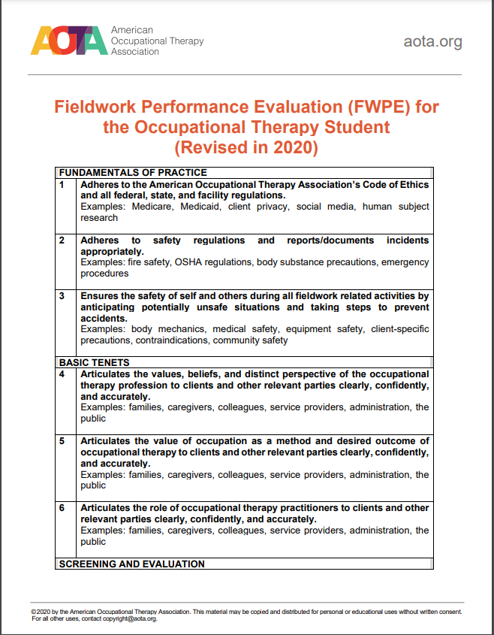
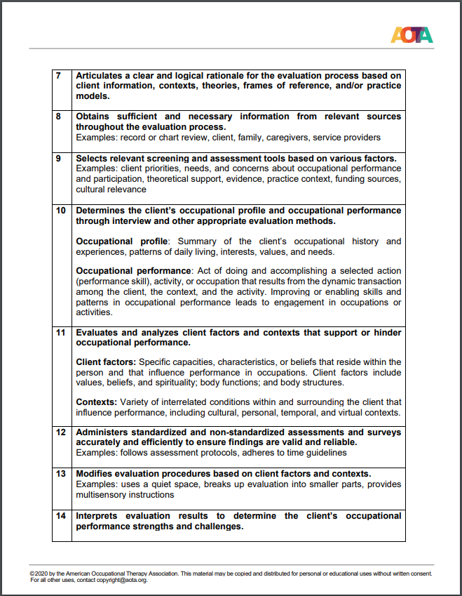
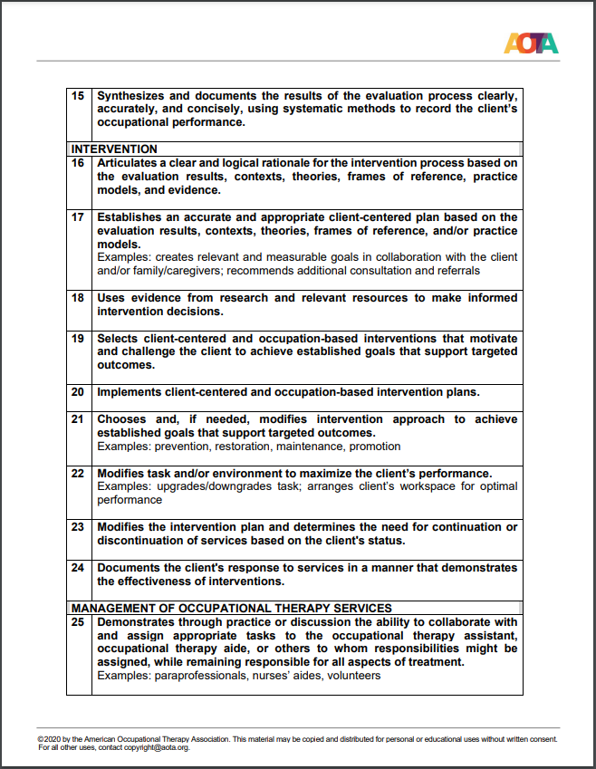
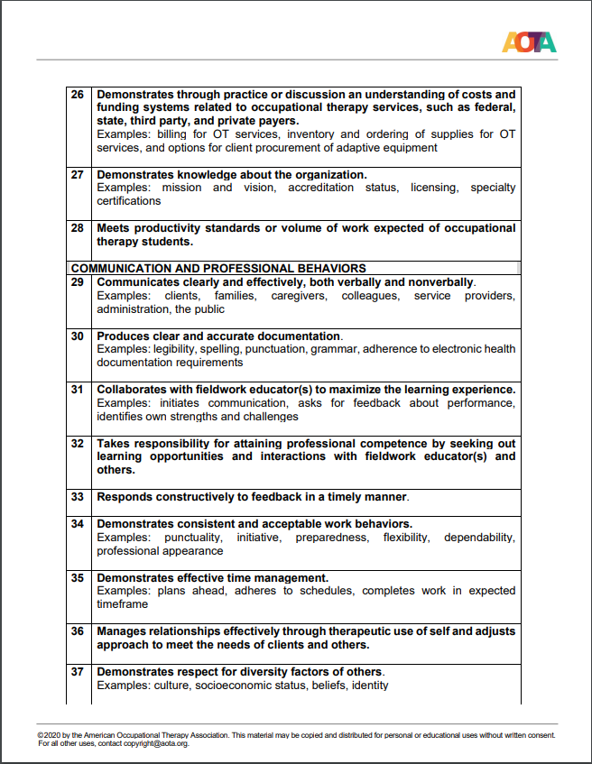
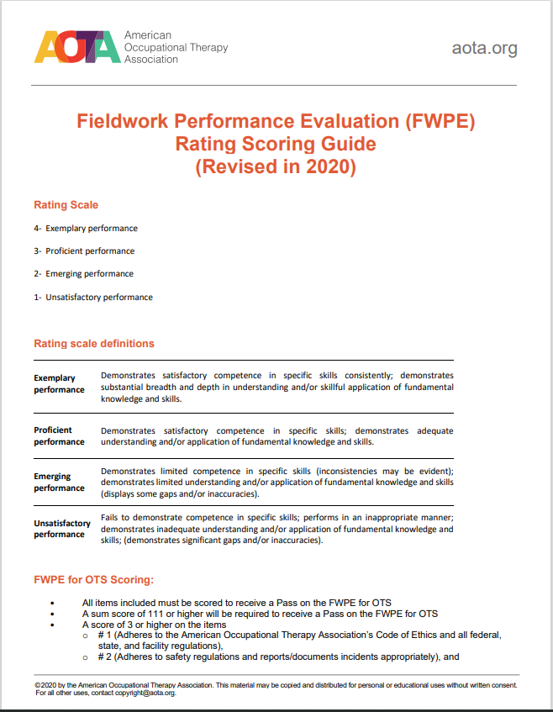
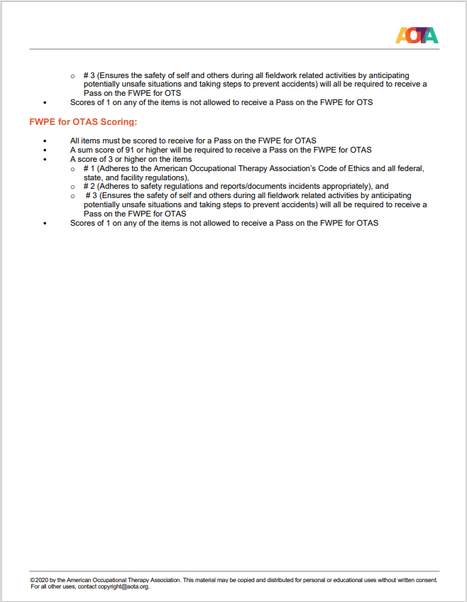

APPENDIX
Student Requirements for Fieldwork Participation

A. Student Immunization Requirements
1) Diphtheria and Tetanus (Tdap): Documentation of Tdap vaccination from within the last ten years. If Tdap has expired, must provide proof of your past vaccination and a current booster.
2) Measles/Rubeola, Mumps and Rubella (MMR): Documentation of two live MMR vaccines or provide documentation of serological proof of immunity (positive IGG titer) for rubella, rubeola/measles, and mumps. Equivocal or negative titer results are not acceptable. Individuals who received killed measles vaccine, combination of killed and live measles vaccine, or measles vaccine of an unknown type in the period 1963-1978 are considered unvaccinated and should receive two doses of live vaccine at least one month apart.
3) Varicella: Documentation of two doses of live varicella vaccine, or documentation of physician-diagnosed disease, or laboratory evidence of immunity.
4) Tuberculosis Test:
- Students have the following options for TB testing:
TB Blood Test (Quantiferon, T-Spot, IGRA) or TB Skin Tests
If you choose the blood test option, only one test and result are required. If you choose the skin test option, you will be required to complete two tests at least seven days apart, no more than three weeks apart. You will have to provide two two-step test results to be considered complete.
- If you receive, or have received, a positive result for TB testing you will have to provide proof of a negative chest x-ray from a certified health care provider. They must attest that you are not infectious and are able to work in the health care industry.
- It is recommended that all students traveling from countries where tuberculosis is endemic update their TB test 12 weeks after their trip. It is also recommended that all incoming students who are at high risk for TB should have a current TB test.
- For more information, go to the CDC website (http://www.cdc.gov/tb/publications/factsheets/testing/TB_Factsheet.pdf)
5) Hepatitis B: Documentation of a series of three vaccines (within 6-month period) or a Reactive titer.
a. Reactive – Immune (indicates baseline protection). No other testing or immunizations needed.
b. Nonreactive – Not immune, student must complete a second vaccination series
6) Polio: documentation of 4 dose Polio vaccination or a titer will need to be performed to prove
immunity. If titer shows non-reactive (not immune), a booster shot will be required.
7) Influenza vaccine: Available every fall semester from Magers Health and Wellness Clinic. If a student chooses to decline this vaccination due to medical or religious reasons, a written declination form must be provided to the AFWC and this may limit a student’s fieldwork site placement.
8) COVID vaccination series and Booster shot: many fieldwork sites require a student to show proof of the COVID vaccination series and possibly a Booster shot. Students who decline this immunization may be at risk of not meeting the timeline for graduation. Students may have the option to file a religious or medical exemption but are required to follow the fieldwork site’s guidelines for the exemption process.

B. Applicability, Documentation and Enforcement of Immunizations
- This policy applies to all domestic and international students entering the University for the first time, unless medical or religious exemptions pertain.
- Submission of these records, by date specified, is mandatory. Failure to comply will result in participation in fieldwork experiences being cancelled and/or restricted.

C. Additional Fieldwork Placement Requirements
- Occupational Safety and Health Administration (OSHA) Blood-borne Pathogen and Tuberculosis Education: Students are required to complete mandatory annual OSHA Blood-borne Pathogen and Tuberculosis education each fall.
- Health Information Portability Accountability Act (HIPAA): Students are required to complete a HIPAA course module during the first fall semester of the OT program.
- Background checks/Drug Screens/Additional Medical Screening: A criminal background check (CBC) and drug test is required for all students prior to formal admission to the OT program and having any opportunity for patient/client interaction.
- A single negative check does NOT preclude the requirement of additional checks at a future time.
- Students should be aware that any affirmative results from a CBC could restrict ability to participate in a clinical experience and therefore restrict the ability to complete degree requirements.
- In addition, the lack of an acceptable report on a CBC could bar the student from sitting for certification examinations and thus from practice.
- If requested, students are required to submit drug or additional medical screenings because of affiliation agreements at the fieldwork center.
- Students are responsible for any cost associated with the above requirements.
- CPR certification: Students are required to obtain Basic Life Support (BLS) through the American Heart Association.
- Incident Reporting: Students involved in an activity requiring the completion of the facility’s incident report must immediately communicate the occurrence to the facility supervisor and Academic Fieldwork Coordinator. Each will direct you to further action, including personal documentation of your inclusion in the occurrence. If you become ill or are injured because of participating in the incident, medical attention should be sought immediately.

- Professional Liability Insurance: Students participating in FW experiences are required to provide proof of professional liability insurance. Annual student premium fees for the insurance will be collected each fall semester.
- This policy sets forth the terms, conditions, and limits of medical professional liability coverage provided to each student under the program.
- It details the coverage afforded and describes the student’s responsibilities in the event of an occurrence.
- It is very important to note that coverage only applies while the student is acting within the scope and course of normal student responsibilities.
- Compliance Failure: Failure to comply with these requirements will result in the student’s inability to participate in applied experiences, thus resulting in an Incomplete (I) or Failing (F) grade for the associated class (es).
8) Professional Dress and Appearance Policy: In addition to appropriate behaviors and attitudes, presentation extends to appearance and demeanor. Attire should reflect your intent to be perceived as a professional and suitable to the setting and activity. Required dress code for all class outings, applied community service experiences, and level I and level II fieldwork experiences are the program-specific Polo shirt paired with conservative black slacks, closed-toed shoes, and your program nametag. Additional dress codes may be required by individual fieldwork sites. The following information describes suitable dress and personal hygiene.
1) For class outings, applied community service experiences, and level I and level II fieldwork you may not wear/display:
a. Clothing that reveals undergarments, cleavage, or midriff and gluteal areas, especially when you are reaching above the head or bending over. Thin straps such as ‘spaghetti-straps’ or tank tops must be covered with a sweater or jacket.
b. Pajama style or sweatpants
c. Slippers/house shoes
d. Jewelry that is excessive, can injure a client/yourself, or that interferes with activity demands.
2) Appropriate hygiene is always expected.
3) All tattoos and facial piercings must be covered when participating in fieldwork experiences. (must adhere to site requirements)
4) Footwear should be functional and modest. Most sites require socks and closed toe/heel shoes such as an athletic or leather shoe.
5) Sites vary in guidelines, and therefore, students will follow the requirements of the facility, such as requirement of scrubs.

