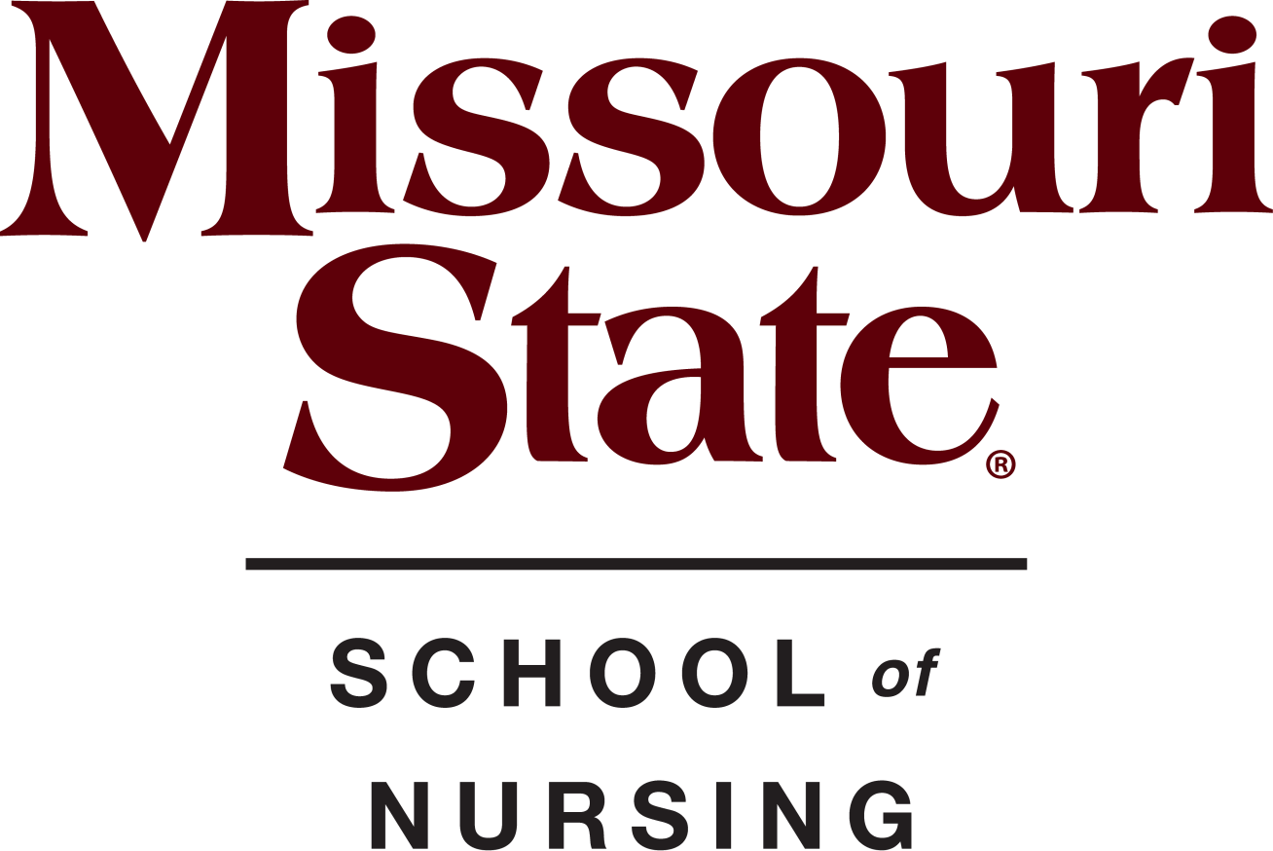

Pinning and Awards Ceremony

Juanita K. Hammons Hall
525 S. John S. Hammons Parkway
Springfield, MO 65806

May 12th
7:00 pm
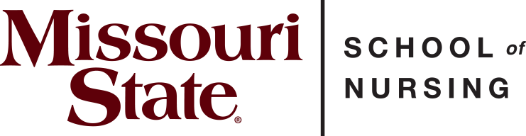

Directors
Kathryn Patterson, DNP, FNP-C Director, School of Nursing
Alison Alaimo, MSN, RN, BA Undergraduate Program Director
Rebecca Johnson, MSN, RN Undergraduate Program Director

Faculty
Cindi Aurentz, DNP, RN, MSN-Ed, CNE Yvonne Callahan, MSN, RN
Alexis Curran, MSN, RN Karla Conner, MSN, RN Helena Cox, DNP, MSN, RN Alyssa Dieterich, MSN, RN
Alisha Jones, MSN, APRN, FNP-BC Morgan Nemeth, MSN, RN Chelsea Pliler, MSN, RN
Sherri Ramirez, MSN, RN Ami Rohr, MSN, PNP Maria Shade, MSN, RN Ashley Simpson, MSN, RN
Tammy Yoes, MSN, RN, CCRN-K, CNE

Staff
Elizabeth Burrough, BS, Admissions Coordinator Tammy Shelton, MS, Academic Administrative Assistant II

Program
Welcome Dr. Kathryn Patterson Opening Remarks……….Dr. Mark Smith, Dean, MCHHS
Faculty Introductions Alison Alaimo
Pinning History Alison Alaimo
BSN Student Speaker………………………………..Alexis Burr

Pinning and Department Awards
Introduction of Students Dr. Cindi Aurentz Awarding of Pins ………BSN Faculty
Student Nursing Organization .Alisha Jones
CRNA Interview Recipients……………...Dr. Monika Feeney
Award Recipients ..BSN Faculty
International Nursing Pledge…………………..Alison Alaimo
Closing Remarks…………………………..Dr. Kathryn Patterson

Student Nurse Organization Representatives

Cameron Cameron, President Alexis Burr, Vice President
Grace Baker, Secretary Hope Barker, Treasurer Ella Davis, Social Chair
Izzy Struby, Social Chair
Emma Hultz, Pre-SNO Liaison

Alisha Jones and Ashley Simpson, SNO Faculty Advisors

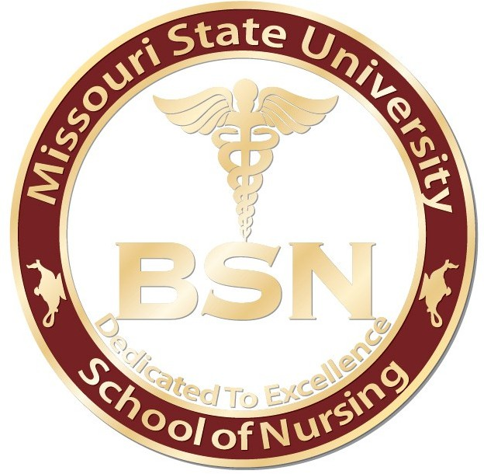

The Missouri State University Nursing Pin was redesigned by the School of Nursing faculty in 2022. It honors many key characteristics designed by the previous faculty in 2005. This pin remains with a round edge and maroon circle with the words Missouri State University
embossed in gold lettering across the top edge, a lamp with a candle on each side of the pin with the added inscription, “School of Nursing”, around the bottom edge.
The center of the pin remains a white background with a Caduceus symbol embossed in gold located directly above the BSN letters, with the wording, “Dedicated to Excellence”, at the lower edge of the pin center.
The symbol of the lamp with a candle on the outer edge pays tribute to Florence Nightingale, the founder of nursing. During the Crimean war (1853-1856), she was sent to the frontlines to take care of wounded soldiers and she carried a lit lamp while caring for injured soldiers. The Caduceus is associated with nursing and healthcare; the nursing sign is a staff covered in two twisting snakes topped with angel wings. This is the symbol most frequently associated with nursing.
The BSN letters signify completion of the Bachelor of Science in Nursing degree. The BSN curriculum prepares students for work within the growing and changing healthcare environment. Completion of the four-year BSN degree provides the educational and
experiential base not only for entry-level professional practice but also as the platform on which to build a career through graduate-level study. This degree also qualifies nurses for the
widest range of positions in the nursing field.
Finally, the MSU School of Nursing motto, “Dedicated to Excellence”, completes the pin.

Graduating Class of Fall 2024 Bachelor of Science in Nursing (BSN)
Sydnie Rains~+

Megan Ravela~

Claudia Reed~

Jordan Richards~+

Estrella Risco Ramirez

Grace Roberts~+

Giavanna Russo~+

Maggie St. John~+

Megan Swaters~

Esther Tharp~+

Tavania Tran~

Cristina Turney~+

Abigail Van Hoye~+

Emma Yabut~
Miriam Harpt~

Emma Heckemeyer~+

Kaelin Holden~

Kylie Hope~

Madison Jung~

Calvin Kellogg~

Nathanael Kim~

Taylor Kochs~

Grace Lewis~

Macey Maas Hauver~

Ivymitchele Magut~

Allison Meyer~

Austin Millick

Anna Niewald

Emily Phillips~

Grace Pupillo~

Mckenna Atherton+

Aidan Benker

Faith Bonacker~+

Alexis Burr~*+

Cameron Cameron*+

Andrew Clemons~

Mallory Clifton~

Elise Dahm

Ella Davis*+

Dixie Dowell~

Khloe Farmer~

Lauryn Freeman~

Talia Giustiniano

Lexi Graves

Nick Greener

Emme Hall~

#
~University Honor
*Student Nurse Organization Board Member
+Active Member Student Nurse Organization

International Nursing Pledge

In full knowledge of the obligation I am undertaking, I promise to care for the sick with all the skills and understanding I possess without
regard for race, creed, color, politics or social status, sparing no effort
to conserve life, to alleviate suffering and to promote health.

I will respect at all times the dignity and religious belief of the patients under my care, holding in confidence all personal information entrusted to me and refraining from any action which might endanger life or health.

I will endeavor to keep my professional knowledge and skills at the highest level and to give loyal support and cooperation to all members of the health team.

I will do my utmost to honor the international code of ethics applied to nursing and to uphold the integrity of the registered professional nurse.

