

Pinning and Awards Ceremony

Juanita K. Hammons Hall
525 S. John S. Hammons Parkway
Springfield, MO 65806

May 8th
7:00 pm
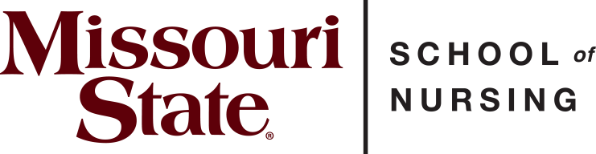

Directors
Kathryn Patterson, DNP, FNP-C Director, School of Nursing
Alison Alaimo, MSN, RN, BA Undergraduate Program Director
Rebecca Johnson, MSN, RN Undergraduate Program Director

Faculty
Cindi Aurentz, DNP, RN, MSN-Ed, CNE Yvonne Callahan, MSN, RN
Alexis Curran, MSN, RN Karla Conner, MSN, RN Helena Cox, DNP, MSN, RN Alyssa Dieterich, MSN, RN
Alisha Jones, MSN, APRN, FNP-BC Morgan Nemeth, MSN, RN
Sherri Ramirez, MSN, RN Ami Rohr, MSN, PNP Maria Shade, MSN, RN Ashley Simpson, MSN, RN
Alisha Tuttle, MSN
Tammy Yoes, MSN, RN, CCRN-K, CNE

Staff
Ashley Bluebaum, Academic Administrative Assistant II
Elizabeth Burrough, BS, Admissions Coordinator Tammy Shelton, MS, Academic Administrative Assistant II
Program
Welcome Dr. Kathryn Patterson Opening Remarks……...Dr. Mark Smith, Dean, MCHHS
Faculty Introductions Alison Alaimo
Pinning History Alison Alaimo
BSN Student Speaker……………………….Elliot Whitehead

Pinning and Department Awards
Introduction of Students.................. Dr. Cindi Aurentz
Awarding of Pins..........................................BSN Faculty
Student Nursing Organization.....SNO Executive Board
CRNA Interview Recipients……...…. Dr. Monika Feeney
Award Recipients....................................... BSN Faculty
International Nursing Pledge………………..Alison Alaimo
Closing Remarks………………………..Dr. Kathryn Patterson

Student Nurse Organization Representatives
Kyra Cullers, President
Addie Wright, Vice President
Lexi Buckner, Secretary
Hannah Thomas, Treasurer
Peyton Bailey, Social Chair
Kennedy Joes, Social Chair
Laci Connelly, Pre-SNO Liaison
Afton Riggs, Pre-SNO Liaison
Alisha Jones and Morgan Nemeth, Faculty Advisors

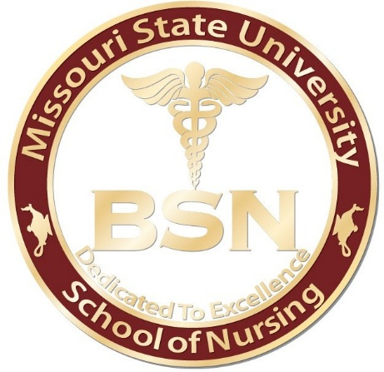

The Missouri State University Nursing Pin was redesigned by the School of Nursing faculty in 2022. It honors many key characteristics designed by the previous faculty in 2005. This pin remains with a round edge and maroon circle with the words Missouri State University
embossed in gold lettering across the top edge, a lamp with a candle on each side of the pin with the added inscription, “School of Nursing”, around the bottom edge.
The center of the pin remains a white background with a Caduceus symbol embossed in gold located directly above the BSN letters, with the wording, “Dedicated to Excellence”, at the lower edge of the pin center.
The symbol of the lamp with a candle on the outer edge pays tribute to Florence Nightingale, the founder of nursing. During the Crimean war (1853-1856), she was sent to the frontlines to take care of wounded soldiers and she carried a lit lamp while caring for injured soldiers. The Caduceus is associated with nursing and healthcare; the nursing sign is a staff covered in two twisting snakes topped with angel wings. This is the symbol most frequently associated with nursing.
The BSN letters signify completion of the Bachelor of Science in Nursing degree. The BSN curriculum prepares students for work within the growing and changing healthcare environment. Completion of the four-year BSN degree provides the educational and
experiential base not only for entry-level professional practice but also as the platform on which to build a career through graduate-level study. This degree also qualifies nurses for the
widest range of positions in the nursing field.
Finally, the MSU School of Nursing motto, “Dedicated to Excellence”, completes the pin.

Graduating Class of Spring 2025 Bachelor of Science in Nursing (BSN)
Shania Adkison~+

Hanna Al-Baaj~

Kaylie Anderson~

Grace Baker#~+*

Ava Barnes~

Halli Beck~+

Madeline Beerman~

Hope Bittick#~+*

Isabelle Bokern~

Sophie Broockerd~

Hannah Cowen~

Kayla Cummins

Lizzie Douthit+

Sam Eberle~

Lindsay Eye+~

Sam Feurt

Abbi Geiger~

Brooklin Gillen~+

Eli Gray~

Sam Hall~+

Lindsey Ham~

Kylie Hawk~+

Kallie Hayes~

Jessica Hebenstreit~+

Maria Hellebusch~

Lexie Hilton~

Isabella Hughes~

Emma Hultz~+*

Caleb Jewell~+

Kirsten Johnson~

Ericka Kosier~

Jaiden Lampe~+

Zachary Langley~+

Sarah Lipski~+

Samantha Malone

Danielle Markham~+

Kaycee Maynard~+

Ryan Meadows
Kaitlyn Miller~+

Olivia Neidt~+

Nylynn Newcombe~+

Brady Niemczyk

Paige Parson+

Emma Parsons~+

Ayden Pennington

Allyson Pollard~+

Hillary Scott~+

Elizabeth Simpson~+

Izzy Struby~+*

Claire Sullivan~+

Natalie Vonderheide~+

Emma Welch~+

Elliot Whitehead~

Favor Yartue

#Honors College
~University Honor
*Student Nurse Organization Board Member
+Active Member Student Nurse Organization

International Nursing Pledge

In full knowledge of the obligation I am undertaking, I promise to care for the sick with all the skills and understanding I possess without
regard for race, creed, color, politics or social status, sparing no effort
to conserve life, to alleviate suffering and to promote health.

I will respect at all times the dignity and religious belief of the patients under my care, holding in confidence all personal information entrusted to me and refraining from any action which might endanger life or health.

I will endeavor to keep my professional knowledge and skills at the highest level and to give loyal support and cooperation to all members of the health team.

I will do my utmost to honor the international code of ethics applied to nursing and to uphold the integrity of the registered professional nurse.

