Initiator Help Guide

Why Update Our Paper PAFs to Dynamic Forms?
- PAF forms have been the same since the 80s!
- The only significant change happened in 2020 due to COVID. Moving offices off campus required PAFs to be submitted by email. That has been only significant change in almost 30 years!
- There are many benefits to implementing Dynamic Form PAFs:
  - Cleaner, neater fillable forms.
  - Employee M#s auto-fill employee information for initiator.
  - Initial approval workflow is determined by initiator; processing workflow is automated.
  - New PAFs can be tracked through the Dynamic Form workflow.
  - The selected form and action type will populate the necessary fields to process changes. Only the required information for the action type will appear on the PAF: if there is a field – complete it; if there isn’t a field – then information isn’t needed.
- The Dynamic Forms PAFs are only replacing the current paper PAFs. Hiring through the ATS and both the Per Course BearPAF and GA BearPAF systems will not change. Full-time employees will still be hired through the ATS, .5 Per Course Instructors will still be hired through the Per Course BearPAF system, and GAs will still be hired through the GA BearPAF system. Those systems are not changing in functionality because of the new Dynamic Forms PAF, nor are they going away at this time.

Before Completing a PAF:
- You must know an employee’s M# before you can complete a PAF for them.
  - M# Creation Request Form - If the employee does not have an M#, or if you are not sure if the employee has an M#, you can submit an M# Creation Request form.
    - This form is listed at the top of the same webpage that the PAF forms are listed on.
    - Based on the information provided on the form, HR Records will identify the employee’s existing M# or assign one if one does not exist.
    - Once your M# Creation Request form has been reviewed and processed, you will receive an email containing the employee’s M#.
    - A Social Security Number is required for Per Course Instructors.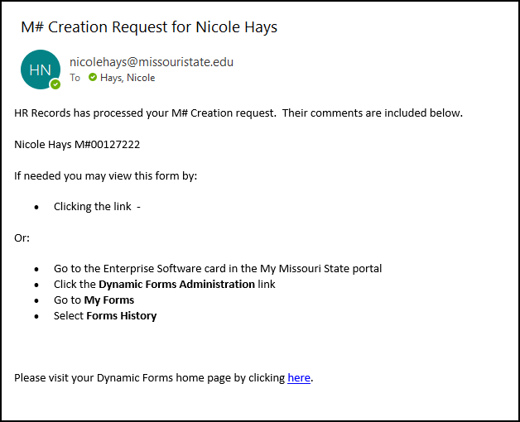

- You must know the designated, authorized approvers and their email addresses at each approval level for your PAF. Once these email addresses are entered, Dynamic Forms will forward the PAF on to each approver, then the PAF will be moved through the processing workflow set up in Dynamic Forms. If you send the PAF to the wrong approver or wrong email address, it may be delayed because that person was not looking for it. Three approver levels are available.
  - For the Provost’s Office, please use the Provost’s Executive Assistant’s email address.
  - For the President’s Office and the Executive Vice President’s Office, please use their Executive Assistant’s email address.

Accessing the New Electronic PAF Forms, PAF FAQs and Help Guides, and TEST PAFs:
- To access the new Dynamic Forms PAFs:
  - Go to the My Missouri State portal > Personnel Action Forms card > Dynamic Forms PAFs (NEW Personnel Actions Forms!) link.

  - To access the PAF Help Guides:
    - Go to the My Missouri State portal > Personnel Action Forms card > Dynamic Forms PAF FAQs and Help Guides.

  - For TEST environment for Dynamic Form PAFs:
    - Go to My Missouri State TEST Experience portal > Personnel Action Forms card > Dynamic Forms PAFs (NEW Personnel Actions Forms!) link.

  - The Dynamic Forms PAFs (NEW Personnel Actions Forms!) link takes you to a webpage that will explain each form separated by employee types/actions - full-time, part-time, supplemental, summer, per course, graduate assistant, or university associates.
  - To submit or test a PAF form, click on the name of the appropriate form; this will open the PAF for completion.
  - Below is a form definition/explanation of the types of changes for each PAF form:

- Full-time employees:
      - The Full-time Change of Status (PAF – FT Change of Status) Form - Used to report faculty promotion/rank changes, title changes, staff reclassifications, transfers, faculty reappointments, staff continuation of appointments, faculty tenure, going back to faculty, emeritus, and FTE % changes.
      - The Full-time Leave (PAF – FT Leave) Form - Used to report leave with or without pay, leave with or without benefits, sabbatical leave, educational leave, and administrative leave.
      - The Full-time Compensation (PAF – FT Compensation) Form - Used to report salary adjustments, budget changes and other compensation changes.
      - The Full-time Separation/Termination (PAF – FT Separation) Form is used to report resignations, retirements, involuntary terminations, faculty non-reappointments, lay-offs, and deaths.

- Part-time Employees:
  - The Part-time Change of Status (PAF – PT Appointment/Change of Status) Form - Used to report new appointments, continuation of appointment, and FTE % Change.
  - The Part-time Compensation (PAF – PT Compensation) Form - Used to report salary adjustments, budget changes and adding additional rate of pay.
  - The Part-time Separation/Termination (PAF – PT Separation) Form - Used to report resignations, terminations, involuntary terminations, and deaths.

- Supplemental Employees:
  - The Supplemental PAF (PAF – Supplemental Compensation) is used to report new appointments, terminations, increase or decrease in pay, cancelation of appointment, reappointments, budget changes, interim/acting appointments, and premium pay.

- Summer Employees:
  - The Summer PAF (PAF – Summer Appointment) is used to report new appointments, increase or decrease in pay, cancelation of appointment, resignations, terminations, and budget changes.

- Per Course Employees:
  - The Per Course PAF (PAF – Per Course) - Used to report .74 new appointments, increase or decrease in pay, cancelation of appointment, resignations, terminations, budget changes, and FTE% changes.

- Graduate Assistants:
- The GA PAF (PAF – Graduate Assistant) - Used to report late new appointments, increase or decrease in pay, resignations, terminations, and budget changes.

- University Associates:
  - The University Associates PAF (PAF – Adjunct Faculty/University Associate/Volunteer) - Used to report two-year university associate appointments and renewals, two-year adjunct faculty appointments and renewals and no-pay volunteers.

SPECIAL NOTES ON ACCESSING THE FORMS:
    - If you save the form links and do not go through the My Missouri State portal each time, you will need to sign in before you are able to open and complete a form. This could also cause problems in the future if/when we release new versions of the forms if you do not use links on the PAF Form webpage.
    - Each PAF submission is for only one action!
    - Each form contains only the fields necessary for that action and each field must be completed. If you feel the form is missing a necessary field for the change you are requesting – you are most likely using the wrong form. Please refer to the form definitions above and contact HRRecords@MissouriState.edu with questions.
    - For AmeriCore Volunteers - use the PT Change of Status form and select part-time paid monthly. Then in the comment field, you must explain that the form is for an AmeriCore Volunteer.

What the PAFs Look Like
- Layout of the Form:
    - Timer in Top Right Corner – This is the form timer. It starts with 45 minutes to complete or save work on the form. If interrupted while completing the form, each time work is saved, the timer will reset to 45 minutes. It shows how much longer the current session will remain active. If the timer reaches 0, the session will end and you will lose any unsaved work. You will receive a two-minute warning if the form has been inactive: “For security reasons, your session will end in two minutes. You may click the Save My Work button below to save your work and avoid timing out.”
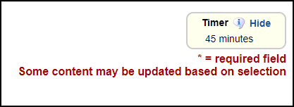
    - Title of the Form - This is located at the top of each form.
    - Six Form Sections:
      - Section I: Form Participant Information – Completion of this section determines the approval workflow for the personnel action.
      - Section II: Current Employee Information – This section is automatically populated from Banner after the employee’s M# is entered so is reflection of employee’s information already in Banner. You cannot change this information on the form. If something is incorrect, contact HRRecords for correction.
      - Section III: Current Classification Information – This section is automatically populated from Banner after the employee’s M# is entered so is reflection of employee’s information already in Banner for reference in completing the form.
      - Section IV: Action Details – This is where the initiator will enter the action information or desired action to be taken – the purpose for the form, the FOAP information, enter supporting comments for the action, and attach required supporting documentation.
      - Section V: Contributor Information – This section has three sub-sections for data entry used only by Human Resources Records, Finance, and Budgeting.
      - Section VI: Approvals – This section contains comment fields for anyone who may be part of the approval workflow for the PAF, not just initial department level approvers, but also any other form contributors or university approvers such as HR, budgeting, finance, etc. Anyone who is signing/approving a form may enter comments in their section.
      - REMINDER: PAFs are part of an employee’s personnel file and serve as legal documentation of their employment history. Copies of personnel files may be obtained by formally submitting a request under the Sunshine Law. Therefore, please make sure all comments are appropriate.

Completing a PAF:

The form is divided into sections and only certain form participants have access to enter or change information in each of those sections. This is a necessary control feature for the forms. It would be counterproductive for someone late in the approval flow to change information on a form after it’s gone through other different levels of approvals where that initial information was reviewed for their approval.
If something on a form is wrong or missing information for the action, it must be returned to the initiator or the contributor who entered/missed that information.
If it is a section that the initiator completed, then once the initiator corrects the information, the PAF must go through the entire department level approver workflow again. Initiators need to take the time to ensure that they enter accurate and complete information – entering things incorrectly will delay processing the form. Do not guess when entering information! Contact HRRecords with questions on forms, contact budgeting/finance to verify funding/FOAPs, etc. BEFORE submitting a PAF if you have a question.

- Section I - Form Participant Information – Entered by Form Initiator:
  - Questions: The answer to these questions help determine the university approval workflow of the form:
      - Does this employee work in West Plains?
        - Yes – then the university approval workflow is determined, and initiator may begin entering email addresses for each department/cost center approver;
        - No – then this determines/sets a different university approval workflow:
      - Does this employee’s department report to the Provost, Academic Affairs, or require 3 approvers?
  - Approver Email Entry: All PAF forms for West Plains will have 3 university approval levels. All Springfield campus will need either 2 or 3 university approval levels.
    - NOTE: If completing the PAF at a higher level in the university approval level workflow, in these cases, you might need to use the same approver more than once.
  - Enter the MSU email address for each university approver level by entering the email address for the “Approver for” each level of approval, and then hit Tab and WAIT for the approver’s first and last names to populate. If it doesn’t, then the email address entered is not valid and must be corrected/changed before the form can be submitted.
    - NOTE: “Approver for” email addresses –You will enter the email address of the person who has the authority to approve the PAFs. For example, the “Approver for Provost” will always be the Executive Assistant to the Provost, and the “Approver for the President or Vice President” will always be the Executive Assistant to those positions. Thus, an “Approver for” may be an executive or administrative assistant or supervisor and not the actual Director/Dept Head, Dean, or Major Administrator. Departments must verify who these people are for each level of approver BEFORE submitting a PAF; this will help keep PAFs moving through the approval workflow and not get buried in someone’s email who may not regularly be available to approve things or who is not an authorized approver.
    - Tip on typing email addresses: As you type the email address, type over the “@” symbol as if it wasn’t there. You cannot tab past it; tabbing over it will take you to the name fields.
    - An email address will not populate by completing the first and last name fields. You must know and enter the approver’s email address. Names are not unique identifiers, but email addresses are – this is why you must enter the email address and why names cannot be used to search for email addresses.

- Sections II and III - Current Employee Information and Current Classification Information – Pulled from Banner on Current Primary Position:
  - M# must be entered with an upper case “M” and then number, then hit tab and WAIT for the Section II and Section III fields to populate before continuing. Otherwise, the form will be submitted without any employee information completed and will have to be returned to the initiator and a new form will have to be started and then go through the entire approval process again.
- NOTE: Please be aware that using a lower case “m” for the M# may populate some of the form fields, but not all the fields. Please enter an upper case “M” for the M# to ensure the form pulls all information from Banner that is available.
    - If the employee information pulled into the PAF from Banner is wrong:
    - If it is the wrong person, double check the M# entered and either re-enter and refresh the form or close it and start over.
    - If the employee is correct but the information is incorrect - contact HRRecords@MissouriState.edu so that information can be researched and corrected.

- Section IV - Action Details – Entered by the Form Initiator:
  - Under section title “Action Details”, the form name/type will be displayed again. Please verify again that this is the correct form for the personnel action type.
  - Fields to Complete:
    - State Physically Working - this field is NOT pulled from Banner. The initiator must complete this field. It is extremely important for payroll purposes that this field have the correct state in which the employee is physically performing or completing their work responsibilities for MSU.
- Missouri and Arkansas are listed first because they are most common. All other states are listed in alphabetical order.
    - Job Type - For this field the Initiator selects whether the employee is either faculty or staff. After making selection, a “Change of Status Type” field will be displayed with a drop-down menu. There are different change of status types depending on whether the initiator is making a change to faculty or staff.
    - Change of Status Type - For this field the Initiator selects the type of change needed
from the drop-down list.
- The form will display different fields based on the selections you make.
- Each of the fields populated by the selection are necessary for the action to be processed and must be entered to avoid having the form returned to the initiator. Due to technical limitations, not all fields can be designated as required on a form; however, if a field is displayed - the information is needed or required to process the change/action, so please complete all fields!
      - You must not submit the form until you have provided all the required information.
      - This process/form is much different from the paper PAF forms which were often missing needed information and/or might contain extra, miscellaneous, or unnecessary information.
    - FOAP Information -
      - Only University Funds may be entered using the FOAP fields. If using a Foundation Fund, please list the FOAP information in the Initiator Comments field in the section. B02222 should be used as the Fund, users should use a university org assigned to their department/unit and program code 065.
      - To enter the FOAP information in the FOAP fields, initiator must click on the gray triangle under each header (Fund, Org, Account, Program, and Activity Code) and field will appear.
      - To enter the account information, begin typing the account number and a suggested list will populate from Banner.
      - Initiator MUST select/click the correct number in the list and verify that it has populated the field before moving to the next section of the FOAP. If the field did not populate, then click the gray triangle and begin entering the number again and be sure to click/select the correct number.
      - Fund, Org, Account, and Program numbers are required fields, the Activity Code is not a required field.
      - For each line of the FOAP, enter the percentage in the % field. The FOAP Percent column must add up to 100% or initiator will not be allowed to submit the form.
      - If you need more than 6 FOAP lines, then please attach a separate file by clicking the “Attachments” button.
    - Initiator Comments - The initiator may use this comment field to enter any additional information and details that may aid in processing the form, for example: foundation funds; faculty overload information - number of credit hours, number of classes, number of students, etc. for instruction calculations, etc.
    - Attach File - This button allows the initiator to attach all relevant documentation for the action taken. The PAF cannot be fully processed until all relevant documentation is received with the PAF.
    - Documents that can be attached to a PAF:
        - Appointment letters
        - Red-lined job descriptions for title changes or reclassifications
        - Reclassification memos
        - Curricula vitae
        - Resignation letters
        - End of employment forms
        - Additional FOAP lines
        - Documents NOT to attach to PAFs:
          - I-9 forms should NOT be attached to PAFs, I-9's should be hand carried to HR whenever possible.

- Save Progress and Next Buttons: There are 2 buttons at the bottom of the page when an initiator creates a new PAF submission: Save Progress and Next. If not all of the required fields have been completed on the form, then these buttons will not show until those required fields have been completed.
    - NOTE: ALWAYS click “Save Progress” when working with a form. Whether you are saving to complete it later, making changes to a saved form draft, returning or rejecting a form, completing the form to submit for approval, etc. – ALWAYS click “Save Progress” to ensure that your changes and/or comments will be saved and included on the PAF and in emails.
    - After clicking “Save Progress”, the following message will pop up “Your form has been saved as a draft. If you need to stop working on this form and continue it later, you may find the form in the pending/ drafts section under "My Forms", then you will either click “Continue” to continue with processing the form to submit by clicking “Next” then at the bottom of the form which will take you to electronically sign and submit the form, or you may click “Log Out” to save the form as a draft and come back to it later.
    - If you save the form to complete later, it will be saved as a draft and can be found in “My Forms” on your Dynamic Forms home page to complete later.
    - If you click “Next” then you will go to a page to electronically sign and submit the form. Once signed and submitted, the form will go to the first university approver level that was designated on the form by the initiator and continue through the contributors/approvers and processing workflows.

- SPECIAL NOTES ON COMPLETING A PAF:
- If you change what you are doing on the form several times, it might not populate the needed fields correctly - simply refresh or close the form and start over. Closing the form and starting a new form would be best practice to ensure that the correct fields have been populated for completing the action.
- If someone in the department other than an approver needs to know about the PAF, it will be the Department’s responsibility to inform them. The initiator can export the PAF to a PDF and email anyone outside of Dynamic Forms.

The PAF Workflow Process:
A PAF begins with the initiator. The initiator will determine who within their department/cost center needs to approve the form by entering in the emails of the “Approver for” the Department Head/Director, Dean, and Major Administrator. The PAF then travels through a preset processing workflow which includes human resources, budgeting/finance, payroll, etc.
  - NOTE: To expedite processing of forms, please determine who the appropriate “Approver for” is for each approval level BEFORE submitting a PAF.
  - For the Provost’s Office – The “Approver for” the Provost’s Office will be the Executive Assistant to the Provost.
  - For the President’s Office or the Executive Vice President’s Office – The “Approver for” will be the Executive Assistant to each of those offices.

Emails During the PAF Process:
Various email messages are sent while the submission is going through the approval workflow and being processed. HINT: As you become familiar with the emails received/sent by Dynamic Forms, in order to better manage them, you may want to create folders and rules in Outlook to help you manage/sort submitted notifications from approval needed notifications, etc.
Below is an explanation of each of these email messages.
- Confirmation Email Received by the Initiator:
    - This email message confirms the initiator has successfully submitted a new PAF for approval and processing.
    - Initiators should receive a similar email message shortly after submitting each PAF:

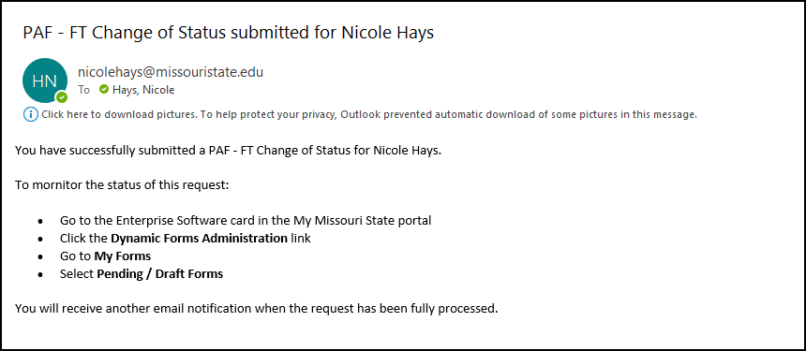

- Approval Needed Email Notification - Received by Each Approver in the Approval Workflow
    - Each “approver for” each approval level in the approver workflow will receive an “Approval Needed” notification email similar to the one below when it’s their turn to review and approve a PAF submission.
    - NOTE: The “approver for” each approval level will continue to receive this email message every 3 days until they review and approve the PAF submission.
      - The Initiator also has the ability to resend an email notification to an approver manually if needed. This process is explained in the section about Pending PAF submissions.
      - The Initiator may also change an “approver for” an approval level by:
      - going to “My Forms History,” then
      - “Manage Approvers,” and
      - entering a new “approver for” the approval level. This might be necessary if the original approver is unable for any reason to approve the PAF - illness, on vacation, leaves employment, etc.
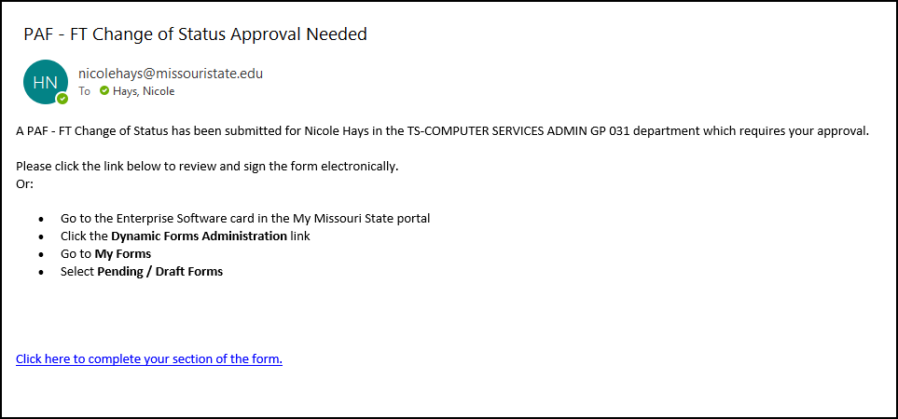

- Notification Email - Received by the Initiator:
    - This email message is received by the Initiator when the approval process has ended. There are two situations that cause the approval process to end: one, the approval process has been completed, or two, the PAF submission has been rejected/ended.
        - Completed - Once a PAF submission has been approved by the last approver in the approval process workflow, a notification email similar to the one below will be sent to the Initiator. It does not mean the action has been entered into Banner yet; there will not be an email notification when the change is entered into Banner.

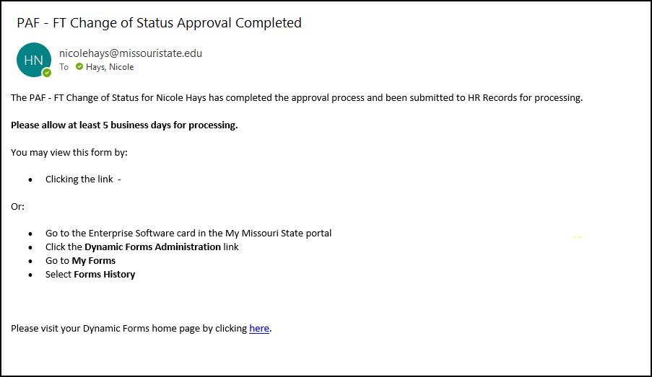

REJECTED OR RETURNED FORMS (THE DIFFERENCE) AND EMAILS

- Rejected Forms and Emails – Received by Initiator:
    - Some approvers have the ability to reject a PAF submission. If a PAF is rejected, this means that the submission has ended and the PAF will not be processed any further. It is done.
          - The approvers have been instructed to enter a comment in their specific approver comment field explaining why they rejected the submission.
          - In this situation, the Initiator will receive an email notification similar to the one below.
          - The Initiator can also view the form in Dynamic Forms to see the comment about why the approver rejected the submission.
          - If the submission was rejected by mistake instead of returned to the Initiator and the change is actually needed, the Initiator will have to submit a new PAF.
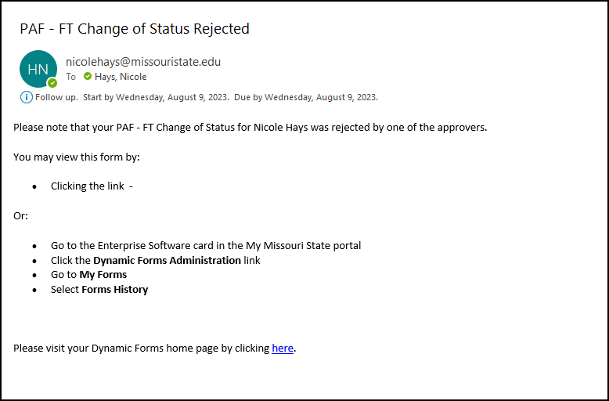

- Return Email and Forms - Received by Initiator OR Approver OR Contributor:
    - This email message is sent when an approver returns the PAF submission for a correction or because more information is needed.
    - All approvers have the ability to return a PAF submission. The PAF can be returned to the Initiator or any approver in the approval workflow before the approver who is returning it. This list of approvers will be apparent in the return process – there will be a drop down list of available approvers that the form may be returned to for correction or addition of information.
    - The subject line and body of the return email message should be entered by the approver returning it. However, approvers are given instructions about what the email message should contain and it should look similar to the example below.
    - Do not directly reply to a returned PAF email. It is a Dynamic Forms generated email from HRPAF@MissouriState.edu which is not a regularly monitored email address. (HRPAF@MissouriState.edu email address should not be used to contact HRRecords with questions, it is a Dynamic Forms systems email for the HRPAF.) If an email is replied to HRPAF email, Dynamic Forms does not know how to send the response directly to the approver who returned and sent the email – it will not go directly to the approver who returned the email. Look in the body of the email for the person who returned the email and contact them directly if there are any additional questions about why it was returned.
    - Maybe get a new screenshot that should the HRPAF email instead of Nicole’s address
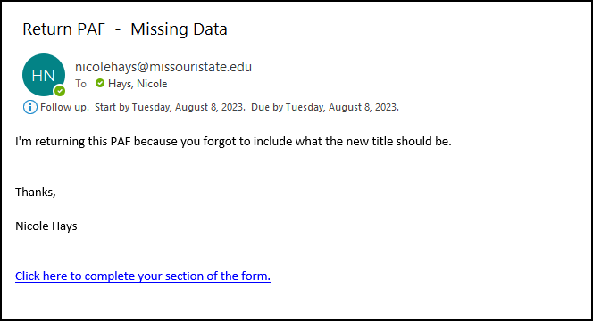

How to View/Manage Your PAFs in Dynamic Forms as They Are Being Processed:
Go to My Missouri State portal > Enterprise Software card > Dynamic Forms Administration link.
To view/find your forms, on the Dynamic Forms homepage, you will click on “My Forms” and a drop-down menu will be displayed:
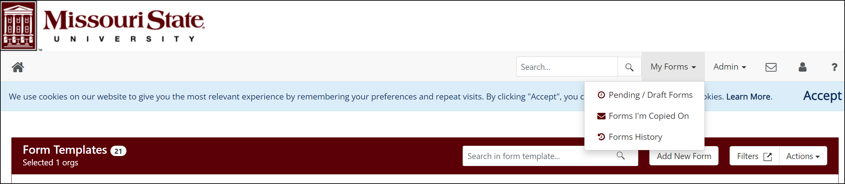

- Pending/Returned/Draft Forms – These are forms that are in the workflow and may be awaiting your action, or action by another PAF approver or contributor.
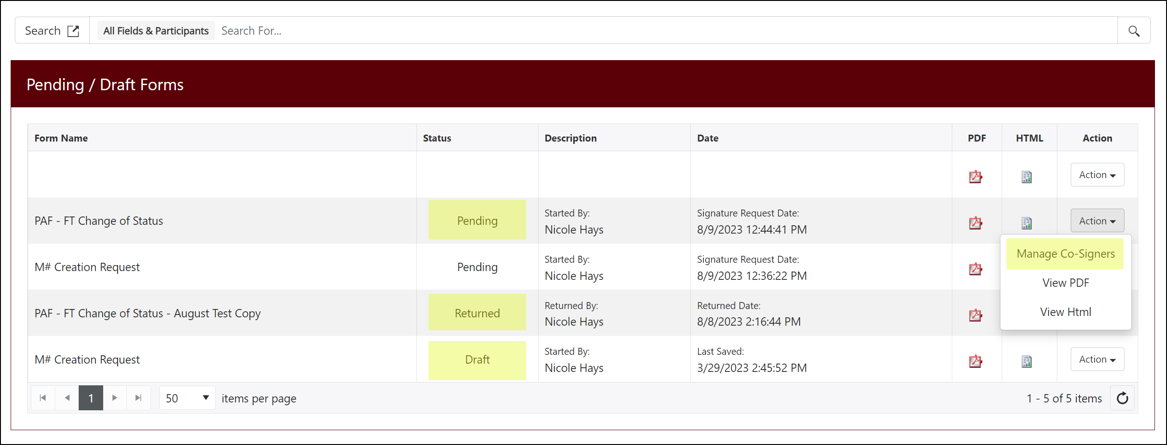
  - Drafts are forms you as the initiator have started but not completed or submitted yet. These forms are waiting on you.
  - Pending forms have been submitted and are now going through the approval process.
    - If you click the Actions button on a Pending request, the dropdown list will contain Manage Co-Signers as an option. If you click this option, a new window will open displaying information about the approver process.
    - In this window you will have another Actions button with 2 options in the dropdown list: Edit Cosigner and Re-send Notifications.
      - Edit Cosigner - this option is only available for certain approvers like Department Head/Director, Dean and Major Administrator. It allows you to change the person selected for this approver role if needed.
        - For example, if you submit the form with “John” as the Department Head but later realize John is out for 2 weeks on vacation, you can use the Edit Cosigner option to change John to Mary so the form can still be processed in a timely manner.
      - Re-send Notifications - this option allows you to manually resend an approval notification email to the current approver.
        - Please note that approver notification emails are sent automatically every 3 days. Please DO NOT overuse this option!
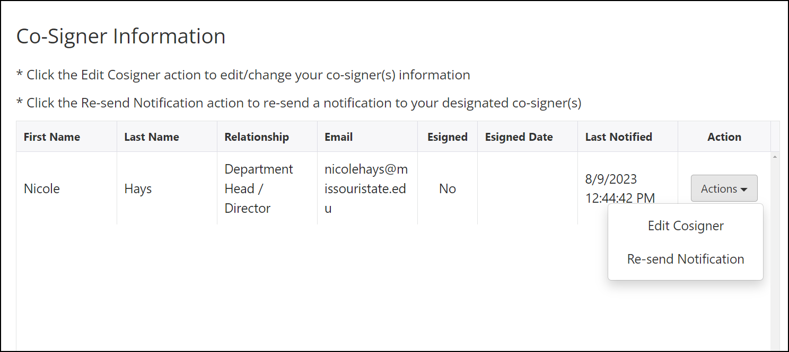

  - Returned forms are also listed here. This is a PAF form submission that has been returned to you by someone in the workflow for you to take further action, such as making a correction or adding additional needed information to approve or process the PAF.
    - To correct a returned PAF submission, click the Action button next to the submission then select Complete Form from the dropdown list.
    - The PAF submission will open and you will have the ability to change any information that you originally entered or add more information.
    - After you have corrected the information, click Save Progress and then the Next button at the bottom of the form. You will be prompted to electronically sign the form again. Once this is done, the approver workflow will start over.
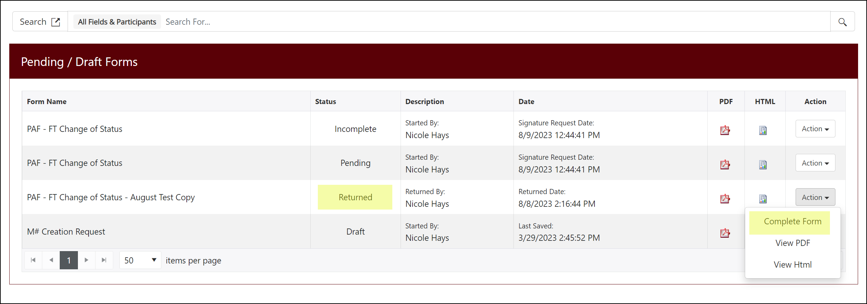

- Forms History – This will show forms that have completed the approval process and are now being processed by HR.
  - Pending - The approval process for this PAF form submission is complete and it is now ready for HR Records to process and make the requested change in Banner.
    - You can normally expect forms to be processed and changes to be made in Banner within 5 business days.
    - However, some forms are submitted too early to be processed. If you notice a form has been “pending” for a long time, please open the form and look at the HR Records Comment field. This field should contain information about when HR plans to process the form and make the requested changes in Banner.
  - Processed - The form has now been processed by HR Records and the changes have been made in Banner.
  - Archived - These are older forms that have already been processed and reported on. These forms are kept for historical purposes, but they are no longer “active” forms”.

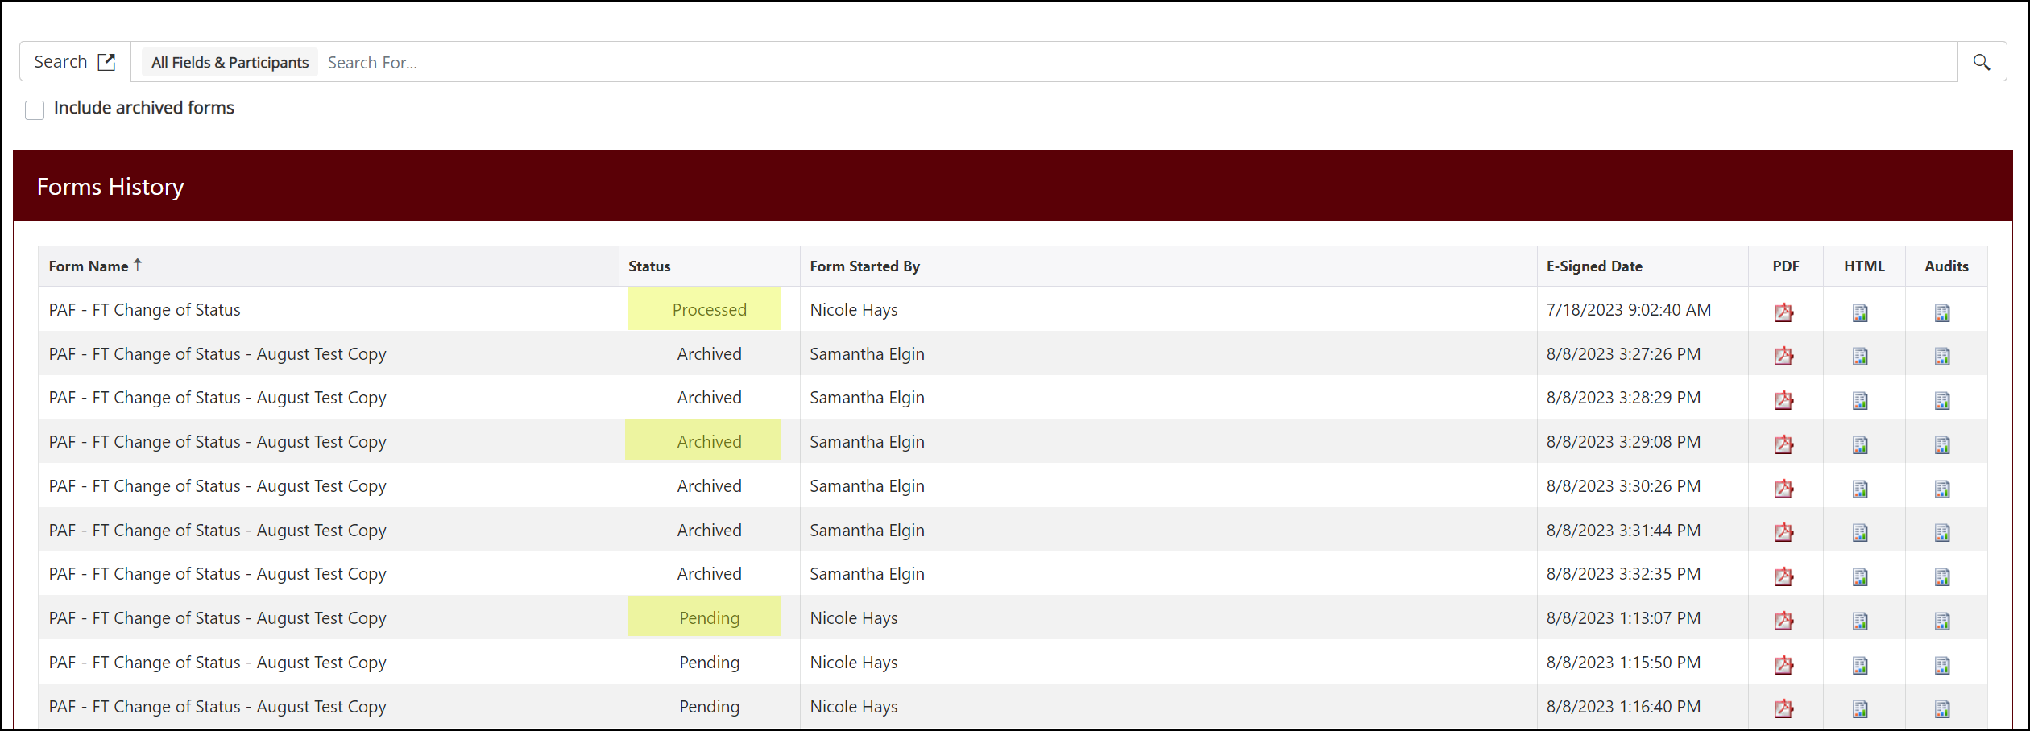
You may use the column headers to click and sort your forms, or you may use the search text field. You may also click on the “Search” field to display a “Search Filter” and then you have two choices:
- Search by Field Names – click in the empty box to select, then click inside search field for a drop-down list of all the form text fields that you can select to search; or
- Search by Participants – click in the empty box to select, then you can search by name of a participant of a form.

How to search:
- Click the Search option icon to display the Search Filter window:

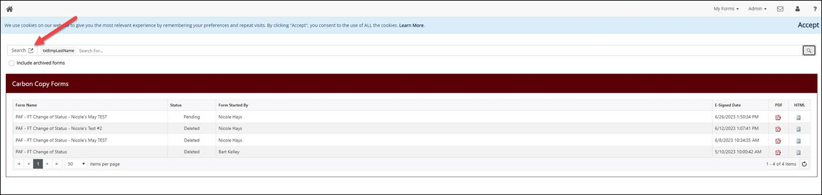

- Check the Search by Field Names box then enter the name of the field you want to search by then click the Apply button. For example: txtEmpLastName

(HR can provide the specific field name for any information on the form that you want to search by.)

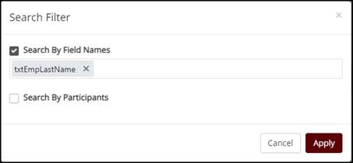
- Now enter the value you are searching for in the Search field and press the Enter key on your keyboard. The search is NOT case-sensitive. Now only the forms with that value in the field you selected will be displayed.

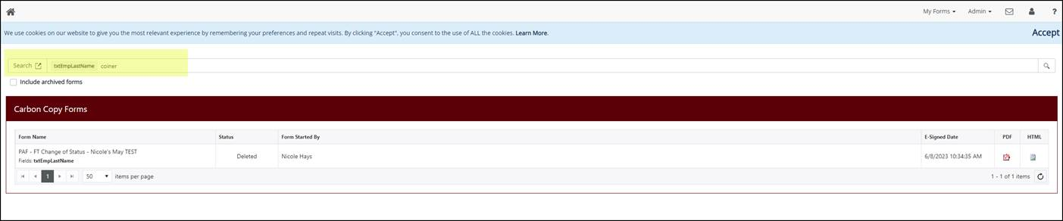

Obviously, over time this list will continue to grow and there might be more than one submission for a specific employee. In that case you should be able to identify the most recent submission by the E-Signed Date. HR does plan on regularly archiving the forms to keep the Admin screens from getting too cluttered and overwhelming. If you leave the Include archived forms box unchecked, this will help to reduce the number of form submissions returned by the search.

