Open Enrollment FAQs
Mo State Benefits | 2027 Plan Year
Open Enrollment runs November 1 through December 1, 2026. Elections made during this period generally take effect January 1, 2027.

Quick Links
- What is Open Enrollment?
- Who does this apply to?
- Do I need to complete Open Enrollment?
- When will my changes go into effect?
- Where can I find more information or share it with my decision-making partner?
- How do I begin the process?
- What if I need assistance or do not have computer access?
- Can I make changes during 2027 if I take no action now?
- What benefits can I change during Open Enrollment?
- Why does my wellness incentive credit not appear?
- What happens if I do not complete Open Enrollment?
- Can I save my elections and return later?
- When is the enrollment deadline?
- How do I confirm my enrollment is complete?
- Do recent new hires need to complete Open Enrollment?
- How do I remove a dependent?
- Can I change my Open Enrollment elections?

What is Open Enrollment?
- Open Enrollment is the annual period when eligible employees can elect, decline, or change medical, dental, vision, and cafeteria/flexible spending benefits for the upcoming calendar year. Flexible spending elections must be made annually. Voluntary benefit carriers may also offer guaranteed issue during this period, as determined by each carrier.
- For the 2027 benefits year, Open Enrollment runs November 1 through December 1, 2026.

Who does this apply to?
- Open Enrollment applies to all benefit-eligible employees.

Do I need to complete Open Enrollment?
- Yes. Even if you do not want to make changes, you should review your plans for accuracy, verify that your personal information is current, and check your beneficiaries.
- Cafeteria/flexible spending elections are completed separately from the Mo State online enrollment system and must be made every year.
- Enroll through ASIFlex: ASIFlex Enrollment


When will the changes I make go into effect?
- Elections or changes made during Open Enrollment will generally become effective January 1, 2027.

Where can I find more information or share information with my decision-making partner?
- Find benefit information on the Mo State Benefits website.
- Visit the Virtual Benefits Fair for benefits information to review with a decision-making partner. The fair is available during Open Enrollment, November 1 through December 1, 2026.


How do I begin the process?
- Log in to My Missouri State.
- Search for “benefits.”
- On the Benefits card, select Online Benefits Enrollment.

What if I need assistance or do not have computer access?
- Mo State partners with a benefits call center. Licensed benefits counselors are trained on Mo State benefits and can answer questions, discuss options, and assist with enrollment by phone.
- Call toll-free 877-282-0808 or locally at 417-836-3000, Monday through Friday, 7 a.m. to 4 p.m. Central Time.

Can I make changes during 2027 if I take no action now?
- Changes to medical, dental, vision, and cafeteria/flexible spending plans generally cannot be made outside Open Enrollment unless you experience a qualifying event. Requests must be submitted to Human Resources within 31 days of the qualifying event and require supporting documentation.
- Use the Qualifying Event Change Form or contact Human Resources for the current form and instructions.

What benefits can I change during Open Enrollment?
- Available changes depend on the plan and carrier rules. Review the plan materials and enrollment system for the options available to you.
- Voluntary benefits offering guaranteed issue for the 2027 plan year, if any, will be identified in current Open Enrollment materials.
- Medical — Add or decline coverage, change between the Base and Buy-Up plans, and add or remove covered dependents.
- Dental — Add or decline coverage and add or remove covered dependents.
- Vision — Add or decline coverage, change between available plan options, and add or remove covered dependents.
- Cafeteria/flexible spending plan — Elect pre-tax funds for eligible health care or dependent care expenses, and make eligible cafeteria plan elections. Enrollment is completed separately through ASIFlex.
- https://asiflex.com/MissouriState/Enrollment.aspx

- Accident insurance — Review available options for coverage, dependents, and beneficiaries, as permitted by the carrier.
- Critical illness insurance — Review available options for coverage, dependents, and beneficiaries, as permitted by the carrier.
- Identity protection — Review available coverage and dependent options, as permitted by the carrier.
- Universal or whole life insurance — Review available coverage, dependent options, and beneficiary options, as permitted by the carrier.
- Short-term disability — Review available coverage levels and election options, as permitted by the carrier.
- Hospital indemnity insurance — Review available coverage levels and dependent options, as permitted by the carrier.
- Supplemental term life insurance — Review available coverage levels, dependent coverage, and beneficiary options. Some increases or new elections may require medical underwriting.
- Employees currently purchasing supplemental term life insurance may increase coverage one benefit level without medical questions, provided the benefit level increase is not in excessive of $300,000 employee coverage during this year’s open enrollment.

- Benefit level equals salary multiplier; example: movement of 1x salary option to 2x salary option constitutes one benefit level.

- Requests to increase coverage more than 1 benefit level, increases exceeding $300,000 or requests to enroll in supplemental term life insurance when not previously participating, WILL require medical approval by UNUM before coverage will be in force.

- Employees currently purchasing supplemental dependent term life insurance may increase coverage one benefit level without medical questions, provided the benefit level increase is not in excessive of option 3 during this year’s open enrollment.

- Requests to increase coverage more than 1 benefit level, increases exceeding option 3 or requests to enroll in supplemental dependent term life insurance when not previously participating, WILL require medical approval by UNUM before coverage will be in force.

- **dependent children are not required to answer medical questions.

Important life insurance note: Requests to increase supplemental life insurance or enroll when not previously covered may require medical approval. Eligibility, guaranteed-issue limits, coverage maximums, and underwriting requirements are governed by the current carrier materials. Review those materials before submitting elections.
- Cafeteria/flexible spending enrollment: ASIFlex Enrollment

Why does my wellness incentive credit not appear?
- For the 2027 plan year, employees can qualify for the $30 monthly wellness incentive by completing two of the three qualifying activities: the assigned wellness course, a qualifying flu vaccination, and a biometric screening.
- The flu vaccination must be completed during the qualifying period of August 1 through December 1, 2026. Biometric screening must be completed during January 1 through December 1, 2026. Required documentation must be received and recorded by Magers Health and Wellness by December 1, 2026.
- The wellness course is assigned in November. Check the applicable wellness communications for completion instructions and deadlines.
- The incentive may not appear in the enrollment system during open enrollment. Wellness incentives are reconciled at the close of Open enrollment. Verify the applicable payroll deductions after the plan year begins. If the incentive is missing or appears incorrect, contact Human Resources at HRbenefits@missouristate.edu.
- For questions about screening records, vaccination documentation, or wellness activity credit, contact Magers Health and Wellness.

What happens if I take no action or do not complete Open Enrollment?
- If you do not complete Open Enrollment by December 1, 2026, most existing benefit elections will generally roll over, except cafeteria/flexible spending elections, which must be made annually. Flexible spending funds are subject to plan rules and deadlines; unused funds may be forfeited.
- Reviewing your elections helps reduce the risk of incorrect coverage, payroll deductions, or beneficiary information.

Can I stop at any point, save my elections, and return later?
- You may save your progress and return later. Be sure to complete and confirm your elections by 11:59 p.m. Central Time on December 1, 2026.

When is the deadline to complete my enrollment?
- The deadline is December 1, 2026, at 11:59 p.m. Central Time.
- Complete your elections early so you have time to review the confirmation, ask questions, or make corrections before the deadline.

How do I know my enrollment is complete and finalized?
- Proceed to the confirmation page and click Confirm/Sign. You must digitally sign to ensure your elections or changes are recorded.
- You should also receive a confirmation email from the enrollment system. (Keep this for your records)
- Cafeteria/flexible spending enrollment is separate. Enroll through ASIFlex Enrollment and look for a separate confirmation email from ASIFlex.

I am a recent new hire and already enrolled in my benefits. Do I still need to complete this process?
- Yes. Review your plans for accuracy, verify that your personal information is current, and check your beneficiaries.
- Cafeteria/flexible spending elections must be made annually through the separate ASIFlex enrollment process.
- ASIFlex Enrollment

How do I remove a dependent?
- In most cases, you do not need to remove someone from the dependent listing. The listing may show people who are available to cover under a plan or designate as beneficiaries.
- If a person should be completely removed from your record, such as after a divorce when they should no longer be a beneficiary, or following a death, contact Human Resources.
- If the person should no longer be covered under a benefit plan, continue through enrollment and make the appropriate election changes.
- If the coverage level changes, select the appropriate coverage level, such as Employee Only. If the coverage level does not change, use the edit/pencil option next to covered people to remove the dependent from that coverage, where available. (See Screenshots below)
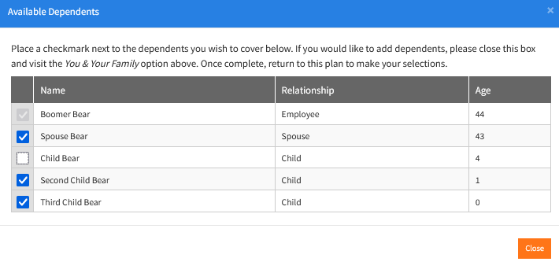
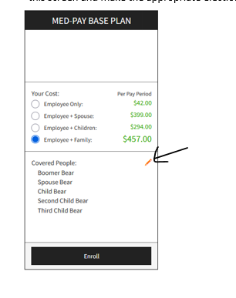

Can I change my Open Enrollment elections?
- You may make changes during the Open Enrollment period. The latest saved and confirmed elections submitted by the deadline will be used for the 2027 plan year.
- If your elections are locked after submission, select the Unlock option to make changes, if available. Be sure to save and digitally confirm your final elections before the deadline.
- Outside Open Enrollment, changes to medical, dental, vision, and cafeteria/flexible spending plans generally require a qualifying event. Submit the Qualifying Life Event Change Form to Human Resources within 31 days of the event and provide supporting documentation.
Please note: This FAQ is a general guide. Official plan documents and carrier provisions govern eligibility, coverage, and deadlines.

