Find the answers to these common questions:
  - What is Open Enrollment?
  - Who does this apply to?
  - Do I need to complete open enrollment?
  - When will the changes I make go into effect?
  - Where can I find more information or share information with my decision-making partner?
  - How do I begin the process?
  - What if I need assistance and/or I do not have computer access?
  - Will I be able to make changes during the year 2026 if I take no action now?
  - What benefit(s) does this apply and what kind of changes can I make?

Why doesn’t it appear that I have received my wellness incentive credit?
  - How do I remove a dependent?
  - Can I change my open enrollment elections?

What is Open Enrollment?
- Open enrollment is the annual period during which you can elect/decline/or make changes to your medical, dental, vision, and cafeteria/flexible spending plans for the upcoming calendar year. (Flexible spending elections must be elected annually). Additionally, voluntary benefit carriers may provide guarantee issue during this period as well (determined yearly by the carrier). Open enrollment for the 2026 benefits year will run from Nov. 1, 2025, through Dec. 1, 2025.

Who does this apply to?
- All benefit eligible employees.

Do I need to complete open enrollment?

Yes!

Even if you do not wish to make changes, you should complete open enrollment to review your plans for accuracy, verify your personal information is up to date, and make sure you have your beneficiaries updated.

Enrollment in the cafeteria plan is outside of the open enrollment system. Flexible spending elections must be made yearly. Enroll with ASIflex at: https://asiflex.com/MissouriState/Enrollment.aspx



When will the changes I make go into effect?
Any elections/changes you select during the open enrollment period will become effective Jan. 1, 2026.

Where can I find more information or share information with my decision-making partner?

Information about all benefits is housed on the Missouri State University benefits website. https://www.missouristate.edu/Human/benefits.aspx

Visit our Virtual benefit fair (running concurrent with Open enrollment Nov. 1, 2025 through Dec. 1, 2025) https://app.airbo.com/ard/missouri-state-university-benefits


How do I begin the process?
- Log in to My Missouri State
- Search "benefits"
- On the Benefits Card select Online Benefits Enrollment.

What if I need assistance and/or I do not have computer access?
- MSU partners with a benefit call center. Call center employees are licensed benefit counselors trained on Missouri State University benefits. Counselors can assist you with questions, make recommendations, and help you to enroll over the phone. Call toll free 877-282-0808 or local 417-836-3000, M-F; 7 a.m. to 4 p.m. (CST)

Will I be able to make changes during the year 2026 if I take no action now?
- Changes to medical, dental, vision, and cafeteria (flexible spending plans) cannot be made outside of open enrollment. Changes can only be made to these plans within 31 days of a qualifying event. Request for Qualifying event changes must be made to Human Resources and require the corresponding support documentation.
- Qualifying Event Change Form

What benefit(s) does this apply and what kind of changes can I make?
- Click on the links to find additional information.
- Voluntary benefits with guaranteed issue during this open enrollment are denoted with an asterisk *

  - Medical- add coverage, change plans (Base or Buy-up), add/delete dependents, decline coverage.

  - Dental- add coverage, add/delete dependents, decline coverage.

  - Vision- add coverage, change plans (Base or Premium), add/delete dependents, decline coverage.

  - Cafeteria/flexible spending plan- elect pre-tax funds to be utilized for known health or dependent care expenses, opt out of pre-tax deductions for medical, dental, vision premiums. Cafeteria plan elections are made outside of the Missouri State University open enrollment site and directly on the State of Missouri Cafeteria plan vender site. To enroll visit: https://asiflex.com/MissouriState/Enrollment.aspx


  - Accident insurance *- add coverage, add/delete dependents, decline coverage, update beneficiaries.

  - Critical insurance * - add coverage, add/delete dependents, decline coverage, update beneficiaries.

  - Identity Protection* - add coverage, add/delete dependents, decline coverage.

  - Supplemental Term life insurance - add coverage, add/delete dependents, increase/decrease coverage, decline coverage, update beneficiaries

- Employees currently purchasing supplemental term life insurance may increase coverage one benefit level without medical questions, proved the benefit level increase is not in excessive of $300,000 employee coverage during this year’s open enrollment.

- Benefit level equals salary multiplier; example: movement of 1x salary option to 2x salary option constitutes one benefit level.

- Requests to increase coverage more than 1 benefit level, increases exceeding $300,000 or requests to enroll in supplemental term life insurance when not previously participating, WILL require medical approval by UNUM before coverage will be in force.

- Employees currently purchasing supplemental dependent term life insurance may increase coverage one benefit level without medical questions, proved the benefit level increase is not in excessive of option 3 during this year’s open enrollment.

- Requests to increase coverage more than 1 benefit level, increases exceeding option 3 or requests to enroll in supplemental dependent term life insurance when not previously participating, WILL require medical approval by UNUM before coverage will be in force.

- **dependent children are not required to answer medical questions.

  - Universal/ Whole life insurance *- add coverage, increase/decrease coverage, add/delete dependents, decline coverage, update beneficiaries.

  - Short term disability *- add coverage, increase/decrease coverage level, decline coverage.

  - Hospital Indemnity insurance*- add coverage, increase/decrease coverage level, add/delete dependents, decline coverage.

Why doesn’t appear that I have received my wellness incentive credit?
- To receive the full $30 wellness incentive credit, you must complete 2 of 3 wellness incentive activities: flu vaccination ($15 credit), Biometric Screening ($15 credit) or “Did you know 2.0” questionnaire ($15 credit). Completion of all 3 is encouraged but max incentive is $30 monthly. Biometric screening and Flu vaccination records require documentation to be received by Magers Health and Wellness prior to Dec 1, 2025.
  - Employees unable to receive a flu vaccination due to disability, medical contraindication, or sincerely held religious belief can still qualify for the full $30 incentive by completing the biometric screening and the “Did You Know 2.0” questionnaire. No accommodation is required when the other 2 activities are completed.
- Verified documentation received by Magers prior to 10/24/2025 will have discounts loaded into the open enrollment system to reflect discounted rates.
- For individuals who complete the questionnaire or receive/submit vaccination documentation to Magers during open enrollment, email confirmation will be sent in later and will not be reflective in the open enrollment system.
- Employees should verify Medical and dental deductions on the December paycheck to verify the discount has been applied correctly. Contact HRbenefits@missouristate.edu immediately if the discount is not reflected accurately on that check.
  - Only Medical/Dental Changes are reflected on the December paycheck; all other benefit changes should be verified on the January paycheck.

What if I take no action/ Do not complete open enrollment?
- Failure to act or confirm your existing benefits or make changes by December 1 will result in a rollover of your previous benefit elections with the exception of cafeteria plan elections, which require re-enrollment annually (flexible spending funds are “use it or lose it”, benefits do not carry forward and must be utilized and reimbursement submitted by the plan deadlines). Failure to review benefits could result in incorrect benefit coverages, deduction amounts, or benefits paid to the wrong beneficiary.

Can I stop at any point, save my elections, and then return later to complete them?
- Yes
- Changes must be completed no later than 11:59 p.m. on December 1.

When is the deadline to complete my enrollment?
- December 1, 2025, at 11:59 p.m.
- It is strongly encouraged to complete your elections early during open enrollment so you can receive confirmation of your elections and have time to seek assistance or make changes if needed.

How do I know my enrollment is complete and finalized/ How do I know I have successfully completed my enrollment?
- By getting to the confirmation page and clicking on Confirm/Sign.
  - You must digitally sign at the completion of your enrollment or election changes will not be recorded/saved.
- You should also receive a confirmation email from the enrollment system.

Cafeteria/Flexible spending enrollment requires separate enrollment through https://asiflex.com/MissouriState/Enrollment.aspx and you will receive a separate confirmation email directly from ASIflex.

I am a recent new hire and already enrolled in my benefits. Do I still need to go through this process again?

Yes!

Even if you do not wish to make changes, you should complete open enrollment to review your plans for accuracy, verify your personal information is up to date, and make sure your beneficiaries are updated.

Enrollment in the cafeteria plan is outside of the open enrollment system. Flexible spending elections must be made yearly. https://asiflex.com/MissouriState/Enrollment.aspx

How do I remove a dependent?

In most cases, you do not need to remove the dependent from the dependent listing. It is just showing who is available and may either be covered on the plan OR listed as a beneficiary.

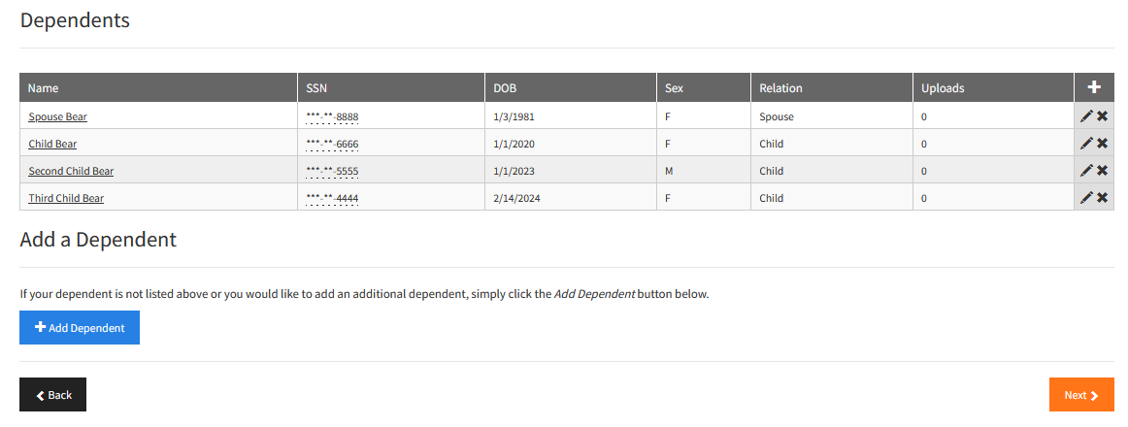

If the person should be completely removed (such as the case of divorce where you no longer want the person as a beneficiary or death), contact HR.

If the dependent is not to be listed as covered under the benefit plan, continue past this screen and make the appropriate election changes, outlined below:

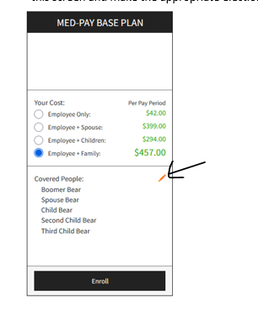

If the coverage election changes, select the appropriate coverage level (example: employee only); if the coverage election does not change, click on the pencil next to covered people and remove the dependent for whom coverage should not apply

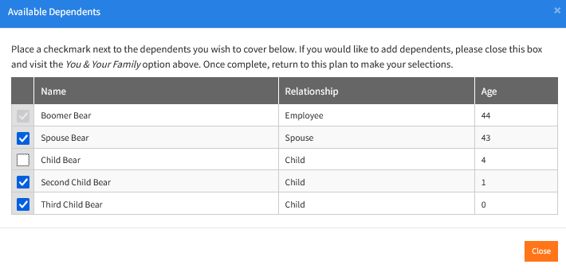

Can I change my open enrollment elections?
- During open enrollment, you may make changes. The last completed/Saved change will be utilized for the 2026 plan year.
- To make changes you will need to select the “unlock” button
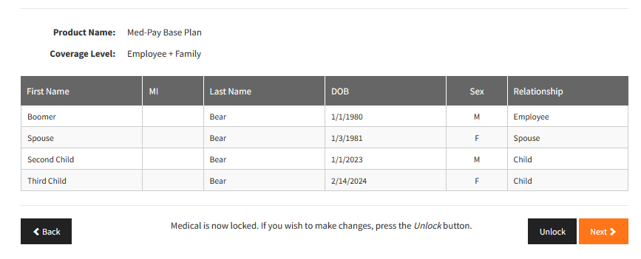

- Changes to medical, dental, vision, and cafeteria (flexible spending plans) cannot be made outside of open enrollment. Changes can only be made to these plans within 31 days of a qualifying event. Request for Qualifying event changes must be made to Human Resources and require the corresponding support documentation.
- Qualifying Event Change Form

