Frequently Asked Questions (FAQs)

1. How do I access the fee waiver system?
Answer
- Log-in to My Missouri State
- Search/Discover “ Fee Waiver Benefits”
- Credit Fee Waiver Request
2. Is there a deadline for submitting a few waiver request?
Answer
You can request a fee waiver up until the end of the term in which classes are taken (the day before graduation). Fee waivers will NOT be processed for previous terms. Requests should be made as early as possible to prevent processing issues. Also, requests must be made and processed prior to dropping a class.
3. I want to use the waiver for my child, spouse, sponsored dependent.
Answer
If this is the first time using the system you will need to add them as a recipient in the system. The recipient will need to have a BearPass M# to add them. They also need a university email and to complete a FERPA; see FAQ 7
4. When will my fee waiver and applicable fees be processed?
Answer
Fee waivers and applicable fees are processed at the end of the first week of class.
5. What if I dropped a class or cancelled and want to use the fee waiver again?
Answer
You'll receive an email stating the class was dropped or cancelled and will indicate if you have any available credit hours remaining. You can check the current balance screen to see the hour(s) added back on. Note: Credit hours are processed in whole increments and not in partial increments. Greenwood is an exception and 7.5 hrs are allowed per academic year.

6. I'm trying to complete a fee waiver for my student/child but the system said they needed to complete a "fee waiver FERPA request". What do I do?
Answer
- Make sure the student/child is added as a recipient.
- At the bottom of the Current Balance screen, click on Send Email next to the student/child name.
- Send an email requesting they sign a FERPA Waiver Agreement.
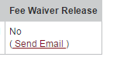
OR
For the Springfield campus - the student, your child, can go to the electronic contract page and simply check that the release is signed.
- Have the student log into My Missouri State portal.
- Access the Profile tab.
In addition the student/child may or will need to set up an email address as a regular MSU student. create email
Click Review Online Agreements.
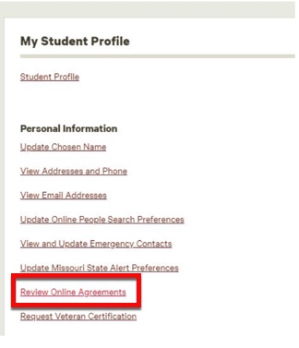
- Scroll down to Fee Waiver FERPA Agreement. Click on Agreement.
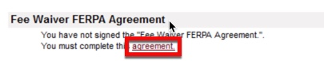
For the West Plains campus:
To Log into the Faculty/Staff Fee Waiver FERPA release form follow these directions:
- Log into http://mygrizzlyden.missouristate.edu using your Bearpass ID
- Click on the Fee Waiver FERPA Release Form under Student Resources section of the My Enrollment tab.
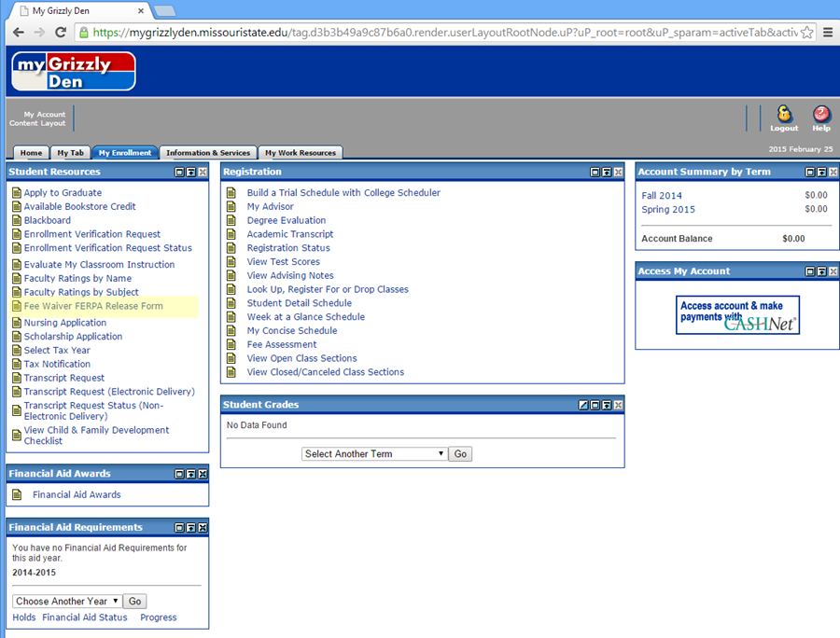

- Please read the Release of Confidential Information statement and choose "Yes, I agree with the above release." and click Submit.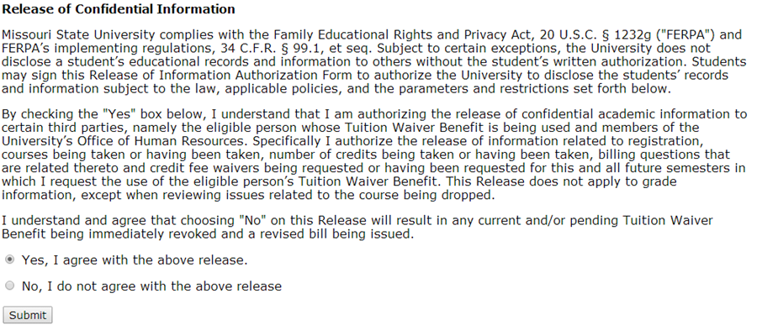
Please Note: Greenwood students do not have to complete a release.
7. I’m retired (Emeritus) and want to use the fee waiver for my spouse or children. This wasn’t a problem on the old system. The new system doesn’t give me an option on the pull down menu. What do I do?
Answer
You’ll need to add the spouse and or children as recipients first. The recipients of retired spouses and children weren't carried over on the new system.
8. I'm a Per Course Instructor at the Springfield Campus. Can I use the fee waiver?
Answer
Per Course instructors, other than those from the West Plain Campus, are not eligible for the fee waiver.
9. Does the fee waiver cover MSU’s cooperative program with the University of Missouri Columbia and Missouri University of Science and Technology.
Answer
Yes, it covers charges billed through MSU as a part of this program
10. New employee starts work on October 1st. The new employee’s dependent child started classes on August 18. Is the new employee eligible to use the fee waiver?
Answer
No, the employee handbook states that in order for the University to pay the required student fee, employees must be employed by the University prior to the start of the semester for which they have enrolled and intend to use the fee waiver benefit.

11. Are part-time employees whose status changes to full time during the semester eligible for the fee waiver?
Answer
No, they would have to be full time at the beginning of the semester.
12. Does the fee waiver cover the SOAR program?
Answer
No.
13. When are intersession classes paid?
Answer
They are posted after the first week of classes. For example, if classes start on Monday, the payment will be posted on the Friday of the same week.
14. If an individual is a retired staff/faculty and is a dual credit instructor are they eligible to use both benefits for themselves?
Answer
Yes, the total hours for themselves would be 8 (5 per term for retired staff/faculty and 3 per academic year for dual credit).
15. Can I apply for the fee waiver to a dropped class?
Answer
Only if the fee waiver was requested and applied prior to the student dropping the class.

For additional questions about Course Fee Waivers please contact hrbenefits@missouristate.edu

