MISSOURI STATE UNIVERSITY
Banner finance

TRAINING MANUAL

U-Link

Financial Services
901 S National Avenue
Carrington Hall - Room 113/119/424
Springfield MO-65897
BannerFinance@MissouriState.edu

Project website: http://www.missouristate.edu/ulink/
Financial Services: http://www.missouristate.edu/financialservices/BannerFinance.htm
Documentation: http://experts.missouristate.edu
Helpdesk: http://helpdesk.missouristate.edu/
Revised: May 28th 2008

Banner Finance training agenda
- MXXXXXXXX number & SSB PIN
- Introduction to new Budget Numbers PowerPoint and Handout
- Login into Banner Self-Service General Navigation
- Budget Query & Transfers Documentation
- Requisition Documentation
- Approve Documents Documentation
- View Completed Documents Documentation
- Helpdesk guide Handout and Web help
- 15 minutes Q & A session
Introduction to FOAPAL:
- Introduction to FUND ORGANIZATION ACCOUNT PROGRAM (FOAPAL) See Handout
Budget Querying
- This section will cover the basics of using Self-Service banner querying tools to retrieve Budget Information.
- Budget transfers
Requisition:
- Code lookup features
- Vendor querying and address defaults
- Additional Document Text Information
- Using existing templates and creating new templates
- Thresholds and procedural rules and regulations
Approving Documents:
- Approving documents
- Viewing documents requiring approval in future
View Documents:
- Viewing documents previously entered by user
- Completed Requisitions, Purchase Order’s and Invoice Information
Viewing documents- Banner Xtender Solutions
- Viewing documents within SSB
- view documents outside of SSB using Banner Xtender Solutions http://ct.missouristate.edu/appxtender/

Helpdesk tools and additional support information
Question & Answer session: 15 Minutes

Table of Contents

- Chart of Accounts
- Based On Budget
- Based On Activity
- New Account Request Form and Procedures

- New Budget Numbers
- Current Budget Numbers – New Budget Numbers
- FOAPAL – Fund/Organization/Account/Program/Activity/Location

- BUDGET Information
- Budget Status report
- Querying for Budget reports
- View available budget

- Procurement Processing
- Requisition Process
- Payment Request Process
- View completed Banner Documents

- Approvals Processing
- Viewing Documents Awaiting Approval
- Viewing Banner Documents

- Banner Xtender Solutions – Imaging
- Viewing Invoices
- Viewing Banner Documents

CHART OF ACCOUNTS
Fund Organization Account Program Activity Location (FOAPAL) Examples
FUND | Identifies a set of self-balancing accounts and identifies hierarchical ownership by Cost Center. | General Operating  Income Accounts  Auxiliary Accounts  Grants and Contracts
ORGANIZATION | Identifies a unit of Budgetary responsibility within an Institution. It defines “who” spends the money. The organization unit responsible for financial activity within the fund or grant code. “Org” is your department, hierarchical by Cost Center. | President  Provost  Colleges  Departments
ACCOUNT | This code identifies objects, such as the general ledger accounts and operating ledger accounts. For example Income, Expenditures and Transfers. Classifies revenues and expenditures by type and spending categories. Revenue account codes are codes for the types of revenue received, such as tuition or auxiliary sales revenue. Expenditure account codes are codes for the types of expenditure, such as salaries or supplies. | Sales & Service  Salaries  Services  Furniture & Fixtures (>5K)
PROGRAM | Identifies a function and enables the institution to establish a method of classifying transactions across organizations and accounts. The major purpose of expenditures. Program codes accumulate expenditure information into major categories such as instruction, research, and academic support. | Revenue  Instruction  Research  Academic Support  Auxiliary Revenue & Expenses
Activity | Is used to further define an object of expenditure Information for a specific event or major activity. Activity codes are assigned to transactions that are funded or shared by more than one organization.  Not all FOAPALs have an Activity. | Will be used as needed
Location | Is primarily used by the Fixed Asset Module The physical location of an asset being purchased.  Not all FOAPALs have a location. | Will be used as needed

- You will see references to ‘FOAPAL’ which is the acronym for the entire accounting string. The “FOAP” are required fields for every Expense transaction in Banner .The A which stands for Activity and L for Location will be used on an as needed basis.

- If you feel an error has been made, please e-mail us at BannerFinance@MissouriState.edu . As a general rule, with few exceptions, no changes are allowed. However, we can advise you on how to resolve or address your concerns.

- To request new accounts, please fill out a New Account Request Form. All documentation will be available either through the U-Link Website or through the Financial Services Banner webpage.

NOTES

Budget Status Reports
There are three methods of looking at Budget information in Self-Service Banner
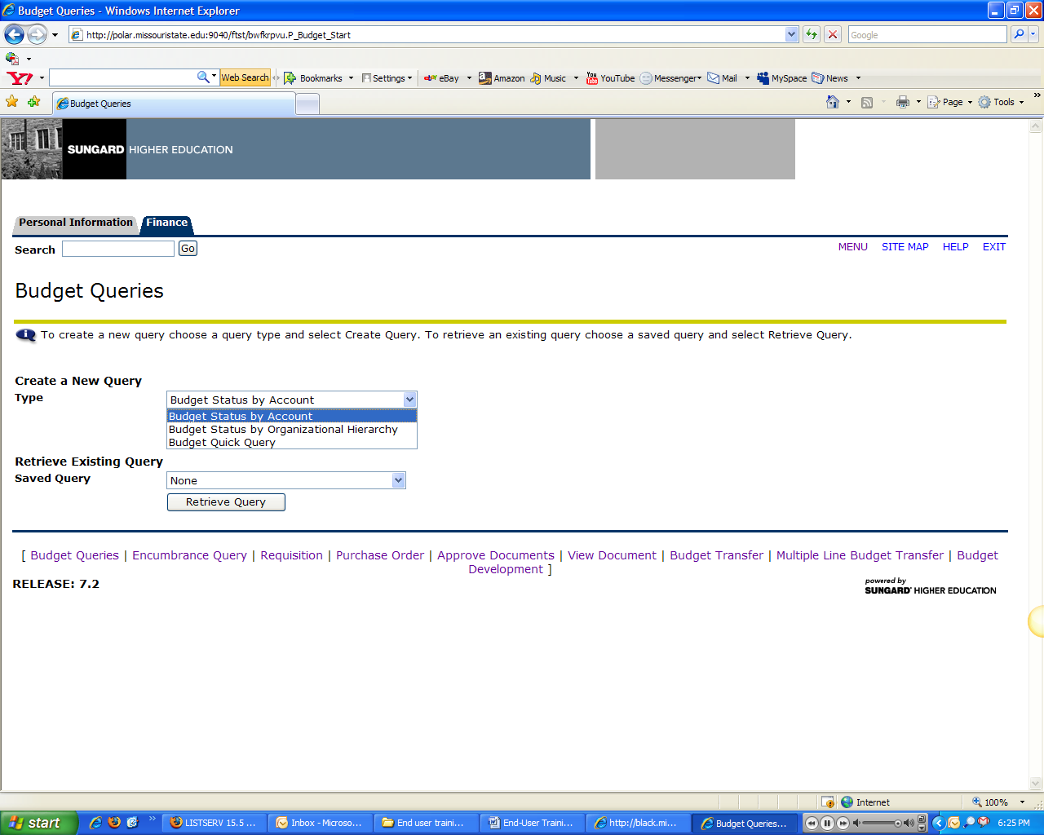
- Budget Status by Account:
Enter Organization code and Submit to view Budget information.
- Budget Status by Organizational Hierarchy:
The Organizational hierarchy report allows for roll up information. View access is determined by Fund/Org security or authority. For example, 010 represents the Presidents Rollup, all areas under him will roll up to this Org code which is 010. The president will be able to view all budget and transaction information under this org code.

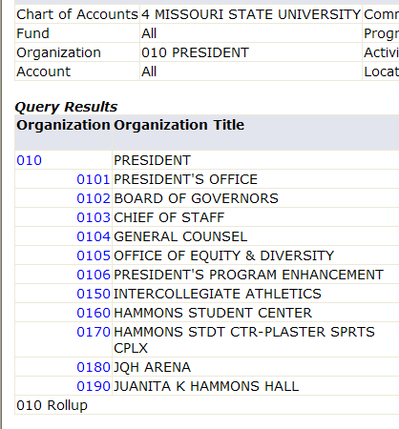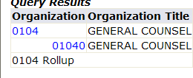
- Budget Quick Query:
The Budget quick query does not allow for drill down information. To access transaction information directly, enter Org code and click submit.
PROCEDURES:
- Budget transfer to and from Salaries & Wages accounts are not allowed.
- Transfer within the general Operating fund is permitted. The general operating for Springfield is A02000.
- Budget Transfers can be done only to and from Budgets for which you have Fund/Org authority over. For transfer between funds or transfers to and from Budgets which you do not have authority over contact your cost centers budget officer or budget analyst.
- While making a transfer, only a Temporary budget adjustment is allowed. For a permanent budget adjustment, please contact your budget officer or analyst.

RULES AND REGULATIONS FOR PROCESSING UNIVERSITY PURCHASES

Procurement Services: (Carrington 106)

- Requisitions

- Requisitions will be completed by following the suggested template. Commodity/Service codes will be required.
- All Requisitions will be processed by the Office of Procurement Services. Those personnel that have current purchasing authority will have authority to enter requisitions against their budget through Self-Service Banner.
- Requisitions will be entered for all purchases to be processed by the office of Procurement Services will process. Purchase Orders will be created and e-mailed to the departments instead of the pink copy.
After commodity is received, departments will verify the contents, quantity, and condition of the delivery, and will sign on e-mailed copy of PO and return copy of PO, two copies of Invoice, and Packing slip to Office of Procurement Services.
- P-cards should be utilized for purchases under the threshold except in those instances where the vendor will not accept a p-card in those situations where the department desires to immediately encumber the funds, and/or for larger or high dollar items where a purchase order is desirable for product tracking.
- Blanket Orders: All invoices that are to be paid against a blanket PO should be sent to the Office of Procurement Services. A copy of the PO must be attached to the Invoice, and a PO number must appear on the invoice. And a Requisition must be entered into Banner Self-Service as a request for additional funds.
- Disclaimer: Office of Procurement Services reserves the right to delay processing of Invoices that do not have a Financial Services/Banner generated form attached.

Financial Services - Accounts Payable: (Carrington 424)

- Payment Request:

- In such instances that a P-Card is not accepted by a vendor, and a purchase under the threshold has been made, a Payment Request form should be completed and forwarded to Financial Services Carrington Hall 113.

- For those purchases above the threshold that have been made without approval from the Office of Procurement Services, processing will be dependent on the situation the order was placed. Attach Invoice to Payment Request form and send to Financial Services, Carrington Hall 113.

- Disclaimer: Accounts Payable reserves the right to delay processing of Invoices that do not have a Financial Services/Banner generated form attached. Exceptions will be given to identified departments only.

Purchasing thresholds

Proposed Purchase Thresholds |  | PENDING BOARD APPROVAL | Current Thresholds
P-Card | $3,000.00 | PENDING BOARD APPROVAL | $999.00
Payment Request | $3,000.00 | PENDING BOARD APPROVAL | $750.00
Bid Review Threshold | $3,000-$10,000 | PENDING BOARD APPROVAL | $3,000.00
Bid Threshold | $10,000 & above | PENDING BOARD APPROVAL | $5,000.00

checklist for entering requisitions

SELF-SERVICE BANNER

Requisition
- Delivery date will not default. Enter or search for specific commodity code and click on Commodity Validate, associated description + lead time will appear. Calculate desired delivery date and change delivery date to reflect lead time.
- Search for Vendor and Validate after entering Vendor ID number
- Available Address types:
- PR – Permanent address type will default for all vendors
- Ship Code: the default for Ship code is STMA – Stores & Maintenance
- Attention To: Name of vendor contact, if known
- Comments: add additional comments, if sending Requisition for Additional Funds, mention this in the comments field.
- Document text - entering document text is required
- Copy and paste the following template into Document Text and enter additional information
Commodity Detail
- Name of Item:
- Key Description:
- Product/Service Specification:
- Manufacturer Name & Product Number:
- Distributor Catalog Number:
- Quantity per Case:
- Ordered for:
- Enter Clause, choose any one
  - If available, ship to receive prior to:
  - Do not ship to receive prior to:
- Shipping Information:
- Confirm/Coordinate Delivery With:
Missouri State University
Receiving Department
901 S National Avenue
Springfield, MO 65897
417.836.5776
- Confirm/Coordinate Delivery With:
Missouri State University West Plains Campus
Receiving Dock
218 West Broadway
West Plains, MO 65775
417.255.7268
After Entering above information in Document Text, click SAVE to save text to Requisition.
- FOAPAL information is required.
- The Accounting Column has to be divided up if there are multiple FOAPAL’s being charged
  - If there is one budget being charged with the entire amount of the Commodity, the accounting field must state 100, when the Percent radio button is selected.
  - If there are two FOAPAL’s being shared equally, then the accounting field must state 50 against each FOAPAL.
- It is not necessary to enter the Activity and Location.
- Click on validate to ensure there are no errors in the document.
- To save Template, enter name in field, SAVE TEMPLATE AS:
- Click on COMPLETE to complete Document and save Template.

PURCHASING OFFICE/COMPUTER EQUIPMENT:
  - Go to http://helpdesk.missouristate.edu/gethardware/recommend/
  - Highlight everything under Specifications:
  - Copy and paste entire specification into Document Text under Commodity Detail
  - Copy and paste E-quote number also under Document Text and SAVE
    - This is essential for quick processing of the requisition. Requisitions that do not have this information will be processed as time permits.

REQUEST FOR ADDITIONAL FUNDS
- Enter same information as stated above under Requisition and follow below:
- In the Comments Field enter : additional Funds needed with current Purchase Order number
- While sending supporting documentation, attach copy of Requisition or Purchase Order

NOTES

Banner Xtender Solutions
There are two methods of accessing Banner Xtender Solutions (Imaging)
    - While viewing an Invoice in Self-Service Banner
    - Enter http://ct.missouristate.edu/appxtender and select BXSPROD to view documents after July 1, 2008
    - To view documents in the training instance, select BXSUTRAIN

- Webxtender can be invoked through Self-Service Banner.
- View supporting documentation through the Invoice view in Self-Service Banner.
- Click on and chose type of document (Invoice) from the drop-down menu and enter Invoice number if known, otherwise chose type of document as requisition and enter Requisition number to query to Invoice information.
Accessing images through WebXtender
- Enter http://ct.missouristate.edu/appxtender
- Select BXSPROD, after July 1 or BXSUTRAIN for practicing.
- BXSUTRAIN should appear with a list of folders
- Navigate to
- Right click on the folder, 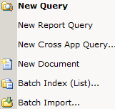
- A drop down menu will pop up, from this menu select
- A search page will appear prompting for a search value under Document ID.
- Under search value , enter the Invoice number or search against any of the Index name fields
- For viewing documentation as of July 1, search for Banner Invoice number which will appear on the view documents link under Invoice.
- Viewing scanned documents:
  - A toolbar that has additional functions can be accessed. Please review the extended guide on the website for more information.
  - Online help functions may be accessed by clicking on the

  - Logout of Webxtender, click on the File menu and Logout

