New Finance User Resources

If you are new to Banner Finance, this article will help you find most of the information you will need. We will continue to update this article to reflect any changes.

- Access Control - FOAPAL Authorization - All access to University and Foundation Finance data is based on the Fund/Organization (Budget) Access that has been authorized/established for an individual. Dependent upon the Fund/Organization access in place, an individual may view associated budget information, originate purchase requisitions against associated budgets, approve or disapprove purchase requisitions created by others, or perform authorized budget transfers.

- To request “Approver” access, submit a FOAPAL - Approver Access Request. This form can be used to replace approver access.

- To request “Originator” or “View Only” access once approver access is established, submit FOAPAL - Originator/View Access Request. (This is an automated process where Financial Services staff are not involved, once your request is submitted, budget (fund-org) approver will get an email notification asking them to log into the system to act on your request (either approve or deny). Once the approver approves your request, you will get Fund/Organization Access immediately.)

Fund-Org access (view, originator, or approver) does not grant your Argos Finance access; the next session covers how to get Argos Access. It does not grant your PAF access either as HR controls PAF access. This fund-org access is not related to P-Card access, you need to contact Procurement Service for P-Card related access.

Fund/Organization Access (Budget) request can also be submitted through Budgets Channel under Work Resources tab:
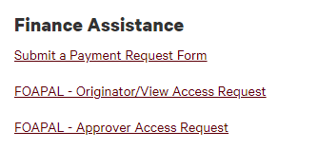
- To remove access, please send the email request to BannerFinance@MissouriState.edu.

- Finance Dashboard & Training Resources – Finance Dashboard (Self-Service Banner-SSB) is available to authorized university finance users only. Dashboard allows department users to review and manage their authorized budgets as well as initiate and approve requisitions for purchases to be charged against their budgets. The Finance Dashboard features resources available to departmental users who process purchases and monitor the budgeted balance available for those purchases.

Finance Dashboard (Self‐ Service Banner 9): Creating and approving requisitions & purchase orders (West Plains only), checking available balance, managing budget transfers, and viewing documents.
Finance Dashboard user guides can be access from this page: https://www.missouristate.edu/FinancialServices/banner‐training‐guides.htm

Legacy Finance Self‐Service* (Self‐ Service Banner 8): Grant Comparison Queries and View Documents.

*We are keeping the legacy finance self‐ services for grant comparison queries and the view document functions because there are some missing features from those two functions in SSB9. We are continuingly working with Banner Support for those issues and hope they can be resolved soon.

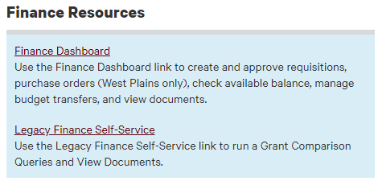

- Argos Bear Finance Access – You must have Argos finance access before you can run any of Bear Finance reports and Argos Finance access is granted separately from Fund-Org access and is not controlled by Financial Services. When a user is granted Fund/Organization (Budget) access (Approver, Originator or View) by Finance Services, that does not give them access to run Argos Finance Report.
To request for Argos Finance access, user MUST send an email to informationsecurity@MissouriState.edu to request access.

Tips for running an Argos Report: If you run ODSPROD report, you will need to use your ODSPROD password; if you run PROD report, you will need your PROD password. Your User ID is usually the first letter of your first name followed by your full last name for both ODSPROD and PROD. Go to cams.missouristate.edu to reset your database password if you do not remember it. If your ODSPROD/PROD account is locked, please contact the Information Security Office at informationsecurity@MissouriState.edu only they can unlock your account.

Link to Bear Finance reports: https://www.missouristate.edu/FinancialServices/bear-finance.htm

- Fund - Organization (Budget) Access Report – Fund and Organization (Budget) Access Reports are designed to provide fund and organization access and approver information for both University and Foundation charts to authorized individuals who help manage this access. All users with Finance (fund-org) access should be able to run these reports and if you run into any issues or questions when running them, please email us at BannerFinance@missouristate.edu.

Location of the reports:
https://www.missouristate.edu/FinancialServices/fund-and-organization.htm
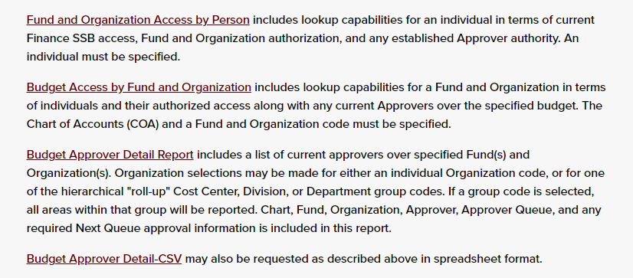

- Chart of Accounts

Understanding our Chart of Accounts helps in reviewing and processing transactions on SSB and Administrative Banner. https://apps.missouristate.edu/financialservices/BannerFinance/Understanding_Chart_of_Accounts.pdf

University Chart of Accounts
https://www.missouristate.edu/FinancialServices/chart-of-accounts-chart-u.htm

Foundation Chart of Accounts
https://www.missouristate.edu/FinancialServices/chart-of-accounts-chart-f.htm

- University and Foundation Reports - Reports are designed to reflect departmental budget and actual activity based on the type of fund category being reported. Any information returned is based on authorized Fund/Organization access.
University Departmental Reports
https://www.missouristate.edu/FinancialServices/university-departmental-reports.htm

Foundation Reports
https://www.missouristate.edu/FinancialServices/foundation-reports.htm

- You Cost Center Budget Analyst - Your Analyst serves as your primary point of contact for your cost center. Analysts help with budget tracking, developing, and maintaining efficient accounting processes including internal billings and budget/expense transfers and provide effective communication of processes between financial services and the cost center. Analysts are available for specific policy and procedural questions about all Accounting and Budgeting processes.
https://www.missouristate.edu/financialservices/yourbudgetanalyst.htm

- Accounting Best Practices for departments: https://www.missouristate.edu/FinancialServices/accounting-best-practices.htm

Other Finance Related Resources

- Transact CASHNet storefront – Transact Payments (CASHNet) is the University’s online payment system and there is no cost to University Departments for utilizing this service. Storefronts help reduce cash flow at the departments and provide fast, easy, and convenient ways for departments across campus to collect funds for various approved items. A Storefront provides secure and easy online collection points for departments and can handle credit cards and electronic checks. Reports, notification of payment, overnight automatic posting to the ledger, design tailored to your website specifications are all capabilities of Storefronts.

- To request new storefront, please submit a Storefront Request Form. Requests must be approved (electronically signed) by all parties including VP/Dean/Provost and Internal Auditor before Financial Services can start work on them. Request form can also be accessed from Bursar’s page here: https://www.missouristate.edu/Bursar/Transact/default.htm

- To request to update existing storefront items, please email us at BannerFinance@Missouristate.edu. Please always provide us with the original URL that we sent to you or staff from your office, which helps us locate your storefront item faster.

- Dynamic Forms ‐ Dynamic Forms is a new system used to build online forms which allows us to collect signature/approval electronically. It reduces the use of paper and makes form flow faster, securer and more efficient compared to the traditional use of campus mail. However, Dynamic Forms is a separate system outside of Banner. Examples of forms currently in use are Payment Request Form, FOAPAL Authorization ‐ Approver Request, Storefront Request Form and Foundation Fund Transfer Request

- Financial Service Blog - Subscribe Financial Servicers blog to receive important notices or monthly posts regarding fiscal period closing, Payroll recasting from Financial Services.

- New FOAPAL Request - Please contact your Cost Center Budget Analyst for request of new FOAPAL (Fund, Organization, Account, Program, Activity and Location) element.

- BDM ‐ Banner Document Management is a Banner document storage system. It stores all the back up for financial documents such as Journal Voucher, Purchase Order, Invoice and Check. The BDM system has Fund‐Organization security so department users can only view documents for which they have Fund‐Organization access.

- Administrative Banner ‐ Admin Banner is Missouri State University's centralized academic and administrative records system. Chrome and Firefox are recommended, while Internet Explorer is not recommended. Admin Banner requires multi‐factor authentication to log in. Administrative Banner is accessed through My Missouri State under the Work Resources tab. If you have questions about security and access or have additional access needs, contact InformationSecurity@MissouriState.edu.

If you have any other Finance Related question, please contact us at BannerFinance@MissouriState.edu.

