Brightspace: Grading after Making Changing to Quiz Questions
Changes to quiz questions—such as scoring or grading method updates—only affect future quiz attempts. Edits do not apply to attempts that are already completed or currently in progress. Each learner’s previous attempt reflects the quiz content and scoring exactly as it appeared when they began the quiz.
To update the grades of learners with existing attempts you can choose to update attempts for all learners for the edited question or update them individually.

To update all attempts for a single question:
- Navigate to Assessments from the course menu and select Quizzes from the list of options.
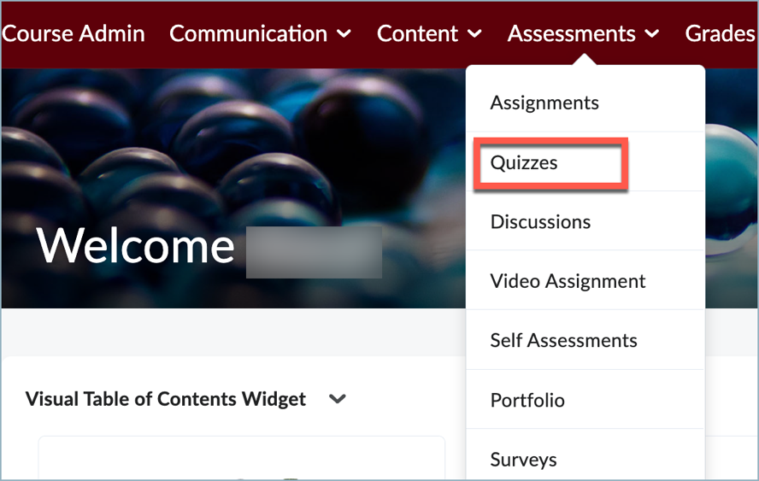
- Locate the quiz and from the Actions drop down menu of the quiz you have edited, select Grade.
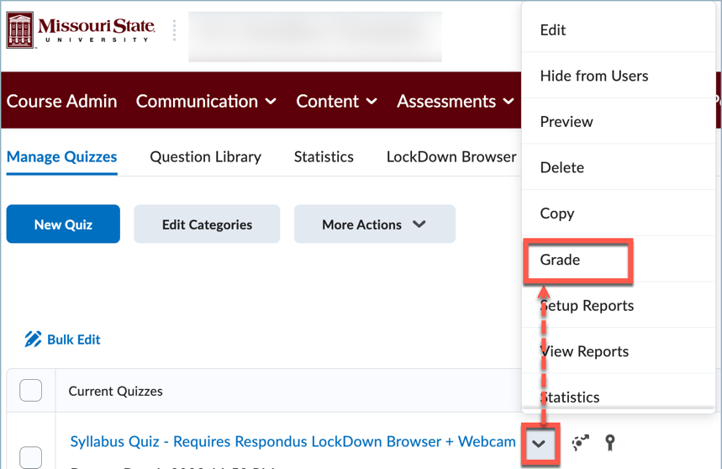
- Select the Questions tab. Choose the Update all Attempts option.
- Next under the section "Questions that are not in the quiz anymore" select the edited quiz question.
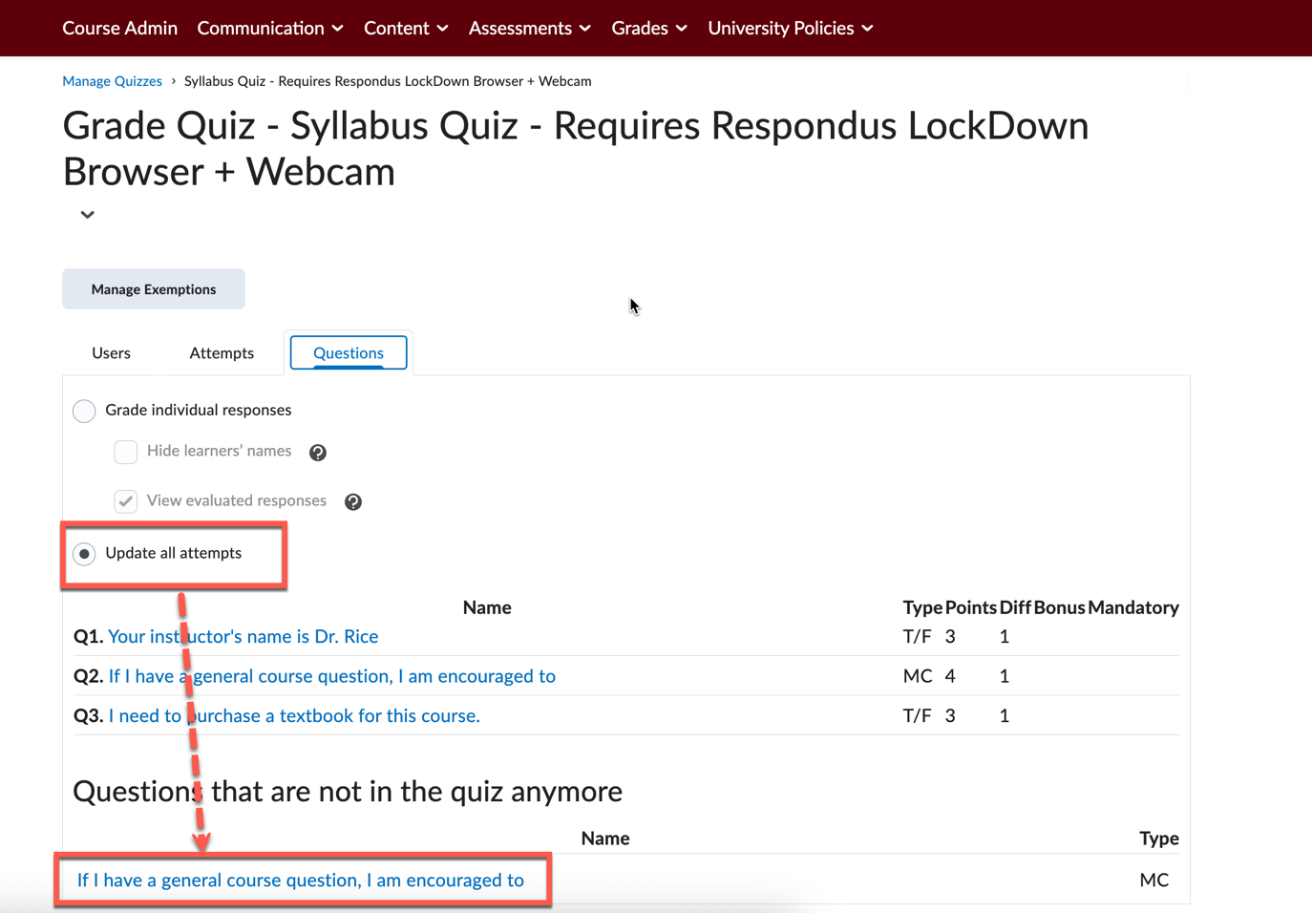
- Under Grading Type
  - enter the point value you wish to award to all learners who would have missed points prior to the change, or
  - enter the point value you wish to award to those with a specific answer.
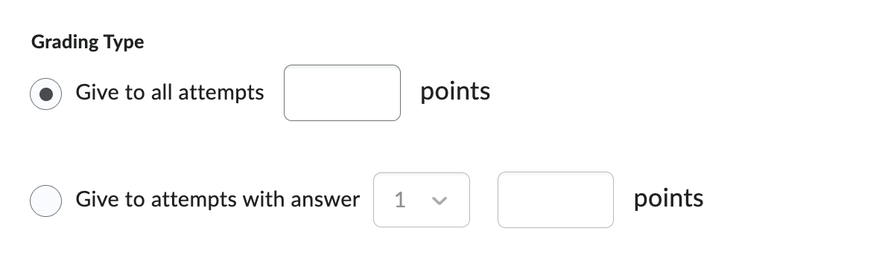
- Select Save and then select the Go Back to Questions button to return to the quiz questions tab.

