INDIVIDUALIZED SUSTAINABILITY MAJOR

Are you passionate about sustainability? Are you looking for a degree that will allow you to work with faculty from multiple academic departments to give you a well-rounded knowledge base and skill set to address environmental, social, and economic sustainability issues for our wellbeing and that of future generations? Then consider an Individualized Sustainability Major at MSU. The new major allows students to work with dedicated sustainability-focused faculty from various academic departments to develop a customized course plan to fit your future career goals.

For more information about the Individualized Sustainability degree process and requirements, contact:
Amy Aufdembrink
Assistant Director for Interdisciplinary Studies
amymarieaufdembrink@missouristate.edu
417/836-5258
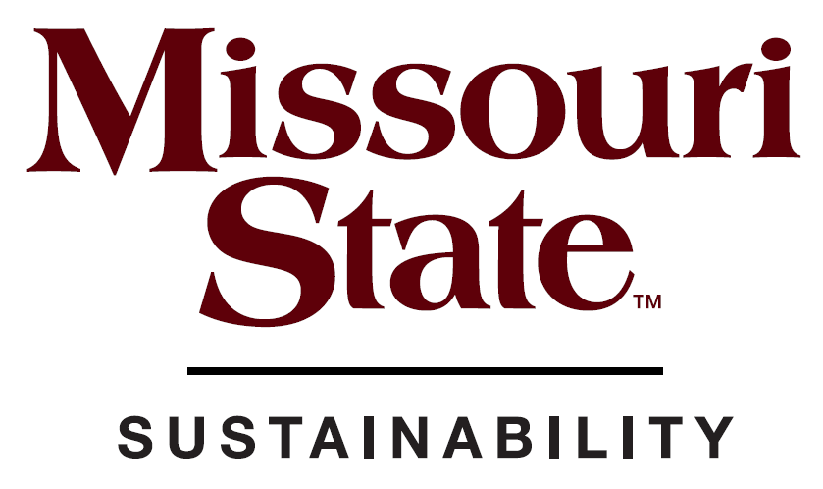
Doug Neidigh
Sustainability Coordinator
Neidigh2009@missouristate.edu
417-836-8729
www.missouristate.edu/sustainability

.

