Missouri State University

Strategic Enrollment Management (SEM) Plan for Student Success

2020-2026



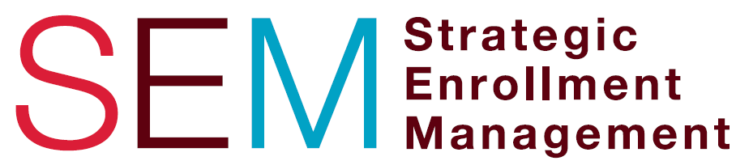

Situational Analysis: The Case for a SEM Plan

The University has experienced growth in undergraduate enrollment over the past 20 years but that growth plateaued in 2017. This fact along with projections that high school graduations will decline over the next 5-10 years led us to investigate a SEM plan. “[Strategic] Enrollment management is a comprehensive and coordinated process that enables a college to identify enrollment goals that are allied with its mission, its strategic plan, its environment, and its resources, and to reach those goals through the effective integration of administrative processes, student services, curriculum planning, and market analysis.” Also, strategic enrollment management includes the areas of recruitment (including outreach), retention, research, and structure. Projected enrollment for fall 2020 prior to the pandemic was a new loss of approximately 834 undergraduate degree-seeking students. After the campus closed in spring 2020 due to the pandemic and the university began planning for fall, expectations based on national survey data were that enrollment could be down closer to 1,200 to 1,500 students overall. However, fall 2020 overall enrollment was flat, even with a small increase, in spite of the pre- and post-pandemic projections. Student headcount from 2011 through 2020 is noted in Figure 1.

Figure 1 – Fall 2011 to Fall 2020 Enrollment (Student Headcount)

Of the university’s total enrollment, those students pursuing undergraduate degrees has shown a decline since 2017. In fall 2020, the total headcount for degree seeking students was 15,714 down from 16,205 in 2019. However, the rate of the decline from fall 2019 to fall 2020 shrunk to -3.1% as opposed to the -4.3% decline the previous comparison years (see Figure 2).

Figure 2 – Undergraduate Degree Seeking Students (Headcount)

Graduate student enrollment, on the other hand, has been steadily increasing over the past four years as noted in Figure 3. Total student headcount for graduate enrollment in fall 2020 rose to 3,985 (a record enrollment of graduate students), compared to 3,815 in 2019.

Figure 3 – Fall 2011 to Fall 2020 Graduate Enrollment (Student Headcount)

The University has also seen growth in dual credit students (high school students who take college level credit) noted in Figure 4. The 18% growth in enrollment from fall 2018 to fall 2019 was a significant factor in helping reduce the decline in overall enrollment that year. The increase again in fall 2020 certainly helped to maintain enrollment levels equal to last year despite the impact of the pandemic.

Figure 4 – Dual Credit Enrollment at the Springfield Campus

Meanwhile, the university’s overall first to second year retention rate for first-time new in college students has remained flat for the last five years up to fall 2019 (see Figure 5). However, the fall 2019 to fall 2020 first to second year overall retention rate for first-time new in college students rose to 79.2%.

Figure 5 – Undergraduate Retention Rate by Specified Group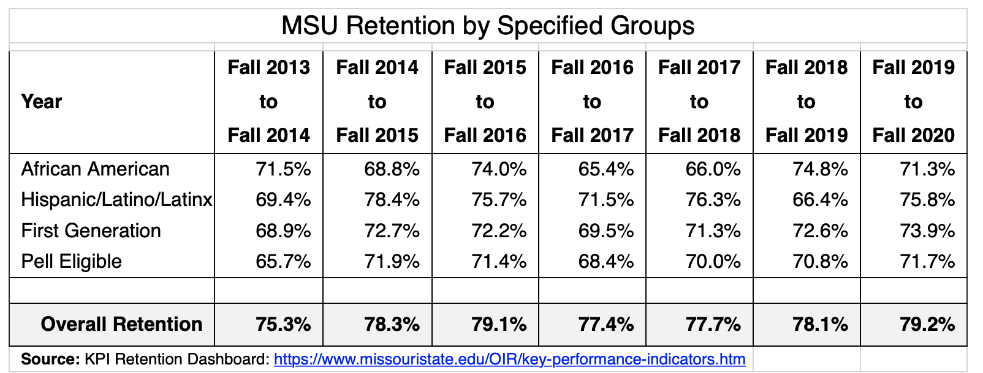

Taking into consideration external factors, the direct from high school market shows no signs of growth from within the state of Missouri as noted in Figure 6. Another external factor is transfer students from Missouri community colleges. The enrollment in area community colleges has been declining for the past 5 years.

Figure 6 – Projected MO High School Graduates

While enrollment size remains important to institutional health and the well-being of the communities we serve, enrollment mix does as well. It is imperative and consistent with the mission of the University to support the enrollment and retention of students from underserved populations, such as African American, Hispanic/Latino/Latinx, first-generation and Pell eligible students. Like overall headcount, enrollment of underrepresented students has been overall increasing, with a small decline starting in 2017, but recovery to 3,300 students in fall 2020.

Figure 7 – Enrollment of Underrepresented Populations at MSU

In summary, fall 2020 overall enrollment remained relatively flat, first to second year retention of first time new in college students increased, and the total number of underrepresented students grew as well. Considering the many future internal and external challenges for higher education, a more strategic approach to future enrollment management planning is needed to ensure our recruitment, retention, and completion goals are addressed.

SEM Planning Overview
Missouri State University adopted a definition of strategic enrollment management that recognized the connection between the SEM Plan and the Long-Range Plan:
Strategic enrollment management is a concept and process that [through strategic planning of enrollments] enables the fulfillment of institutional mission and students’ educational goals.

This included viewing SEM within a larger planning process:

[Strategic] Enrollment management is a comprehensive and coordinated process that enables a college to identify enrollment goals that are allied with its mission, its strategic plan, its environment, and its resources, and to reach those goals through the effective integration of administrative processes, student services, curriculum planning, and market analysis.

The President and Administrative Council endorsed the development of a SEM plan through a campus wide effort, including administrative, faculty, staff, and student representation. Guiding principles were established to direct this work. These were:

- Stabilize enrollment short term
- Grow enrollment in targeted areas
- Improve retention
- Facilitate successful degree and credential completion
- Broaden access to underserved populations
- Identify new and emerging academic programing that meets student and workforce demands
- Equip students for successful career outcomes
- Employ actions and modify processes that eliminate barriers that impair student success
- Raise the profile of the University
- Develop a culture of enrollment growth among faculty, staff, and students

These principles grounded the SEM planning and directed the team towards the type of university we desire to be. The framework we utilized for establishing this SEM Plan is described in Figure 8.

Figure 8 – SEM Framework

A SEM Steering Committee with four councils were formed to carry out this work. This committee structure remained in place through March of 2020 when we paused for the pandemic. As we refocused to finish the work we not only decreased the number of goals but we decreased the working councils as we proceeded through the fall of 2020. This structure is described in Figure 9.

Figure 9 – SEM Plan Development Committee Structure

In addition to guiding principles, the SEM plan was grounded in evidence. An environmental scan captured both external and internal factors that influence enrollment and student success at the University. Enrollment trends, along with demographic data of projected high school graduates and college bound transfers, together tell a story about MSU that informs the development of four strategic enrollment goals. Strategic enrollment goals are intended to capture MSU’s desired future based on the University’s vision and long range plan and are informed by our environmental scan. Data will also be used to establish and measure the benchmarks that will be set within each of the enrollment goals.

Strategies are the means by which our enrollment goals will be achieved. These were developed through the four SEM Councils and approved by the SEM Steering Committee. Tactics, in support of our strategies, will be developed, or deployed when they already exist, by support units and colleges institution-wide. This is where support units find opportunities to collaborate, where colleges develop new programming and interdisciplinary studies and where support units and colleges come together to collaborate on student success initiatives. Given the operational nature of tactics, they will be developed, or identified where they already exist, upon final approval of the SEM Plan.

Enrollment Goals
The purpose of our SEM Plan is to provide a long-range outlook for student enrollment and student success. The intention of the plan is for the University to establish, achieve and maintain optimum enrollment, a balanced mix of desired students and higher rates of student success. However, it is challenging to now forecast changes that will undoubtedly occur in student needs and enrollment patterns due to the extraordinary disruption caused by the COVID-19 pandemic. The university has successfully made it through the fall 2020 semester by offering courses in a variety of modalities and we recognize the need to expand resources for increased online courses, programs, and services. As a result of the pandemic and the university beginning development of the next long range plan, our enrollment goals were streamlined and we have set 5-year benchmarks for our goals anticipating that additional data will continue to inform our planning during such unprecedented times.

The SEM Steering Committee, along with the four SEM councils, carried out the work of determining the strategic enrollment goals that would shape the enrollment future of the University. This work was further informed by those who participated in multiple opportunities for feedback (e.g., kickoff event, town hall meeting, volunteer involvement form) supported by senior leadership at regular intervals throughout the year. The enrollment goals include: outreach and recruitment; student retention and success; successful graduation and/or credential completion; and financial preparedness. The baseline for these goals will be fall 2020 for goals one and two, FY20 for goal three, and the 2019-20 academic year for goal four. While 2026 exists as the target end date, because of varying internal and external circumstances (e.g., demographic shifts, the economy, university funding, challenges related to the pandemic, significant hindrances regarding international students), the SEM Council (see Figure 11 below) will annually review goals and adjust accordingly with approval from the Senior Leadership Team. In addition to recent factors, a historical enrollment perspective will be considered as well.

Eye to the Future
SEM planning is about establishing clear goals for the number and types of students needed to fulfill our mission and meet our long range plan objectives. It is also about promoting students’ academic success by improving access, transition, persistence, and graduation – in other words to positively impact the overall student learning experience. Enrollment goals help shape the future of the university. Strategies build the roadmap by which those goals will be achieved. And tactics determine how we will get there. Not all strategies and tactics will be deployed in the first year of the plan. Further, some tactics support more than one strategy and some strategies support more than one enrollment goal.

Existing key performance indicators were reviewed so that new SEM goals were complementary of them. They defined optimum enrollment mix and student success objectives, and will continue to guide us in measuring the future impact of our SEM plan. The entire lifecycle of the student is taken into consideration when determining metrics for assessment. Assessment is necessary to ensure our strategies and tactics achieve what they intend to. The revised SEM committee structure for plan completion was tasked with sharpening the vision for the enrollment goals post-pandemic.

Upon receiving Board approval for the SEM Plan, colleges and support units will link existing strategies and tactics to these enrollment goals and begin working on developing and implementing new tactics. Through interdisciplinary approaches and working across divisional lines we will deploy new strategies and tactics that will ensure we achieve our strategic enrollment goals leading to our desired enrollment and ultimately to improved student success. The SEM Council, for sustaining the plan, will determine the schedule for implementing the strategies and tactics for the enrollment goals and for the assessment of them (see Figures 10 and 11 below).

Figure 10 – SEM Plan Sustainability – Committee Structure
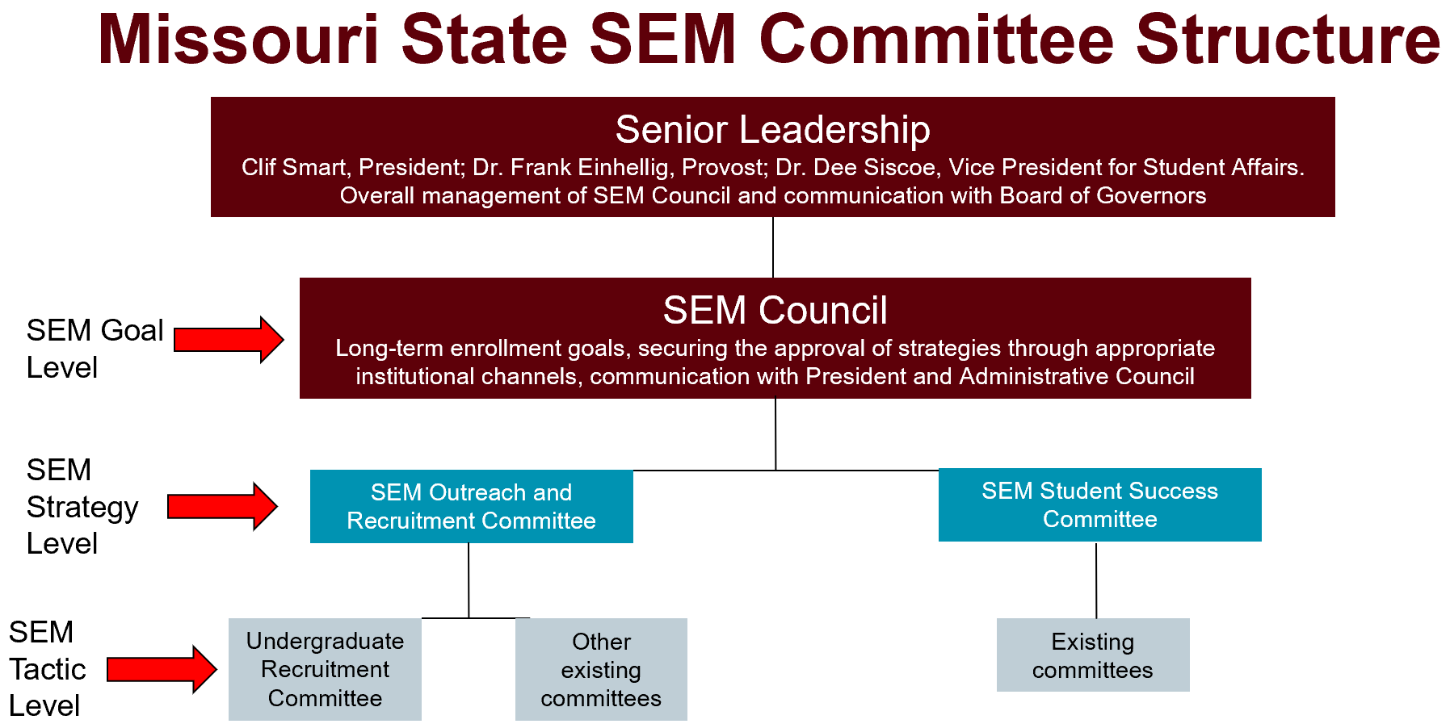

Figure 11 – Tracking, Measuring and Implementing Strategies
As our SEM plan is a living document, tracking, measuring and assessing strategies and tactics will be an iterative process with a constant feedback loop to inform and influence future action. To further support this work, those support units and colleges responsible for the implementation of tactics, will develop action plans, initiatives, outreach and recruitment plans, operational plans, etc. SEM planning is a way to link, integrate and extend those initiatives that affect enrollment. It is an enterprise-wide effort where data is linked, effort is integrated and our vision for student success is extended across the campus and into the long range plan. We will, therefore, continue to measure our success by the successes of our graduates and the communities our graduates serve. As a part of this process, the SEM council and committees will assess tactics and determine if they can be accomplished with current staffing and budget resources. When determined additional resources are needed, a mechanism for requesting this support will be developed in consultation with the SEM Senior Leadership Team.

The information that follows provides a working summary of our enrollment goals and strategies for student success and in turn overall institutional enrollment health.

SEM Plan Goals and Strategies

The baseline for these goals will be fall 2020 for goals one and two, FY20 for goal three, and the 2019-20 academic year for goal four. While 2026 exists as the target date, because of varying internal and external circumstances (e.g., demographic shifts, the economy, university funding, challenges related to the pandemic, significant hindrances regarding international students), the SEM Steering Committee will annually review goals and adjust accordingly with approval from the Senior Leadership Team. In addition to recent factors, a historical enrollment perspective will be considered as well.

1. Outreach and Recruitment
By 2026, with particular focus on targeted student populations, increase overall headcount enrollment by 5% and increase FTE enrollment by 3%.

Strategies
- Through a data-driven approach, project targeted student populations (e.g., FTNICs, new UG transfers, graduate, international, underrepresented, adult/non-traditional, online, geographic location, academic aptitude) for growth or decline and develop appropriate communication and recruitment efforts accordingly.
- Elevate the reputation of the University’s academic programs through the pursuit of new and emerging academic offerings and delivery modes, enrichment of existing curriculum and research, and equipping of students for successful career outcomes that meet workforce and market demands.
- Enhance both internal and external communication and marketing about the University’s enrollment, recruitment, and brand to both maintain and grow an engaged and educated campus community, and appeal to prospective students and other external stakeholders.
- Increase emphasis on outreach through relationship-building and effective communication with high school counselors, teachers, community college advisors, community partner organizations, and access programs for underserved populations.

2. Retention and Student Success
By 2026, increase the first to second year undergraduate student retention rate by 3%, with a focus on improving retention by 5% for each of these sub-groups: African American, Hispanic/Latino/Latinx, first-generation and Pell eligible students; and improve persistence at other critical transition points.

Strategies
- Support initiatives that foster student success, develop and strengthen early alert communications, enhance advising approaches, coordinate comprehensive student life cycle communications, and enhance collaboration among units and faculty/student connections, keeping in mind the various characteristics of different student populations.
- Strengthen the first-year experience through enhancing faculty and student connections in first-year gateway and foundation courses, improving the effectiveness of GEP 101, and promoting opportunities that offer student engagement and support.
- Improve the support services for students who historically have been less likely to persist.
- Develop and strengthen programs that recruit and retain a diverse faculty and staff.
- Enhance faculty, staff, and student accountability in becoming more culturally conscious by building a stronger sense of belonging and engagement at Missouri State and in the general community.

3. Successful Graduation and/or Completion
By 2026 increase the number of credentials (e.g., degrees and certificates) awarded to 5,800 per year.

Strategies
- Collaborate with advising administrators and stakeholders to discuss and refine advising models, policies and practices, within both centralized and college/department offices to support students on successful pathways to credential completion.
- Support career readiness activities throughout the student life cycle through collaboration between the Career Center, academic and advising units, and other areas; the use of appropriate technology; and other relevant initiatives.
- Refine curricular options (i.e., degrees and certificates) and remove perceived barriers to help students successfully navigate their academic program and connect it with workforce, market, or graduate/professional school demands.

4. Financial Preparedness
By 2026, decrease the average loan debt of undergraduate degree recipients by 5% after inflation.

Strategies
- Proactively implement targeted interventions and realignments of institutional resources that help prevent attrition and decrease student loan debt.
- Develop and deploy a financial preparedness education program for students and family members that begins with the financial aid award letter and continues through graduation.
- Identify and implement advising practices that improve enrollment efficiency and therefore contribute to lowering student debt.

Kerlin, Christine (2008), “Community College Roadmap for the Enrollment Management Journey,” College and University Journal, Vol. 83, No. 4, p. 11.
Bontrager, Bob. “Enrollment Management: An Introduction to Concepts and Structures”, College and University Journal, Vol. 79, No. 3, Winter 2004, p. 12.
Kerlin, Christine (2008), “Community College Roadmap for the Enrollment Management Journey,” College and University Journal, Vol. 83, No. 4, p. 11.
Kerlin and Smith (2018), adapted from Bontrager and Green, 2004.

