BIO 300 – Service Learning Final Report

Due on or before: Wed Dec. 8th at midnight

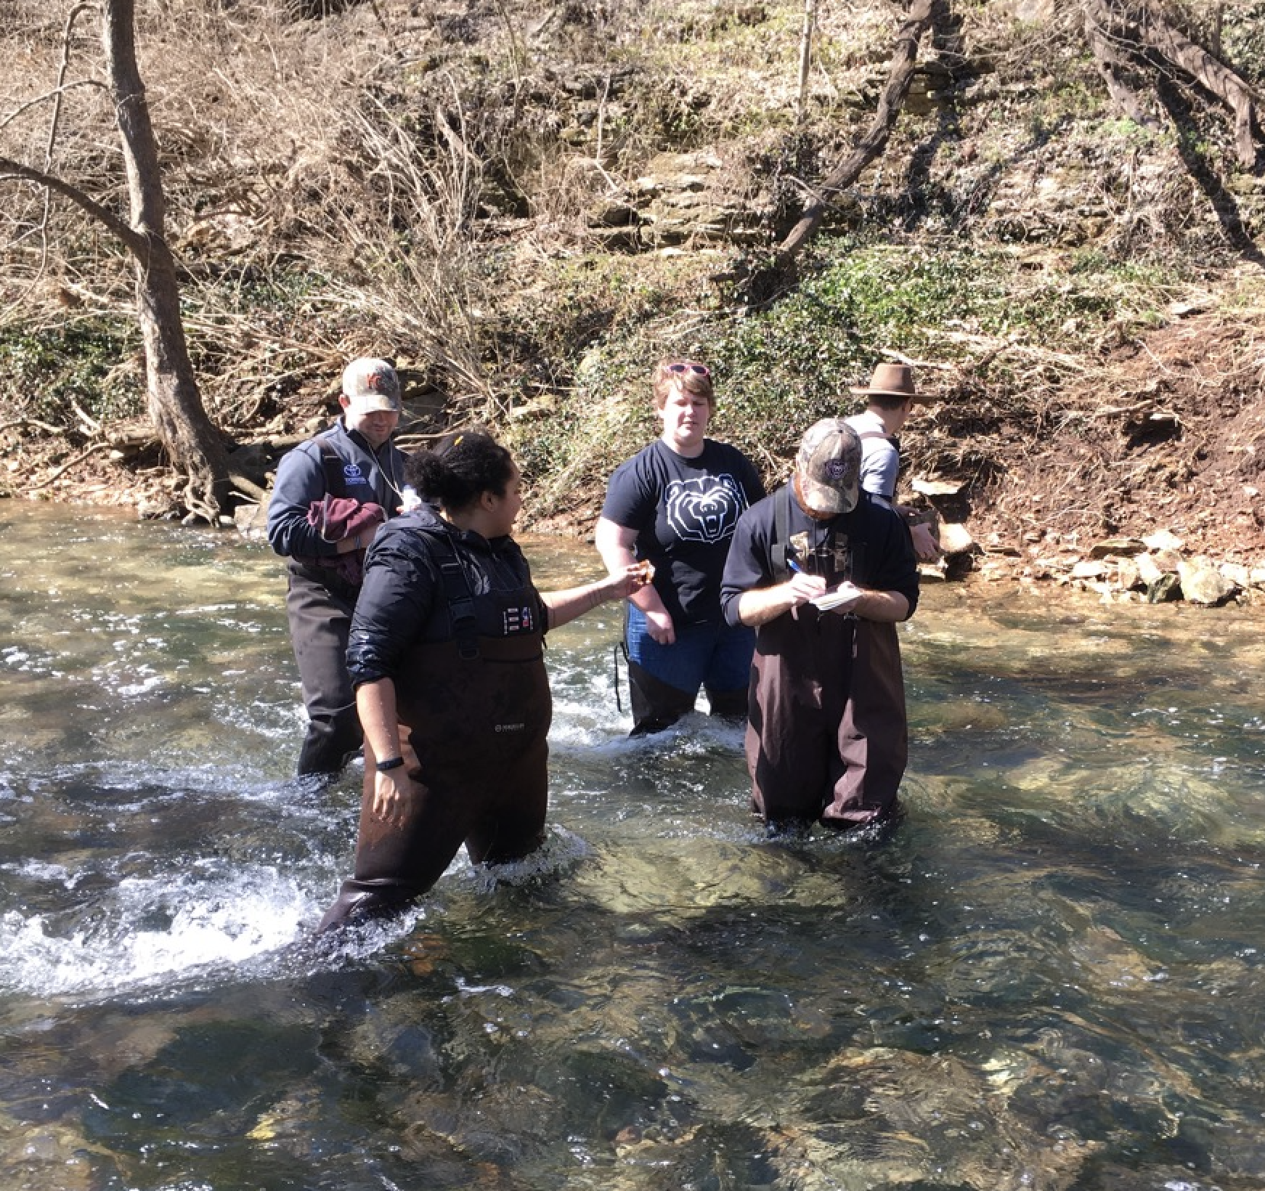
I hope your Biology Service Learning experience this semester has been enjoyable and fulfilling. The last step you need to take to finish the one-credit course is to submit a short report filling me in on your experience and how it was related to one or more topics covered in BIO 122 class. Style of the two-page report is relatively open-ended, and creativity is welcome. Content needs to include at the very least the following (but please do include any additional details that you think are cool!):
Example image caption: We love working in streams!
- The name of the organization and/or community partner that you volunteered with, and a brief description of the group’s mission. Note that if you use acronyms, you should spell the whole thing out the first time you mention it.
- What your role was with this organization, including any skills or expertise that you brought to the position
- Important: describe at least one topic that we covered in BIO 122 that was relevant in your role with the organization or community partner. Be as specific as possible here. How did a general biological concept from class “play out” in your real-world Service-Learning experience?
- What you learned from your experience and how you might be able to apply it to the rest of your time at MSU or potentially your desired career path (if you have one in mind)
- If you’d like to include an image, you are welcome to (but it is not required). If you do, be sure to say something about it in the text you write (see example image above).

Format guidelines:
- Submit as a Word doc through the assignment link on Blackboard.
- Write in paragraphs.
- 2 pages max
- double-spaced
- font 10-12 point in something “normal”, like Times New Roman, Helvetica, Cambria, Calibri
- margins “normal” (1 inch on each side)
- Put your name and a title at the top
- If you include an image, make it no larger than approximately 2x3 inches (like the one above)

By the way, the CASL might decide to include you in their “Service-Learning Stories” on their website. They would likely do this by taking some or all of your report to publish there (sort of like a blog, I guess). If you prefer to opt OUT of this, just let me know in an email, and I’ll pass the word to them.

I look forward to reading about your experiences!
Email me with any questions (dfinn@missouristate.edu).

