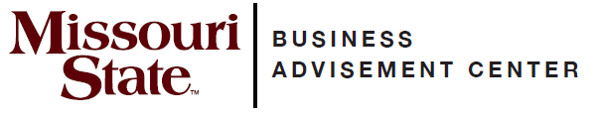
College of Business

Transfer Guide

North Arkansas College

Transfer Equivalencies
North Arkansas course | MSU equivalent
*BA 2003 | *ACC 201
*BA 2013 | *ACC 211
*SPCH 2303 | *COM 115
*ECON 2313 | *ECO 155
*ECON 2323 | *ECO 165
ENGL 1013 | *ENG 110
*BA 2103 | *MGT 286
*MAT 1223 | *MTH 136
*PSYC 2003 | *PSY 121
*MAT 2133 | *QBA 237
*BA 2713 | *LAW 231
CIS 1343 | ITC 201
Choose one:  FL 1303, 1313  ANTH 2023  PHIL 2203  SOC 2013  *Courses are Admission Requirements to  MSU’s College of Business. | Meets 3 hours of Globalization requirement¹

**Check with your transfer school about prerequisites**

Complete North Arkansas’ Associate of Arts. The AA degree will meet MSU’s general education requirements. Select your courses with the assistance of your North Arkansas advisor and include the previous North Arkansas courses, as they will transfer and fulfill part of your MSU major requirements.

Important notes about MSU College of Business courses

- Must earn a “C” or higher in MAT 1223 if ACC 201 and/or QBA 237 are taken at MSU.
- ¹Globalization requirements include three hours of foreign language or three hours of culture courses.
- For graduation, at least 120 hours are required. Fifty percent of all business coursework must be completed at MSU. At least 40 hours of 300-level or above coursework is required to graduate.
- This information is provided as a guide. Students are required to fulfill MSU graduation requirements to receive a degree and should consult their MSU advisor and the MSU undergraduate catalog for details.

Online resources for prospective transfer students
MSU catalog www.missouristate.edu/catalog
General transfer information www.missouristate.edu/admissions/transfer
Transfer equivalency guide www.missouristate.edu/transfer/courseequivalencies.htm

For assistance with admission and general questions
Bart Tibbs
Assistant Director of Admissions-Transfer Outreach and Recruitment
417-836-5517
Transfer@MissouriState.edu

COB Transfer Advisor
COBTransferAdvisor@MissouriState.edu

Business Advisement Center
Glass Hall 276
417-836-5386
www.missouristate.edu/BusAdv

This document was prepared by the MSU Business Advisement Center in the MSU College of Business. This information was last updated September 2024 and is subject to change.

