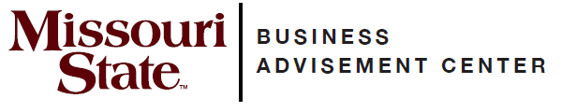
College of Business

Transfer Guide

Mineral Area Community College

Transfer Equivalencies
MAC course | MSU equivalent
*BUS 2000 or MGT 1190 | *ACC 201
*BUS 2050 or MGT 2062 | *ACC 211
*ENG 1440 | *COM 115
*BUS 2930 | *ECO 155
*BUS 2940 | *ECO 165
*ENG 1330 | *ENG 110
*OST 1400 | *MGT 286
*MAT 1270 | *MTH 136
*PSY 1130 | *PSY 121
*BUS 2570 | *QBA 237
*BUS 2530 | *LAW 231
CIS 2200 | ITC 201
Choose one:  MFL 1370, 1470, 2230, 2250  GEO 1130  PHI 1410  SOC 1130, 1540  *Courses are Admission Requirements to  MSU’s College of Business. | Meets 3 hours of Globalization requirement¹

**Check with your transfer school about prerequisites**

Complete MAC’s Associate of Arts. The AA degree will meet MSU’s general education requirements. Select your courses with the assistance of your MAC advisor and include the previous MAC courses, as they will transfer and fulfill part of your MSU major requirements.

Important notes about MSU College of Business courses

- Must earn a “C” or higher in MAT 1270 if ACC 201 and/or QBA 237 are taken at MSU.
- ¹Globalization requirements include three hours of foreign language or three hours of culture courses.
- For graduation, at least 120 hours are required. Fifty percent of all business coursework must be completed at MSU. At least 40 hours of 300-level or above coursework is required to graduate.
- This information is provided as a guide. Students are required to fulfill MSU graduation requirements to receive a degree and should consult their MSU advisor and the MSU undergraduate catalog for details.

Online resources for prospective transfer students
MSU catalog www.missouristate.edu/catalog
General transfer information www.missouristate.edu/admissions/transfer
Transfer equivalency guide www.missouristate.edu/transfer/courseequivalencies.htm

For assistance with admission and general questions
Bart Tibbs
Assistant Director of Admissions-Transfer Outreach and Recruitment
417-836-5517
Transfer@MissouriState.edu

COB Transfer Advisor
COBTransferAdvisor@MissouriState.edu

Business Advisement Center
Glass Hall 276
417-836-5386
www.missouristate.edu/BusAdv

This document was prepared by the MSU Business Advisement Center in the MSU College of Business. This information was last updated September 2024 and is subject to change.

