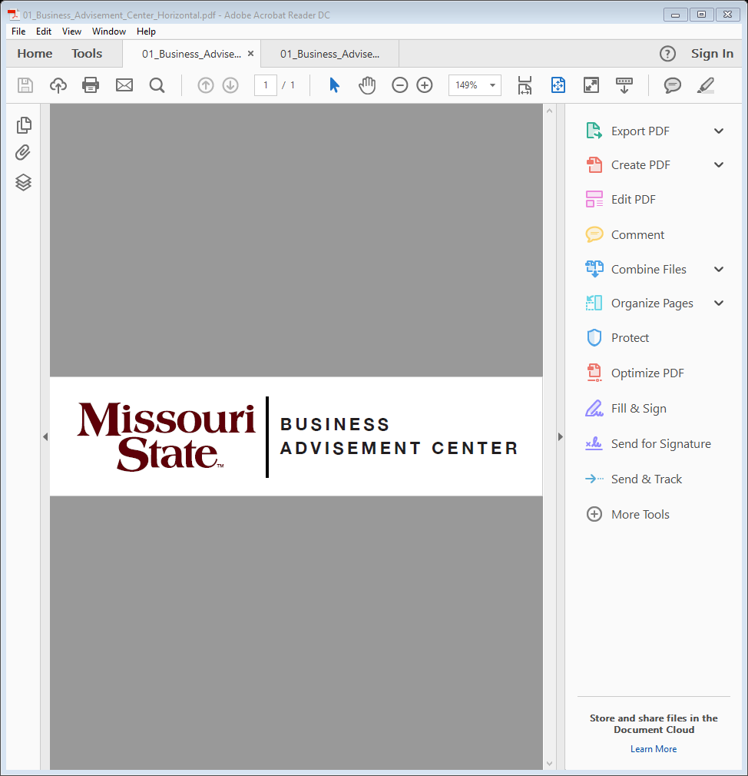College of Business

Transfer Guide

Johnson County Community College

|  |
| --- |
| **Transfer Equivalencies** |
| |  |  | | --- | --- | | JCCC course | MSU equivalent | | *ACCT 121 | *ACC 201 | | *ACCT 122 | *ACC 211 | | *COMS 121 | *COM115 | | *ECON230 | *ECO 155 | | *ECON 231 | *ECO 165 | | *ENGL 121 | *ENG 110 | | *BUS 150 | *MGT 286 | | *MATH 171 | *MTH 136 | | *PSYC 130 | *PSY 121 | | *MATH 181 | *MTH 340 (substitutes for QBA 237) | | *BLAW 261 | *LAW 231 | | CPCA 110 | ITC 201 | |  |  | | Choose one:  FL 120, 121, 130, 131, 140, 141, 165, 166, 170, 171, 182, 183, 220, 221, 230, 231, 240, 241  ANTH 125, 130  GEOS 145  MUS 126  POLS 132, 135  REL 120  SOC 122  *\*Courses are Admission Requirements to*  *MSU’s College of Business.* | Meets 3 hours of Globalization requirement1 | |

**\*\*Check with your transfer school about prerequisites\*\***

Complete JCCC’s **Associate of Arts**. The AA degree will meet MSU’s general education requirements. Select your courses with the assistance of your JCCC advisor and include the previous JCCC courses, as they will transfer and fulfill part of your MSU major requirements.

Important notes about MSU College of Business courses

* Must earn a “C” or higher in MATH 171 if ACC 201 and/or QBA 237 are taken at MSU.
* 1Globalization requirements include three hours of foreign language or three hours of culture courses.
* For graduation, at least 120 hours are required. Fifty percent of all business coursework must be completed at MSU. At least 40 hours of 300-level or above coursework is required to graduate.

**This information is provided as a guide. Students are required to fulfill MSU graduation requirements to receive a degree and should consult their MSU advisor and the MSU undergraduate catalog for details. **

**Online resources for prospective transfer students**

MSU catalog [www.missouristate.edu/catalog](http://www.missouristate.edu/catalog)

General transfer information [www.missouristate.edu/admissions/transfer](http://www.missouristate.edu/admissions/transfer)

Transfer equivalency guide [www.missouristate.edu/transfer/courseequivalencies.htm](http://www.missouristate.edu/transfer/courseequivalencies.htm)

**For assistance with admission and general questions**

Bart Tibbs

Assistant Director of Admissions-Transfer Outreach and Recruitment

417-836-5517

[Transfer@MissouriState.edu](mailto:Transfer@MissouriState.edu)

**COB Transfer Advisor**

[COBTransferAdvisor@MissouriState.edu](mailto:COBTransferAdvisor@MissouriState.edu)

Business Advisement Center

Glass Hall 276

417-836-5386

Fax: 417-836-6757

[www.missouristate.edu/BusAdv](http://www.missouristate.edu/BusAdv)

This document was prepared by the MSU Business Advisement Center in the MSU College of Business. This information was last updated on July 2, 2021 and is subject to change.