Sustainability proposal
LED lighting for Parking lot 4

Submitted by:
Juan renteria

Submitted on:
03/17/2013
Missouri State University
Student Government Association



- Identification of Sponsors
  - Project Sponsors (insert project sponsors and contact information below)
      - Juan Renteria
1001 East Madison Street – Blair Room #308B
Springfield, MO 65807
(417) 3102878
Renteria92@live.missouristate.edu

2. Lauren Bansbach
1237 E. Belmont St.
Springfield, MO 65804
(314) 488-0674
Bansbach009@live.missouristate.edu

  - Faculty/Staff advisor (insert faculty/staff contact information below)
1. Pilar Karlen
Energy manager
901 South National Avenue
Springfield, MO 65897
(417) 836-8984
PilarKarlen@missouristate.edu

  - Project Manager
      - Juan Renteria
II. Description of Proposed Project
- General Description of Proposal Funding to replace the lights in parking Lot 4 from high-pressure sodium to the light emitting diode.
Proposal Details It funds 8 LED lights (Model: General Electric EAMT 0 D5N F 57A1 A DKBZ --- the same model in Lot 13) for parking lot 4.
Quote information compiled by Pilar Karlen from Lighting Solutions Group (10579 Widmer Lenexa KS 66215)

- Proposed location for the object of the proposal Parking Lot 4 on the Missouri State University Springfield campus.
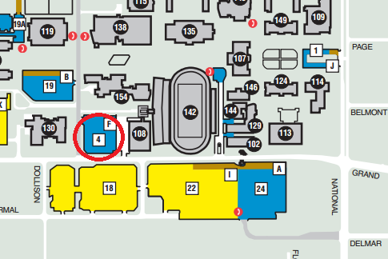
Figure 1. Lot 4 is located immediately north of Grand between Kemper Hall and the Central Stores and Maintenance building.
- Alternative Uses LED lights can deter crime.
- Drawbacks LED lights have a high initial cost, but pay themselves off in a short timeframe.
- Necessary modifications to existing structures None - the original lights will be replaced.
- Estimated Cost of the Project $8726
  - Provisions of Alternatives in Order of Preference Lights purchased could potentially be used in a different location as deemed appropriate by Facilities Management should Lot 4 no longer be a suitable place for LED lights.
  - Provisions of Complete Cost Breakdowns
8 LED lights= $10,200
8 pole adapters= $1,080
8 dimming driver adders= $568
Installation= $2,000
Subtotal = $13,848
+ 10% contingency $1,384.80
Total = $15,232.80
  - Provisions of any Ongoing Costs There are no on-going cost outside of regular maintenance, which occurs regardless of light bulb style.
- Estimated Completion Time of Project once the lights are purchased and shipped they take very little time to install (2-3 days).

- Estimated Life of Project up to 50,000 hours per light bulb.
- Justification of Project
Not only is this project environmentally responsible, but it is fiscally responsible as well. These lights use less energy, which means that less fossil fuels will need to be burned in order to light our parking lots. In addition, since the LED lights do not need to be replaced as often, less energy will be used for production and transportation of materials, and fewer items will be going to the landfill.

- University Support Pilar Karlen provided the details for the proposal and other support was provided by Jen Cox. Facilities have already implemented two other LED lighting proposals and administration and students are generally satisfied with the performance.

