Sustainability proposal
(Glass recycling containers)

Submitted by:
(Colton Strother)

Submitted on:
02/12/2014

- Identification of Sponsors

  - Project Sponsors

      - Teresa Frederick
Assistant Director, Residence Life, Housing and Dining Services
Facilities and Operation
901 South National Avenue
Springfield, MO 65807
(417) 836-8923
TeresaFrederick@missouristate.edu

2. Donald Clark
Custodial Specialist, Residence Life, Housing and Dining Services
Facilities and Operation
901 South National Avenue
Springfield, MO 65807
(417) 299-5226
dclark@missouristate.edu

3. Colton Strother
Student Recycling Coordinator, Residence Life, Housing and Dining Services
Facilities and Operations
901 South National Avenue
Springfield MO 65897
(573) 470-1481
coltonstrother@gmail.com

  - Faculty/Staff advisor
1. Jessica Yates
Graduate Assistant, Residence Life, Housing and Dining Services
Facilities and Operations
901 South National Avenue
Springfield, MO 65897
(417) 836-8923
Yates619@missouristate.edu

  - Project Manager
1. Colton Strother

II. Description of Proposed Project
- General Glass Recycling Containers Project Description
As a means to reduce waste, on behalf of Residence Life and Housing and Dining Services, I would like to propose the purchase of sixty glass recycling containers to be installed in Missouri State University Residence Halls. The purpose of this proposal is to make Missouri State University more sustainable, by producing less waste. We would like to see glass recycling containers in all of the closets that now have comingle and paper recycling. Having more readily available glass recycling will not only promote glass recycling, but it will also make recycling much more convenient for students.

- Proposal Details
In every Residence Hall, there are designated areas for students to recycle. On the floors of the halls there are closets that contain garbage containers along with paper and comingle recycling containers. The project would be to install glass recycling containers into these closets. As of right now, if students have glass recycling, they either have to take it to the first floor lobby or put it in the comingle containers. The contract that we have with Waste Management does not allow us to recycle glass with them. Therefore, if students put glass in the comingle containers, Student Recycling Coordinators, such as myself, have to sort through the recycling to find the glass and put it in the appropriate containers. This not only slows down the recycling process, but is overall inefficient.

Here is a picture of what the proposed bins would look like:

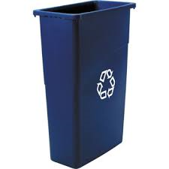

- Proposed location for the object of the proposal
The locations of the containers will be distributed to certain Residence Halls. These proposed bins would specifically be going to Freudenburger House, Blair-Shannon House, Wells House, Woods House, and Monroe Apartments. These buildings have the most sporadic and inefficient glass recycling of the Residence Halls. Inside each Residence Hall there are specific locations in which the bins will be installed. Most of these buildings have trash room closets that these containers will be installed into. The other Residence Halls have common areas throughout the building designated for recycling purposes; the extra glass recycling bins will be put in those designated areas to allow for easier access by the students.

- Alternative Uses
The convenience of location will make students aware of our new recycling options while promoting glass recycling.

- Drawbacks
The most considerable drawback we face is that this project is being proposed in the middle of the year. If we get approved, the bins will be installed and fully functional around the half-way point of the semester. These bins will be new to the students currently residing on campus, and there is always a certain amount of tension when projects are implemented during awkward times of the semester. To relieve any stress or confusion these new bins might add to the students, we plan on providing signs that will blatantly state the purpose of the new bins. The cost of these signs will be covered by Residence Life. These signs will be consistent in design and size throughout the Residence Halls; the signs will be printed on 8x11 pieces of paper. As of now, the current signage can be sporadic and inconsistent. The new signs will not only shed more light on recycle, but will also be more attractive.

This is an example of what the new glass recycling signs will look like:
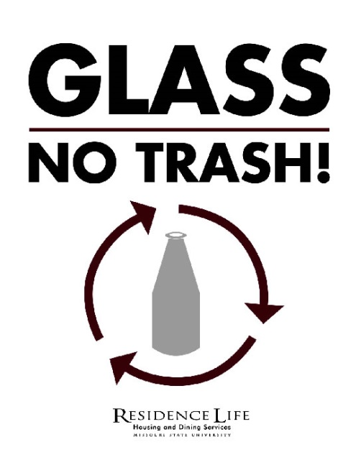

Being clear with what the bins are for and why they are important will undoubtedly ease any frustration that might result from these new containers. At the beginning of the next semester this will be a non-issue. Students residing on campus, incoming and current, will be completely acclimated to the new system of recycling that we are initiating.

- Necessary modifications to existing structures
The bins will be located in trash room closets and will not require any additional modifications to the structures around them. That being said, they will take up a certain amount of space in said trash rooms. Modifications do not need to be made to any existing structures, but there will be less room available for additional containers beyond proposed glass containers to potentially be installed. The containers size are 20”x11”x30” (w/d/h). The area that these containers would take up is not vast in any sense, but is noteworthy.

- Estimated Cost of the Project
  - Provisions of Alternatives in Order of Preference
The most optimal choice with regards to bin selection would be through a company called Landmark Studios. This company gave us the priced sixty bins with shipping and handling included at $2,960.
Another option that we have is using a company called Grainger. Missouri State University has a contract with Granger and could potentially get us bins at lower cost. However, before ordering from them, we will want to confirm they could provide a similar quality product to our first choice from Landmark. The purpose of this proposal is for these bins to be implemented and remain in their locations for years to come. If we compromise on quality it could hurt us in the long run.
  - Provisions of Complete Cost Breakdowns
The total number of bins required would be sixty. After conferring with a representative from Landmark Studios, they gave us a price estimate of forty-four dollars a bin. The total cost of the bins would be $2,640. The representative also priced shipping for these bins which would be $320 total. Ultimately the total cost of the project would be $2,960.

These costs are not inclusive of the time it will take for the bins to be installed in the proper closets. The breakdown of how this will happen will be handled by Residence Life, Housing and Dining Service, Custodial staff and will not require outside funding.

  - Provisions of any Ongoing Costs
The only ongoing costs that can be anticipated with these bins would be transplanting the glass that is being recycled to the recycling company. All of these costs would be covered by Residence Life Housing and Dining Services. In the event of a bin being damaged to the point where the bins would no longer be usable, Residence Life would cover any replacement costs.

- Estimated Completion Time of Project
Upon approval this project will last around sixty days. After being approved the next step would be to order the authorized containers and get the delivery process underway. Shipment of these containers should take no longer than two weeks. Once we receive the shipment we will implement the containers into the appropriated closets, given that the custodial staff workers will be aiding in the moving and installing portion of this project, this should only last about a week as well. Finally, the last portion of this project will be label the containers so that the students will be able to easily recognize the purpose of these recycle bins. The project should last no more than sixty days.

- Estimated Life of Project
This project will last until the Springfield Recycling Center (glass collection agency) closes, or our Waste Management contract allows us to collect glass with all of our other recycling. The purpose of these bin is longevity, we desire for them to last for as long as possible so we can get the most out of them as we can. These bins will be installed in these closets indefinitely.

- Justification of Project
These extra bins will enable Missouri State University as a whole to reduce its carbon footprint and become more sustainable. The more that we recycle, the less waste we produce. With the installation of these new bins, students will have easier access to recycle their glass, and they will be encouraged to dispose of the glass containers properly. Not only does this benefit the students, but it will also benefit the workers who pull recycling. The addition of these new bins will allow Student Recycling Coordinators to spend less time digging and sorting through recycling, and more time removing and collecting recycling. These bins will allow all custodial staff to more efficiently handle recycling.

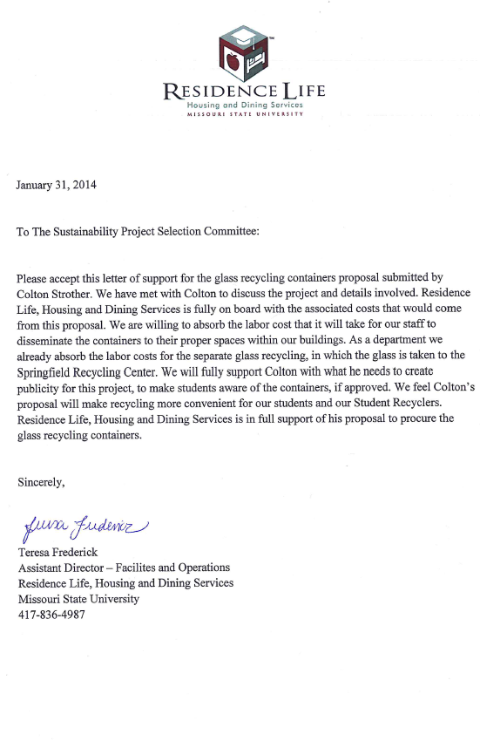
- University Support

