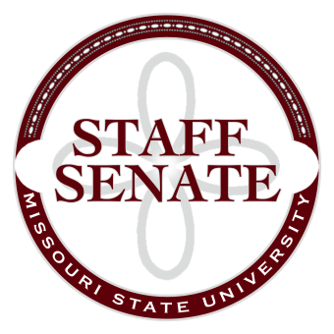
Staff Senate Agenda
9/3/15
11:00-12:00
- Roll Call
  - Excused Absences
  - Welcome new MSU Employees in Attendance
- Call To Order
- Approval of Agenda
- Approval of Minutes (August, 2015)
- Guest Speaker – Terry Weber
- Chair Report
  - Staff Satisfaction Survey update
  - Meals a Million Sign Up
- Chair Elect Report
  - Bear Fest Village Tent Report and Sign Up
- Past Chair Report
  - No report
- Secretary/Treasurer Report
  - Financial Update
- Director of Staff Relations
  - Committee Sign Up
  - Committee Reports
Standing Committees
    - Public Affairs Committee
    - Staff Relations Committee
    - Scholarship Committee
    - Staff Activities Committee
      - Request for funds
    - Administrative Professionals Forum Committee
Ad Hoc Committees
    - Denim Day Committee
    - Staff Excellence in Service Awards Committee
University Representative Committees
    - My Ideas Committee
    - Public Arts Committee
    - Sustainability Commission
    - Wyrick Commission
    - Shared Leave Committee
- Old Business

- New Business

- Announcements

- Adjournment
Next Meeting: October 1, 2015, 11:00 in PSU 313

