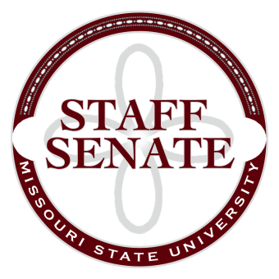
Staff Senate Agenda
10/1/15
11:00-12:00
- Roll Call
  - Excused Absences
  - Welcome new MSU Employees in Attendance
- Call To Order
- Approval of Agenda
- Approval of Minutes (September, 2015)
- Guest Speaker for Universal Life Insurance
- Chair Report
  - Staff Satisfaction Survey update
  - Bear Network Report
  - Reminder of Robert’s Rules
- Chair Elect Report
  - Bear Fest Village report including updates for Homecoming, October 17, 2015
- Past Chair Report

- Secretary/Treasurer Report
  - Financial Update
- Director of Staff Relations
  - Committee Reports
Standing Committees
    - Public Affairs Committee
    - Staff Relations Committee
    - Scholarship Committee
    - Staff Activities Committee
    - Administrative Professionals Forum Committee
Ad Hoc Committees
    - Denim Day Committee
    - Staff Excellence in Service Awards Committee
University Representative Committees
    - My Ideas Committee
    - Public Arts Committee
    - Sustainability Commission
    - Wyrick Commission
    - Shared Leave Committee
- Old Business

- New Business

- Announcements
  - Division of Diversity and Inclusion, Shattering the Silences: All Black Lives Matter Program
- Adjournment
Next Meeting: November 5, 2015, 11:00 in PSU 313

