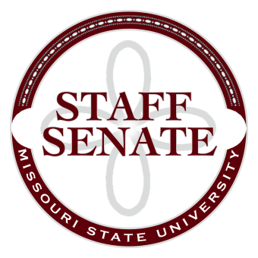
Staff Senate Agenda
11/6/2014
- Roll Call
  - Excused Absences
  - Welcome new MSU Employees in Attendance
- Call To Order
- Approval of Agenda
- Approval of Minutes (October, 2014)
- Chair Report
  - Board of Governor’s Meeting Update
  - Staff Senate Polo Shirts
  - Master Planning Committee Update
- Chair Elect Report
  - Staff Handbook Committee Report
- Past Chair Report
  - Faculty Senate Update
- Secretary/Treasurer Report
  - Financial Update
- Director of Staff Relations – Committee Reports
    - Possible Change in Committee Structure
    - Staff Salary Incentive Program Update
  - Bylaws Committee
  - Denim Day Committee
  - Public Affairs Committee
  - Public Relations Committee
  - Scholarship Committee
  - Staff Activities Committee
  - Staff Excellence in Service Awards Committee
  - Administrative Professionals Forum Committee
  - Faculty Senate
  - My Ideas Committee
  - Public Arts Committee
  - Sustainability Committee
  - Wyrick Commission
  - Shared Leave Committee
- Old Business
  - Graduate Assistant Survey – Follow-up
  - Staff Satisfaction Survey – Follow-Up
- New Business
  - Beginning discussion regarding Sit/Stand Work Stations
- Announcements
- Adjournment
Next Meeting: December 4, 2014 11:00am, PSU313

