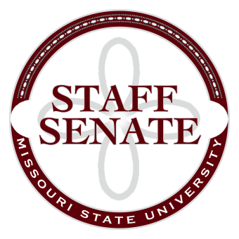
Staff Senate Agenda
3/5/15
- Roll Call
  - Excused Absences
    - Allison Overmyer

  - Welcome new MSU Employees in Attendance
- Call To Order
- Approval of Agenda
- Approval of Minutes (February 2015)
- Chair Report
  - Dr. Tamara Jahnke – Update on HLC progress
  - Julie Dubinski – Proposed new Fee Waiver System Overview
  - Motion to move Proposed Resolution to front of the agenda
- Chair Elect Report
  - Staff Handbook Committee
  - Parking Fee Increase
  - Common Reader
- Past Chair Report
  - Faculty Senate Update
- Secretary/Treasurer Report
  - Financial Update
  - Call for nominations for open Senator Seats
  - Call for nominations for open Board Seats
- Director of Staff Relations – Committee Reports
    - Staff Salary Incentive Program Update – Brian Edmond
  - Bylaws Committee
  - Denim Day Committee
  - Public Affairs Committee
  - Public Relations Committee
  - Scholarship Committee
  - Staff Activities Committee
  - Staff Excellence in Service Awards Committee
  - Administrative Professionals Forum Committee
  - Faculty Senate
  - My Ideas Committee
  - Public Arts Committee
  - Sustainability Committee
  - Wyrick Commission
  - Shared Leave Committee
- Old Business
  - Staff Satisfaction Survey – Follow-Up (no report)
  - Sit/Stand Work Stations survey and possible campus study (no report)
- New Business
  - Inclement Weather Policy – Andrew Garton
- Announcements
- Adjournment
Next Meeting: April 2nd, 2015 at 11:00am, PSU 313

