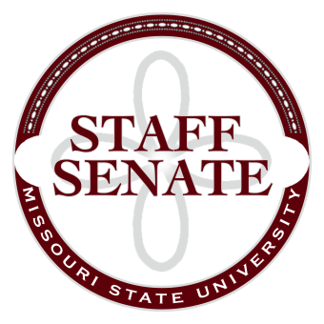
Staff Senate Agenda
7/9/15
11:00-1:00 (Lunch Provided)
- Roll Call
  - Excused Absences
  - Welcome new MSU Employees in Attendance
- Call To Order
- Approval of Agenda
- Approval of Minutes (June, 2015)
- Chair Report
  - Board of Governor’s Meeting Report
  - Presentation on Staff Senate
  - Ice Breaker Activity
- Chair Elect Report
  - Bylaws Work Group
- Past Chair Report
  - No Report
- Secretary/Treasurer Report
  - Financial Update
  - 2015-16 Meeting Dates, Times and Locations
  - Gift cards for perfect attendance
- Director of Staff Relations – Committee Reports
  - Bylaws
  - Denim Day Committee
  - Public Affairs Committee
  - Staff Relations Committee
  - Scholarship Committee
  - Staff Activities Committee
  - Staff Excellence in Service Awards Committee
  - Administrative Professionals Forum Committee
  - Faculty Senate
  - My Ideas Committee
  - Public Arts Committee
  - Sustainability Commission
  - Wyrick Commission
  - Shared Leave Committee
- Old Business
  - Tents for Homecoming
  - Money for custodial staff member
- New Business
  - Work/life balance issues being discussed by the President’s Leave Task force
- Announcements
  - Bear Crew, New Student Convocation
- Adjournment
Next Meeting:

