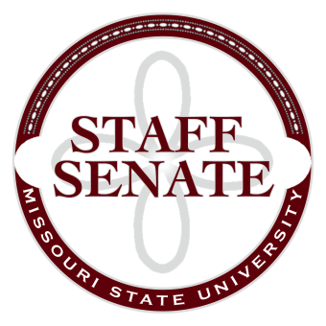
Staff Senate Agenda
12/3/15
11:00-12:00
PSU Ballroom East
- Roll Call
  - Excused Absences
  - Welcome new MSU Employees in Attendance
- Call To Order
- Approval of Agenda
- Approval of Minutes (November, 2015)
- Guest Speakers:
  - Julie Dubinsky, Human Resources, and Matt Morris, VP AIS
  - Suzanne Shaw, Vice President for Marketing and Communications
- Chair Report (Christina Bowles)
  - Staff Satisfaction Survey update
  - Written reports from committees
- Chair Elect Report (Ryan Wilson)
  - Senate Representation
- Past Chair Report (Scott Fiedler)
  - Faculty Senate
  - Tours of new buildings
- Secretary/Treasurer Report (Rob Moore)
  - Financial Update
  - Staff Leadership Training
- Director of Staff Relations (Vacant Position)
  - Standing Committee Reports
    - Administrative Professionals Forum Committee (Sandra Johnson)
    - Public Affairs Committee (Christina Bowles)
    - Scholarship Committee (Addie Douglas)
    - Staff Activities Committee (Janelle Melton)
      - BearFest Village Report (Andrew Garton)
    - Staff Relations Committee (Ryan Wilson)
  - Ad Hoc Committee Reports
    - Denim Day Committee (Kelly Bridges)
    - Staff Excellence in Service Awards Committee (Paul Essel)
  - Staff Senate Representative Reports
    - My Ideas Committee (Sharon Lopinot)
    - Public Arts Committee (Kelly Bridges)
    - Shared Leave Committee (Brenda Stewart)
      - Representative Structure (Ryan Wilson)
    - Sustainability Commission (Ryan Wilson)
    - Wyrick Commission (Janelle Melton)
- Old Business

- New Business
  - Administrative Professionals/Staff Senate Scholarship Luncheon, April 18th
- Announcements
  - President’s Holiday Reception, Tuesday, December 8, 2:00-4:00, PSU Ballroom
  - Staff Awards Luncheon, Thursday, January 7, 11:30-1:30, Hammons Student Center
- Adjournment
Next Meeting: January 14, 2016, 11:00 in Glass Hall, Room 102.

