|  |  |  |  |  |  |
| --- | --- | --- | --- | --- | --- |
| |  | | --- | | Fall 2019 Volume 19, Issue 1  Notes from Missouri State Psychology Department  *Published by the Psychology Department*  Please welcome Dr. Jeff Foster, Dr. Gabriel Saenz, Dr. Dana Paliliunas (again), and Ms. Kerri Mothersead to the Psychology Department.  Dr. Foster has been teaching for us as a Per Course faculty member since 2013. He was also a student of ours from 1994-1998 when he received his B.S. in Psychology. He then continued at UMSL where he received his Ph.D. in I-O and since then has been working as a consultant for Hogan and Associates.  Dr. Saenz is coming to us from Texas A&M with a PhD in Cognitive Psychology. He was born in Caracas, Venezuela and raised in Houston, Texas. He is going to focus his research on Metacognition, Education and Memory.  Dr. Paliliunas is in her second year at Missouri State University; last year she taught as a visiting assistant professor. She now is a tenure track assistant professor, working with the Clinical and ABA programs.  Ms. Mothersead is a graduate of Missouri State University with a B.S. in Child and Family Development and holds a Master’s degree in Counseling with a School Counseling Certification.  She will take over as coordinator of Project SUCCESS housed in the Learning Diagnostic Clinic. | | **Winter Intersession Information**  Jan. 6 – Winter 2020 classes begin  Jan 10 – Winter 2020 classes end  Jan 13- Grade rosters available  Jan 21 – Grades due by 2pm  Jan 22- Grades available on website  Department of Psychology Newsletter | |  | |  | **Important Dates**   * Drop deadline for 1st block classes: 9/25 * 1st block classes end: 10/8 * 1st block final exams: 10/9 * Fall Holiday: 10/10-10/11 * 2nd block classes begin: 10/14 * Midterm grades due by 2pm online: 10/16 * Midterm grades available: 10/17 * Drop deadline for full semester classes: 11/8 * Drop deadline for 2nd block classes: 11/18 * Apply for graduation by 10/31 * Thanksgiving Holiday: 11/27-12/1 * Last day of classes: 12/5 * Study day (no classes): 12/6 * Final Exams: 12/7-12/12 * Fall Commencement: 12/13 |

From the Department Head’s Desk



**Graduates**

If you are graduating 12/13/19

* Congratulations and best wishes on your future endeavors!
* Remember: Apply for graduation by October 31s to have your name included in the printed commencement program.
* Your academic advisor can help make sure you are fulfilling all graduation requirements and can assist with career and/or graduate school planning.

We have not had a Psychology Department newsletter since the fall 2017 issue. Since then there have been a significant number of changes. The department relocated to the Glen Isle shopping center in May 2017, where we were housed for the 2017-2018 academic year. In August 2018, we returned to campus and a newly renovated Hill Hall. We have spent the last year adjusting to our “new” home and I believe we are finally getting settled. We also have seen a number of retirements, resignations, and new hires. In fact, in the past two years, we have hired two new instructors (Drs. Hannah Harris and Ashley Payne), five assistant professors (Drs. Jordan Belisle, CaSandra Stanbrough, Dana Paliliunas, Gabriel Saenz, and Jeff Foster), and two new staff (Kelli Helton, recently reclassified as an Administrative Assistant II and Kerri Mothersead, new Project Success coordinator). This represents turnover of more than a quarter of our staff and faculty in less than three years.

So what does this mean? In addition to seeing many new faces I think we have an opportunity to shape the future of the Psychology Department in meaningful ways. Over the 2018-2019 academic year the Curricular Review and Assessment Committee (CRAC) met on multiple occasions to closely examine the undergraduate degree. The CRAC will be proposing some changes to the major that will have an impact on both students and faculty. Effective February 1, 2019, Dr. Helen Reid, MCHHS Dean, retired. Dr. Letitia White-Minnis had served as interim Dean until she was replaced by Dr. Mark A. Smith who came to us from the University of Northern Colorado, and began on August 1, 2019. Again, I think we have an opportunity to substantially shape the future of the Psychology Department with this change in leadership. More to come on these initiatives.

Related to our future will be a more focused and targeted outreach to our alumni and donors. The Psychology Department has a reasonably active Facebook page (<https://www.facebook.com/MSUPSYCH/>). Beyond that we (especially me) have not been nearly as proactive as we could be. There will be some new initiatives in the coming year designed to improve our connections. To start I would like to draw your attention to the section of the newsletter where our spring 2019 scholarship recipients are identified and their respective scholarships described. This support would not be possible without the support of alumni, donors, friends and family. We thank you.

Welcome to the new academic year, best wishes for success!

PaulDepartment of Psychology Newsletter

Student Organization Meetings

Hill Hall, Room 337

2:00 – 3:00 P.M

* August 26
  + Welcome Meeting
* September 9
  + Walk to End Alzheimer’s
* September 23
  + Graduate School Prep
* October 7
  + Fall Fundraiser Kickoff
* October 21
  + Long Term Care Administration
* November 4
  + Veteran’s Day Cards
* November 18
  + The Truth About Hospice Care
* December 2
  + Gift Drive Wrap Party

Gerontology Club Meetings & Events

Hill Hall, Room 101

4:00 – 5:00 P.M.

* August 26
  + Brain Food Event
* September 9
  + Leadership Compass Workshop
* September 16
  + Game Night
* September 30
  + Suicide Awareness
* October 14
  + Indigenous People’s Day
* October 28
  + Health Psychology
* November 11
  + PTSD/Healing Arts
* December 2
  + Self-care/De-stress

Psychology Club Meetings & Events



<https://www.facebook.com/MSUPSYCH/> AND

<https://www.facebook.com/MSUGerontologyProgram/>



**Once a Bear, always a Bear!**

If you have not joined the Alumni Association please consider doing so. It’s a great way to stay connected to Missouri State. You get access to alumni benefits, transcripts, university news and you also get too connect with fellow Bears.

**Upcoming Events:**

**Missouri State Night at the K – August 31, 2019 at 6:15PM**

*Cheer for the Royals with fellow bears and friends in KC. Use a special theme ticket like to receive an exclusive MSU/Royals bucket hat.*

**Bears in the Know Luncheon Series – September 4, 2019 – July 8, 2020 at 11:30a-1p**

*The MSU Foundation is excited to continue to host this series of luncheons designed to showcase unique areas at MSU and connect personally with our friends and supporters in the community.*

**Bobby Bones VIP Reception – October 1, 2019 at 5:30-7:30pm**

*The most popular country music DJ in America is coming to MSU! Bobby Bones, an on-air personality and host of the award-winning “Bobby Bones Show”, will be the 2019 Public Affairs Conference keynote speaker. Meet Bobby Bones at the VIP Reception prior to the keynote speech.*

**Geography, Geology and Planning Alumni Reunion – May 1, 2020 – May 3, 2020**

*If you missed the 1st GGP Reunion, you won’t want to miss the 2nd! Mark your calendar and update your contact information today.*

Click for more information: [https://maroonation.missouristate.edu](https://maroonation.missouristate.edu/)

Missouri State Alumni News



Department of Psychology Newsletter

Department of Psychology Newsletter

Missouri State Psychology Department

Scholarhip recipients 2018-2019

Department of Psychology Newsletter

Missouri State Psychology Department

Scholarhip recipients 2018-2019

During the Spring 2019 Honor’s reception in April the Psychology Department and Gerontology Program announced the recipients of a number of scholarships generously supported by our alumni, donors, emeritus faculty and friends. A brief description of each scholarship and recipient follows, with pictures of each where available.

|  |  |
| --- | --- |
| **Louis H and Seryl E. Fisher Community Service Scholarship in Gerontology** | |
|  | This scholarship was established in the year 2000, by Dr. Bradley Fisher (now Emeritus Professor) after his father passed away in 1999. Lou and Ethel Fisher were married for 50 years. Both valued education and were known to be generous individuals. Dr. Fisher’s mother passed away in 2017, so this scholarship not only helps and rewards a student, it also stands as a memorial to two very special people.  Ms. Lacey Buck was awarded this scholarship. She is a Gerontology major, GER major and Health Care Management minor, member of Alpha Chi Omega sorority and Vice President of the Gerontology Club. She has volunteered at Good Shepherd Hospice and Harmony House (both in the Springfield area) and at Golden Age Living Center in Stover, Missouri. |
| **Louis H and Seryl E. Fisher Community Service Scholarship in Gerontology** | |
|  | The Lillian and Julius Fisher Memorial Gerontology Scholarship was established in 1994 by the older of their twin boys, Louis, and the fourth grandchild Dr. Bradley Fisher, to honor the family name. Julius is remembered by his family as a hard worker, a family man who was there when you needed him, and not above getting on the floor to play with his grandchildren. Lillian was loved by people both in and outside the family. This scholarship is a fitting tribute to both Lillian and Julius Fisher since neither went to college, but both saw it as very important. They felt college allowed people to make a better life for themselves and, in return, a better life for others. In the fall 2018 semester Ms. Kaitlyn Long was awarded this scholarship. Ms. Long worked at a job that allowed her to care for older adults and had enrolled in service learning credits. In her integrated service learning courses, she had always gone above and beyond expectations. Ms. Long demonstrated respect, curiosity, and passion as she interacted with faculty, students, citizens, residents and clients. |
| **Lillian & Julius Fisher Memorial Gerontology Scholarship** | |
|  | The Lillian and Julius Fisher Memorial Gerontology Scholarship was established in 1994 by the older of their twin boys, Louis, and the fourth grandchild Dr. Bradley Fisher, to honor the family name. Julius is remembered by his family as a hard worker, a family man who was there when you needed him, and not above getting on the floor to play with his grandchildren. Lillian was loved by people both in and outside the family. This scholarship is a fitting tribute to both Lillian and Julius Fisher since neither went to college, but both saw it as very important. They felt college allowed people to make a better life for themselves and, in return, a better life for others. In the fall 2018 semester Ms. Kaitlyn Long was awarded this scholarship. Ms. Long worked at a job that allowed her to care for older adults and had enrolled in service learning credits. In her integrated service learning courses, she had always gone above and beyond expectations. Ms. Long demonstrated respect, curiosity, and passion as she interacted with faculty, students, citizens, residents and clients. |

Department of Psychology Newsletter

Missouri State Psychology Department

Scholarhip recipients 2018-2019

|  |  |
| --- | --- |
| **Lea Landon Scholarship in Gerontology** | |
|  | For several decades, Ermaleen (Lea) Landon advocated for the aging population in a variety of ways as an ordained licensed minister, as a nursing home Ombudsman, and as a volunteer with hospice and the Alzheimer’s Association. Lea recognized the need for more and better educated persons in the fields of Gerontology and Health Care. In 2004, she established the Lea Landon Scholarship in Gerontology. It was her hope this scholarship would help students achieve excellence in care for older adults.  In fall 2018 there were two recipients of this scholarship, Ms. Heather Felske (pictured) and Ms. Nicky Berg. Ms. Berg had served in a leadership position in the Gerontology Club, had a demonstrated record of service and dedication, and worked in the CASL office. Ms Felske was active in the Celebrate Recovery Program, demonstrated exceptional leadership skills in her various positions, and had an extensive volunteer and service record. She is a strong advocate for individuals with dementia. |
| **The Arbuckle Leadership Award** | |
|  | The Arbuckle Leadership Award is given for leadership in research, peer advisement, service to Psi Chi / Psychology Club, Missouri State University or the Springfield Community. Dr. Arbuckle’s gift was initially intended to be used to purchase A/V equipment for classrooms in the Psychology building after a visit to campus several years ago when he was honored as an Outstanding Young Alumnus of Missouri State. However, his major professor and mentor, Dr. Harry Hom, encouraged him to establish the gift as an endowment to benefit students in our department for years to come. The spring 2019 recipient was Ms. Randi Mitchell, psychology major from Bolivar, Missouri who will be starting in the Clinical Master’s track here at MSU. Ms. Mitchell is a first generation college student who is working to take advantage of the opportunities provided her. She volunteered at the Polk County jail and offered guidance about alternative means and mentored women upon their release to help then make positive changes in their lives. She is very passionate about investing time and energy into reducing recidivism and negative outcomes. |

|  |  |
| --- | --- |
| **The Richard and Virginia Wilkinson Psychology Scholarship** | |
| The Richard and Virginia Wilkinson Psychology Scholarship, established by Richard and Virginia Wilkinson in 1991. Dr. Richard Wilkinson retired as an Emeritus Professor of Psychology after coming to Southwest State Teachers College in 1939 as the first Psychologist on the campus and in the southwest Missouri region. He taught in the Education Department until the late 1960’s at which time the Psychology Department was formed. He was instrumental in the development of the Burrell Mental Health Center, founded in 1977, and in the formation of the Ozark Area Psychological Association, providing a network for area Psychologists. Recipients for this particular award must aspire and show promise to gain admission to a Ph.D. program in the area of Psychology other than Clinical. In spring 2019, there were three recipients of this scholarship, Ms. Tori West-Staples, Ms. Hannah Johnson, and Ms. Hannah Fox. | |
|  | Ms. West-Staples was a member of the Missouri State University Pride Band and distinguished herself as top competitive winter guard in her sophomore and junior years. She had been on the Dean’s List since 2016. In the fall 2019 semester, she will be a senior with a major in Psychology and a minor in Chemistry. Her goal is to earn a doctorate in neuroscience and establish a career as a university research professor. She has served as a research assistant in Dr. Yadon’s lab. |
|  | Ms. Hannah Johnson was a junior psychology major and a member of Psi Chi, the international honor society in psychology. Ms. Johnson’s long-term goal was to pursue a doctorate in experimental psychology and is well on her way toward this goal with co-authorships on several papers that have been submitted for publication. She also presented some of her research at the 2019 Great Plains Psychology Conference held at MSU. |
|  | Ms. Hannah Fox was a sophomore psychology major and a member of Missouri State’s Honor’s College. She was a member of Psychology Club, and hoped to one day earn a doctorate in educational. In the fall of 2018, Ms. Fox served as an Undergraduate Learning Assistant for Dr. Shoptaugh’s honor’s section of Introductory Psychology. Ms. Fox works at Kumon Math and Reading after school K-12 learning program. Of note is her non-academia teaching experience; she has a third-degree black belt in Tai Kwon Do and was also a martial arts instructor for two and half years. |

Department of Psychology Newsletter

Missouri State Psychology Department

Scholarhip recipients 2018-2019

|  |  |
| --- | --- |
| **The Maxwell Research Award** | |
|  | The Maxwell Research Award is given to an undergraduate student who meets the following criteria: has been admitted to the Psychology or Gerontology Major; has conceived of, and conducted an original research project during the 15 months prior to the award being made; and has submitted an APA style article to the Scholarship Committee for consideration. This scholarship was made available through the support of Dr. Fred R. Maxwell and his wife, Dr. Evelyn Maxwell. The recipient of this award was Ms. Makenna Snodgrass, a Psychology major, with a minor in Criminology and a Forensic Child Psychology undergraduate certificate. Ms. Snodgrass completed an independent research project entitled Attitudes toward Pain Management using Narcotics. This topic is of considerable importance considering that much of the “opioid crisis” stems from the use of prescription medications prescribed for pain. She presented her research at the Great Plains Students' Psychology Conference in March. |
| **The Larry and Meredith Bass Memorial Scholarship** | |
|  | The Larry and Meredith Bass Memorial Scholarship was created in 2000 by family and friends of Dr. Larry Bass and his wife Mrs. Meredith Bass following their deaths, and the deaths of their son Mark and daughter-in-law Casey Bass in a car accident. Dr. Larry Bass was a well-respected Psychologist in private practice in Springfield who regularly taught a course in the Department. He loved teaching and interacting with students. Meredith Bass returned to college as an adult student, majoring in Psychology. The Psychology Department remembers both of them fondly and is sincerely appreciative of the scholarship their surviving sons and family and friends established in their memory. The spring 2019 recipient was Ms. Juliana Ferrara, a senior who will be starting in the Industrial-Organizational Master’s track at MSU. She presented a poster for the first time at the Southwestern Psychological Association in Albuquerque in April and was actively involved in four different research projects. She is most interested and involved in diversity and inclusion. |
| **The Hom Family Scholarship** | |
|  | The Hom Family Scholarship was established by Dr. Harry Hom and Ms. Susan Hom, both Emeritus faculty in the Department, in hopes of encouraging Psychology majors to consider studying abroad. Although neither of them did so while they were undergraduates, they came to greatly value the experience while living in London in 2006 when Dr. Hom taught in the Missouri London Program.  The spring 2019 recipient was Ms. Sarah Crain, a Psychology major and Dance minor who is a member of the Honors College and is an active member of Psychology club. She actively volunteers in several mental health-focused communities including being a side walker in equestrian therapy, she serves as an officer for the National Alliance for Mental Illness (NAMI) on campus, and many others. She has taught ballet to members of the Chinese dance club and they have taught her traditional Chinese Dance. She used these skills during a mission trip to China where she taught English, dance, and theatre to students. What made her stand out as the ideal recipient for the Hom scholarship is her plans for multiple study away trips. The first trip was to Scotland in August 2019 and the second to Ghana in spring 2020. She hopes her trip to Ghana will strengthen her knowledge and skills in African dance and culture. |

Department of Psychology Newsletter

Missouri State Psychology Department

Scholarhip recipients 2018-2019

|  |  |
| --- | --- |
| **Psychology Department Scholarship** | |
| Established in 2002, the Psychology Department Scholarship is a general scholarship given to psychology majors who show excellence in scholarship in the area of psychology. It is awarded to students who are majoring in Psychology. Students must have a Psychology GPA and Overall GPA of at least 3.25. For the spring 2019 there were two recipients, Ms. Shannan Braun and Mr. Nick Stoll. | |
|  | Ms. Braun is a first-generation college student, and has negotiated daily life as a college student on her own while helping her mother raise three younger siblings. She will be the first person in her family to graduate from college and she desires to set an example for them. |
|  | Mr. Stoll is majoring in Psychology with a secondary major in the Conflict and Dispute Resolution Certificate program, with a minor in Health Care Management. He is a freshman and an active member of the Psychology Club, as well as in the Honors College. He is a University Residents Assistant, the Scholars House Hall Council Publicity Chair, and a member of the Scholars House Hall Council Executive Board. He also works as a peer reviewer for LOGOS: A Journal of Undergraduate Research. |
| **Jennifer L. Stewart Memorial Psychology Scholarship** | |
| Funding is available through the generosity of Byron and Elizabeth Stewart in honor of their daughter, Jennifer. Jennifer was a junior at Missouri State in the field of psychology with hopes to do graduate study in clinical psychology and work with young adults. However, her life was cut short in a boating accident in 2002. Her parents were career librarians—Byron at Missouri State’s Meyer Library and Elizabeth at Springfield-Greene County Library—and they recognized the value and necessity of higher education. In addition, they saw the need for mental health professionals, especially for children and young adults, and they hope this scholarship will assist students going into this service profession. This scholarship is awarded annually to students seeking a Masters in Psychology who are enrolled in at least six graduate hours each semester, with preference to those in the clinical track and those seeking careers involving young children/adults. Ms. Jamie-Ann Eggert was the spring 2019 recipient. She is from Clovis, New Mexico and had completed her first year in the Clinical Psychology Master’s track. Her passion for making a difference through her work was evident in her essay. Ms. Eggert is described in one of her recommendation letters as an engaged student who is remarkably organized, enthusiastic, diligent, conscientious, and a pleasure to have in class. She was described by all as bright, hardworking, reliable and dependable, and one of the most pleasant individuals they have worked with. | |

Department of Psychology Newsletter

Missouri State Psychology Department

Scholarhip recipients 2018-2019

|  |
| --- |
| **The Larry and Meredith Bass Memorial Scholarship** |
| The Larry and Meredith Bass Memorial Scholarship was created in 2000 by family and friends of Dr. Larry Bass and his wife Mrs. Meredith Bass following their deaths, and the deaths of their son Mark and daughter-in-law Casey Bass in a car accident. Dr. Larry Bass was a well-respected Psychologist in private practice in Springfield who regularly taught a course in the Department. He loved teaching and interacting with students. Meredith Bass returned to college as an adult student, majoring in Psychology. The Psychology Department remembers both of them fondly and is sincerely appreciative of the scholarship their surviving sons and family and friends established in their memory. The spring 2019 recipient was Ms. Juliana Ferrara, a senior who will be starting in the Industrial-Organizational Master’s track at MSU. She presented a poster for the first time at the Southwestern Psychological Association in Albuquerque in April and was actively involved in four different research projects. She is most interested and involved in diversity and inclusion. |

|  |  |
| --- | --- |
| **The Bryan Scot Schowengerdt Memorial Scholarship** | |
|  | The Bryan Scot Schowengerdt Memorial Scholarship was made available by Ms. Paula Schowengerdt in 1987. This scholarship is awarded to a full-time student who is a sophomore or higher with an overall GPA of 3.0. There were two recipients in spring 2019, Ms. Ashton Vonallmen (pictured) and Mr. Dakota Miller. Mr. Miller has been volunteering since high school and brought that commitment to Missouri State and the Psychology Department. His volunteer activities at Missouri State included Spectrum Advocacy which helps students with autism spectrum disorder and other special needs. He attended weekly meetings when his work allowed and advocated for this group by making fliers for his floor as a Resident Assistant. In addition, Mr. Miller taught basic information about the LGBTQIA+ communities at conferences, along with explaining ways to talk to someone who may be questioning their identity. Ms. Vonallmen graduated with honors from high school and earned her associate’s degree with honors at the same time, and moved on to the Missouri State Outreach Program. She is a first generation college student who has enjoyed great support from her mother throughout her education. She will be a senior in the fall 2019 semester with majors in Psychology, Criminology and Professional Writing. After graduation, she plans to pursue a Master's degree in Criminal Justice through the Accelerated Master’s Program before attending law school with the goal of becoming a prosecuting attorney. |

Want to be featured here in the future? Apply for a scholarship!

Students majoring in both psychology and gerontology have access to exclusive scholarships to help support you on your academic journey.

Learn more at <https://psychology.missouristate.edu/Scholarships.htm>

Department of Psychology Newsletter

Missouri State Psychology Department

Scholarhip recipients 2018-2019

There is considerable support provided to the Psychology Department through the generosity of alumni, donors, friends and family. For example we encourage students to present research at state, national or even international conferences. Funds are allocated from two Foundation accounts, the Psychology Department—General Funds and the Psychology Development Fund. Your donations to University Advancement for these two Foundation funds support our students. From the previous travel award coordinator (Dr. Dave Lutz): “The Department of Psychology at Missouri State University encourages student travel to present research. However, the Department is limited in its resources depending on available funds and the number of students applying for such funds. It is highly unlikely that the Department will be able to fund all or even a large part of an individual students’ travel. Therefore, such funds, should they become available, should be considered a supplement to funds that students obtain from other sources.” For Academic Year 2018-2019 we were able to provide a little over $150 to the following students attending these respective conferences:

|  |  |  |  |
| --- | --- | --- | --- |
| **Student** | **Conference** | **Location** | **Faculty Supervisor** |
| Amanda Bonnot | ABAI Annual Conference | Chicago, IL | Wayne Mitchell |
| Nathaniel Burgstahler | ABAI Annual Conference | Chicago, IL | Dana Paliliunas |
| Juliana Ferrara | Southwestern Psychological Association | Albuquerque, NM | Adena Young-Jones |
| Heather Felske | Alzheimer's Association International Conference | Chicago, IL | Mary Newman |
| Mason Gaspard | Southwestern Psychological Association | Albuquerque, NM | Adena Young-Jones |
| Annalise Giamanco | ABAI Annual Conference | Chicago, IL | Jordan Belisle |
| Logan Griffin | Midwestern Psychological Association | Chicago, IL | Amber Abernathy |
| Kristen Hoffner | Southwestern Psychological Association | Albuquerque, NM | Leslie Echols/Tim Daugherty |
| Autumn Houser | ABAI Annual Conference | Chicago, IL | Wayne Mitchell |
| Taylor Lauer | ABAI Annual Conference | Chicago, IL | Jordan Belisle |
| Breanna Lee | ABAI Annual Conference | Chicago, IL | Dana Paliliunas |
| Alexandra Light | Southwestern Psychological Association | Albuquerque, NM | Tim Daugherty |
| Lydia Needy | Association of Psychological Sciences | Washington, D.C. | Ashley Payne |
| Elana Sickman | ABAI Annual Conference | Chicago, IL | Dana Paliliunas |
| Mason Todd | ABAI Annual Conference | Chicago, IL | Jordan Belisle |
| Erinmarie Travis | Alzheimer's Association International Conference | Chicago, IL | Mary Newman |
| Erin Walker | Southwestern Psychological Association | Albuquerque, NM | Adena Young-Jones |
| Rebekkah Wall | Midwestern Psychological Association | Chicago, IL | Amber Abernathy |

**Support for I-O Graduate Students**

The Industrial-Organizational Master’s program also provides support to their graduate students through the generosity of alumni, donors, friends and family. For example, more than 20 students attended the Society for Industrial and Organizational Psychology convention in Washington, DC, in the spring semester. Through contributions to the Master’s in Industrial-Organizational Foundation account these 20 students were awarded $100 to help offset the considerable expense of this trip. Again, funding for these students would not possible without external support.

Department of Psychology Newsletter

Missouri State Psychology Department

Conference Presentations

Department of Psychology Newsletter

Alumni Spotlight

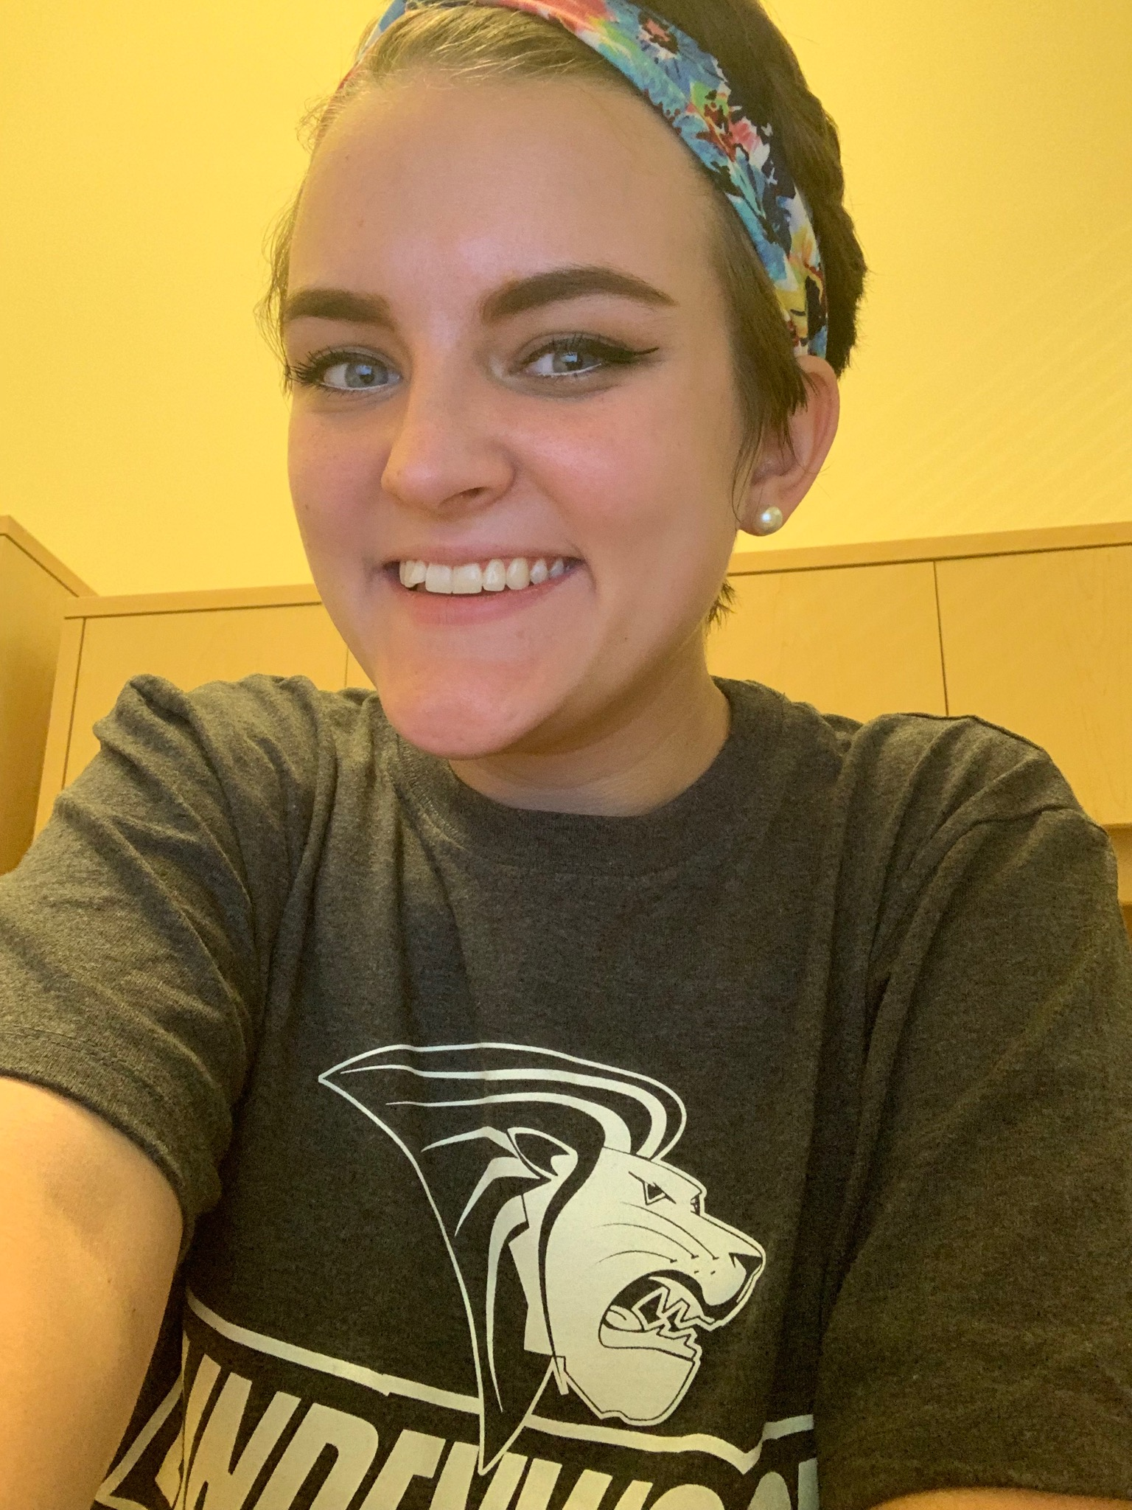

Rachel Frisch graduated from the Gerontology Program in May. She was soon after hired for her “dream job” and works as an Admissions Representative at Lindenwood University for their evening programs. The students she works with are usually working full-time jobs or taking care of their families, which prevents them from being able to take day classes. Her job is to build a personal relationship with each prospective student so she can understand their motivations, backgrounds, and personal circumstances to help create the best academic plan for them. She is their main point of contact from their first inquiry through their first term of classes.

She noted that her background in Gerontology, “Really helped me because it prepared me to understand the different generations I work with and how their approaches to school, work, and family vary. I am able to better empathize with my students so they feel heard and supported. The Gerontology program also taught me how to be an advocate for my students and to ensure they are never put on the back burner because of their age. I am able to share my students’ feedback with higher ups so the program can continue to improve.”

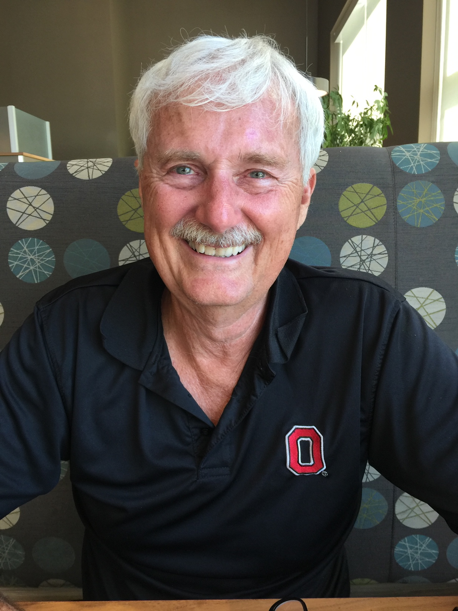

Dr. David Stockburger began teaching in 1974 at SMSU as an Assistant Professor in the Psychology Department. After a long career characterized by a number of notable accomplishments (putting out a fire in the resource room on the 4th floor in Hill Hall for example), he retired in 2001. Dr. Stockburger was one of the first to adopt online technology using the student Bulletin Board System, connected to the SMSU network, and requiring emails as part of a first assignment in a statistics course. He recalls one student complaining to the department head “I don’t understand why he is making me do this. I will never have to do this again in my life!” He has taught an online statistics course for the Psychology Department every semester since 2000. After his retirement from SMSU, he was employed at the US Air Force Academy as Deputy Director of Academic Assessment from 2004 to 2014.  He continues to be involved in teaching and providing a valuable service to not just Psychology majors but also Nursing, Counseling, and Public Health students. Nicely done Dr. Stockburger.

Department of Psychology Newsletter

Emeritus Spotlight

Help Improve Mental Health in Our Community

The Ozarks Mental Health Network was established in 2015. It is public and open to everyone. Its mission is to *facilitate communication about mental health and mental illness through advocacy, education, and outreach to the community in Greene County, Missouri, with the ultimate goal of increasing access and availability of services for those living with mental illness*.

In January 2019, MSU granted permission to the Psychology Department to create and maintain a sponsored website for the Network. The website will contain (1) information about local events, resources, and services, (2) a roadmap and suggestions for navigating services, (3) updates on relevant mental health legislation and (4) an opportunity to connect with others who are concerned about overall wellness.

**We are looking for interested students, faculty and staff to be involved in this creative process. If you want more information, or wish to be added to the mailing list to receive information about the Network's upcoming meetings and activities, please send an email to** OzMHNetwork@gmail.com. Feel free to share this information with other students, faculty and staff at MSU.

The Psychology Department thanks you for all your support!

Come see us in the newly renovated Hill Hall Main Office 319

Opportunities

Department of Psychology Newsletter