Missouri State University
Students for a Sustainable Future

SUSTAINABILITY
PROPOSAL

Solar Power-Dok Tables
Solar Powered Energy Stations for Refueling Electronic Devices

SUBMITTED BY:
Shane Franklin & Vicke Kepling

SUBMITTED ON:
01/29/2014

PROJECT TITLE
SOLAR POWER-DOC TABLES: Solar Powered Energy Stations for Refueling Electronic Devices

CONTACTS
Primary:
Shane Franklin
Phone: (417) 619-4246 Email: Franklin36@live.missouristate.edu

Vicke Kepling
Phone: (417) 987-0144 Email: Vicke333@live.missouristate.edu

Faculty Advisor:
Dr. Alexander Wait
Phone: (417) 836-5802 Email: AlexanderWait@missouristate.edu

PROJECT DESCRIPTION
This project will purchase and install two (2) solar powered docking stations (Solar Dok) to provide green electricity capable of delivering a convenient method for recharging electronic devices while also educating students on alternative, sustainable sources of energy.

PROJECT DETAILS
The system of each table has been designed to produce a given amount of energy per day and store it into the battery bank for use by electronic users. The average sun exposure will vary day to day, depending on weather. The system has been configured with an abundance of storage capacity to handle the ebbs and flows in solar production.
The table systems are virtually maintenance free, with the exception of regular cleaning (as with other picnic tables on campus). The units have lighting (LED bulbs, also powered by solar collection) that stay on for 45 minutes if activated. Time limitation also helps to conserve energy. LED bulbs are made to last for years, but bulbs may need to be replaced in future years.
It is recommended that the solar panels are free from dirt and debris for peak performance. Simply wiping them down with a wet rag periodically will suffice. The battery bank is comprised of maintenance-free solar gel cell, sealed batteries. It is anticipated that these will perform for several years without fail. The solar panels are rated for up to ten (10) years with ninety percent (90%) power output and twenty (20) years for an eighty percent (80%) power output.
PROJECT GOALS & IMPACTS
ENVIRONMENTAL / SUSTAINABLE
Portable electronic devices require a fuel source for recharging. The use of “off the grid” electricity for recharging these devices is just one more step toward improving the atmosphere of the MSU campus. The product not only produces energy. It also provides practical seating made from recycled materials. The product has been engineered to free-standing and to withstand extreme weather conditions and has been tested to withstand wind loads as high as 150 miles per hour.

EDUCATIONAL
While the energy savings provided by these units is not measurable in terms of dollars saved, they are an extremely valuable educational tool for our future leaders of a sustainable environment. The project will provide both student and community engagement. Students (along with faculty and staff) will have a multi-functional, interactive break area, and the community can be engaged through press releases and media communications involving the project.

UNIVERSITY BRANDING & VISUAL APPEAL
The MSU logo will be displayed on the units and will offer visual appeal in the area. The Students for a Sustainable Future will provide (at our cost) a small label by the power outlet to promote our group as well.

ACCESSIBILITY
One of the two tables will be wheelchair accessible.

PROPOSED LOCATION FOR TABLES
MSU Administration (Matt Morris) recommends two options:

Option 1: New plaza to the west of Blair-Shannon Dining Center (between Blair-Shannon Dining Center and Foster Recreation Center)

Option 2: Bookstore (west side; replacing existing picnic tables)

NECESSARY MODIFICATIONS TO EXISTING STRUCTURES

No modifications are needed for Option 1 (new plaza). If Option 2 is chosen (bookstore), the existing picnic tables will need to be relocated. Tables are freestanding up to winds of 150 mph. Bracing is optional.

TIMELINE & ESTIMATED COMPLETION TIME OF PROJECT

The suggested timeline for installation is on or before April 30, 2014, which is our group’s annual event - Ecopalooza. Funding will need to be secured by March 1, 2014. A deposit of fifty percent (50%) is required before work will begin, and construction time for the supplier is approximately eight weeks.
The project would take one afternoon locally. Company representatives deliver and install the units. They are open to speaking as they install the tables. This would be a good time to arrange an event for community, students, and media.

PROJECT COST – PROPOSAL AMOUNT

Itemized budget (Quote is attached; 50% deposit required)

Two Solar Power-Doc units $19,590.00
Delivery and Installation 3,100.00

Funding Request $22,690.00

SOLAR POWER-DOC (2)

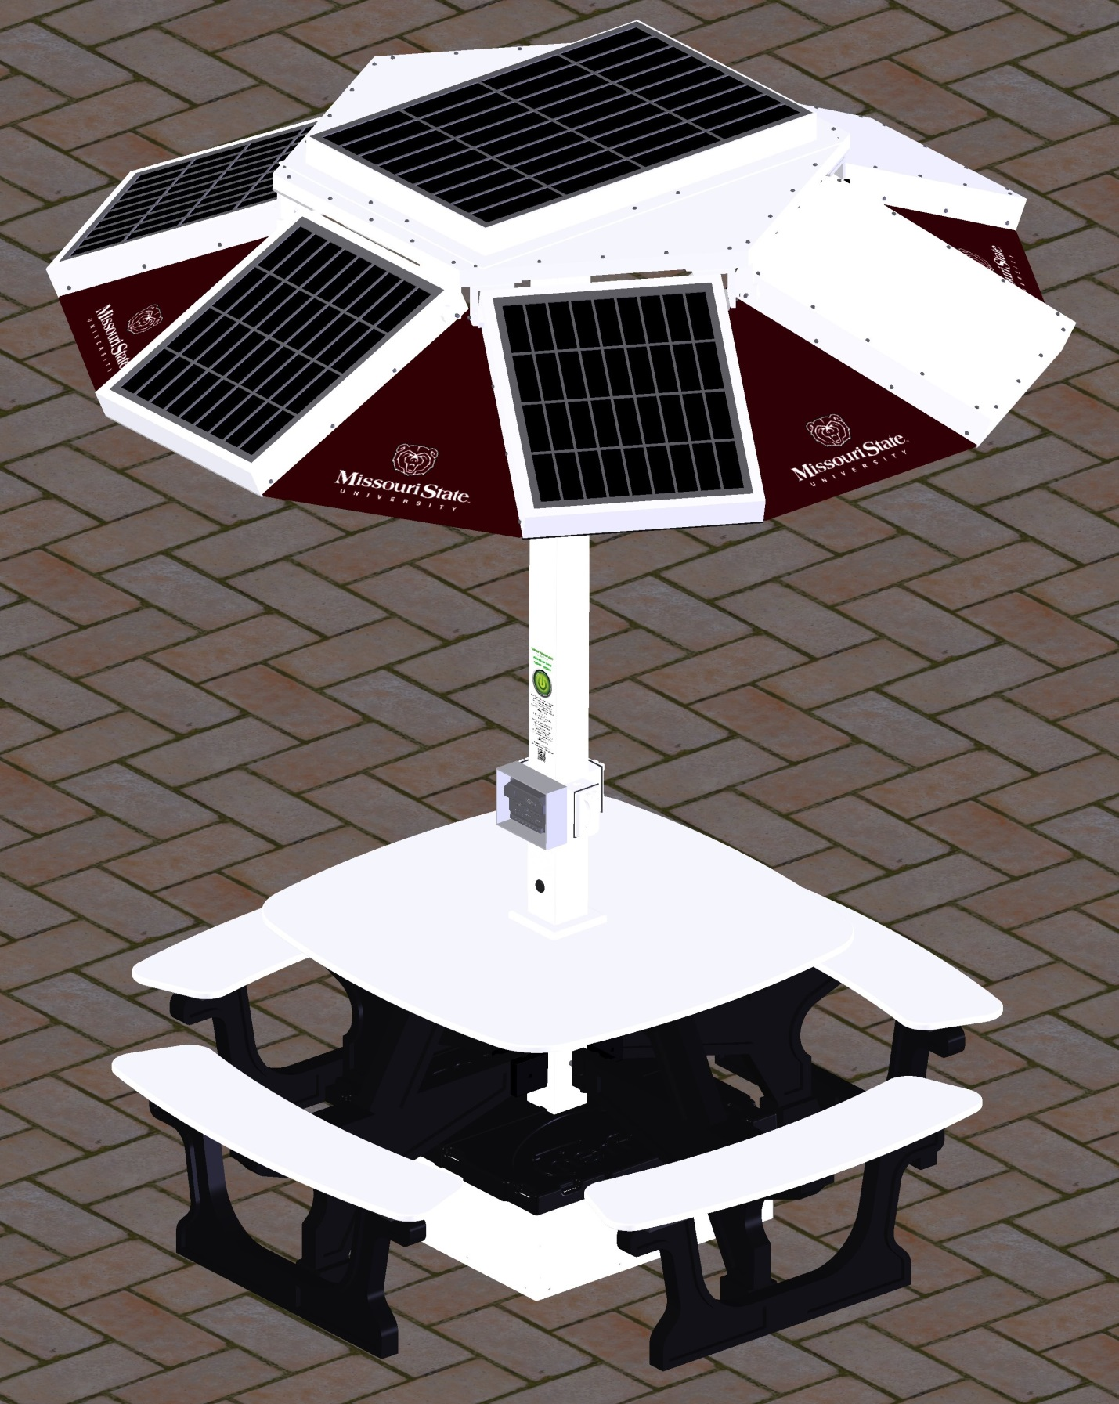
Students for a Sustainable Future

UNIT CANOPY

Panels will display MSU logo

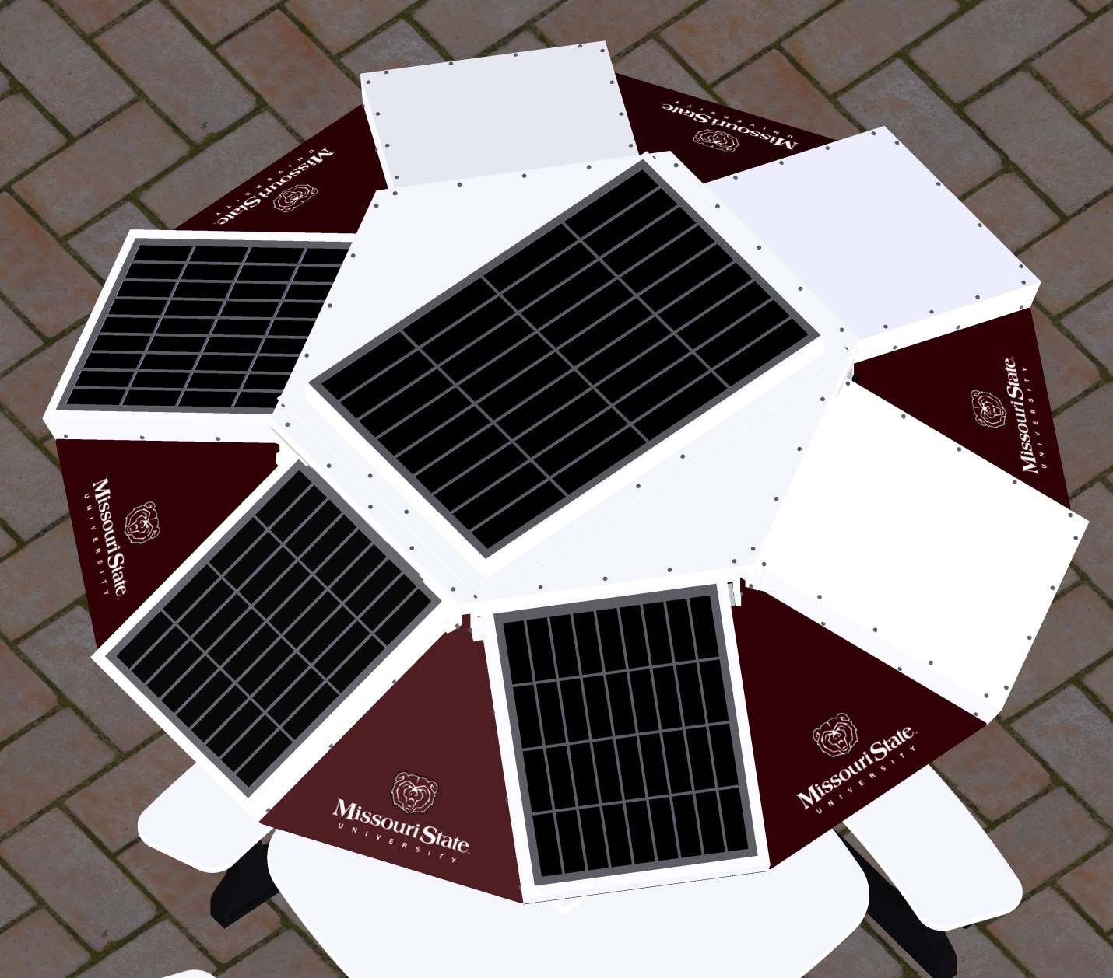

ALTERNATIVES: NOT DESIRABLE

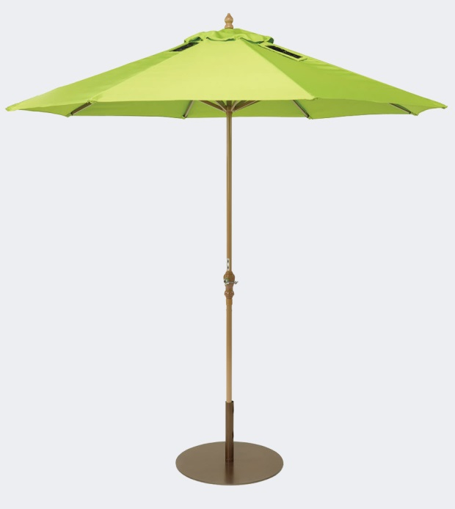
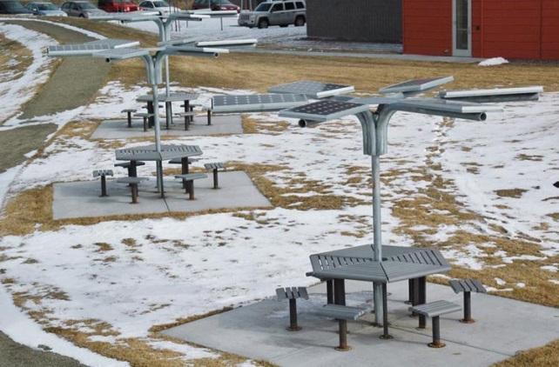

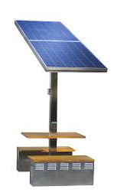

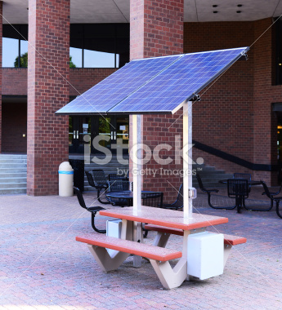

PLACEMENT OPTIONS FOR SOLAR TABLES

