Sustainability PROPOSAL
Pedestrian Light Fixture updates

Submitted by:
Lindsey Kolb and Brandon McCoy

Submitted on:
11/18/2014

- Identification of Sponsors
  - Project Sponsors
      - Lindsey Kolb
505 E Madison Apt B
Springfield, MO 65806
417-664-4974
kolb0503@live.missouristate.edu

2. Brandon McCoy
1116 E Cherry Room #202A
Springfield, MO 65807
(417) 872-5689
mccoy116@live.missouristate.edu

  - Faculty/Staff advisor (insert faculty/staff contact information below)
1. Pilar Karlen
Missouri State University Sustainability Coordinator
901 South National Avenue
Springfield, MO 65897
417-836-8984
pilarkarlen@missouristate.edu

  - Project Manager (identify manager below, should also be a project sponsor)
      - Lindsey Kolb
II. Description of Proposed Project
- General Description of Proposal
This proposal is recommending that the (374) 175 watt Metal Halide pedestrian lights be replaced with 45 watt light-emitting diode (LED) lighting system. With this conversion, there will be a reduction in energy usage of 74%, annual energy savings of $14,294, and an approximately annual maintenance savings of $34,296. The simple payback is 1.6 years.
Proposal Details—See attachment of details or visit this link:
https://drive.google.com/drive/#folders/0B82ED5t7yaDoWXRFdUNOdVJ1Tlk/0B82ED5t7yaDoZ2p2Rmg0dlJ3S00/0B82ED5t7yaDoN2cyVUVYazVydms/0B82ED5t7yaDoX1VhSDI3Z0V5UWs

a. Location for the object of the proposal
Pedestrian Lights are installed all around the campus.
Outdoor lighting layout is attached.
- Alternative Uses
n/a
- Drawbacks
n/a
- Necessary modifications to existing structures
- Estimated Cost of the Project
  - Provisions of Complete Cost Breakdowns
Pedestrian Lights
Item | Units | Price per unit | Total Cost
45W pole top LED | 374 | $177.00 | $77,418.00
Approx. Installation cost | 374 | $30.00 | $11,220.00
Total first estimated cost | 374 | $237.00 | $88,638.00
10% Contingency | 374 | $23.7 | $8,864.00
Total Est. Cost + 10% | 374 | $260.70 | $97,502.00
Total Est. Cost -$9,724 CU Rebate (fronted cost by facilities management) |  |  | $87,778.00

** Facilities has agreed to front the cost of the rebate and they will receive the funds back from CU
*Rebate program is available from City Utilities for updating lights to LED lights.
Total rebate amount: $9,724
Total cost after rebate with contingency: $87,778
See this link for more info from CU: http://www.cityutilities.net/conserve/pgm-comlight-rebate.htm

- Estimated Completion Time of Project
2 months
- Estimated Life of Project
This specific model of LED is rated at 50,000 hours (approx. 12 years). This system will be installed with a photocell and it will work from sunset to sunrise (11.5 hours per day, 4200 hours per year).

The cash flow after the end of the life cycle for the current lighting system is ($484,798) and for the proposed LED retrofit is ($123,098) therefore on the 12th year, the university would have saved $361,700 in maintenance and energy cost.

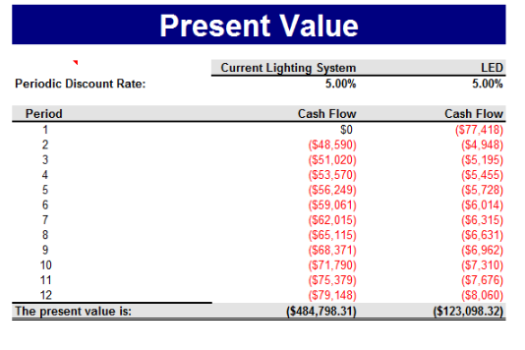

- Justification of Project:
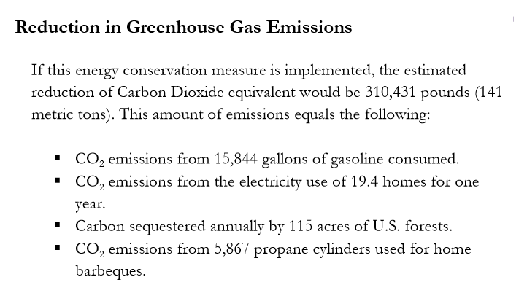

The main advantages of LED lighting systems are:

- Compact size
- Durability and shock-resistance
- No infrared (IR) or ultraviolet (UV) emissions
- Directional light
- Lower operating cost: energy efficiency
- Lower operating cost: longer life
- Wide color temperature range
- Control options
- No toxic metals or chemicals
- Monochromatic light
- No burn out
- Near instant-on and rapid cycling
- Good performance in the cold
- LEED point contribution

This project justifies the university’s sustainability mission because it will be changing the amount of energy that is used for the lights in the parking lots to sustainable energy. This will also save thousands of dollars in energy bills because these lights use less energy. By using less money on energy the university is able to fund other projects that will benefit student success and experience. The University has already done many LED light upgrades in previous years and this is a step forward towards a greener university. Switching to LED lights promotes the ethical leadership pillar in the Public Affairs Mission because it is a step towards taking initiatives to improve the campus community and is being spearheaded by students who took leadership roles in making the campus a more sustainable place.

