Sustainability proposal
Electricity-generating stationary bikes in Foster Recreation Center

Submitted by:
Lauren Nichols, Lauren Bansbach

Submitted on:
02/27/2013
Missouri State University
Student Government Association

- Identification of Sponsors
  - Project Sponsors
      - Lauren Nichols
1001 East Madison Street-Room S300
Springfield, MO 65807
(816) 507-9972
Nichols111@live.missouristate.edu

2. Lauren Bansbach
1237 E. Belmont St.
Springfield, MO 65804
(314) 488-0674
Bansbach009@live.missouristate.edu

  - Faculty/Staff advisor
1. Cynthia Barnett
Director Campus Recreation
901 South National Avenue
Springfield, MO 65897
(417) 836-5334
CindiBarnett@missouristate.edu

  - Project Manager
      - Lauren Nichols
II. Description of Proposed Project
We are putting stationary bicycles into the Foster Recreation Center that will not use energy, but will produce it. The energy produced can be put directly back into the system. Students will have the chance to see the energy that their efforts produce while working out. Using this equipment will lower the energy used in the recreation center, and will be an educational sustainability tool for students using the equipment.
Initially, we proposed purchasing two “Plug Out” electricity generating stationary bikes. After obtaining information from Director Barnett, we looked into a different company, SportsArt Fitness. We are proposing to purchase four of the bikes so that we can test how well the product works as well as student interest and use of the product. The bikes will be purchased from SportsArt Fitness and will be plugged into an inverter.
The bicycles would be placed in the Foster Recreation Center for all students to use and enjoy.
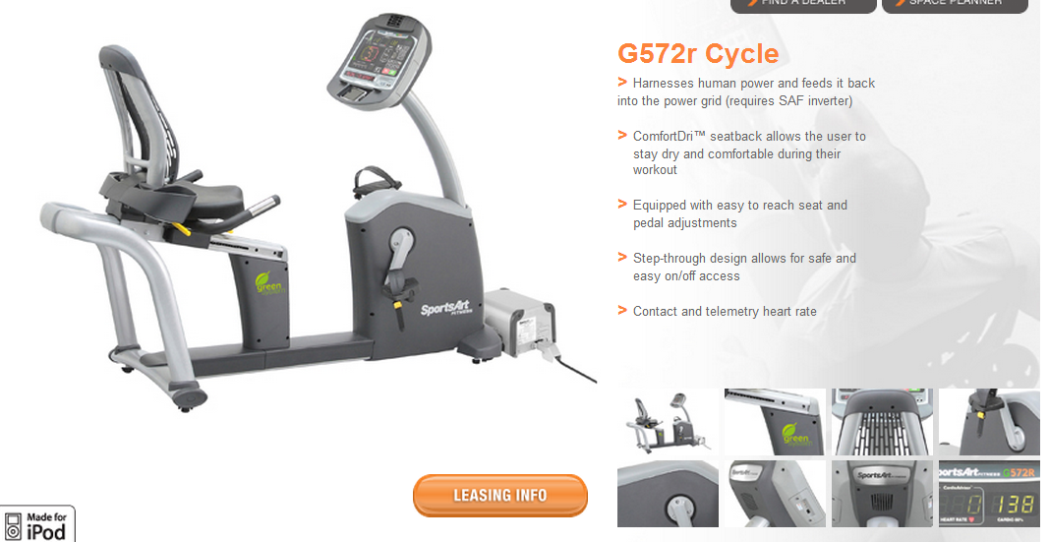Figure 1. G572r Cycle, Recumbent bicycle.
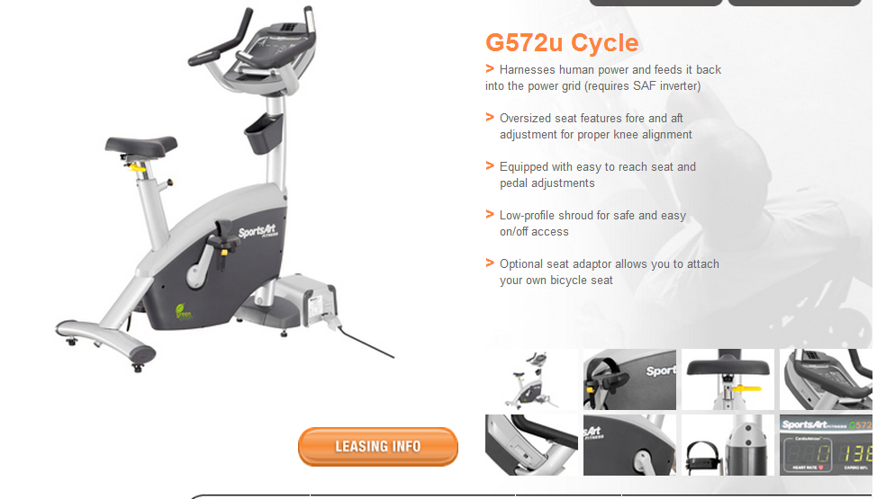
Figure 2. G572u Cycle, Upright bicycle
Estimated Cost of the Project: $14,785
An alternative option would be to purchase from a different company to obtain a lower price, however, the quality might not be equivalent.
Upright Bicycle (x2): $4,495
Recumbent Bicycle (x2): $6,835
Inverter: $1,605
Shipping: $500
10% overhead costs: $1,350
Estimated Completion Time of Project
We expect this to be done by May 1, 2013.

Estimated Life of Project
We expect that the bikes will last a minimum of ten years.

Justification of Project
These bikes will allow students to be more aware of the energy they use. When students go to the gym, they are unaware of the energy used to power the machines. By having these electricity-generating bikes, students can be more aware and conscious of what they are doing and how much energy they are using. The bikes will also give students a chance to contribute energy and be more sustainable and energy conscious while working out.
University Support
Director of Campus Recreation, Cynthia Barnett, approves of putting these bikes in the Foster Recreation Center. There is ample room for the bikes in the building and said she would be willing to put them in for student use.

