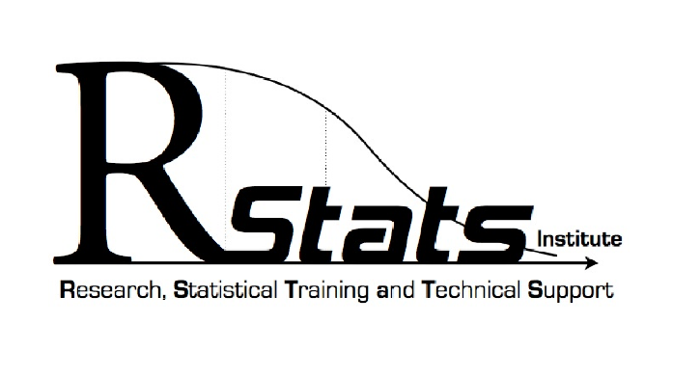
RStats THESIS and RESEARCH Project APPROVAL FORM - 2024

Statistical consultants intend to provide statistical advice and guidance and not to design and analyze a student's thesis or research projects data. When a particular project is beyond the expertise of the student and/or the advisor, then other statistical consultation may be an option. Students who meet independently with a statistical consultant should only do so with the permission of their committee, and the student should inform the committee of the general content of the meeting.

I hereby certify that I have obtained the necessary permission for statistical consultation on my Thesis or research project for the topics indicated on the online, request form

_________________________________________
Printed Name of Student

_________________________________________ ________________
Signature of Student Date

FACULTY ADVISOR APPROVAL
I accept and approve of the collaboration and consultation as indicated above.

_________________________________________
Printed Name of Faculty Advisor

_________________________________________ ________________
Signature of Faculty Advisor Date

RStats APPROVAL
We accept and approve of the collaboration and consultation as indicated above.

_________________________________________
Printed Name of RStats Consultant

_________________________________________ ________________
Signature of RStats Consultant Date

